

**USER MANUAL SIGN-OFF**

**Authorization Memorandum**

This form is to sign-off completion of the Design Phase for **CAMPUS MANAGEMENT SOFTWARE AT WORLD SKILL CENTER (WSC).**

World Skill Centre (WSC) acknowledges receipt of the deliverables as part of the Design Phase through the submission of this document.

|  |  |
| --- | --- |
| **MODULE NAME** | **HRMS** |
| **MODULE OWNER** |  |

**WSC AUTHORITY NAME AND SIGNATURE**

**SOUL AUTHORITY NAME AND SIGNATURE**

 



**Sustainable Outreach And Universal**

**Leadership (SOUL) Limited**

**User Manual**

Of

**HRMS Module**

For Implementation of

**Campus Management Software**

at

**World Skill Center (WSC)**

**Confidentiality**

This document is a strictly confidential communication to and solely for the use of the recipient and may not be reproduced or circulated without SOUL Ltd’s prior written consent. If you are not the intended recipient, you may not disclose or use the information in this documentation in any way

**Document Control History**

|  |  |  |  |  |
| --- | --- | --- | --- | --- |
| **Date** | **Version No.** | **Created By** | **Affected Sections** | **Reviewed By** |
|  |  |  |  | Sharmistha Panda |

Table Of Contents

USER MANUAL SIGN-OFF 1

Authorization Memorandum 1

Table Of Contents 4

1 Introduction 6

1.1 Background 6

1.2 Scope and Purpose of the document 6

2 General Procedures 7

2.1 General Procedure for Save Screen 7

2.2 General Procedure for Submitted Document 14

3 Master Screens 18

3.1 Employment Type 18

3.2 Campus Location 19

3.3 Department 20

3.4 Designation 23

3.5 Employee Grade 24

3.6 Employee Group 25

3.7 Holiday List 27

4 Recruitment 30

4.1 Recruitment Exam Center 30

4.2 Job Requisition 32

4.3 Staffing Plan 34

4.4 Job Opening 36

4.5 Job Applicant 38

4.6 Recruitment Exam Declaration 39

4.7 Recruitment Admit Card Generation Tool 41

4.8 Recruitment Admit Card Generation 43

4.9 Recruitment Exam Result Declaration Tool 45

4.10 Recruitment Exam Result Declaration 47

4.11 Job Offer 48

4.12 Appointment Letter Template 50

4.13 Appointment Letter 52

5 Employee Life Cycle 53

5.1 Employee 53

5.2 Employee Profile Updation 56

5.3 Employee On-boarding Template 58

5.4 Employee On-boarding 60

5.5 Employee Resignation 63

5.6 Employee Separation Template 66

5.7 Employee Separation 68

5.8 Employee Suggestion 72

5.9 Employee Re-engagement 75

5.10 Employee Grievance Cell 78

5.11 Employee Grievance 79

5.12 Employee Transfer 82

6 Leave Management 84

6.1 Leave Type 84

6.2 Leave Policy 86

6.3 Leave Period 88

6.4 Leave Policy Assignment 90

6.5 Leave Allocation 92

6.6 Leave Blocklist 94

6.7 Leave Application 95

6.8 Compensatory Leave Request 98

7 Shift Management 99

7.1 Shift Type 99

7.2 Shift Assignment 102

7.3 Shift Request 103

8 Attendance 106

8.1 Employee Attendance Tool 106

8.2 Attendance 107

8.3 Attendance Request 108

8.4 Employee Checkin 111

9 Appraisal 113

9.1 KRA 113

9.2 Dimensions for Appraisal 114

9.3 Employee Appraisal Evaluation Template 115

9.4 Employee Appraisal Cycle 117

9.5 Employee Appraisal Portal 118

10 Settings 121

10.1 HR Setting 121

11 Roles and Permissions 123

11.1 Masters 123

11.2 Recruitment 125

11.3 Employee Life Cycle 127

11.4 Leave Management 130

11.5 Shift Management 132

11.6 Attendance 132

11.7 Appraisal 133

11.8 Settings 134

# Introduction

The World Skill Center (WSC) is a premier advanced skill training institute established by the Government of Odisha, Skill Development and Technical Education Department, through the Odisha Skill Development Authority (OSDA). The WSC will impart advanced skill training in eight trades from engineering and service sectors. WSC caters primarily to induct the best talent from ITIs and Polytechnics and training them to become globally employable in emerging areas such as "Industry 4.0". WSC is housed in a state-of-the-art, 18-storey, air-conditioned building with nearly half a million square feet of space in the heart of capital city of Bhubaneswar.

With the implementation of campus management software for WSC the goal is to streamline the operations and functions of the campus by integrating various processes, such as admissions, course registration, academic progress tracking, and financial management, HRMS, Procurement and Inventory management, etc into a unified system. The implementation also aims at providing a user-friendly interface for all stakeholders, making it easier for them to access the necessary information and complete their tasks with ease. The modules to be covered during the implementation of the software include:

|  |  |
| --- | --- |
| Students Management Modules | Infrastructure Management |
| Academic System | Finance and Accounting System |
| Procurement & Inventory Management | Training and Placement |
| Human Resources Management System | Application Integration |

# 

## Background

The Web Based Campus Management Application at World Skill Centre (WSC) application is required by WSC for the smooth operation of all departments / support functions with on-line delivery of services to all stakeholders.

The project aims to create a mechanism to provide the basis for evolution of an IT enabled state of the art workflow automation system in a planned manner.

## Scope and Purpose of the document

A user manual is a document provided to a user that helps in using a particular system, product or service seamlessly. It is also known as an instruction manual or a user guide. Such documents cover detailed information around operations, standards & guidelines, [troubleshooting guides](https://document360.com/blog/troubleshooting-guide/" \t "https://document360.com/blog/creating-a-user-manual/_blank), functionalities & more.

This document covers all the aspects of HRMS module. This module helps in organizing the entire HRMS setup such as Masters,Employee Lifecycle,Leave Management,Shift Management,Appraisal and Recruitment process.

The scope of HRMS Module:

* **Recruitment process management**
* **Employee Lifecycle including Employee boarding,promotion,transfer,retirements,separation and re-engagement of employee.**
* **Staff profile management including Educational qualification,work experience,work history and so on.**
* **Attendance Management**
* **Grievance and Disciplinary cases monitoring.**
* **Performance Management System.**
* **Leave management**
* **Shift Management.**

# General Procedures

## General Procedure for Save Screen

**Create New document**

Login on to the system

Go to the required workspace

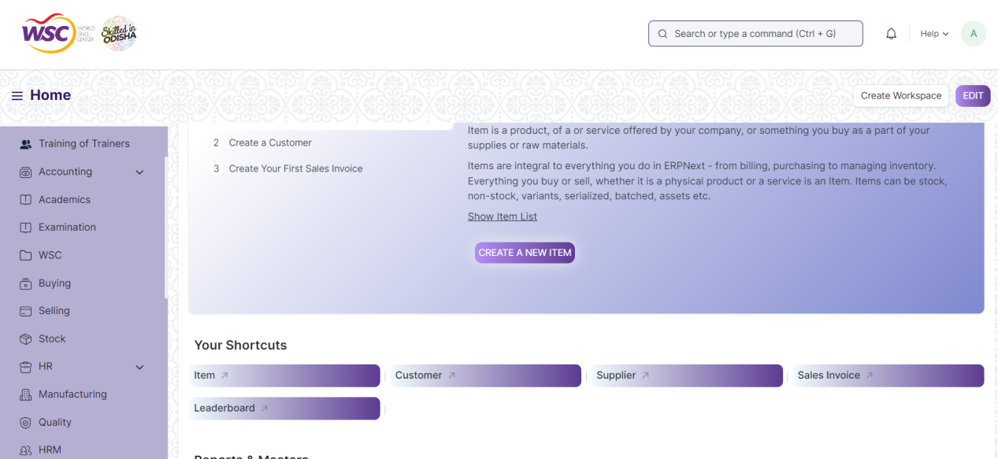

* Go to the required screen.
* Click on the ***“+Add Screen Name”*** button in the right corner of the screen.

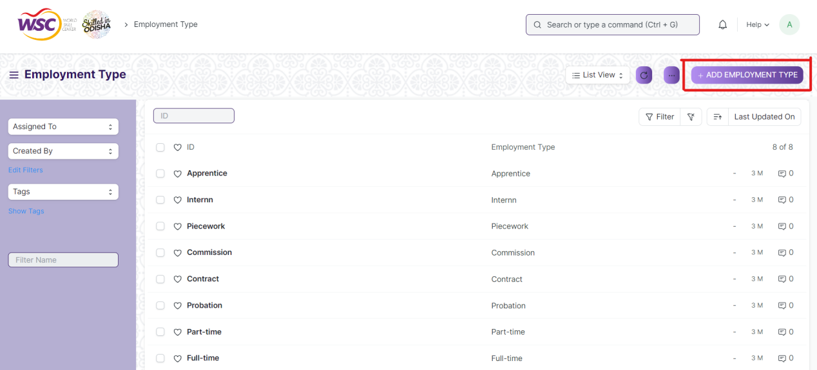

(Example : For addition in the new Employment Type , click +Add Employment Type button).

* Enter the required data.
* Click on “***Save”*.**
* After saving , the record will be visible in the List View of the screen.

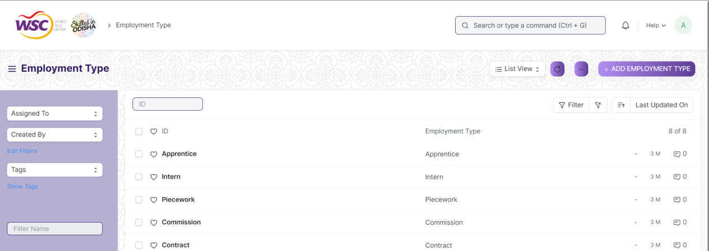

(Example : List view of saved Employment Types)

**Note :** The process of creation can only be carried out by employees who have necessary permission.Kindly refer to the Screen wise permission section in the document.

**View a Saved Document**

* Log in to the system.
* Go to the required workspace
* Go to the required screen.
* Click on the required document from the list view of the screen.

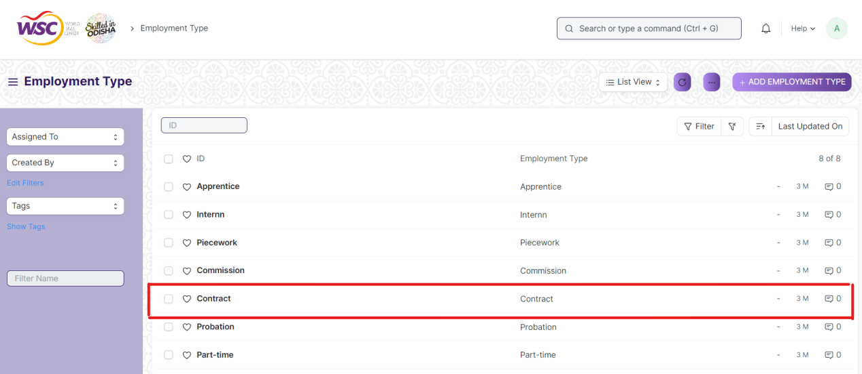

(Example : View of “Contract” Document of Employment Type Screen)

View the clicked document.

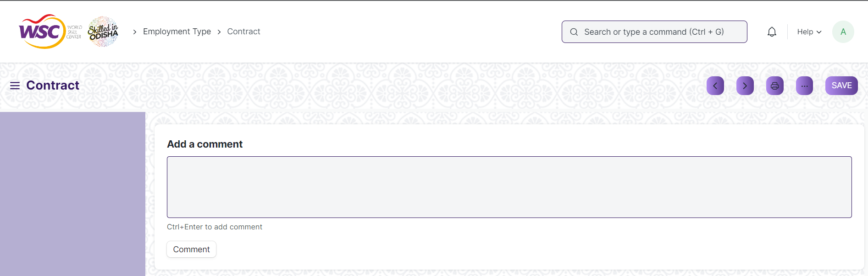

(Example : View of the “Contract” Employment Type)

**Note :** The process of view can only be carried out by employees who have necessary permission.Kindly refer to the Screen wise permission section in the document.

**Delete a Saved Document**

* Log in to the system
* Go to the required workspace
* Go to the required screen.
* Click on the required document from the list view of the screen.
* Click on the 3 dots in the right corner of the screen.
* Click on *“****Delete”*.**

**Note :** If the document you are deleting is linked with any other document then first unlink it , then try to delete.

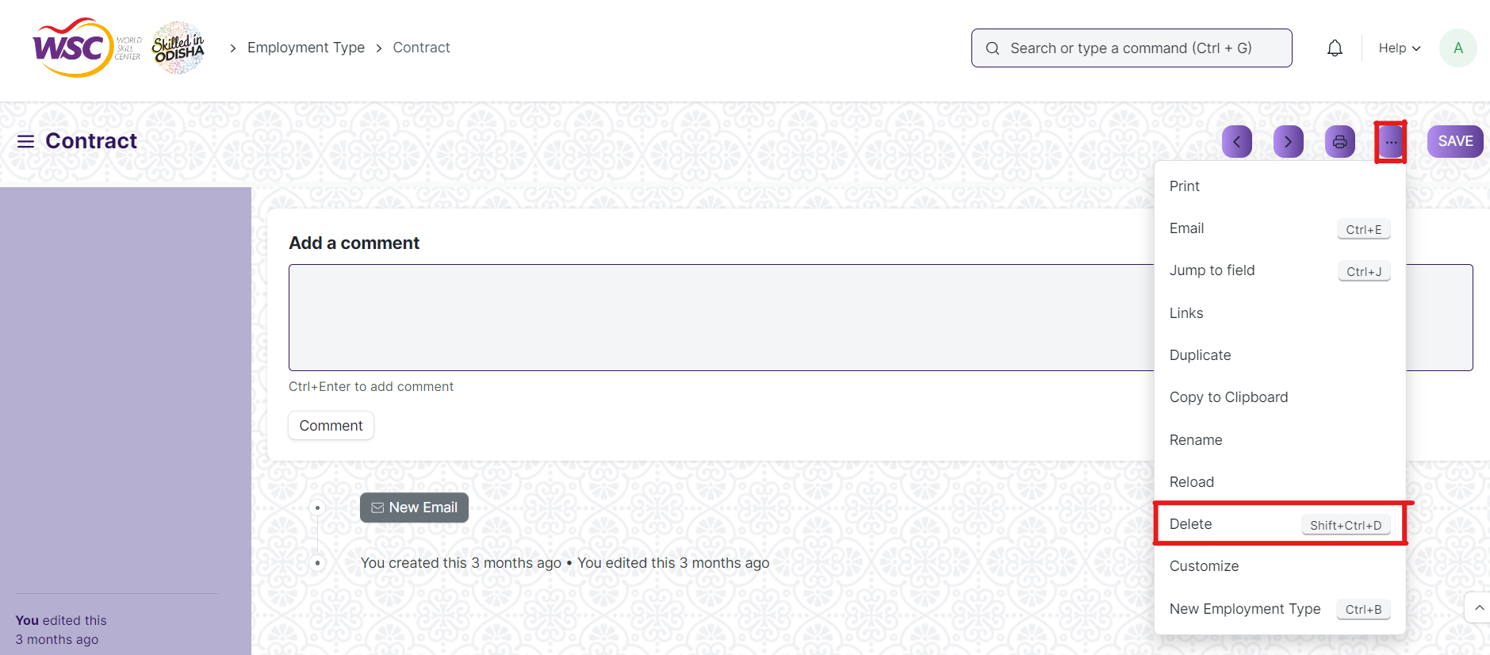

(Example : Deletion of “Contract” document of Employment Type)

* Click yes if you want to delete the selected document.

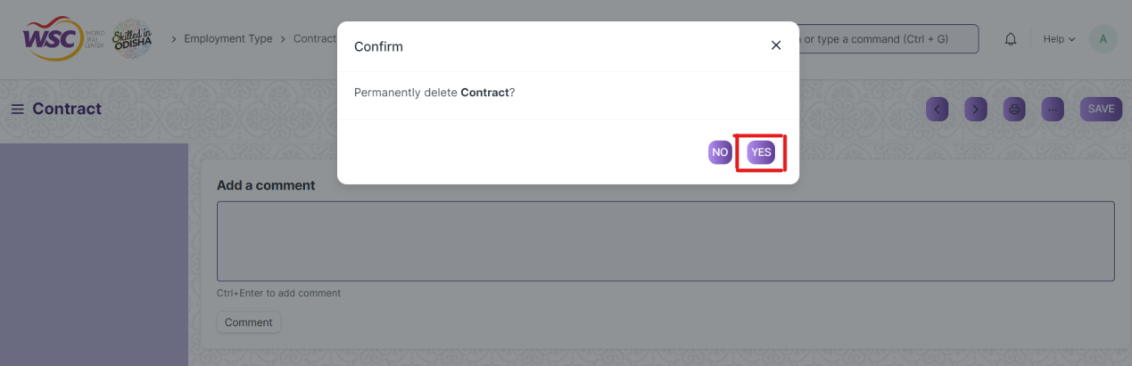

(Example : Clicking Yes to Delete permanently the document)

**Note :** The process of deletion can only be carried out by employees who have necessary permission.Kindly refer to the Screen wise permission section in the document.

**Rename a Saved Document**

* Login to the screen.
* Go to the required workspace
* Go to the required screen.
* Click on the required document from the list view of the screen.
* Click on the 3 dots in the right corner of the screen.
* Click on *“****RENAME”*** .

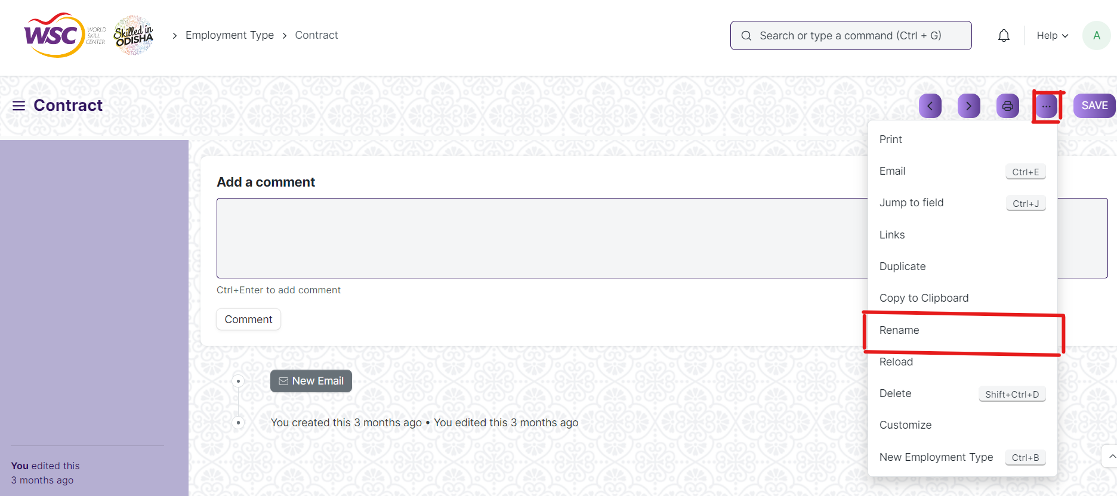

* Click on *“****Rename”*** button to rename the document.

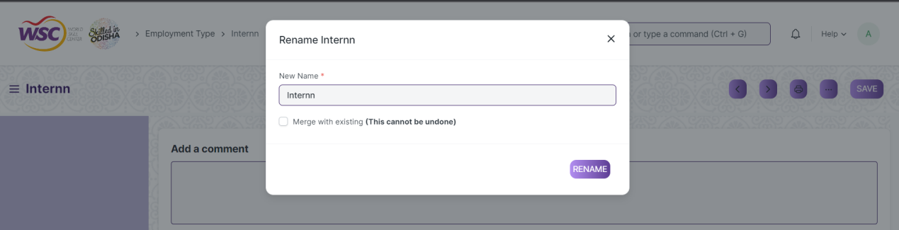

**Note :** The process of deletion can only be carried out by employees who have necessary permission.Kindly refer to the Screen wise permission section in the document.

**Print a Saved Document type**

* Login to the system
* Go to the required workspace
* Go to the required screen.
* Click on a saved document on the screen.
* Click on the print button presented in the right corner of the screen.

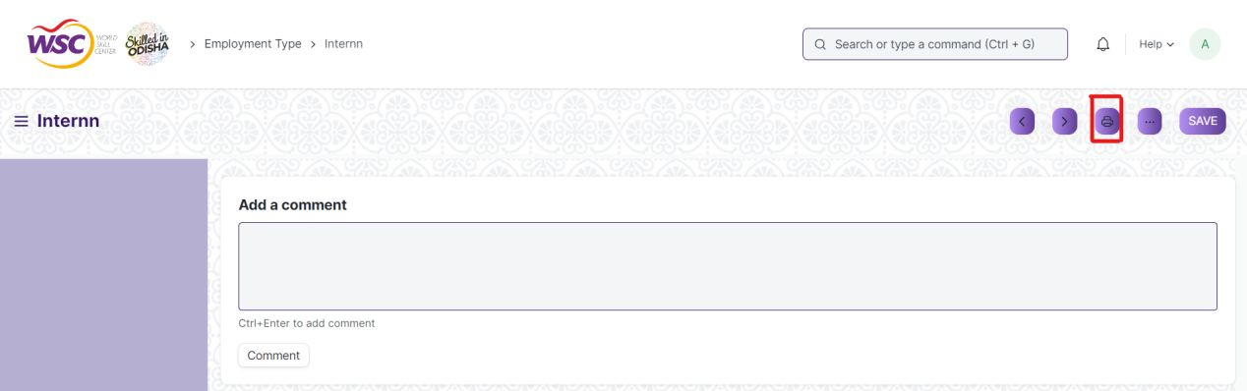

* A new screen will open.
* Click on the print button to print the document.

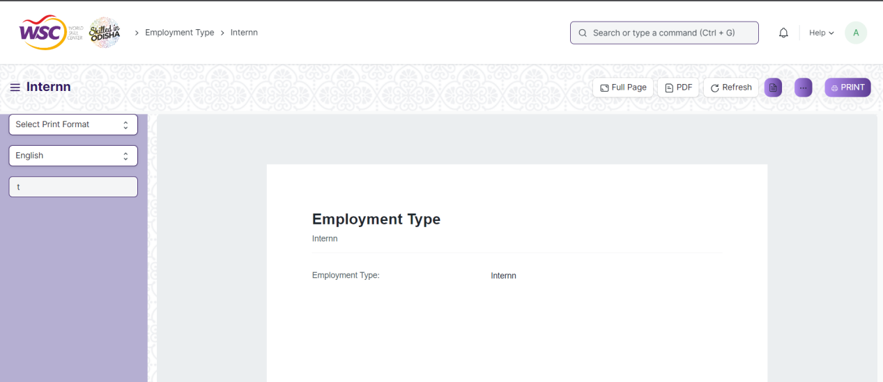

* To download the employment type as PDF , click on the PDF button .

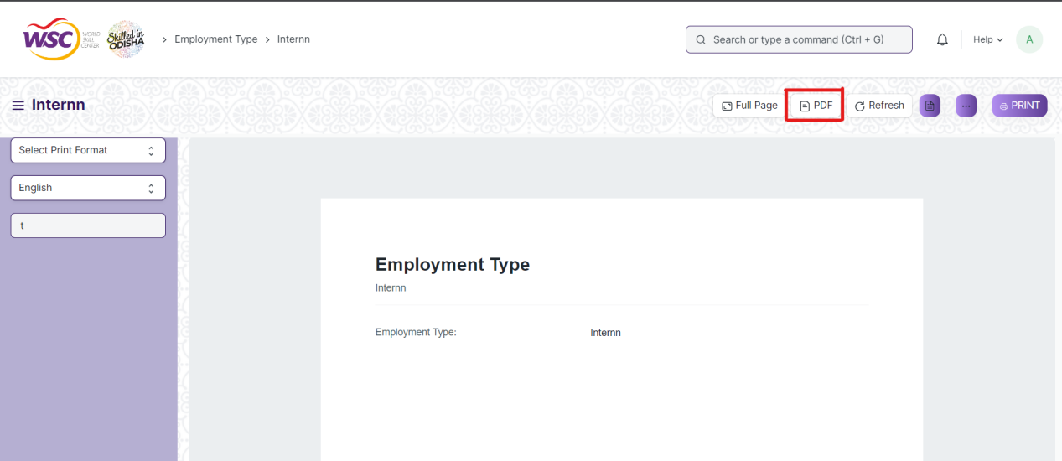

**Note :** The process of printing can only be carried out by employees who have the necessary permission.

**View the saved document in different format.**

* Login to the system
* Go to the required workspace
* Go to the required screen.
* Click on the List View Button in the screen.

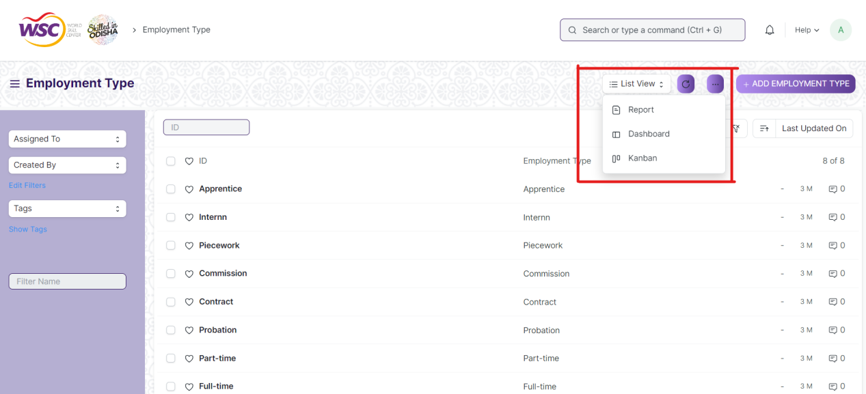

* Select the appropriate view type that you want.

**Note :** The List view button can only be showed to the employees who have necessary permission.

**View the saved documents by applying filters.**

* Login to the screen.
* Go to the required workspace.
* Go to the required screen.
* Click on the ***“Filter”***.

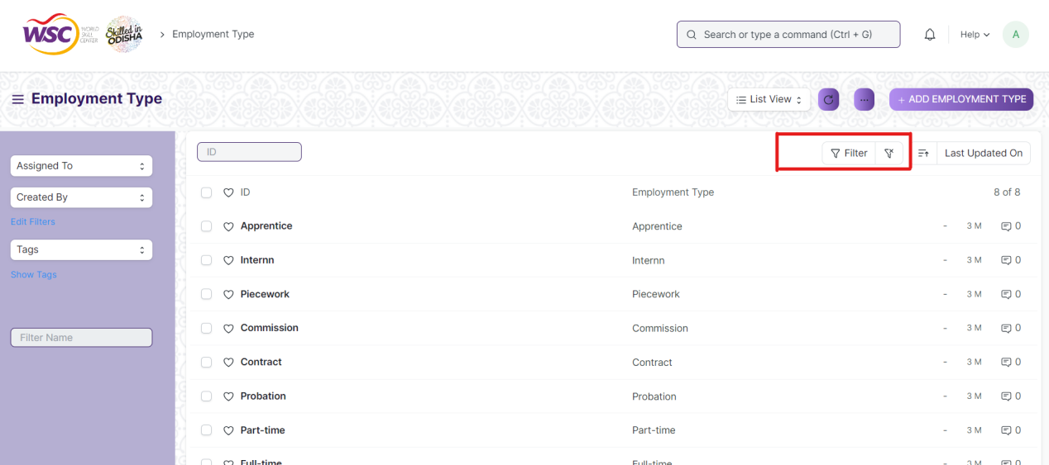

* Select the field of the document based on which you wish to filter the records. All the fields in a form will be selectable in this list.

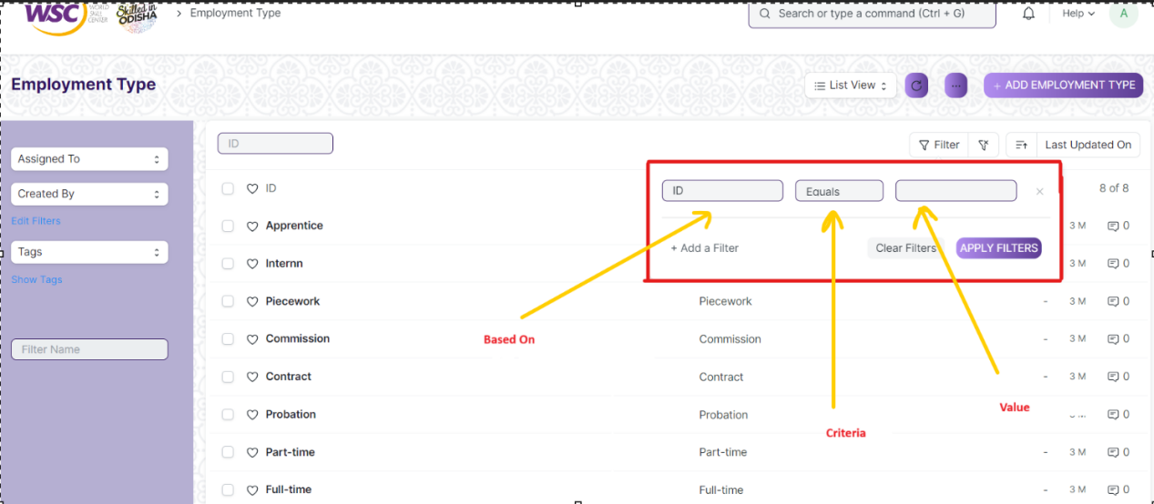

**Based On :** For the field, you will be required to put a value of the field. In the 'based on' field.

**Criteria :** You can define criteria based on which the system will search the document.The different conditions on which the filters are based are: Equals, Not Equal, Like, Not Like, In, Not In, =,>,< etc.

**Value :** Here, you will be required to enter the value for which you are running the document search.

**Some Examples of Viewing the documents in the list view after applying filters.**

Filter on Employee screen where Gender Equals to Male. After clicking the Apply Filter button, all the filtered document will show in the screen.

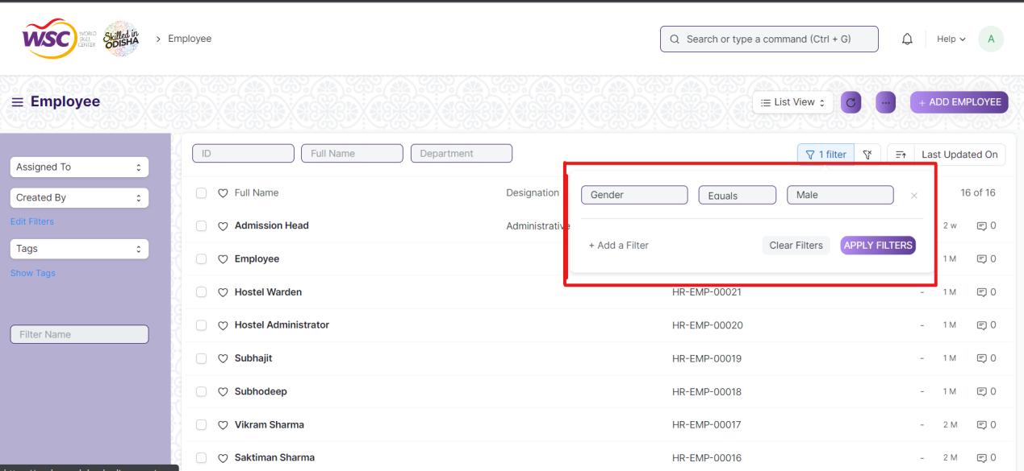

Filter on Employee Screen where, the full name starts with ‘A’.

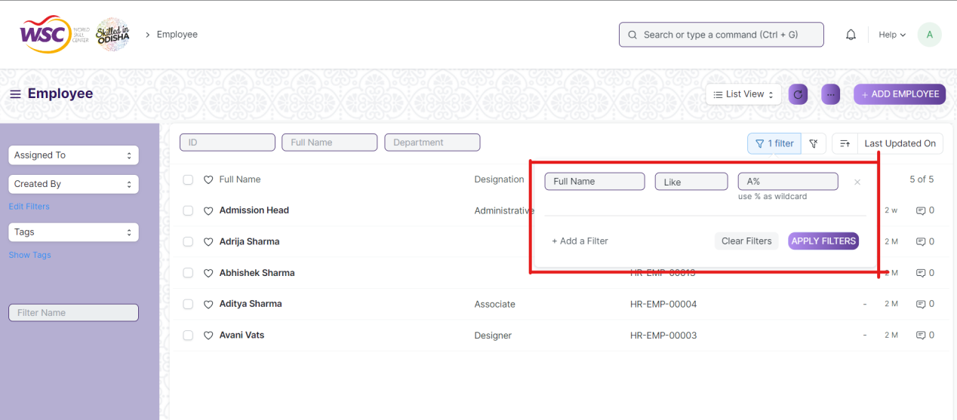

Filter on Employee Screen , where Date of Joining is greater than a particular date.

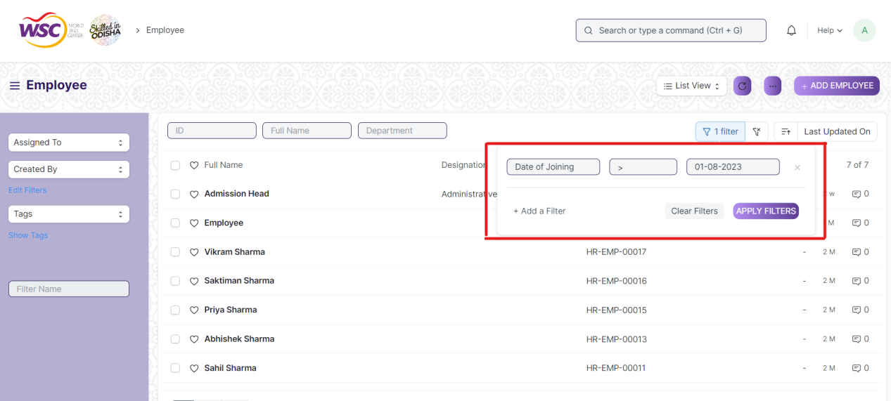

You can also apply multiple filters at a time. To remove a specific filter, just click on 'x' sign on it. To add another filter Click on the +Add a Filter button.

**Example of Multiple filter .**

Applying filter in the employee screen , where date of joining is greater than some date and gender is equal to Male.

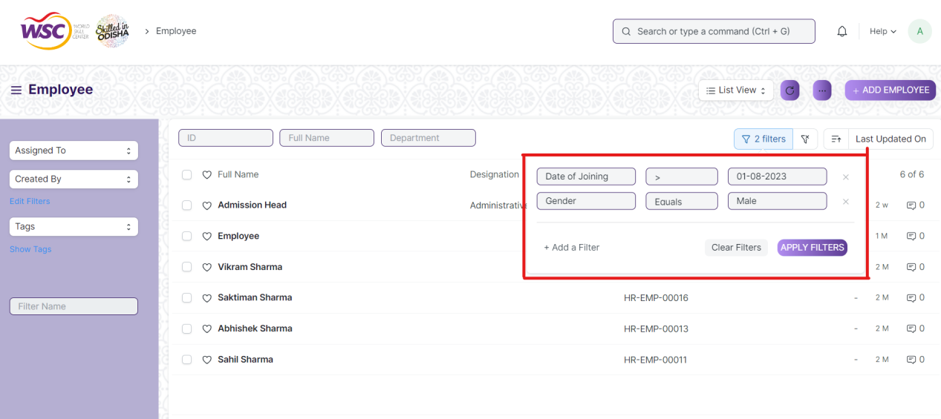

**Default Filters**

There are some filters present out of the box for the views which can be used for filtering the search results.

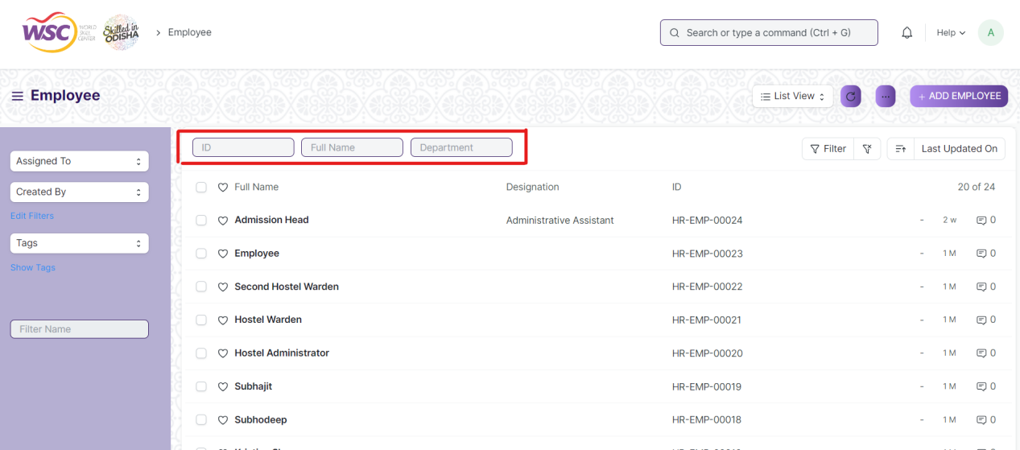

**Note :** The Filter Option can only be showed to the employees who have necessary permission.

## General Procedure for Submitted Document

**Create of New document**

* Login in to the system
* Go the required workspace
* Go to the required screen.
* Click on the ***“+Add Screen Name”*** button in the right corner of the screen.

(Example : For addition in the new Employment Type , click +Add Employment Type button).

* Enter the required information in the document.
* Once you are finished entering the information , click the ***“Save”*** button.
* After saving it , a submit button will appear.

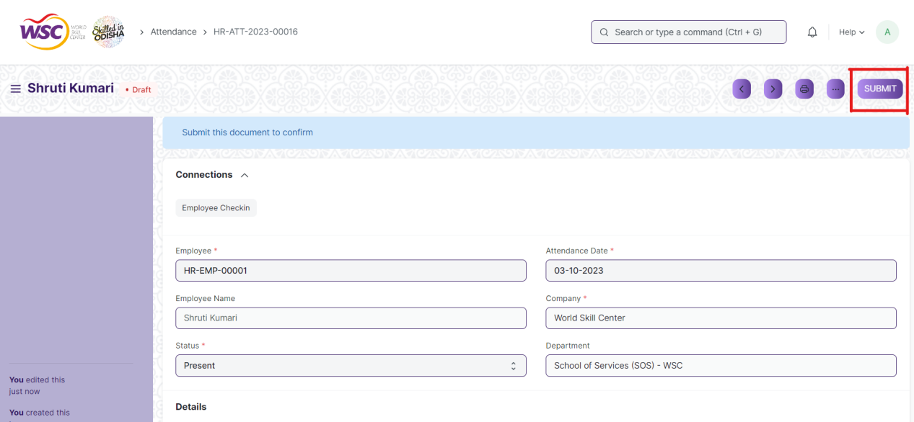

* Click on the **“Submit”** button.
* A confirmation dialog box will appear . Click the Yes button to submit the document.

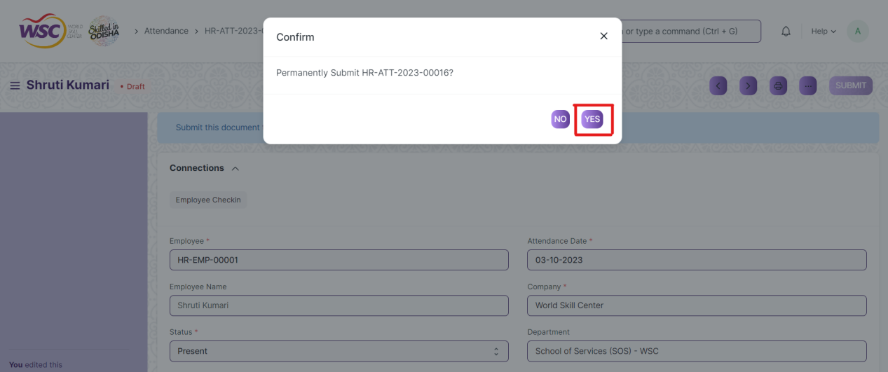

* After submitting , the record will be visible in the List View of the screen.

**Note :** The process of creation can only be carried out by employees who have necessary permission.Kindly refer to the Screen wise permission section in the document.

**Cancel a Submitted Document**

* Log in to the system.
* Go to the required workspace
* Go to the required screen.
* Click on the required document from the list view of the screen.
* Click the ***“Cancel”*** Button .

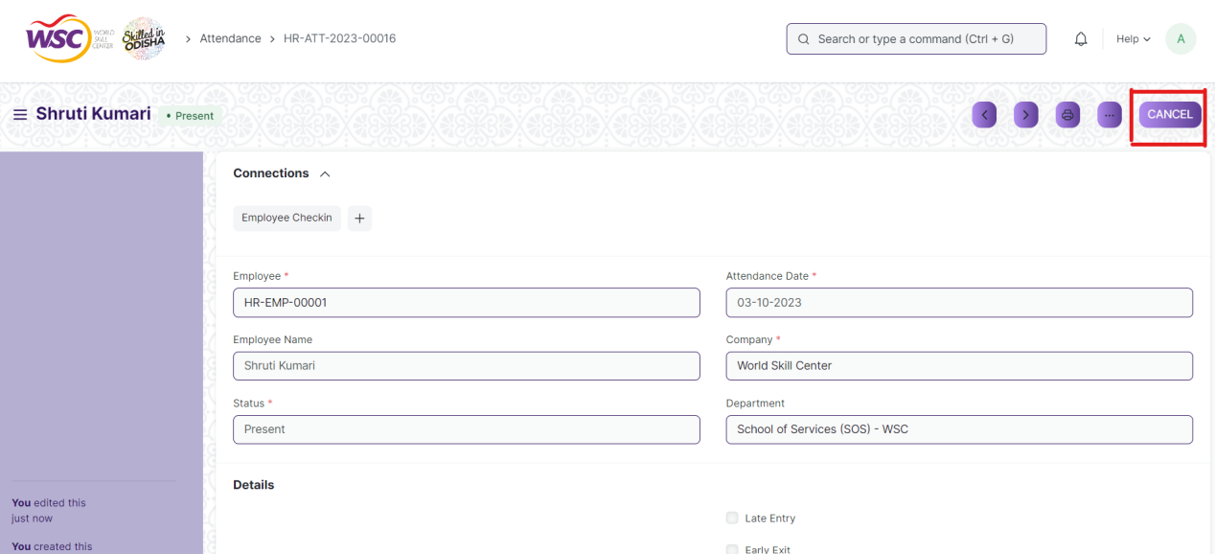

* A confirmation dialog box will appear . Click the Yes button to cancel the document.

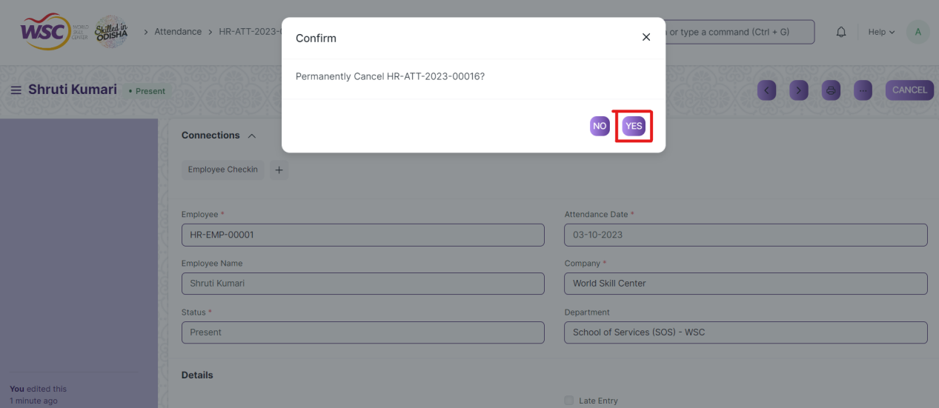

**Note :** The process of cancellation can only be carried out by employees who have necessary permission.Kindly refer to the Screen wise permission section in the document.

**Amend a Submittable Document**

* Log in to the system.
* Go to the required workspace
* Go to the required screen.
* Click on the required document from the list view of the screen.
* After cancellation of the document , an Amend button will appear on the screen.

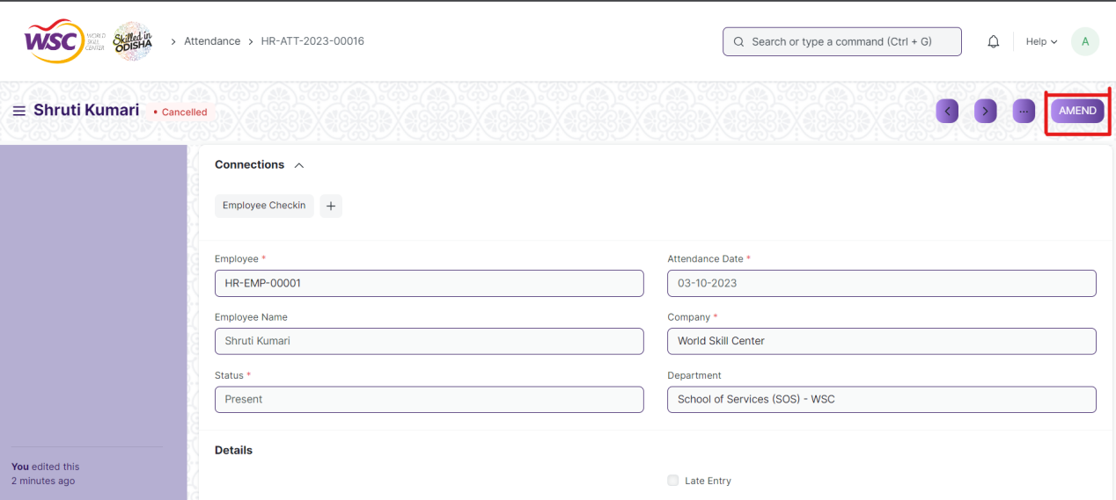

* Click the “***Amend”*** button.
* A new document will be created with the same information as the original document .

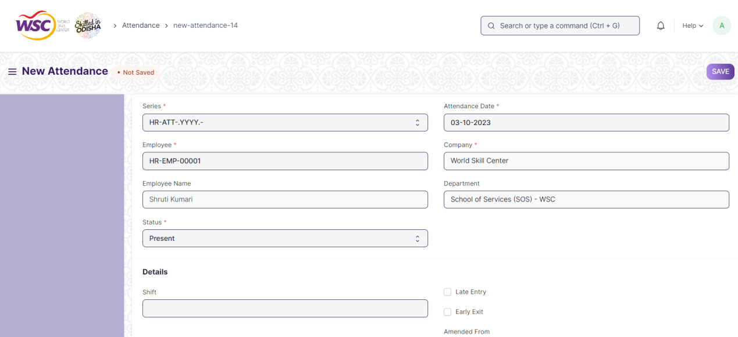

* You can now make changes to the document as needed.

**Note :** The process of Amend can only be carried out by employees who have necessary permission.Kindly refer to the Screen wise permission section in the document.

**Delete a Submittable Document**

* Log in to the system.
* Go to the required workspace
* Go to the required screen.
* Click on the required document from the list view of the screen.
* If the document is in draft sate , you can follow the procedure to delete a save document .
* If the document is submitted , then cancel it first , then delete it.

After cancellation of the document , an Amend button will appear on the screen.

**Note :** If the document you are deleting is linked with any other document , then cancel the dependent document first , then try to delete it.

Example :

In the Attendance Request Screen, when an attendance request record is Approved , then a record in the attendance screen will be created. it is not allowed for deletion of the attendance request record until the associated attendance record is canceled or deleted.

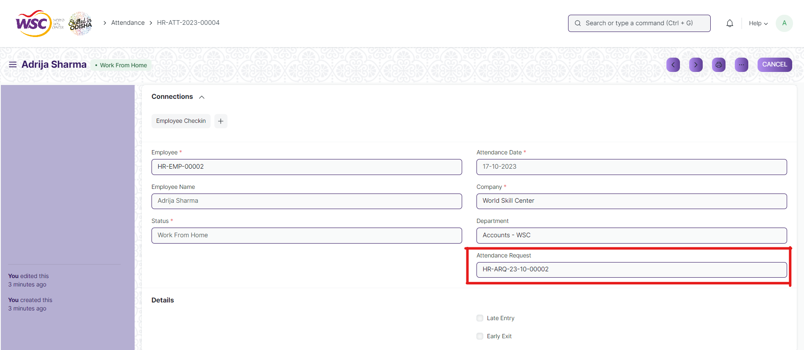

(Attendance Request Record **HR-ARQ-23-10-00002** linked with Attendance **HR-ATT-2023-0004** )

On deletion of attendance request record ,It will show the following message ,

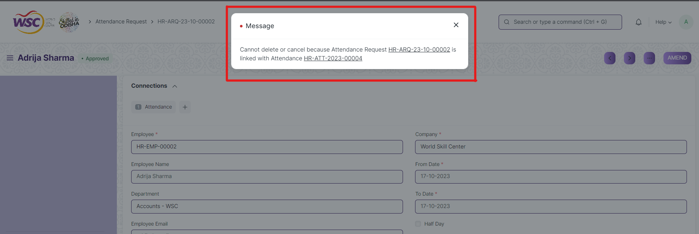

So go the following Attendance Request record document(**HR-ARQ-23-10-00002 )**, and cancel it first . After cancellation , user will able to delete the attendance record ( **HR-ATT-2023-0004)**.

**Note :** To initiate the cancellation process, kindly click on the link labeled **'HR-ARQ-23-10-00002**,' which corresponds to the attendance request record."

**Action Menu on a document.**

The three dots menu, located in the right corner of a document in a Screen , offers a range of actions and options to manage and interact with the document.

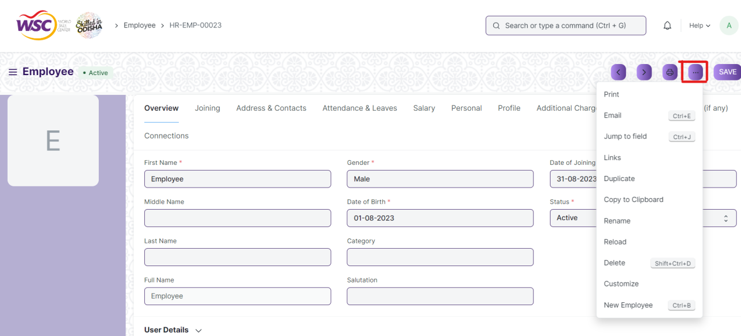

The functionalities available in the three dots menu are given below .

**Print :** Print Enables you to generate a printable version of the document ., which you can save as a PDF or send to a printer.

**Email :** Click on Email allows you to send the document as an attachment via email to specified recipients.

**Duplicate :** Create a new document with the same information as the current one.

**Delete :** Permanently remove the document.

**Cancel :** Cancel the submitted document.

**Submit :** Submit the document . If the document is submittable.

**Links :** This Option displays a list of document that are linked to the current document. You can navigate these linked documents from here.

**Jump to field :** You can directly go the required field by clicking this option and giving appropriate field name.

**Copy to Clipboard :** By clicking this option you can copy the content of the document .

**Rename :** By clicking the Rename option you can Rename the document.

**Note :** These options will be visible to employees who have necessary permission.

# Master Screens

## Employment Type

The "Employment Type" screen typically refers to a configuration or master data form where you define and manage different types of employment statuses or categories within the system.

The screen is accessible to Employee , HR Admin,HR Manager /Cs officer ,Director,HR Assistant.

To access the Employment Type Master screen ,go to :

***Home>HRMS(Base)>Masters>Employment Type***

Screen Type : Save

**Adding a new Employment Type**

As it is a save screen, follow the general procedure to create a save document as mentioned above .

* Go to the Employment Type list, click on New.
* Enter the Name of the Employment Type.
* Save.

After creating an Employment Type , the record will be visible in the List view of the screen.



(List View of Employment Type)

**Note** : The Employment Type can be linked to the Employee Master.

**View Employment Type**

As it is a save screen, follow the general procedure to view a save document as mentioned above .



(View of a saved Employment Type)

**Delete Employment Type**

As it a Save screen , follow the general procedure to delete a save document .

**Edit Employment Type**

Follow the steps to view a saved employment type.

Edit the field that you want to change.

Click on Save.

**Print Employment Type**

As it is a Save screen , follow the general procedure to print a saved document.

**View Employment Type in different format**

As it is a Save screen , follow the general procedure to view a saved document in different format.

## Campus Location

The "Campus Location" screen typically refers to a configuration or master data form where you can define and manage different campus locations associated with your organization.

The screen is accessible to Employee , HR Admin,HR Manager /Cs officer ,Director,HR Assistant.

To access the Campus Location Master screen ,go to :

***Home>HRMS(Base)>Masters>Campus Location***

**Screen Type :** Save

**Prerequisites**

Before creating an Employee Group, it is advisable you create the following documents:

* Company

**Note :** You can link the Branch to the Employee master.

**Adding a new Campus Location**

As it is a save screen, follow the general procedure to create a save document as mentioned above .

* Go to the Branch list, click on New.
* Enter the Details .
* Save.

After creating an Campus Location , the record will be visible in the List view of the screen.

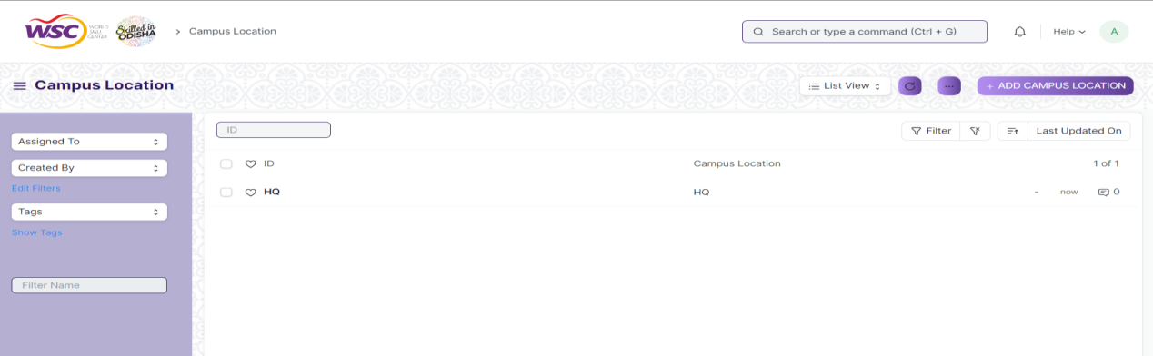

(List View of Campus Location)

**View Campus Location**

As it is a save screen, follow the general procedure to view a save document as mentioned above .

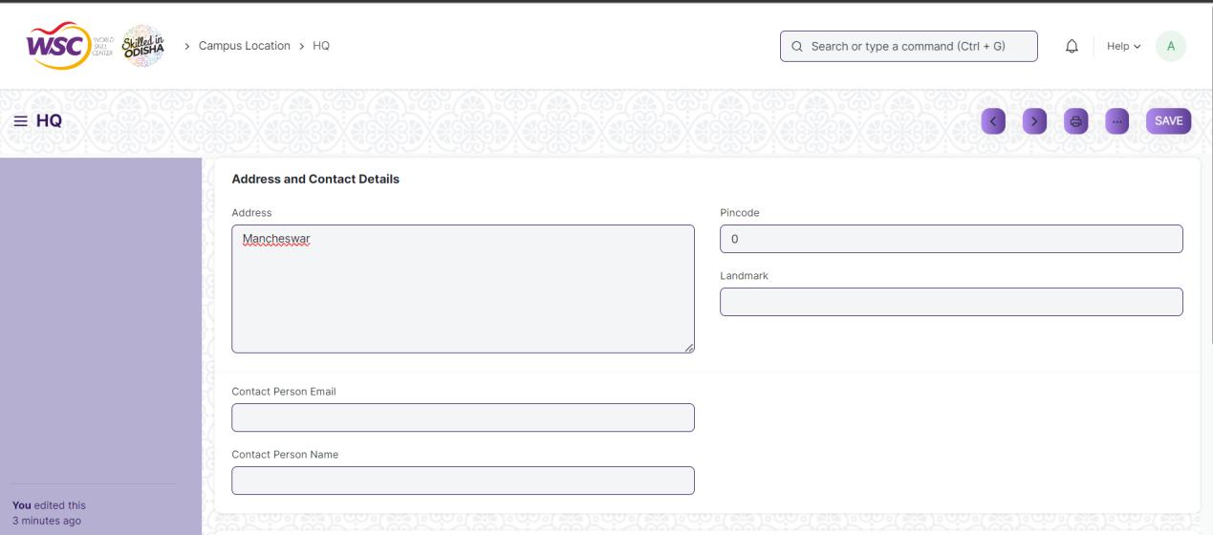

(View of a saved Campus Location.)

**Delete Campus Location**

As it a Save screen , follow the general procedure to delete a save document .

**Edit Campus Location**

Follow the steps to view a saved Campus location document.

Edit the field that you want to change.

Click on Save.

**Print Campus Location**

As it is a Save screen , follow the general procedure to print a saved document.

**View Campus Location Type in different format**

As it is a Save screen , follow the general procedure to view a saved document in different formats.

## Department

The "Department" screen is typically used to define and manage different departments within an organization.

The screen is accessible to employee , HR Admin,HR Manager /Cs officer ,Director,HR Assistant.

To access the Department Master screen ,go to :

***Home>HRMS(Base)>Masters>Department***

Screen Type : Save

**Prerequsites**

Before creating an Employee Group, it is advisable you create the following documents:

* Company
* Leave Block List

**Adding a new Department**

As it is save screen, follow the general procedure to create a save document type as mentioned above.

* Go to the Department list, click on New.
* Enter Department name.
* Select Company name.
* Select Leave Block List (optional) applicable for this department.
* Save.

After creating a Department , the record will be visible in the List view of the screen.

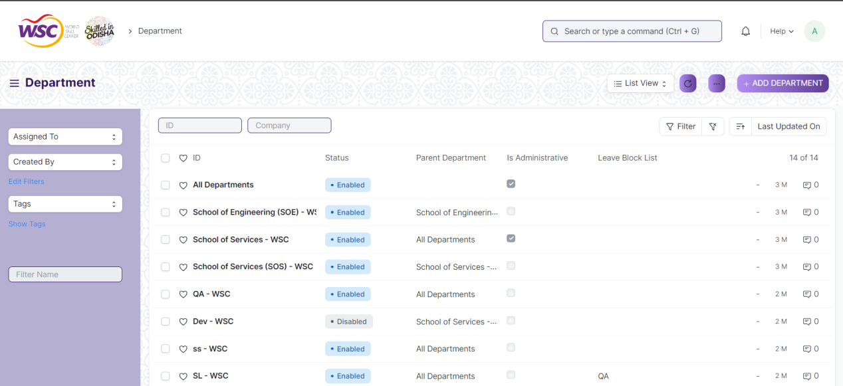

(List View of Departments)

**Some Additional Features in the Department Screen are as follows :**

**Leave ,Shift and Expense Approvers**

You can set Leave ,Shift and Expense Approvers for a particular Department in the 'Leave Approver' ,’Shift Request Approver’ and 'Expense Approver' table respectively.

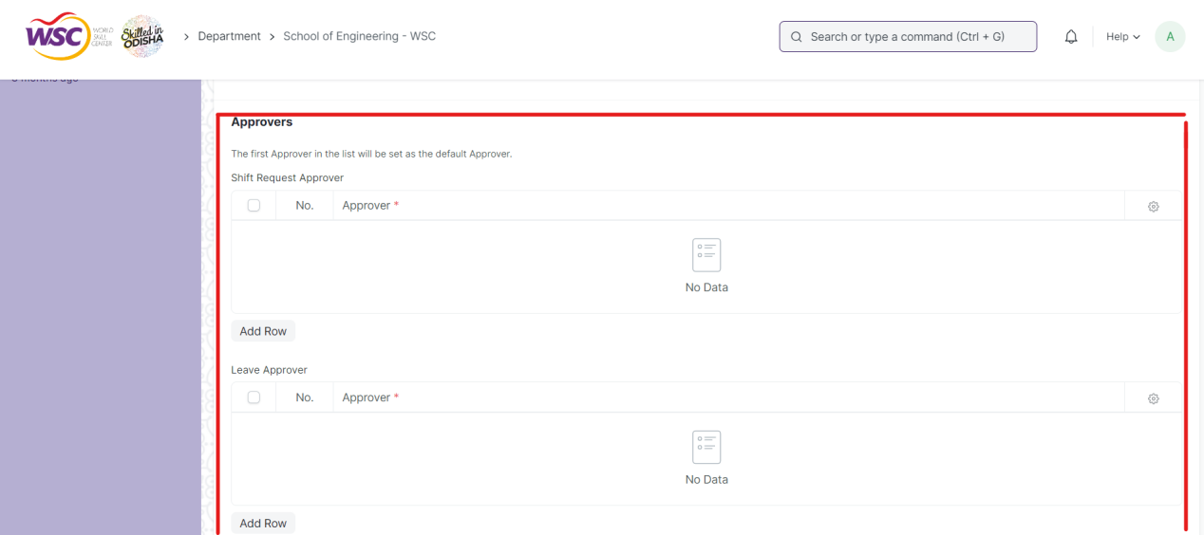

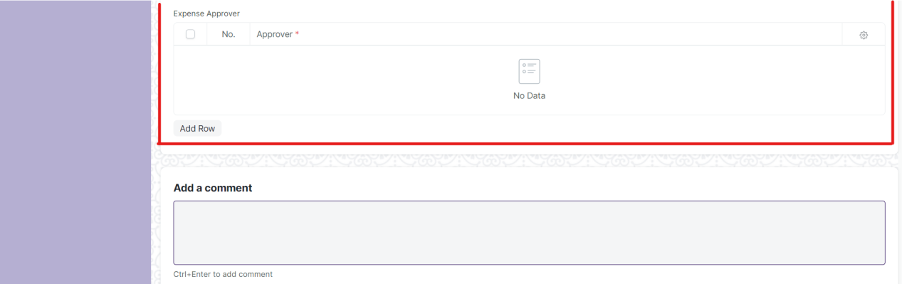

(Types approves in the department screen)

**Note:** Multiple Leave and Expense Approvers can be set for a particular Department. However, the first Approver in the list will be set as the default Approver.

**View Department**

As it is a save screen, follow the general procedure to view a save document as mentioned above .

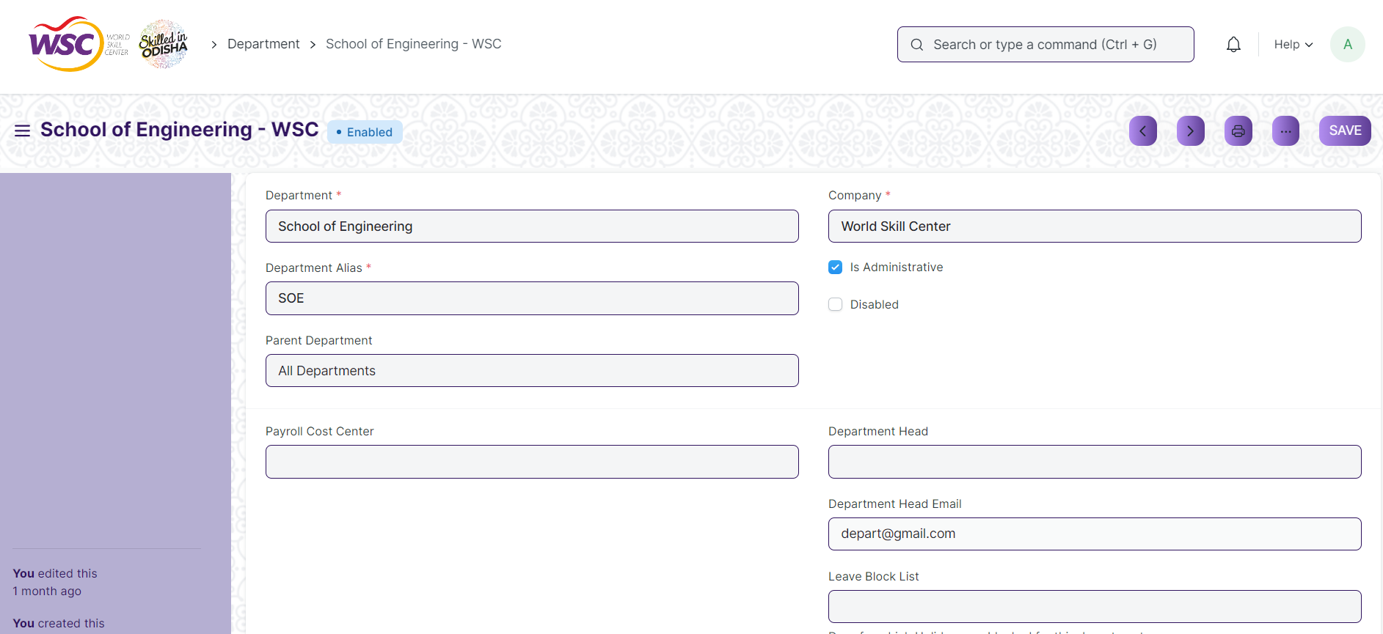

(View of a saved Department.)

**Delete Department**

As it a Save screen , follow the general procedure to delete a save document .

**Edit Department**

Follow the steps to view a saved Department document.

Edit the field that you want to change.

Click on Save.

**Print Department**

As it is a Save screen , follow the general procedure to print a saved document.

**View Department in different format**

As it is a Save screen , follow the general procedure to view a saved document in different format.

## Designation

The "Designation" screen is typically used to define and manage different job titles or positions within an organization.

The screen is accessible to employee , HR Admin,HR Manager /Cs officer ,Director,HR Assistant.

To access the Department Master screen ,go to :

***Home>HRMS(Base)>Masters>Designation***

Screen Type : Save

**Adding a new Designation**

As it is save screen, follow the general procedure to create a save document type as mentioned above.

* Go to Designation list, click on New.
* Enter the Designation name.
* Enter Description and Required Skills (optional).
* Save.

After creating a Designation , the record will be visible in the List view of the screen.

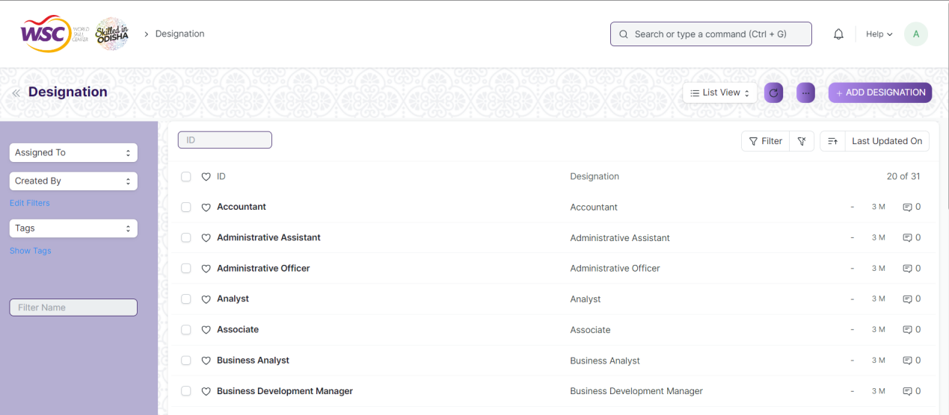

(List View of Designation)

**View Designation**

As it is a save screen, follow the general procedure to view a save document as mentioned above .



(View of a saved Designation.)

**Delete Designation**

As it a Save screen , follow the general procedure to delete a save document .

**Edit Designation**

Follow the steps to view a saved Designation document.

Edit the field that you want to change.

Click on Save.

**Print Designation**

As it is a Save screen , follow the general procedure to print a saved document.

**View Designation in different format**

As it is a Save screen , follow the general procedure to view a saved document in different format.

## Employee Grade

The Employee grade screen helps organizations manage their workforce more effectively by providing a structured way to define and differentiate various levels of employees within the company.

Employee Grade also helps you fetch employee records in bulk based on their grades while processing payroll, allocating leaves, etc.

The screen is accessible to employee , HR Admin,HR Manager /Cs officer ,Director,HR Assistant.

To access the Employee Grade Master screen ,go to :

***Home>HRMS(Base)>Masters>Employee Grade***

Screen Type : Save

**Prerequisites**

Before creating an Employee Group, it is advisable you create the following documents:

* Leave Policy
* Salary Structure

**Adding a new Employee Grade**

As it is a save screen, follow the general procedure to create a save document type as mentioned above.

* Go to Employee Grade list, click on New.
* Enter the Name of the Employee Grade.
* Enter the Default Leave Policy and Default Salary Structure for that Grade.
* Save.

After creating a Employee Grade , the record will be visible in the List view of the screen.

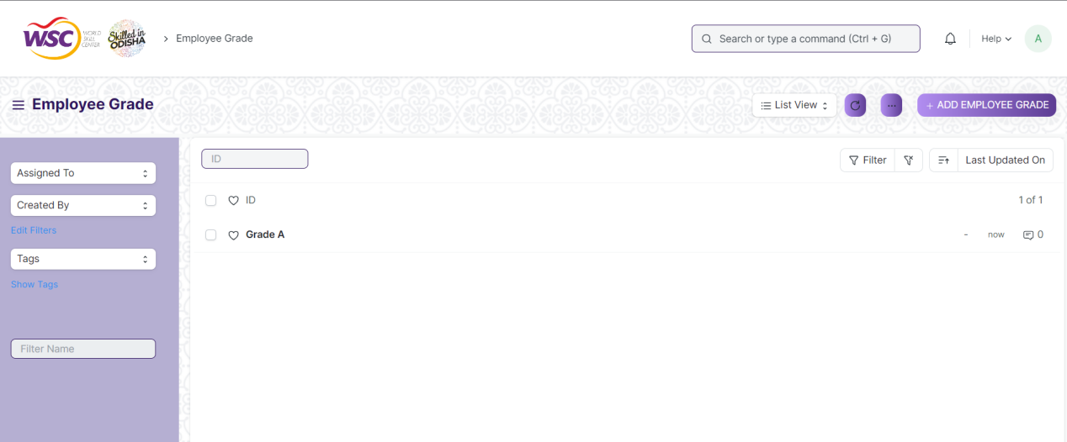

(List View of Employee Grades)

**View Employee Grade**

As it is a save screen, follow the general procedure to view a save document as mentioned above .

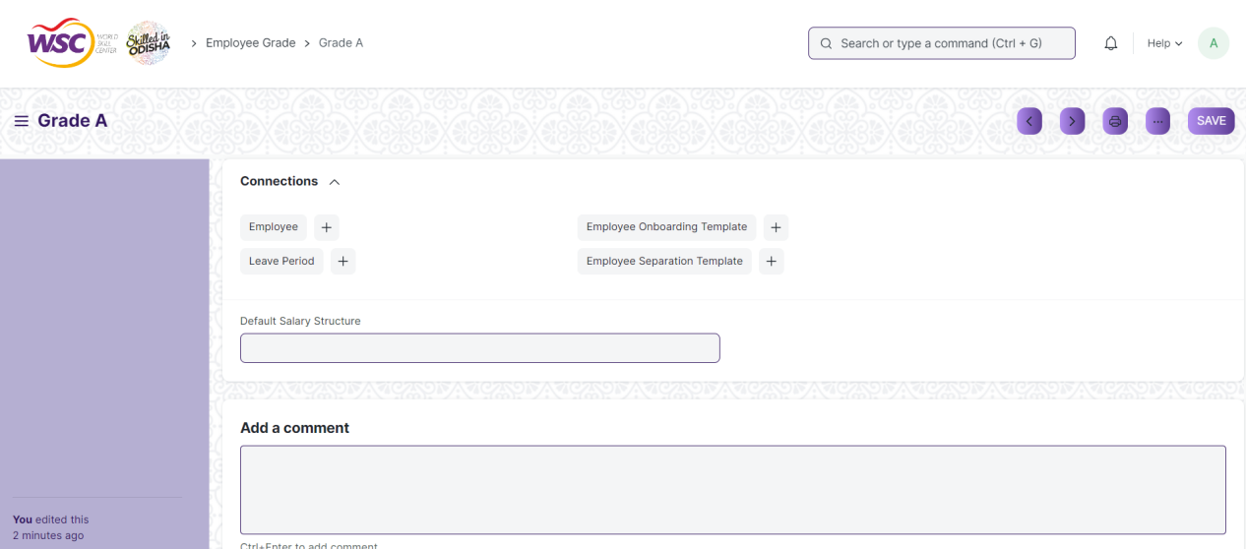

(View of a saved Employee Grade.)

**Delete Employee Grade**

As it a Save screen , follow the general procedure to delete a save document .

**Edit Employee Grade**

Follow the steps to view a saved Employee Grade document.

Edit the field that you want to change.

Click on Save.

**Print Employee Grade**

As it is a Save screen , follow the general procedure to print a saved document.

**View Employee Grade in different format**

As it is a Save screen , follow the general procedure to view a saved document in different format.

## Employee Group

Employee Group is grouping of employees based on some attributes such as Designation, Grade, Branch, etc.

The screen is accessible to Employee , HR Admin,HR Manager /Cs officer ,Director,HR Assistant.

To access the Employee Group Master screen ,go to :

***Home>HRMS(Base)>Masters>Employee Group***

Screen Type : Save

**Prerequisites**

Before creating an Employee Group, it is advisable you create the following documents:

* Employee

**Adding a new Employee Group**

As it is save screen, follow the general procedure to create a save document type as mentioned above.

* Go to Employee Group list, click on New.
* Enter the Name.
* Select and add employee ID to the group. The employee name will be automatically fetched.
* Save.

After creating a Employee Group , the record will be visible in the List view of the screen.

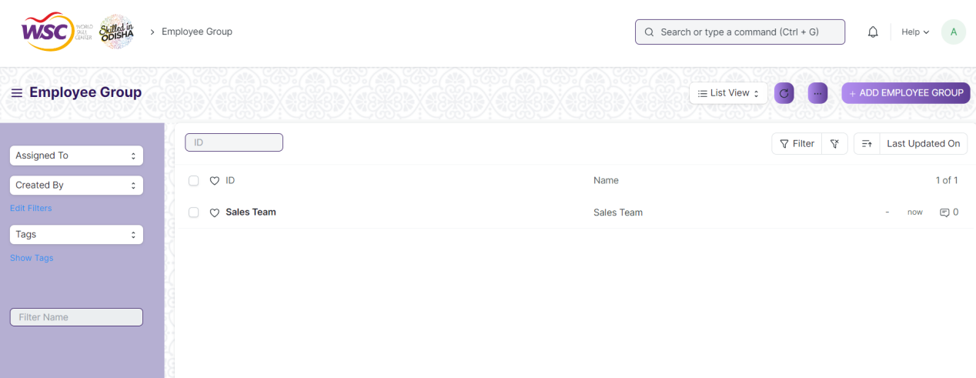

(List View of Employee Group)

**View Employee Group**

As it is a save screen, follow the general procedure to view a save document as mentioned above .

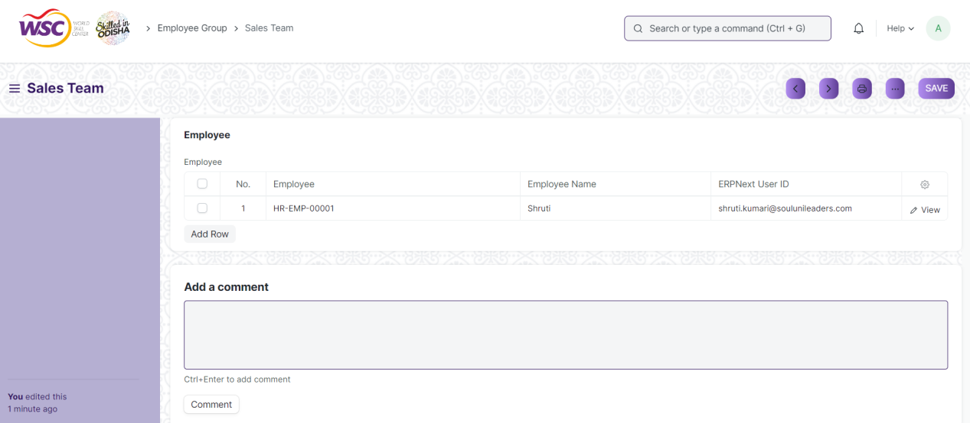

(View of a saved Employee Group.)

**Delete Employee Group**

As it a Save screen , follow the general procedure to delete a save document .

**Edit Employee Group**

Follow the steps to view a saved Employee Group document.

Edit the field that you want to change.

Click on Save.

**Print Employee Grade**

As it is a Save screen , follow the general procedure to print a saved document.

**View Employee Grade in different format**

As it is a Save screen , follow the general procedure to view a saved document in different format.

## Holiday List

Holiday List is a list which contains the dates of holidays.The Holiday List screen helps organization to prepare a standard holiday list for a certain period like Academic Year of Fiscal Year.

The Screen is accessible to Employee , HR Admin,HR Manager /Cs officer ,Director,HR Assistant.

To access the Employee Group Master screen ,go to :

***Home>HRMS(Base)>Masters>Holiday List***

Screen Type : Save

**Adding a new Holiday List**

As it is save screen, follow the general procedure to create a save document type as mentioned above.

* Go to Holiday List, click on New.
* Enter Holiday List Name. It can be based on the Fiscal Year or Location or Department as per the requirement.
* Select From Date and To Date for the Holiday List.

After creating a Holiday List , the record will be visible in the List view of the screen.

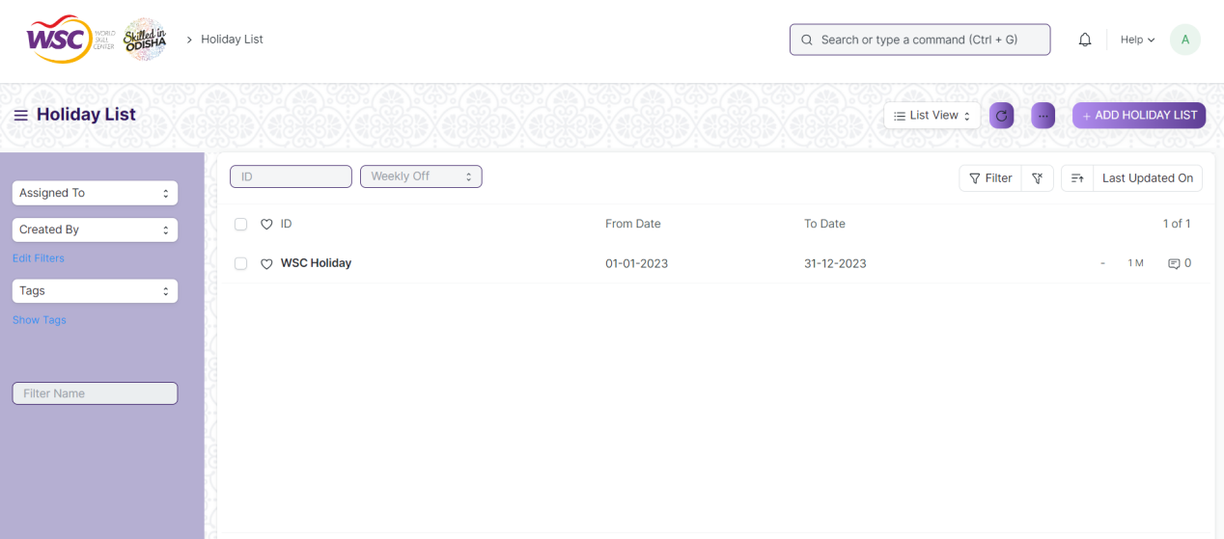

(List View of Holiday lists)

**Some of the additional features in the holiday lists are as follows :**

**Adding weekly Holidays**

In the ‘Add Weekly Holidays’ section , select the day in the weekly off field.

Click on the 'Add to Holidays' button.

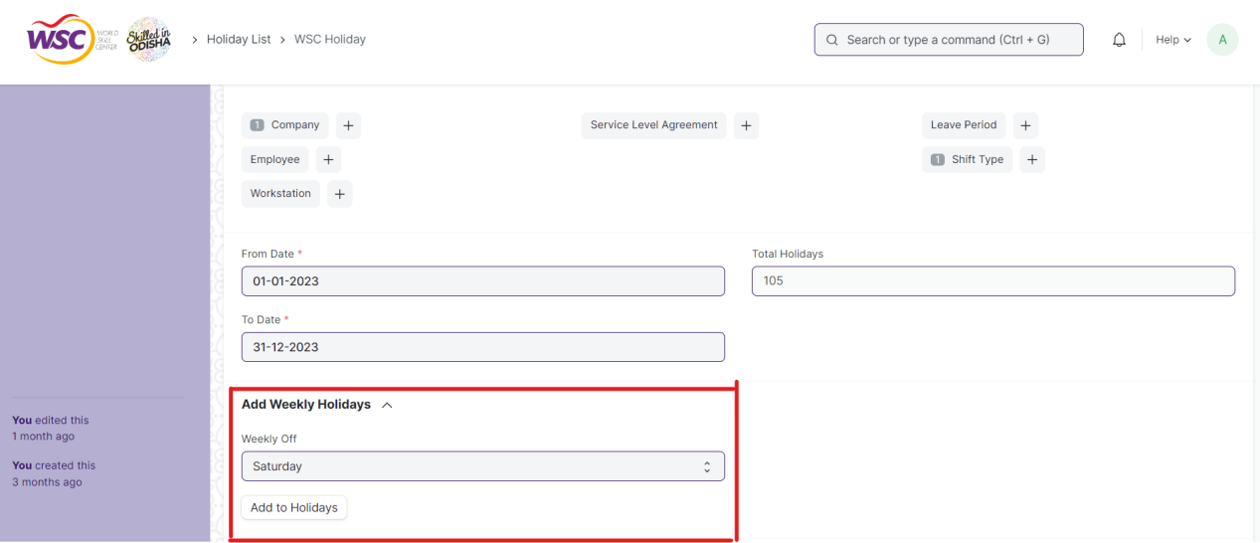

(Feature to add weekly holidays)

**Note :** The Add to Holidays Button will be visible to the Employees who have necessary permission.

**Adding Local Holidays**

In the 'Add Local Holidays' section, select the country.

Some countries have subdivisions with different or additional holidays. If you like, you can optionally select a specific subdivision.

Click on the 'Add to Holidays' button.

**Adding Holidays Manually**

You can also add specific days manually by clicking on the 'Add row' option in the Holidays table.

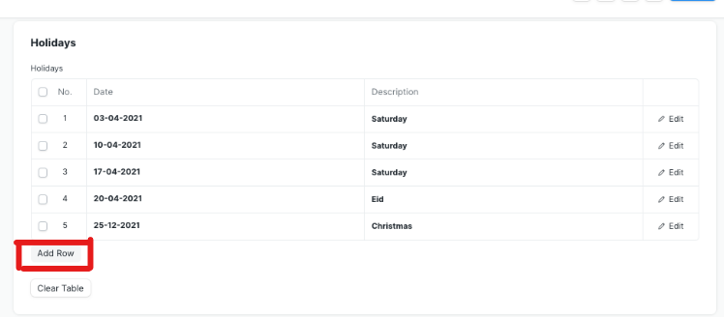

(Add holidays manually)

**Holiday List in Company**

You can set a default Holiday List at the company-level in the Company master in the 'Default Holiday List' field.

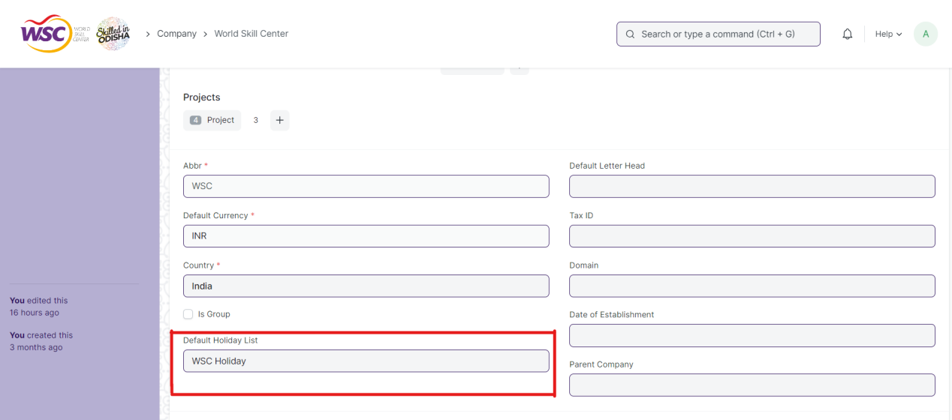

(setting default holiday list in company screen)

**Holiday List in Employee**

If you have created multiple Holiday List, select a specific Holiday List for an Employee in the respective master.

When an Employee applies for Leave, the days mentioned in the Holiday List will not be counted, as they are holidays already.

**View Holiday List**

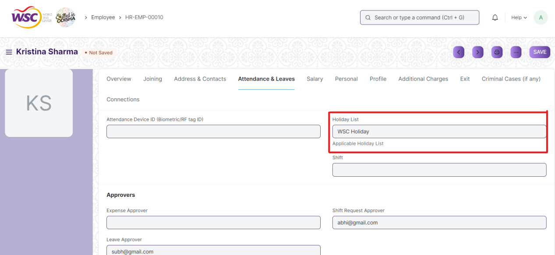

(View of Holiday list in Employee)

**View a Holiday List**

As it is a save screen, follow the general procedure to view a save document as mentioned above .

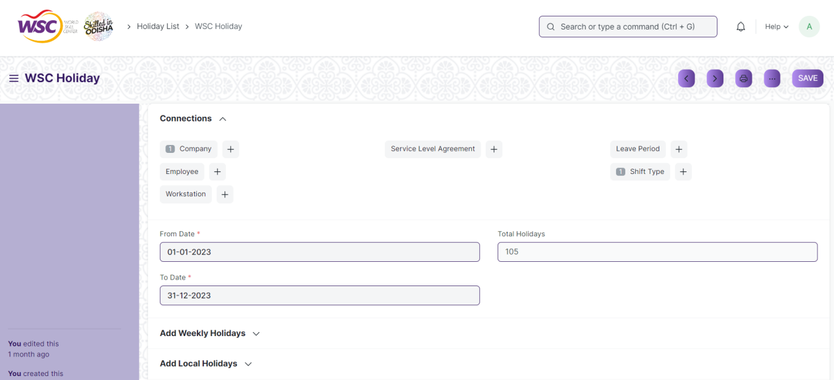

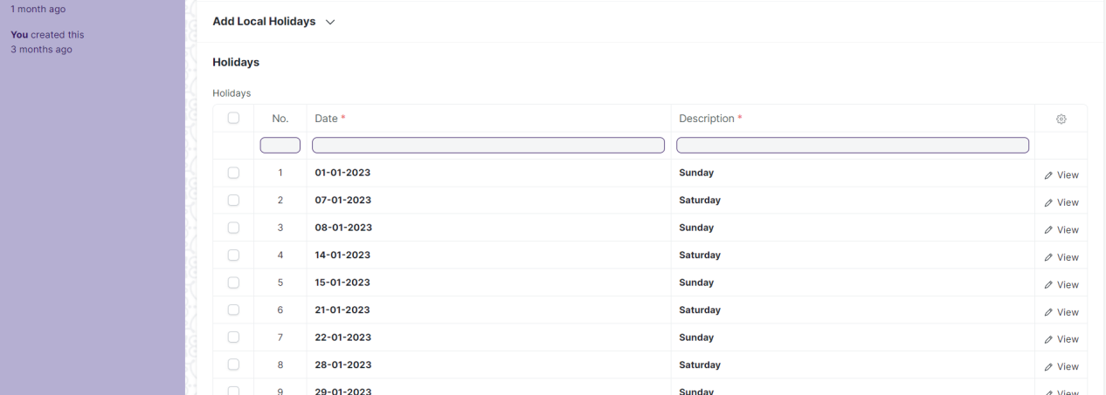

(View of a saved Holiday List.)

**Delete Holiday List**

As it a Save screen , follow the general procedure to delete a save document .

**Edit Holiday List**

Follow the steps to view a saved Employee Group document.

Edit the field that you want to change.

Click on Save.

**Print Holiday List**

As it is a Save screen , follow the general procedure to print a saved document.

**View Holiday List in different format**

As it is a Save screen , follow the general procedure to view a saved document in different format.

# Recruitment

## Recruitment Exam Center

The "Recruitment Exam Center" screen typically contains basic information like center names,state,districts and so on will be present.

The feature is accessible to HR Admin,HR Manager /Cs officer ,Director,HR Assistant.

To access the Recruitment Exam Center screen ,go to :

***Home>HRMS>Recruitment>Recruitment Exam Center***

Screen Type : Save

**Prerequisites**

Before creating Recruitment Exam Center, it is advisable you create the following documents:

* Company
* State
* Districts
* Block

**Adding a new Recruitment Exam Center**

As it is a save screen, follow the general procedure to create a save document as mentioned above .

After creating Recruitment Exam Center , the record will be visible in the List view of the screen.

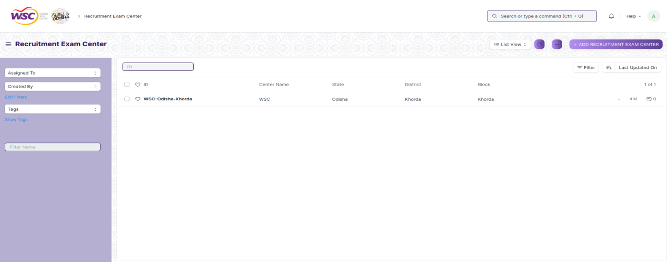

**Note** :

1. All the mandatory fields are marked with red asterisks.
2. You can link Recruitment Exam Center to Recruitment Exam Declaration.

**View Recruitment Exam Center**

As it is a save screen, follow the general procedure to view a save document as mentioned above .

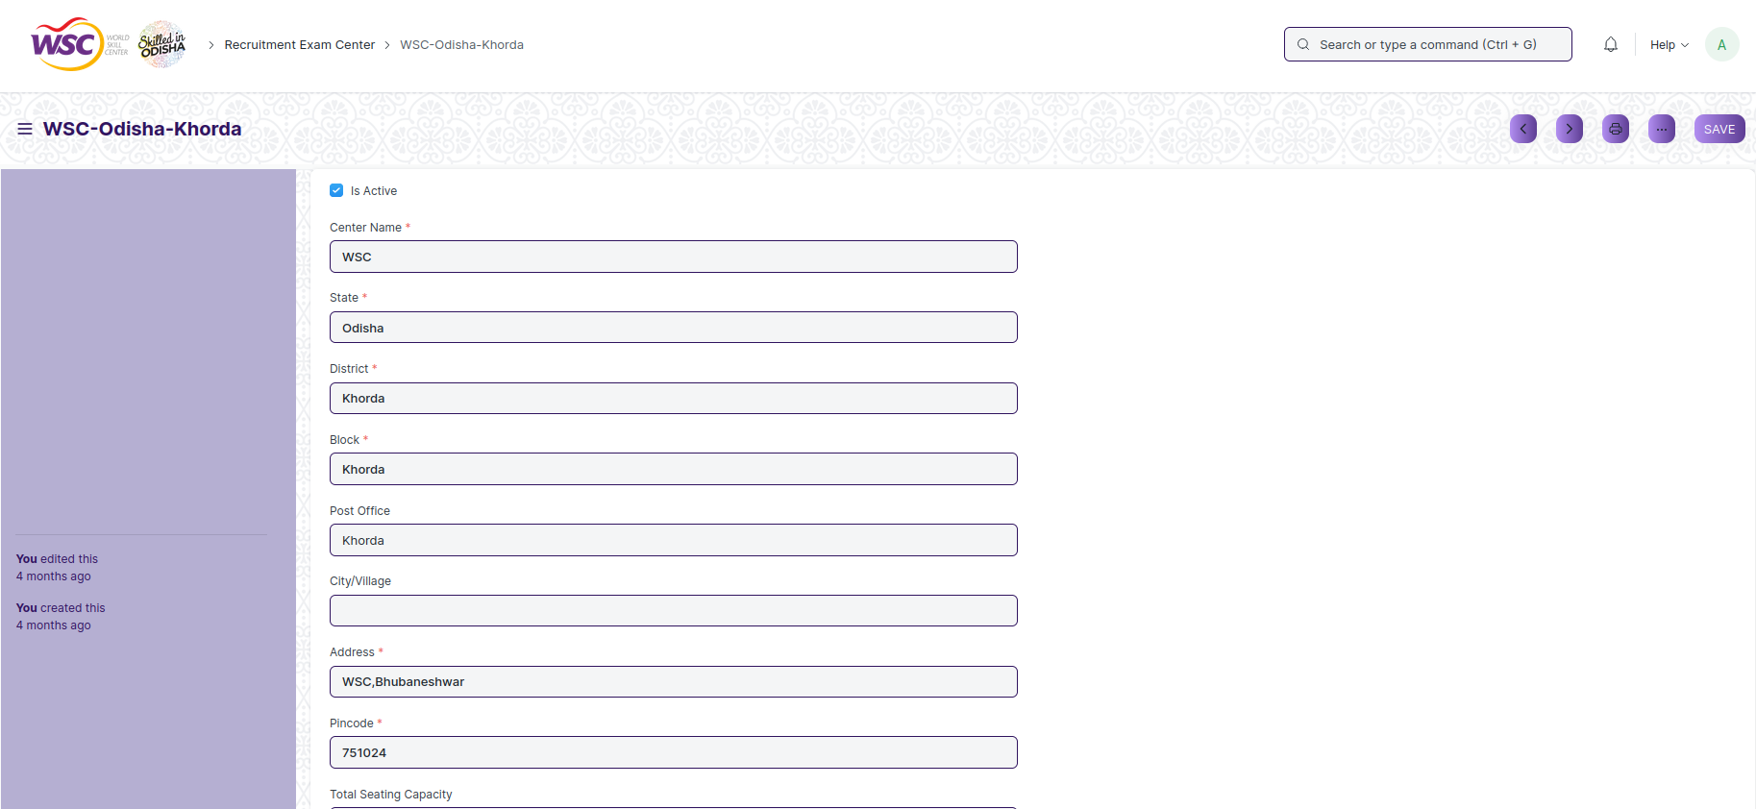

View of a saved Recruitment Exam Center.

**Delete Recruitment Exam Center**

As it a Save screen , follow the general procedure to delete a save document .

**Edit Recruitment Exam Center**

Follow the steps to view a saved Recruitment Exam Center .

Edit the field that you want to change.

Click on Save.

**View Recruitment Exam Center in different format**

As it is a Save screen , follow the general procedure to view a saved document in different format.

## Job Requisition

The "Job Requisition" screen typically refers to formal request recruiters or hiring managers fill out for their company's HR department to create a new position or to fill a job vacancy.

The feature is accessible to Employee , HR Admin,HR Manager /Cs officer ,Director,HR Assistant.

To access the Job Requisition ,go to :

***Home>HRMS>Recruitment>Job Requisition***

**Screen Type :** Submit

**Prerequisites**

Before creating Job Requisition, it is advisable you create the following documents:

* Company
* Department
* Designation
* Employee

**Adding a new Job Requisition**

As it is a submit screen, follow the general procedure to create a submit document as mentioned above .

After creating a Job Requisition , the record will be visible in the List view of the screen.

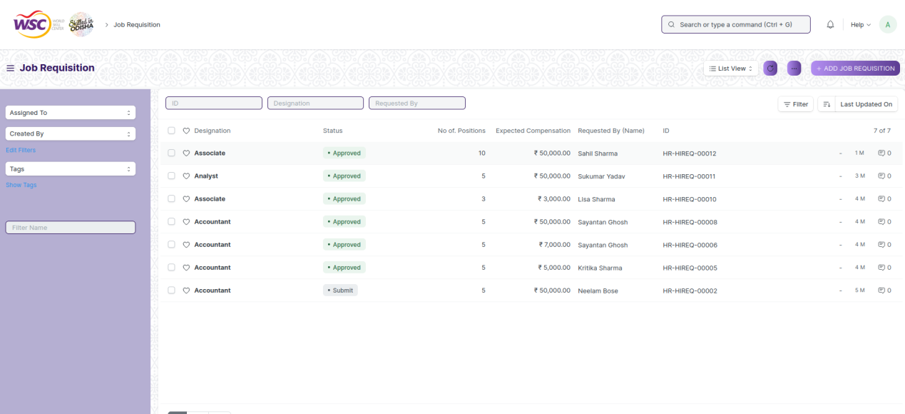

**Note :** After saving the document , a workflow begins. First it will be created by HR Admin,and then forwarded to the Director Admin for the approval.

**Process After Saving**

**Action of HR Admin**

If logged in user is HR Admin,the user will be able to create the Job Requisition and save the form and will be sent for the approval .

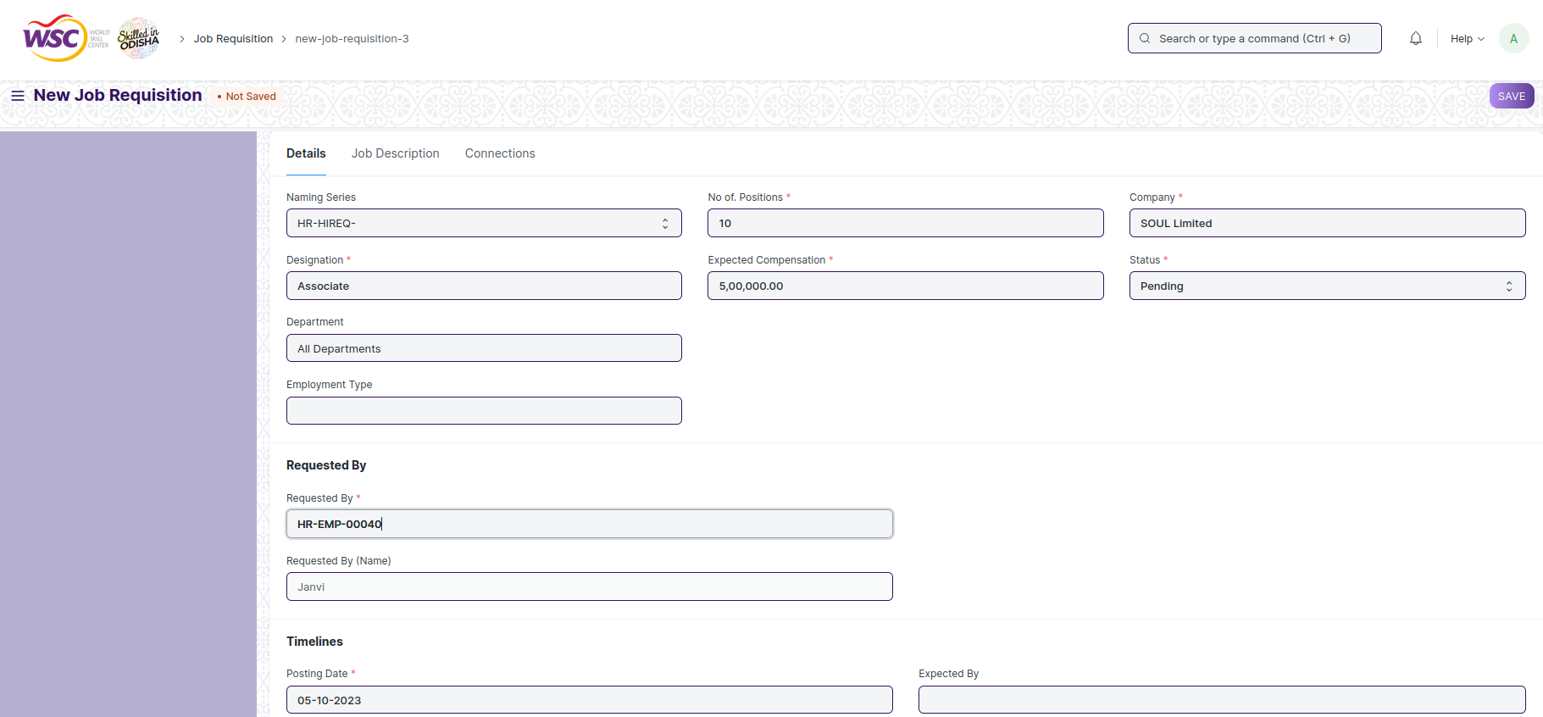

**Action of Director Admin**

If the logged in user is Director Admin Admin and the document status is Pending , then an action button will be visible in the right corner of the document. Click on Action button, select Approve or Reject to End the process.

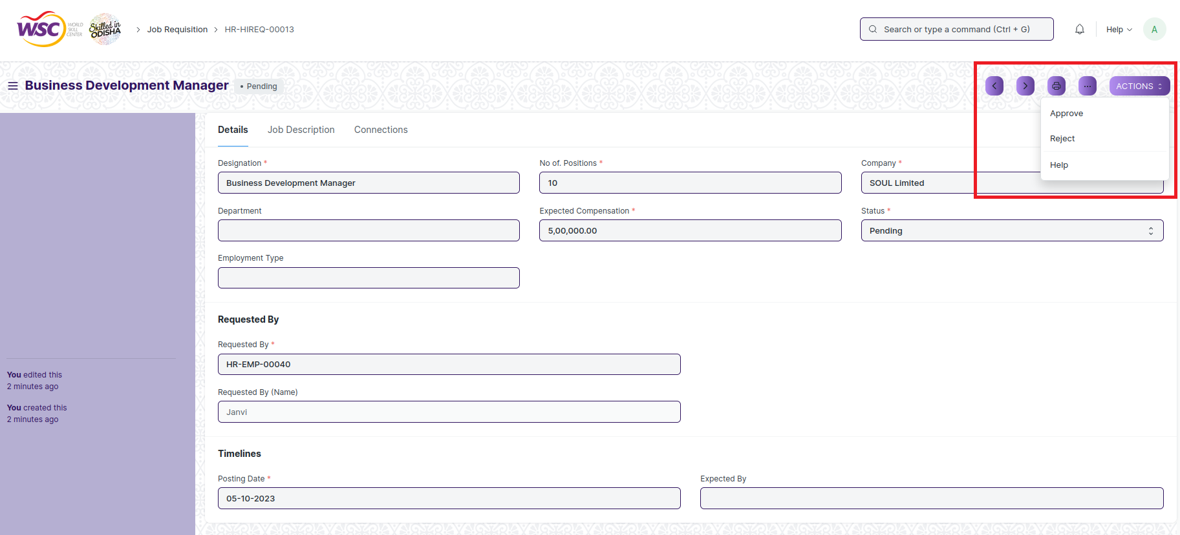

**View Job Requisition**

As it is a submit screen, follow the general procedure to view a submittable document as mentioned above .

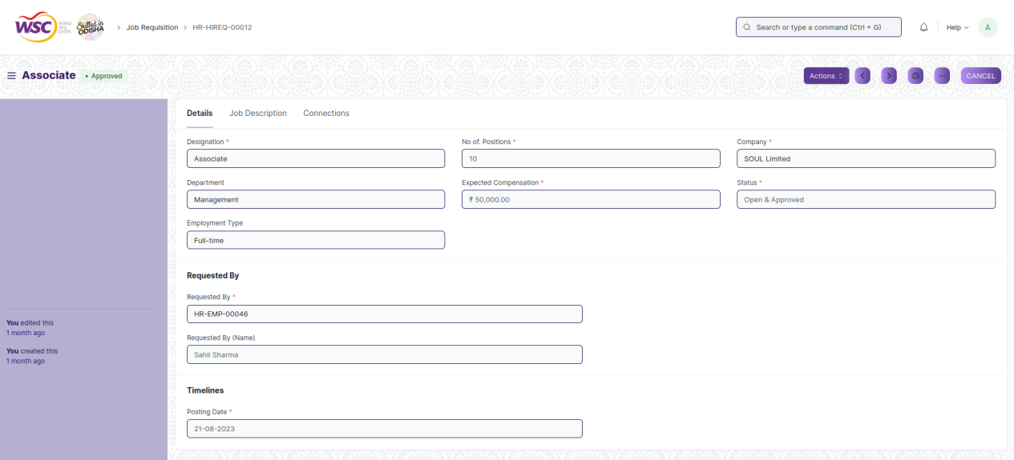

View of a submitted Job Requisition

**After Submitting “Action”button will appear at the top.It will consist of more button:**

1. **Create Job Opening** : It will redirect to the Job Opening Page for you can directly create Job opening for the particular Job Requisition.

**Cancel Job Requisition**

As it is a submittable screen, follow the general procedure to Cancel a submittable document as mentioned above.

**Delete Job Requisition**

If the document is not submitted , it is in pending state , you can delete the document by following the procedure to delete a save document.

If the document is submitted, follow the procedure to delete the submittable document.

**Amend Job Requisition**

As it is a submittable screen , follow the general procedure to Amend the document.

**Edit Job Requisition**

If the document is in pending state , the document can be editable.

Once the document is submitted , it cannot be edited.

**Print Job Requisition**

Follow the general procedure to print a submit document.

**View Job Requisition Type in different format**

As it is a Submit screen , follow the general procedure to view a submitted document in different format.

## Staffing Plan

The "Staffing Plan" screen typically helps you to plan manpower requirements for your Company.

The feature is accessible to HR Admin and Director Admin.

To access the Staffing Plan ,go to :

***Home>HRMS>Recruitment>Staffing Plan***

**Screen Type :** Submit

**Prerequisites**

Before creating a Staffing Plan, it is advisable you create the following documents:

* Company
* Department
* Designation
* Employee

**Adding a new Staffing Plan**

As it is a submit screen, follow the general procedure to create a submit document as mentioned above .

After creating a Staffing Plan , the record will be visible in the List view of the screen.

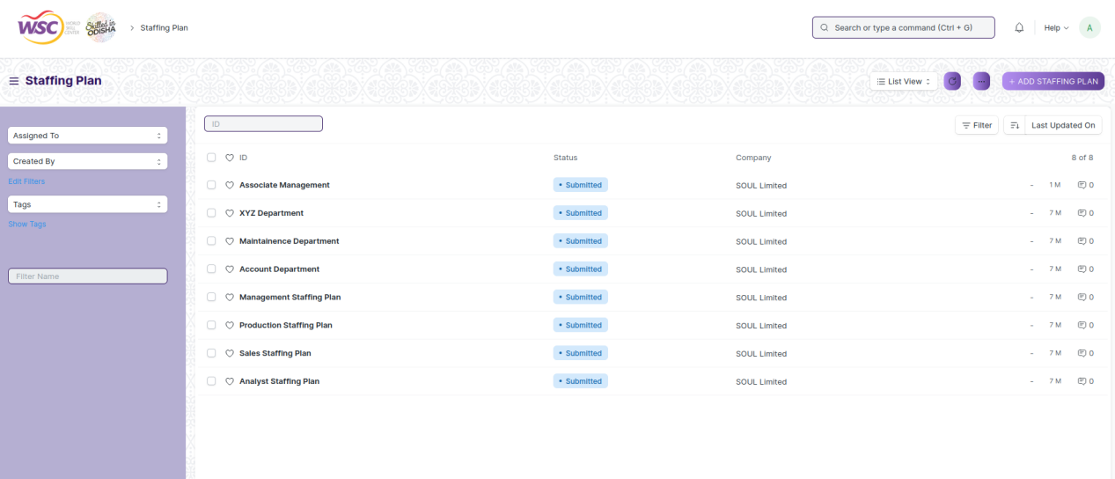

**Note** :

1. All the mandatory fields are marked with red asterisks.
2. You can link a Staffing Plan to the Job Opening.

**View Staffing Plan**

As it is a submit screen, follow the general procedure to view a submit document as mentioned above .

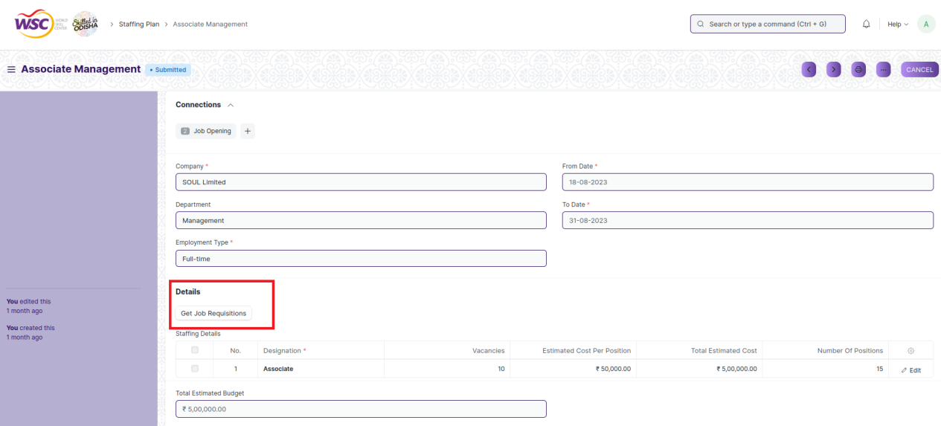

View of a submitted Staffing Plan

**Note** :

1. **Get Job Requisition:** On Clicking **“Get Job Requisition”** if any Job Requisition is present for the given Department ,Designation and Department it will be automatically fetched.

**Cancel Staffing Plan**

As it is a submittable screen, follow the general procedure to Cancel a submittable document as mentioned above.

**Delete Staffing Plan**

If the document is submitted, follow the procedure to delete the submittable document.

**Amend Staffing Plan**

As it is a submittable screen , follow the general procedure to Amend the document.

**Edit Staffing Plan**

If the document is in pending state , the document can be editable.

Once the document is submitted , it cannot be edited.

**Print Staffing Plan**

Follow the general procedure to print a submit document.

**View Staffing Plan Type in different format**

As it is a Submit screen , follow the general procedure to view a submitted document in different format.

## Job Opening

The "Job Opening" screen typically helps to create job vacancy in your Company. You can make a record of the open vacancies in your company using Job Opening.

The feature is accessible to HR Admin and Director Admin.

To access the Job Opening ,go to :

***Home>HRMS>Recruitment>Job Opening***

**Screen Type :** Save

**Prerequisites**

Before creating an Job Opening, it is advisable you create the following documents:

* Company
* Department
* Designation
* Staffing Plan

**Adding a new Job Opening**

* Login to the system.
* Go the HRMS workspace.
* Go to the Job Opening.
* Enter the details like title,Designation,Department,Number of Rounds.
* Under “References” the user can link a Staffing Plan with the Job Opening.
* Click on Save.

After creating a Job Opening , the record will be visible in the List view of the screen.

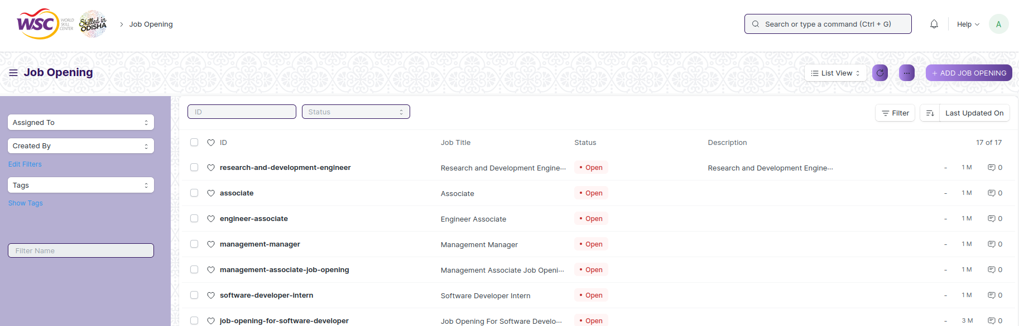

**View Job Opening**

As it is a save screen, follow the general procedure to view a save document as mentioned above .

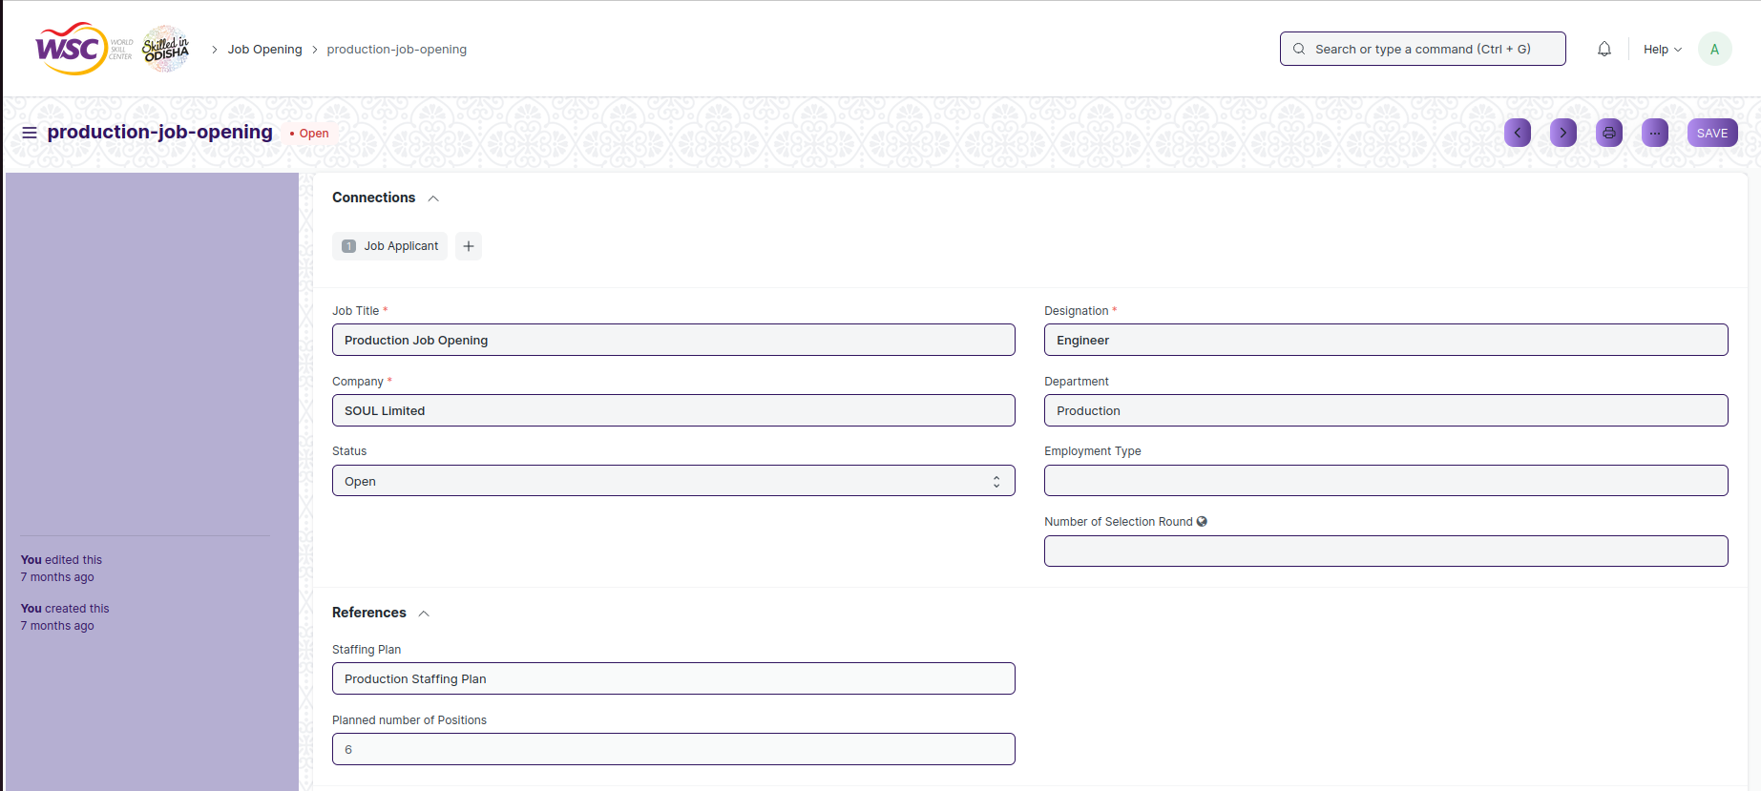

View of a saved Job Opening.

**Note** :

1. **Status:**You can set the Status of the Job Opening as Open/Closed. Once a Job Opening is Closed, you cannot create a Job Applicant against it.

**Delete Job Opening**

If the document is save, follow the procedure to delete the saved document.

**Edit Job Opening**

Follow the steps to view a saved Job Opening .

Edit the field that you want to change.

Click on Save.

**Print Job Opening**

Follow the general procedure to print a save document.

**View Job Opening Type in different format**

As it is a Save screen , follow the general procedure to view a save document in different format.

## Job Applicant

The “Job Applicant Screen” is the screen in which a person can able to apply for a job in your Company against a particular Job Opening.

The feature is accessible to Job Applicant,HR Admin,HR Manager /Cs officer ,Director,HR Assistant.

To access the Job Applicant ,go to :

***Home>HRMS>Recruitment>Job Applicant***

**Screen Type :** Save

**Prerequisites**

Before creating a Job Applicant, it is advisable you create the following documents:

* Company
* Department
* Designation
* Job Opening

**Adding a new Job Applicant**

* Login to the system.
* Go the HRMS workspace.
* Go to the Job Applicant.
* Enter the details like Personal Details,Work Details,Educational Details and select the Job Opening .
* Click on Save.
* Click on Submit

After creating a Job Applicant , the record will be visible in the List view of the screen.

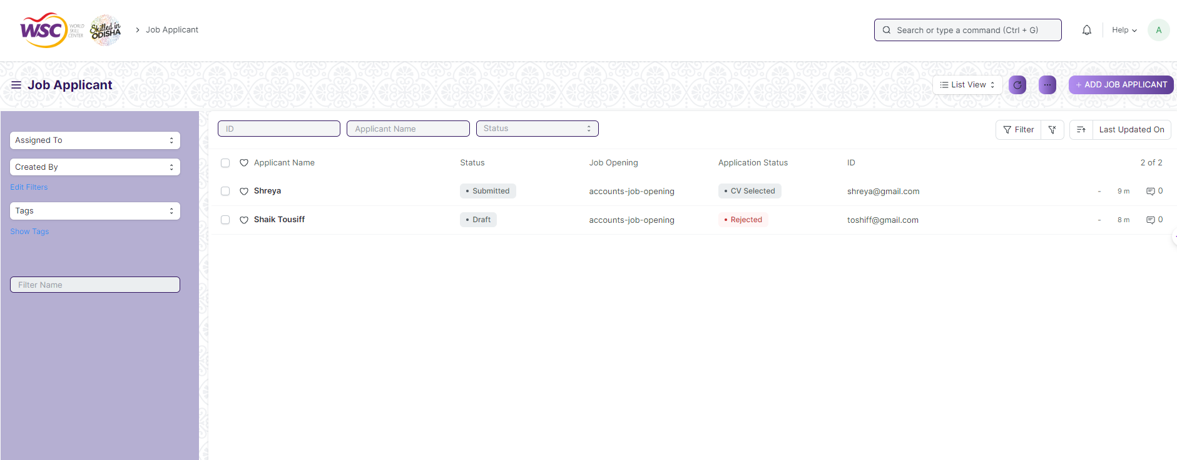

**View Job Applicant**

As it is a save screen, follow the general procedure to view a save document as mentioned above .

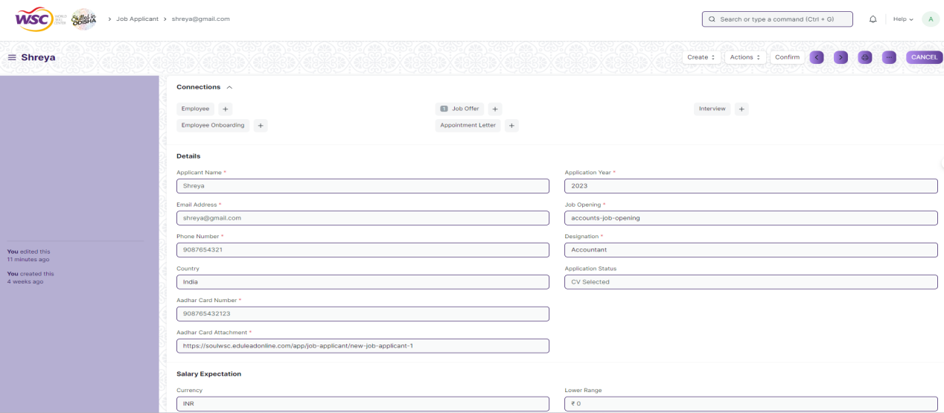

View of a saved Job Applicant.

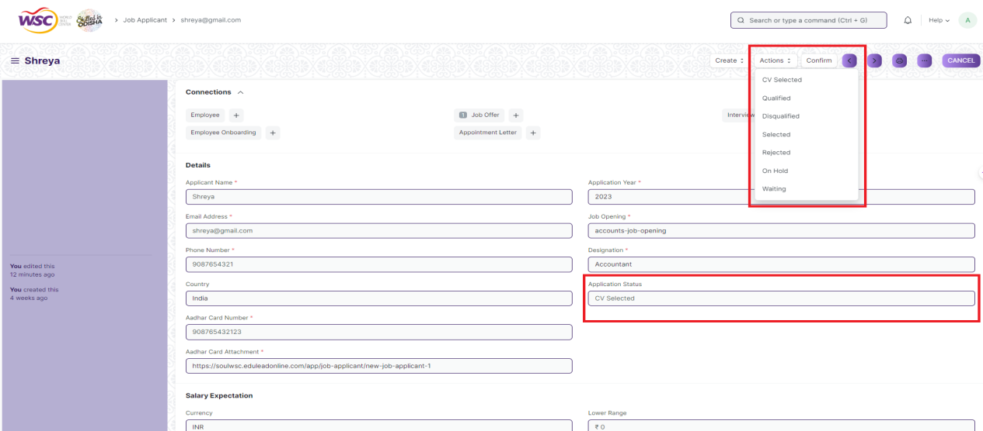

**Note** :

1. **Action:**Once the applicant is saved and submitted by the Job Applicant,HR Admin will view the Action button at the top with options like **CV Selected/Rejected/Selected/Qualified/On Hold and status will also be updated in the field “Application Status” field.**
2. If the Application Status is “Selected” the mail will be triggered to the Job Applicant.

**Delete Job Applicant**

If the document is saved, follow the procedure to delete the save document.

**Edit Job Applicant**

Follow the steps to view a saved Job Applicant .

Edit the field that you want to change.

Click on Save.

**Print Job Applicant**

Follow the general procedure to print a save document.

**View Job Applicant Type in different format**

As it is a Save screen , follow the general procedure to view a save document in different format.

## Recruitment Exam Declaration

The “Recruitment Exam Declaration” consist of information regarding the declaration of recruitment exam like Job Opening,Round,Exam Date,Center Name,Exam Name,Applicants.

The feature is accessible to HR Admin,HR Manager /Cs officer ,Director,HR Assistant.

To access the Recruitment Exam Declaration ,go to :

***Home>HRMS>Recruitment>Recruitment Exam Declaration***

**Screen Type :** Save

**Prerequisites**

Before creating a Recruitment Exam Declaration, it is advisable you create the following documents:

* Company
* Department
* Designation
* Job Opening
* Job Applicant

**Adding a new Recruitment Exam Declaration**

* Login to the system.
* Go the HRMS workspace.
* Go to the Recruitment Exam Declaration.
* Enter the Job Opening,Exam Date,Exam Time and so on and fetch the applicant.
* Click on Save.

After creating a Recruitment Exam Declaration , the record will be visible in the List view of the screen.

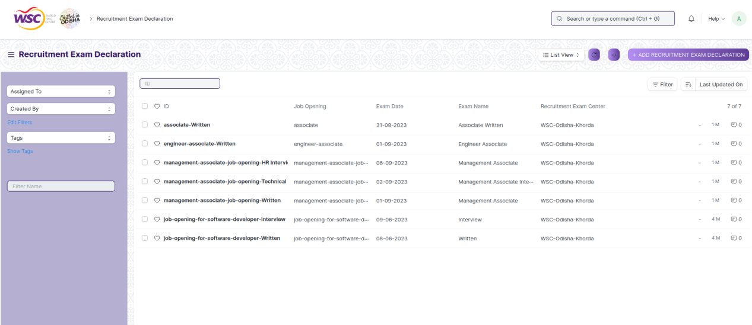

**View Recruitment Exam Declaration**

As it is a save screen, follow the general procedure to view a save document as mentioned above .

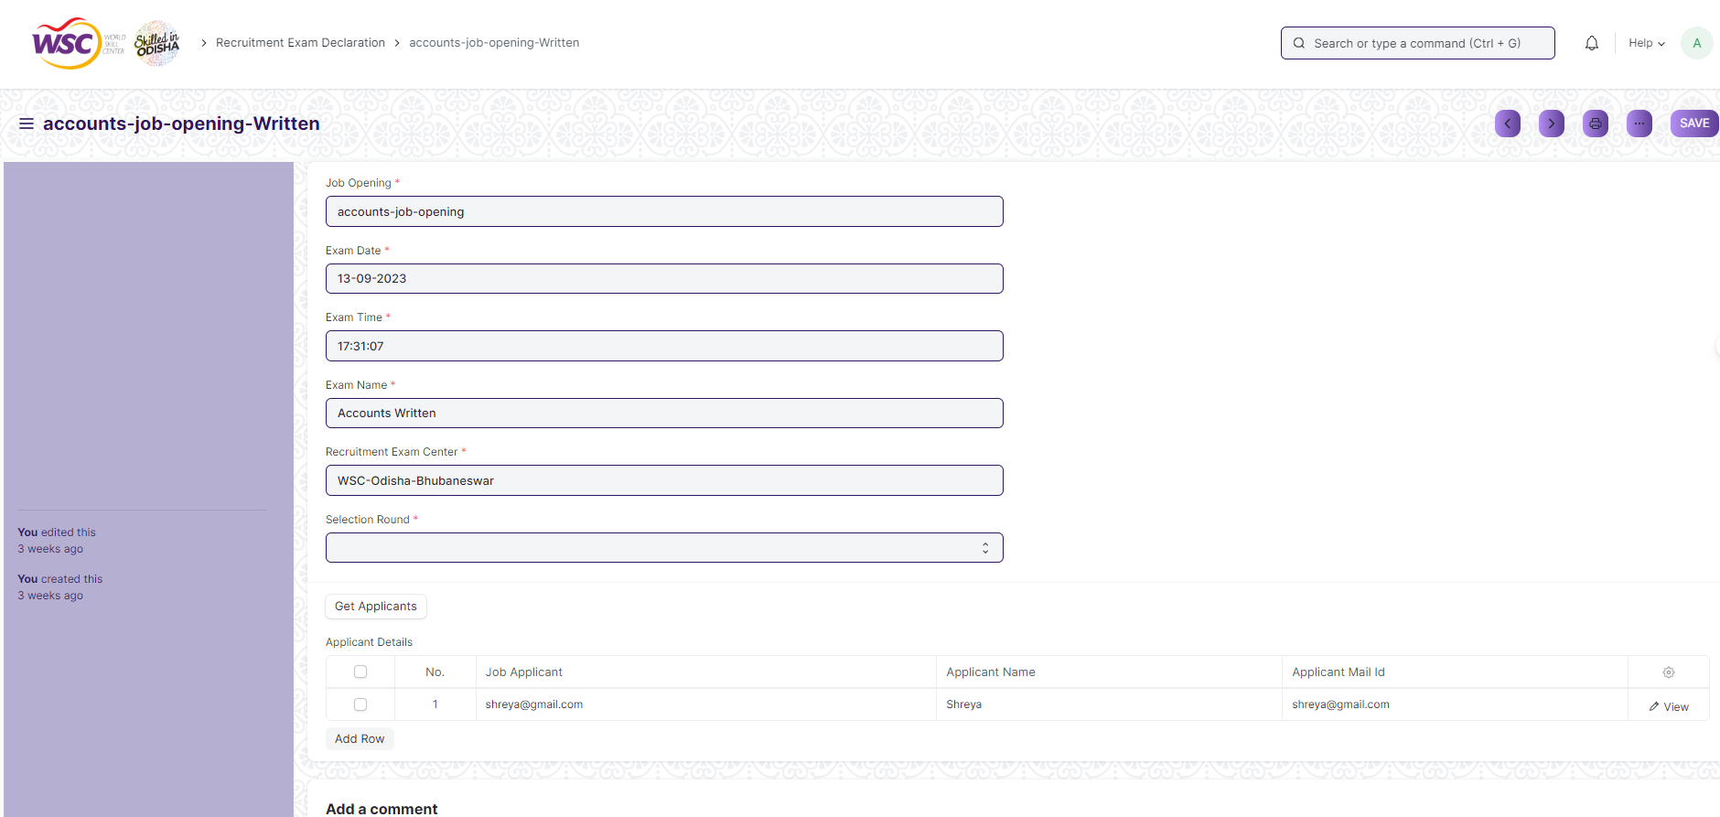

View of a saved Recruitment Exam Declaration.

**Delete Recruitment Exam Declaration**

If the document is saved, follow the procedure to delete the saved document.If any other transactional screen is linked to that Recruitment Exam Declaration the following records needs to deleted first.

**Edit Recruitment Exam Declaration**

Follow the steps to view a saved Recruitment Exam Declaration .

Edit the field that you want to change.

Click on Save.

**Print Recruitment Exam Declaration**

Follow the general procedure to print a save document.

**View Recruitment Exam Declaration Type in different format**

As it is a Save screen , follow the general procedure to view a save document in different format.

## Recruitment Admit Card Generation Tool

The “Recruitment Admit Card Generation Tool” is a tool to generate multiple admit cards for applicants and also allots them a venue for the exam.

The feature is accessible to HR Admin,HR Manager /Cs officer ,Director,HR Assistant.

To access the Recruitment Admit Card Generation Tool ,go to :

***Home>HRMS>Recruitment>Recruitment Admit Card Generation Tool***

**Screen Type :** Save

**Prerequisites**

Before creating a Recruitment Admit Card Generation Tool, it is advisable you create the following documents:

* Company
* Department
* Designation
* Job Opening
* Job Applicant
* Recruitment Exam Declaration

**Adding a new Recruitment Admit Card Generation Tool**

* Login to the system.
* Go the HRMS workspace.
* Go to the Recruitment Admit Card Generation Tool.
* Enter the Exam Declaration and Venue.
* Click on “Get Applicant”
* Click on Save.
* Click on “Create Admit Card”

**Note:**

1. After Clicking on **“Create Admit Card”,**admit card will be generated for the applicants and will be saved in **“Recruitment Admit Card Generation”.**
2. Admit Card will be sent to the respective applicants in email as attachment.

After creating a Recruitment Admit Card Generation Tool. , the record will be visible in the List view of the screen.

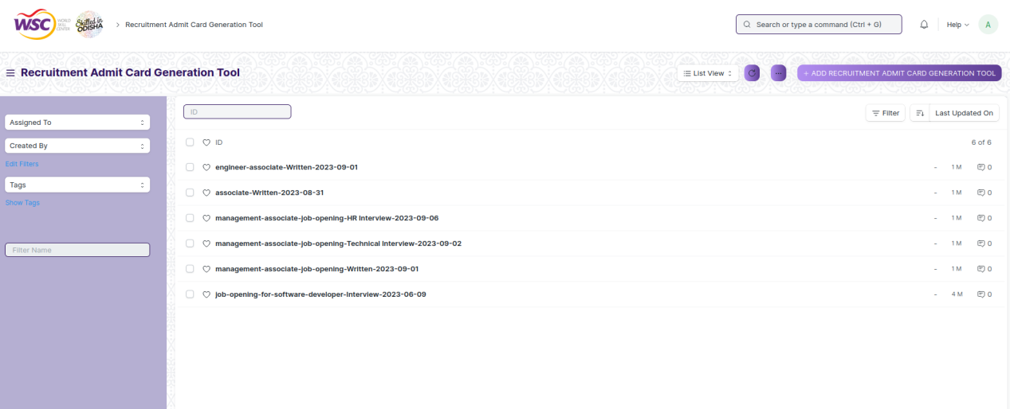

**View Recruitment Admit Card Generation Tool**

As it is a save screen, follow the general procedure to view a save document as mentioned above .

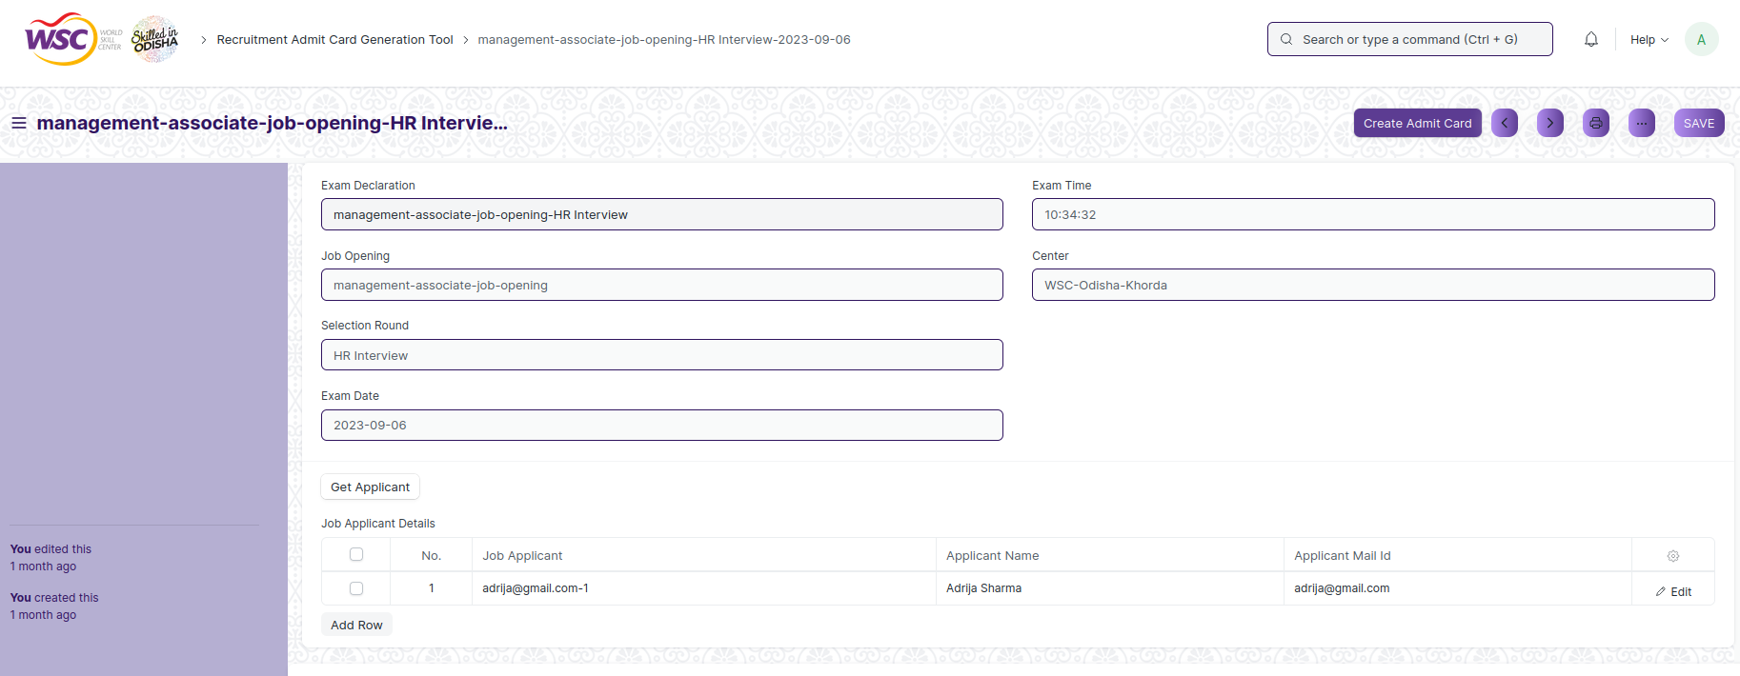

View of a saved Recruitment Admit Card Generation Tool.

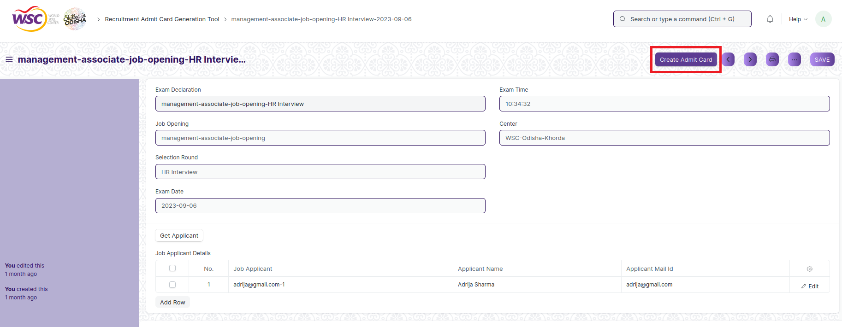

**Note:**

1. After Clicking on **“Create Admit Card”,**admit card will be generated for the applicants and will be saved in **“Recruitment Admit Card Generation”.**

**Delete Recruitment Admit Card Generation Tool**

If the document is saved, follow the procedure to delete the saved document.If any other transactional screen is linked to that Recruitment Admit Card Generation Tool like Recruitment Admit Card Generation the following records needs to deleted first.

**Edit Recruitment Admit Card Generation Tool**

Follow the steps to view a saved Recruitment Admit Card Generation Tool .

Edit the field that you want to change.

Click on Save.

**Print Recruitment Admit Card Generation Tool**

Follow the general procedure to print a save document.

**View Recruitment Admit Card Generation Tool Type in different format**

As it is a Save screen , follow the general procedure to view a save document in different format.

## Recruitment Admit Card Generation

The Recruitment Admit Card Generation screen holds information of an individual job applicants admit card.Most of the data in this field will be filled by the Recruitment Exam Admit Card Generation Tool.User can view admit card for applicants with the help of Recruitment Admit Card Generation.

The feature is accessible to HR Admin,HR Manager /Cs officer ,Director,HR Assistant.

To access the Recruitment Admit Card Generation,go to :

***Home>HRMS>Recruitment>Recruitment Admit Card Generation***

**Screen Type :** Submit

**Prerequisites**

Before creating a Recruitment Admit Card Generation, it is advisable you create the following documents:

* Company
* Department
* Designation
* Job Opening
* Job Applicant
* Recruitment Exam Declaration
* Recruitment Admit Card Generation Tool

**Adding a new Recruitment Admit Card Generation**

As it is a submit screen and the record in Recruitment Admit Card Generation is created by the using Recruitment Admit Card Generation Tool.After record is created in Recruitment Admit Card Generation , the record will be visible in the List view of the screen.

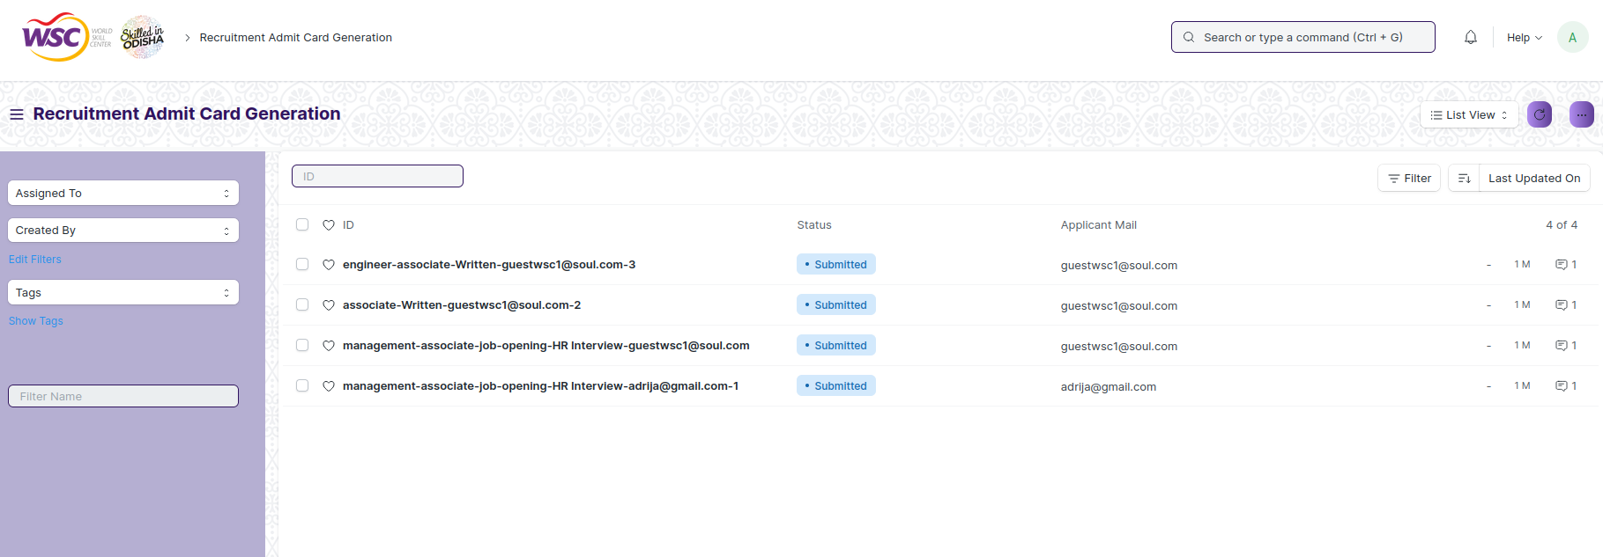

**View Recruitment Admit Card Generation**

As record in Recruitment Admit Card Generation form is created via Recruitment Admit Card Generation Tool,the record is in submitted state

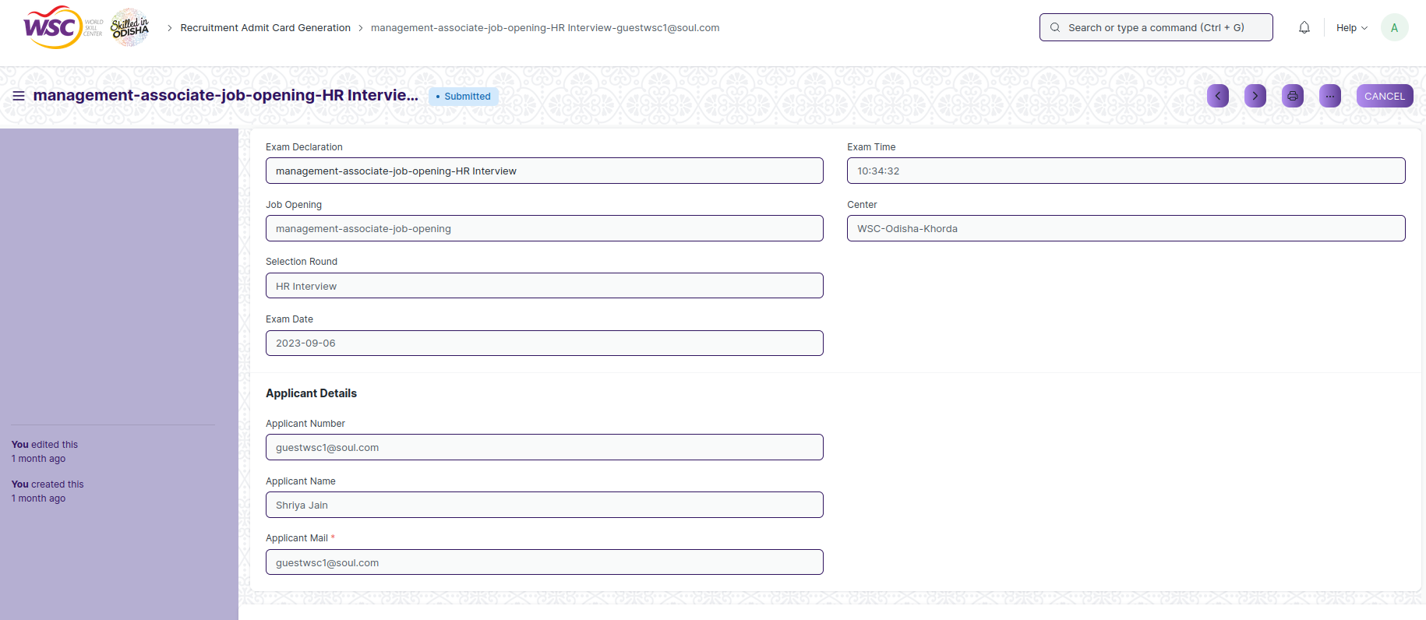

View of a submitted Recruitment Admit Card Generation.

**Cancel Recruitment Admit Card Generation**

As it is a submittable screen, follow the general procedure to Cancel a submittable document as mentioned above.

**Delete Recruitment Admit Card Generation**

If the document is submitted, follow the procedure to delete the submittable document.

**Amend Recruitment Admit Card Generation**

As it is a submittable screen , follow the general procedure to Amend the document.

**Edit Recruitment Admit Card Generation**

Once the document is submitted , it cannot be edited.

**Print Recruitment Admit Card Generation**

Follow the general procedure to print a submit document.

**View Recruitment Admit Card Generation Type in different format**

As it is a Submit screen , follow the general procedure to view a submitted document in different format.

## Recruitment Exam Result Declaration Tool

The “Recruitment Exam Result Declaration Tool” is a tool to generate the result of the applicant for different exam round in bulk.

The feature is accessible to HR Admin,HR Manager /Cs officer ,Director,HR Assistant.

To access the Recruitment Exam Result Declaration Tool ,go to :

***Home>HRMS>Recruitment>Recruitment Exam Result Declaration Tool***

**Screen Type :** Save

**Prerequisites**

Before creating a Recruitment Exam Result Declaration Tool, it is advisable you create the following documents:

* Company
* Department
* Designation
* Job Opening
* Job Applicant
* Recruitment Exam Declaration
* Recruitment Admit Card Generation

**Adding a new Recruitment Exam Result Declaration Tool**

* Login to the system.
* Go the HRMS workspace.
* Go to the Recruitment Exam Result Declaration Tool.
* Enter the Exam Declaration.
* Click on “Get Applicant”
* Click on Save.

**Note:**

1. After Clicking on **“Create Result”,**admit card will be generated for the applicants and will be saved in **“Recruitment Exam Result Declaration”.**

After creating a Recruitment Exam Result Declaration Tool , the record will be visible in the List view of the screen.

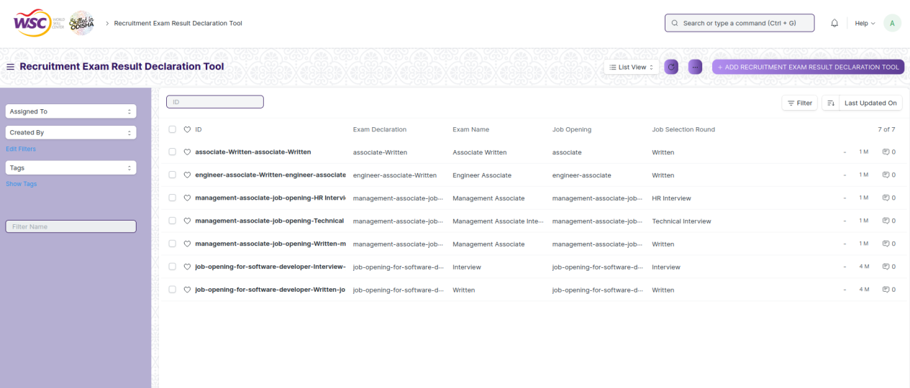

**View Recruitment Exam Result Declaration Tool**

As it is a save screen, follow the general procedure to view a save document as mentioned above .

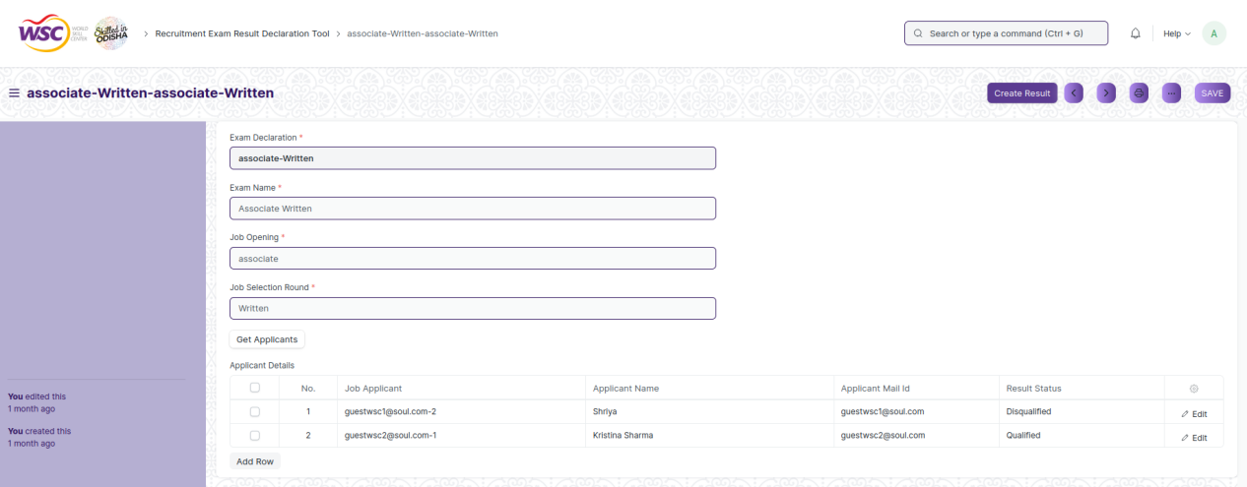

View of a saved Recruitment Exam Result Declaration Tool.

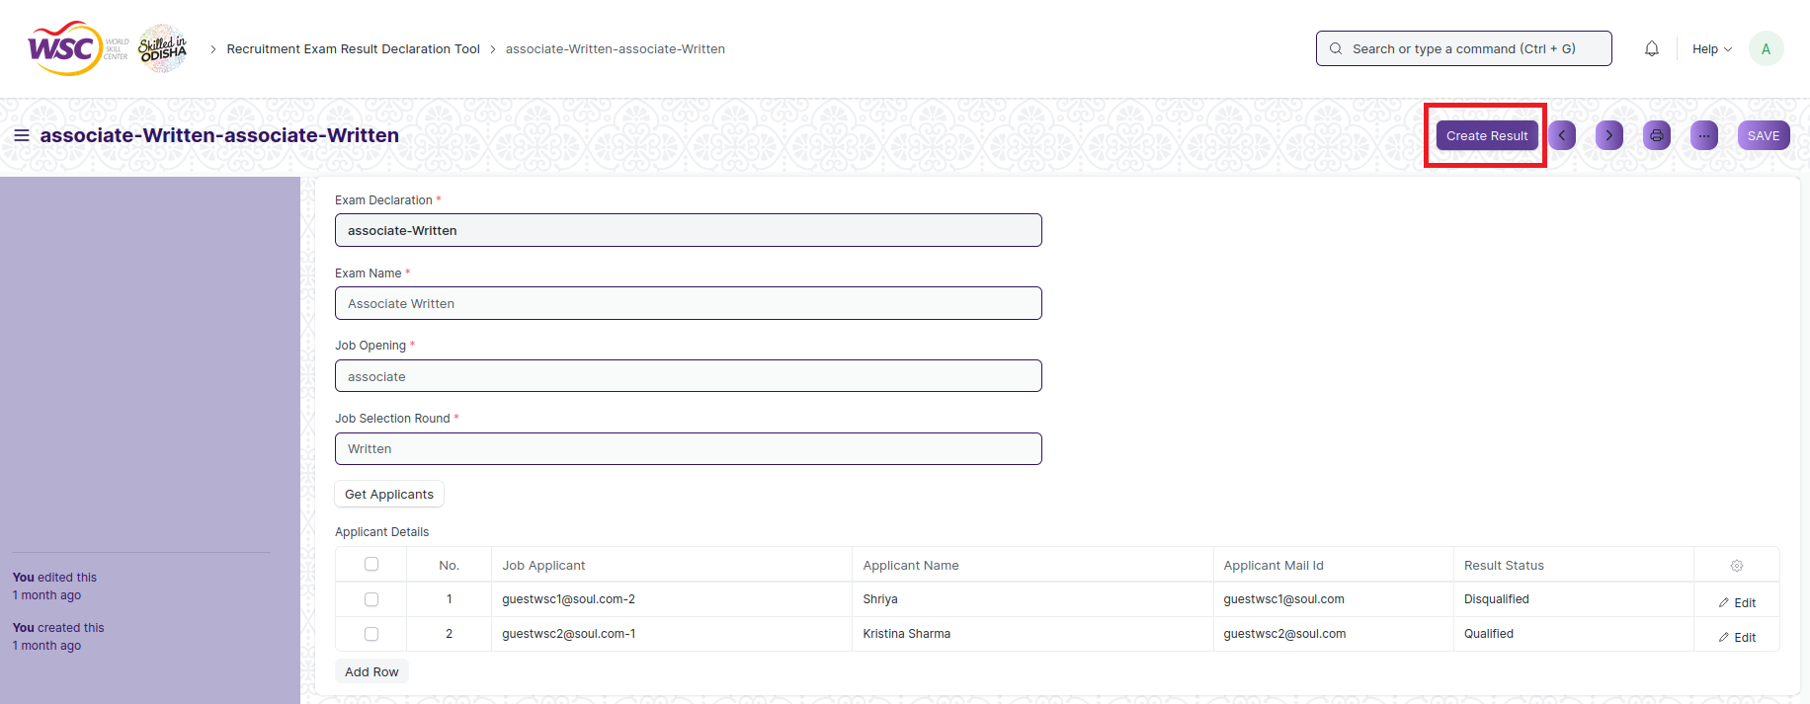

**Note:**

1. After Clicking on **“Create Result”,result** will be generated for the applicants with respect to the selection round and will be saved in **“Recruitment Exam Result Declaration”.**

**Delete Recruitment Exam Result Declaration Tool**

If the document is saved, follow the procedure to delete the saved document.If any other transactional screen is linked to that Recruitment Exam Result Declaration Tool like Recruitment Exam Result Declaration the following records needs to deleted first.

**Edit Recruitment Exam Result Declaration Tool**

Follow the steps to view a saved Recruitment Exam Result Declaration Tool.

Edit the field that you want to change.

Click on Save.

**Print Recruitment Exam Result Declaration Tool**

Follow the general procedure to print a save document.

**View Recruitment Exam Result Declaration Tool Type in different format**

As it is a Save screen , follow the general procedure to view a save document in different format.

## Recruitment Exam Result Declaration

The Recruitment Exam Result Declaration screen holds information of an individual job applicant’s result of each selection round.Most of the data in this field will be filled by the Recruitment Exam Result Declaration Tool.User can view result of each selection round for applicants with the help of Recruitment Exam Result Declaration.

The feature is accessible to HR Admin,HR Manager /Cs officer ,Director,HR Assistant.

To access the Recruitment Exam Result Declaration,go to :

***Home>HRMS>Recruitment>Recruitment Exam Result Declaration***

**Screen Type :** Submit

**Prerequisites**

Before creating a Recruitment Exam Result Declaration, it is advisable you create the following documents:

* Company
* Department
* Designation
* Job Opening
* Job Applicant
* Recruitment Exam Declaration
* Recruitment Admit Card Generation
* Recruitment Exam Result Declaration Tool

**Adding a new Recruitment Exam Result Declaration**

As it is a submit screen and the record in Recruitment Exam Result Declaration is created by the using Recruitment Exam Result Declaration Tool.After record is created in Recruitment Exam Result Declaration , the record will be visible in the List view of the screen.

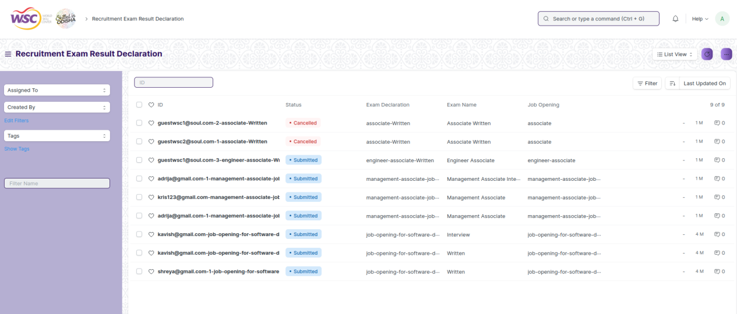

**View Recruitment Exam Result Declaration**

As record in Recruitment Exam Result Declaration form is created via Recruitment Exam Result Declaration Tool,the record is in submitted state

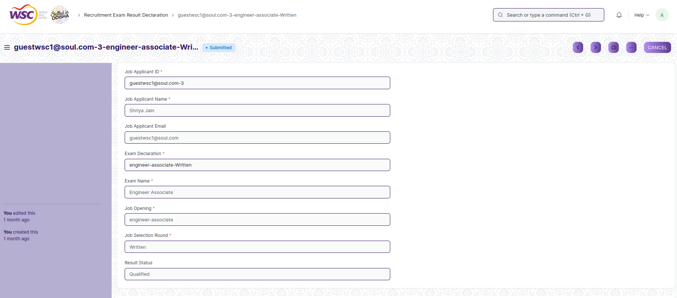

View of a submitted Recruitment Exam Result Declaration.

**Cancel Recruitment Exam Result Declaration**

As it is a submittable screen, follow the general procedure to Cancel a submittable document as mentioned above.

**Delete Recruitment Exam Result Declaration**

If the document is submitted, follow the procedure to delete the submittable document.

**Amend Recruitment Exam Result Declaration**

As it is a submittable screen , follow the general procedure to Amend the document.

**Edit Recruitment Exam Result Declaration**

Once the document is submitted , it cannot be edited.

**Print Recruitment Exam Result Declaration**

Follow the general procedure to print a submit document.

**View Recruitment Exam Result Declaration Type in different format**

As it is a Submit screen , follow the general procedure to view a submitted document in different format.

## Job Offer

The “Job Offer” is given to selected candidates after interview and selection which states the offered salary package, designation, grade, department, number of days entitled for leave among other information.

The “Job Offer”is also given to the Employee after the process of Employee Re-engagement.

The feature is accessible to HR Admin and Director Admin.

To access the Job Offer ,go to :

***Home>HRMS>Recruitment>Job Offer***

**Screen Type :** Submit

**Prerequisites**

Before creating Job Offer, it is advisable you create the following documents:

* Company
* Department
* Designation
* Employee
* Job Applicant
* Terms and Conditions

**Adding a new Job Offer**

* Login to the system.
* Go the HRMS workspace.
* Go to the Job Offer.
* Click on “Is Re-engagement”or “is applicant”
* Enter the Employee or Job Applicant,Department,Designation and select terms. And enter Job Offer Terms.
* Click on “Save”.
* Click on “Submit”.
* On Submitting the status of the Job Offer will be “Awaiting Response”.
* Set the Status as Accepted/Rejected on the basis of Response from Applicant or Employee.

**Note:**

1. Email will be sent to the applicant or employee with the Job Offer as Attachment.

After creating a Job Offer , the record will be visible in the List view of the screen.

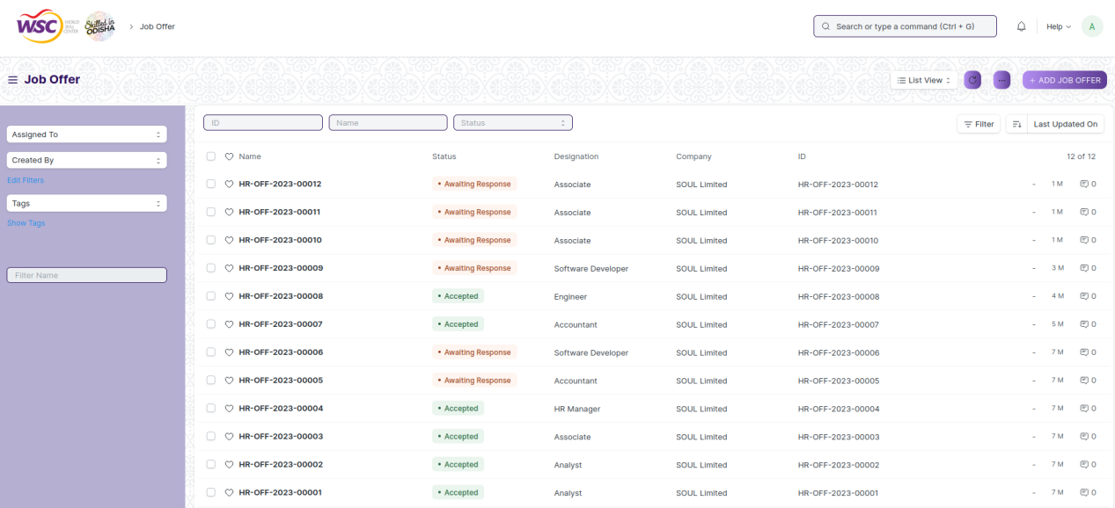

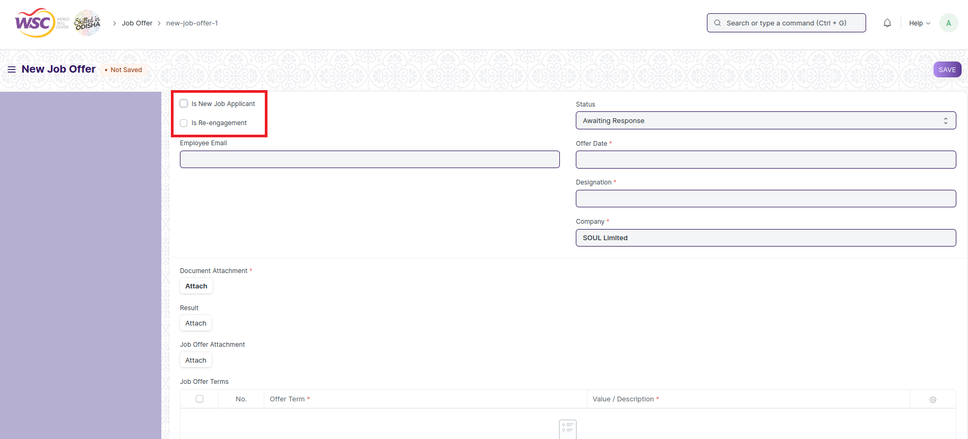

**Note** :

1. All the mandatory fields are marked with red asterisks.
2. There are two check boxes:
   * 1. **Is New Job Applicant:**Select when Job Offer is created for a Job Applicant.
     2. **Is Re-engagement:**Select when Job Offer is created for a Employee after Employee Re-engagement process.

**View Job Offer**

As it is a submit screen, follow the general procedure to view a submittable document as mentioned above .

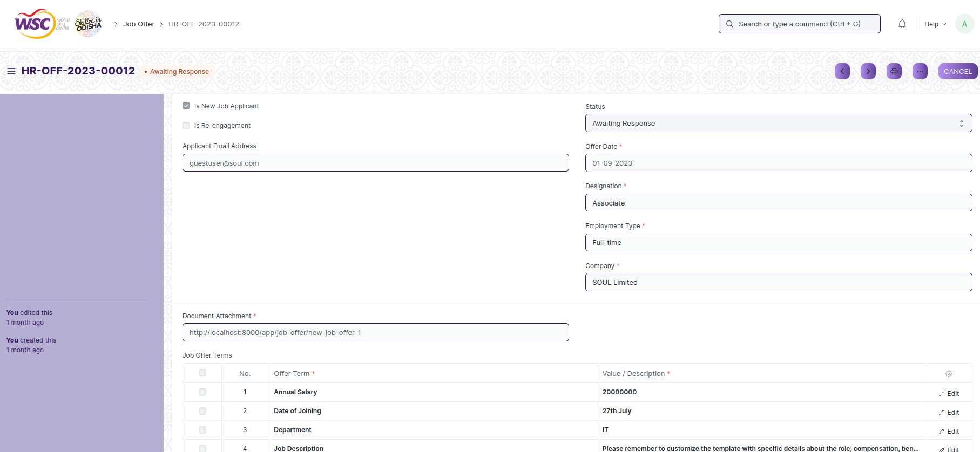

View of a submitted Job Offer.

**Cancel Job Offer**

As it is a submittable screen, follow the general procedure to Cancel a submittable document as mentioned above.

**Delete Job Offer**

If the document is submitted, follow the procedure to delete the submittable document.

**Amend Job Offer**

As it is a submittable screen , follow the general procedure to Amend the document.

**Edit Job Offer**

Once the document is submitted , it cannot be edited.Only Status field can be updated.

**Print Job Offer**

Follow the general procedure to print a submit document.Select the print format.

**View Job Offer Type in different format**

As it is a Submit screen , follow the general procedure to view a submitted document in different format.

## Appointment Letter Template

The Appointment Letter Template is a blueprint which contains a predefined body,introduction and closing notes for Employee Appointment Letter..

The feature is accessible to HR Admin,HR Manager /Cs officer ,Director,HR Assistant.

To access the Appointment Letter Template screen ,go to :

***Home>HRMS>Recruitment>Appointment Letter Template***

Screen Type : Save

**Adding a new Appointment Letter Template**

* Login to the system.
* Go the HRMS workspace.
* Go to the Appointment Letter Template .
* Enter the Template Name,Introduction,Terms and Closing Notes.
* Click on “Save”.

After creating Appointment Letter Template , the record will be visible in the List view of the screen.

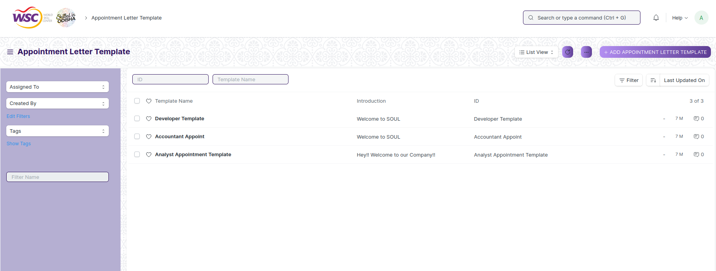

**Note :** Appointment Letter Template can be linked with Appointment Letter.

**View Appointment Letter Template**

As it is a save screen, follow the general procedure to view a save document as mentioned above .

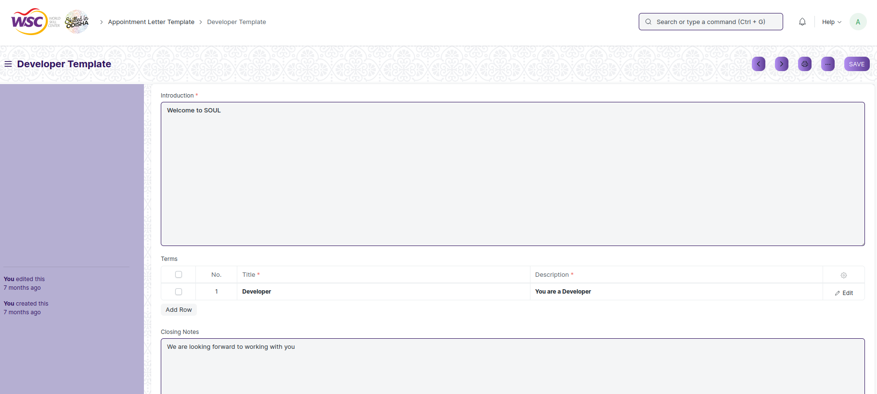

View of a saved Appointment Letter Template.

**Delete Appointment Letter Template**

As it a Save screen , follow the general procedure to delete a save document .

If a Appointment Letter Template is linked with Appointment Letter, you cannot delete directly that template. You have to unlink the Appointment Letter first , then you can delete it.

**Edit Appointment Letter Template**

Follow the steps to view a saved Appointment Letter Template

Edit the field that you want to change.

Click on Save.

**Print Appointment Letter Template**

As it is a Save screen , follow the general procedure to print a saved document.

**View Appointment Letter Template in different format**

As it is a Save screen , follow the general procedure to view a saved document in different format.

## Appointment Letter

The “Appointment Letter” is the letter written by the employer requesting the selected candidates to join in a specific position.

The feature is accessible to HR Admin,HR Manager /Cs officer ,Director,HR Assistant.

To access the Appointment Letter screen ,go to :

***Home>HRMS>Recruitment>Appointment Letter***

Screen Type : Save

**Adding a new Appointment Letter**

* Login to the system.
* Go the HRMS workspace.
* Go to the Appointment Letter.
* Enter the Job Applicant and Appointment Letter Template.
* Click on “Save”.

After creating Appointment Letter , the record will be visible in the List view of the screen.

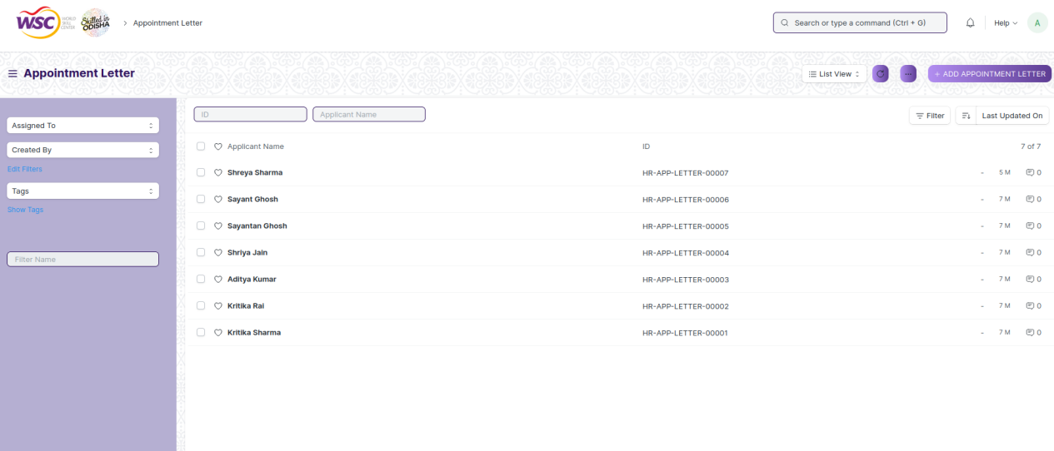

**View Appointment Letter**

As it is a save screen, follow the general procedure to view a save document as mentioned above .

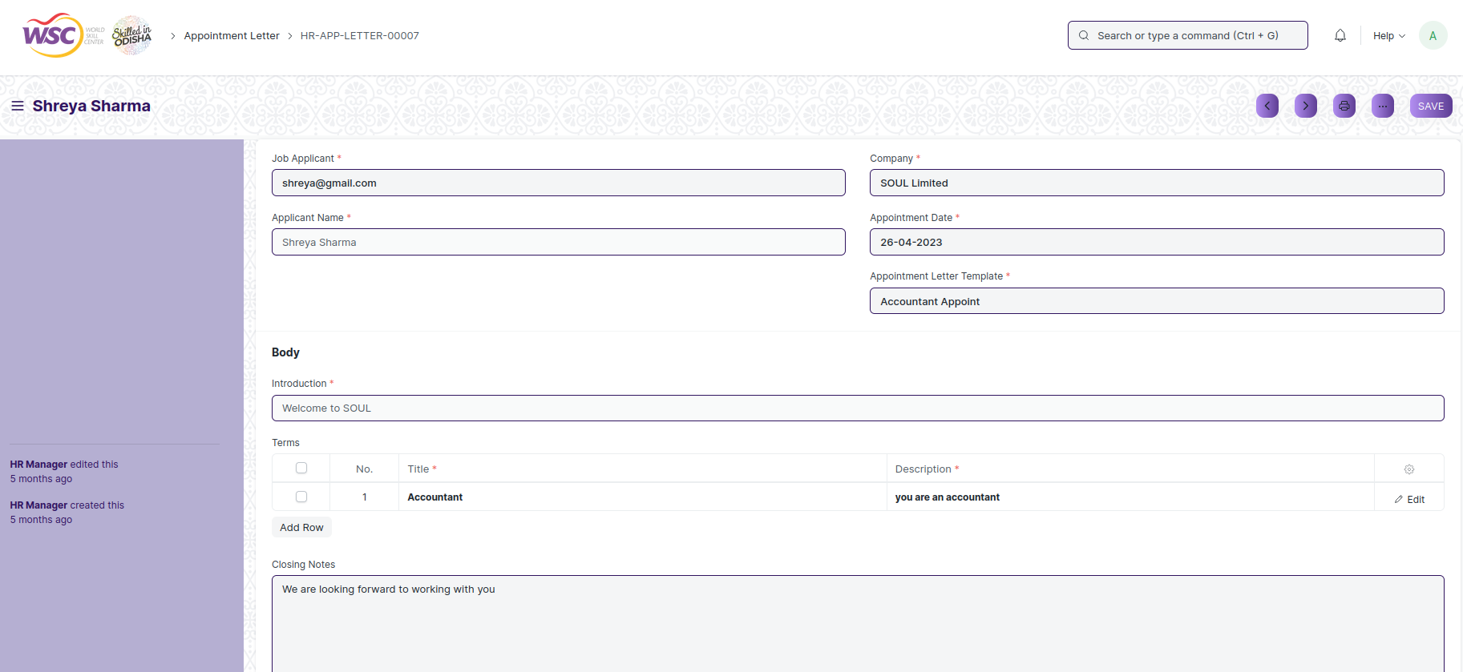

View of a saved Appointment Letter .

**Delete Appointment Letter**

As it a Save screen , follow the general procedure to delete a save document .

**Edit Appointment Letter**

Follow the steps to view a saved Appointment Letter

Edit the field that you want to change.

Click on Save.

**Print Appointment Letter**

As it is a Save screen , follow the general procedure to print a saved document.

**View Appointment Letter in different format**

As it is a Save screen , follow the general procedure to view a saved document in different format.

# Employee Life Cycle

## Employee

The "Employee" screen typically refers to manage and configure the master data of an employee. It captures the demographic, personal, and professional details, joining and leave details, etc. of the Employee.

The screen is accessible to Employee , HR Admin,HR Manager /Cs officer ,Director,HR Assistant.

To access the Employee Master screen ,go to :

***Home>HRMS(Base)>Employee Lifecycle>Employee***

Screen Type : Save

**Prerequisites**

Before creating an Employee Group, it is advisable you create the following documents:

* Company

**Adding a new Employee**

As it is a save screen, follow the general procedure to create a save document as mentioned above .

* Go to the Employee list, and click on New.
* Enter the Employee's personal details such as Name, Gender, Date of Birth, and Date of Joining.
* Save.

After creating an Employee , the record will be visible in the List view of the screen.

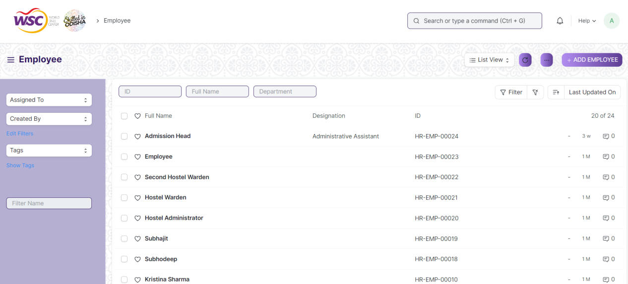

(List View of Employee)

**Note** : All the mandatory fields are marked with red asterisks.

Apart from the aforementioned mandatory details, some additional details that can be captured in the Employee master are as follows:

**Employment Type**

You can set an Employment Type such as Intern, Contract, Full-time, Part-time, Probation, etc. for an Employee.

**Create User**

The User ID can be linked to the Employee. In case the User ID is not created, you can click on 'Create a New User' in the dropdown to create one. The creation of user can be only accessible who have necessary permission.

**Joining Details**

The Joining Details of the Employee such as the Offer Date, Confirmation Date, Contract End Date, Notice (Days), and Date of Retirement can be captured.

**Department and Grade**

In a company, the Employees are usually grouped on the basis of Department, Grade, Designation, and Branch.

**Leave Details**

In Leave Details, you can save the Leave Policy and Holiday List details. Leave Policy specifies the type and number of leaves an Employee is entitled to, and Holiday List is a list which contains the dates of holidays and weekly offs.

**Salary Details**

Here, the mode of salary payment, i.e. through Bank, Cheque or Cash can be selected.

**Contact Details**

Employee's Contact information such as Mobile Number, Current and Permanent Address, Personal and Company Email ID can be captured here. In the Preferred Email ID field, either the the Company Email, Personal Email or User ID of the Employee can be selected depending on the user's preference.

**Personal Details**

Personal Details of the Employee such as Family Background details like name and occupation of parent, spouse and children, Passport Details including date and place of issue, Health Details like height, weight, allergies, medical concerns, etc. can be saved.

**Educational Qualification**

Here, the Educational Details such as School/University, Qualification, Level and Year of Passing of the Employee can be saved

**Previous Work Experience**

Just like Educational Qualification, an Employee's Previous Work Experience can also be captured in the External Work History table.

**Exit**

Exit details of the employee (if any) such as Resignation, Exit Interview and Leave Encashment details can be saved. When the status of the Employee is set to 'Left', it is mandatory to fill the Relieving Date.

**Additional Charges**

Additional work and charges details of the employee can be saved.

**Criminal Cases**

Criminal Cases of the employee can be maintained her.

**Note:** Once the Employee status is set to 'Left', that particular Employee master won't be accessible in further transactions.

**View Employee**

As it is a save screen, follow the general procedure to view a save document as mentioned above .

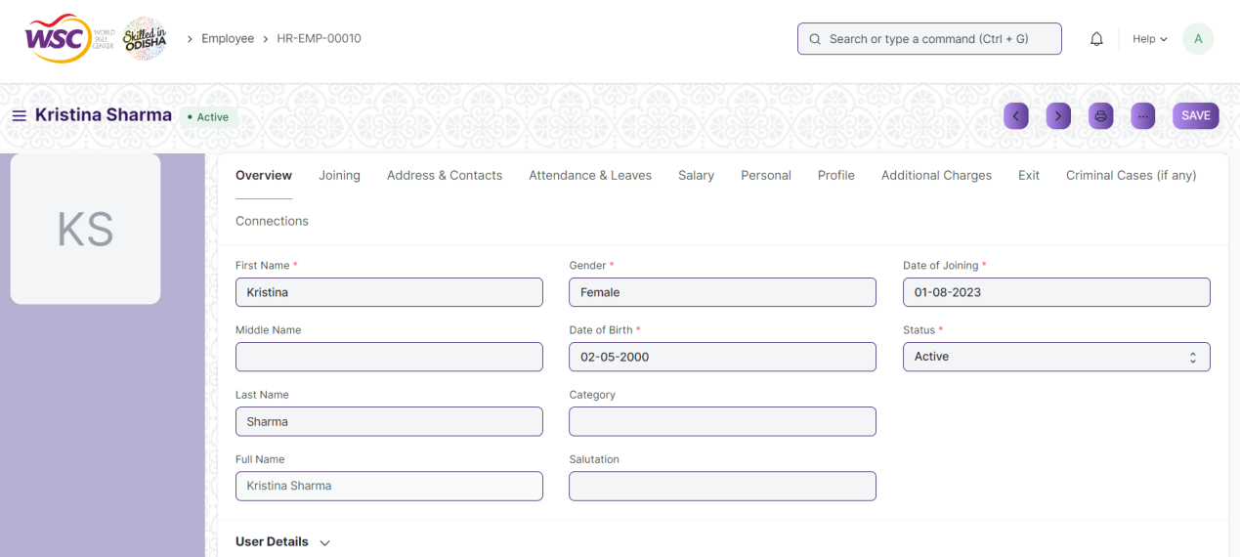

(View of a saved Employee.)

**Delete Employee**

As it a Save screen , follow the general procedure to delete a save document .

**Edit Employee**

Follow the steps to view a saved employee.

Edit the field that you want to change.

Click on Save.

**Print Employee**

As it is a Save screen , follow the general procedure to print a saved document.

**View Employee in different format**

As it is a Save screen , follow the general procedure to view a saved document in different format.

## Employee Profile Updation

The "Employee Profile Updation" screen typically designed to help you manage and update employee profiles efficiently.

The screen is accessible to Employee , HR Admin,HR Manager /Cs officer ,Director,HR Assistant.

To access the Employee Profile Updation screen ,go to :

***Home>HRMS(Base)>Employee Lifecycle>Employee Profile Updation***

Screen Type : Submit

**Prerequisites**

Before creating an Employee Profile updation , it is advisable you create the following documents:

* Employee
* Employee Profile

**Adding a new Employee Profile Updation**

* Login to the system.
* Go the required workspace.
* Go to the Employee Profile Updation screen.
* Enter the Employee ID.
* All the profile details will be automatically fetched.
* Change the field that you want.
* Click on Save.

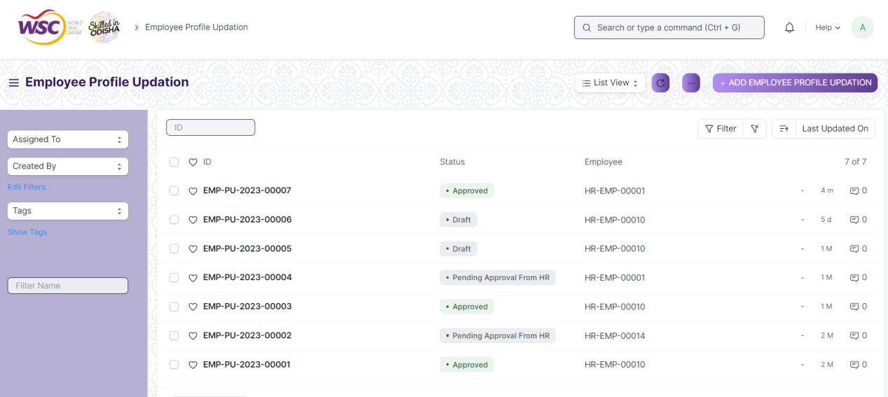

(List View of Employee Profile Updation)

**Note :** After saving the document , a workflow begins. First it will be forwarded to the reporting authority of the employee, then to the HR Admin to end the process.

**Process After Saving**

**Action of Reporting Authority**

If logged in user is the reporting authority of the employee, then an action button will be visible in the right corner of the document. Click on Action button , select approve/reject to Approve or Reject the document.

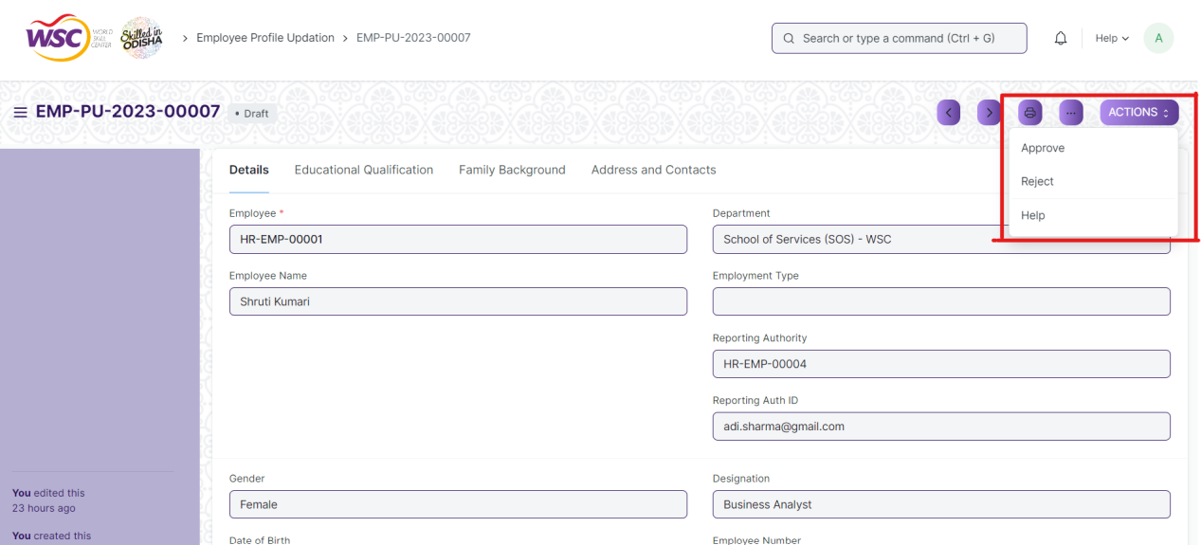

(Action button for Reporting Authority)

**Action of HR Admin**

If the logged in user is HR Admin and the document status is Pending Approval from HR , then an action button will be visible in the right corner of the document. Click on Action button, select Submit to End the process.

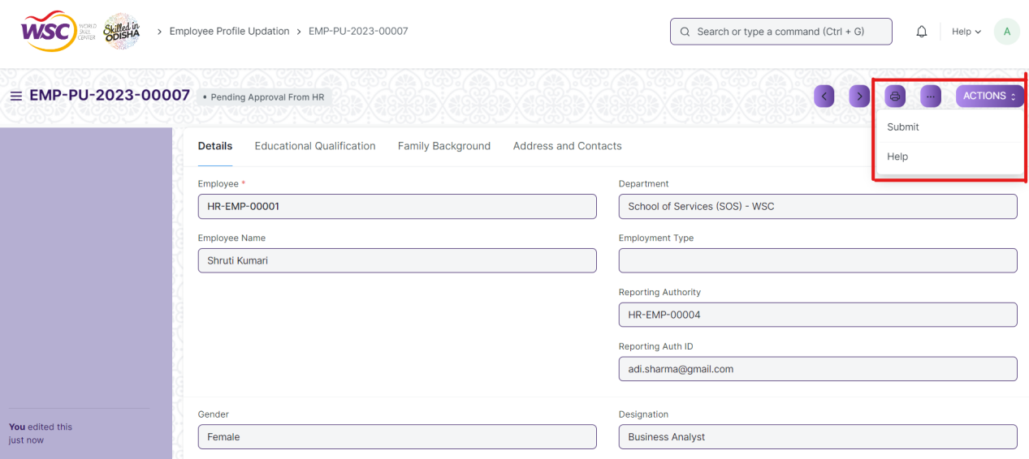

(Action button for HR Admin)

After clicking on submit , the Employee profile will be updated.

**View Employee Profile Updation**

As it is an submittable screen, follow the procedure to view a submitable document as mentioned above.

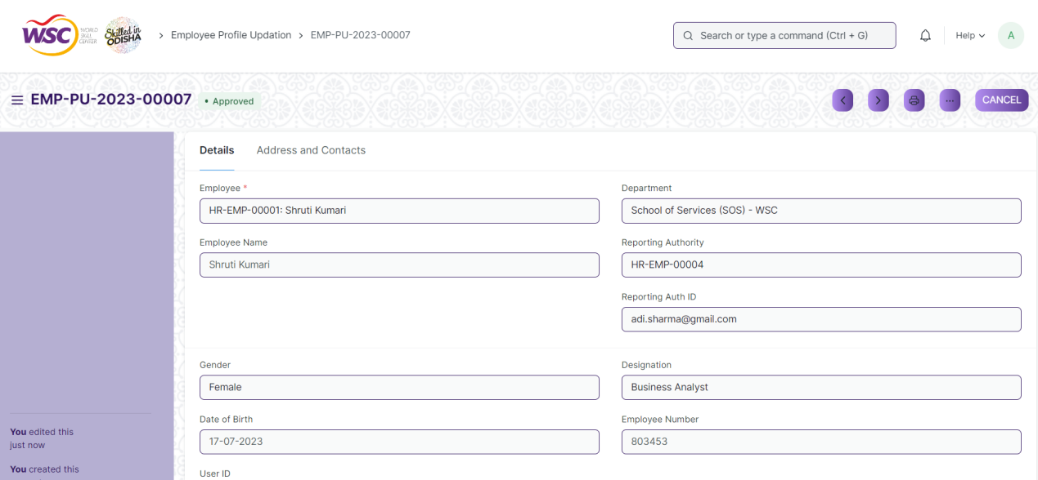

(View of a submitted Employee profile updation)

**Cancel Employee Profile Updation**

As it is a submittable screen, follow the general procedure to Cancel a submittable document as mentioned above.

**Delete Employee Profile Updation**

If the document is not submitted , it is in draft state , you can delete the document by following the procedure to delete a save document.

If the document is submitted, follow the procedure to delete the submittable document.

**Amend Employee profile Updation**

As it is a submittable screen , follow the general procedure to Amend the document.

**Edit Employee Profile Updation**

If the document is in draft state , the document can be editable.

Once the document is submitted , it cannot be edited.

**Print Employee Profile Updation**

Follow the general procedure to print a saved document.

**View Employee Profile Updation in different format**

follow the general procedure to view a saved document in different format.

## Employee On-boarding Template

The Employee Onboarding Template is a blueprint which contains a predefined list of Activities for Employee Onboarding. An Employee Onboarding Template can be created for a particular Department, Designation and Employee Grade.

The screen is accessible to HR Admin,HR Manager /Cs officer ,Director,HR Assistant.

To access the Employee Onboarding Template Master screen ,go to :

***Home>HRMS(Base)>Masters>Employee Onboarding Template***

Screen Type : Save

**Adding a new Employee Onboarding Template**

As it is a save screen, follow the general procedure to create a save document as mentioned above .

* Go to Employee Onboarding Template List , click on Add new.
* Enter the details.
* Mention the Activities for on boarding. For each Activity, you can also mention the User or Role, or one of it, to whom this Activity will be assigned.
* You can also schedule the Onboarding Activities by specifying the Begin On (Days) i.e. when the activity has to start and the Duration (Days) for the same.
* You can mention the dependencies and task order in the template.
* Click on save.

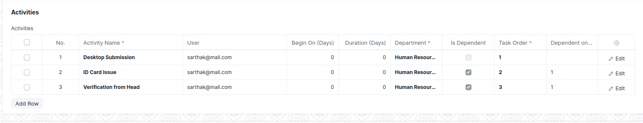

(Activity table in Employee On-boarding Template)

After creating an Employee On-boarding template , the record will be visible in the List view of the screen.

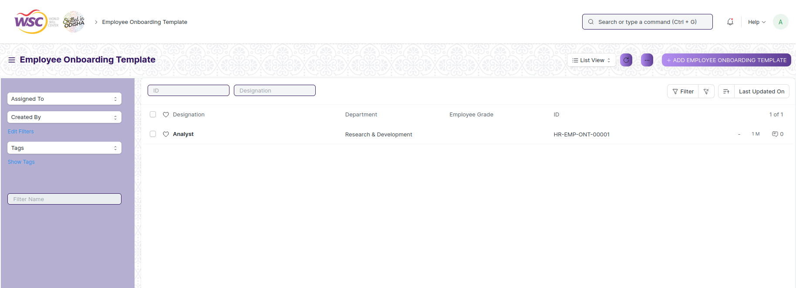

(List View of Employee On-boarding Template)

**Note :** Employee on-boarding Template can be linked with Employee on-boarding

**View Employee on-boarding Template**

As it is a save screen, follow the general procedure to view a save document as mentioned above .

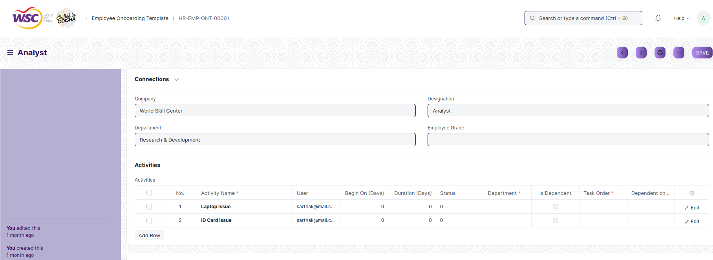

(View of a saved Employee On-boarding Template.)

**Delete Employee On-boarding Template**

As it a Save screen , follow the general procedure to delete a save document .

If an Employee On-boarding template is linked with Employee On-boarding, you cannot delete directly that template. You have to unlink the On-boarding template first , then you can delete it.

**Edit Employee On-boarding Template**

Follow the steps to view a saved Employee On-boarding Template.

Edit the field that you want to change.

Click on Save.

**Print Employee On-boarding Template**

As it is a Save screen , follow the general procedure to print a saved document.

**View Employee On-boarding Template in different format**

As it is a Save screen , follow the general procedure to view a saved document in different format.

## Employee On-boarding

In the process of hiring an Employee, there are set of standard activities which need to be executed. This screen helps you to maintain the masters of these activities, and create a set of tasks at the time of each Employee hiring.

Employee On-boarding is created for a Job Application, who is approved for the hiring.

The screen is accessible to HR Admin,HR Manager /Cs officer ,Director,HR Assistant.

To access the Employee Separation screen ,go to :

***Home>HRMS(Base)>Employee Lifecycle>Employee Onboarding***

Screen Type : Submit

**Prerequisites**

Before creating an Employee separation , it is advisable you create the following documents:

* Job Applicant
* Employee
* Department
* Designation
* Employee Grade

**Adding a new Employee Onboarding**

As it is a submittable screen follow the general procedure to create a submittable document.

* Select the Job Applicant. once the Job Applicant is selected, the corresponding Employee will automatically get fetched.
* Select the Employee On-boarding Template. Based on the template selected, information such as Department, Designation and Employee grade will be automatically fetched (if already mentioned in the On-boarding Template).
* Enter Date of Joining.
* Save and Submit.

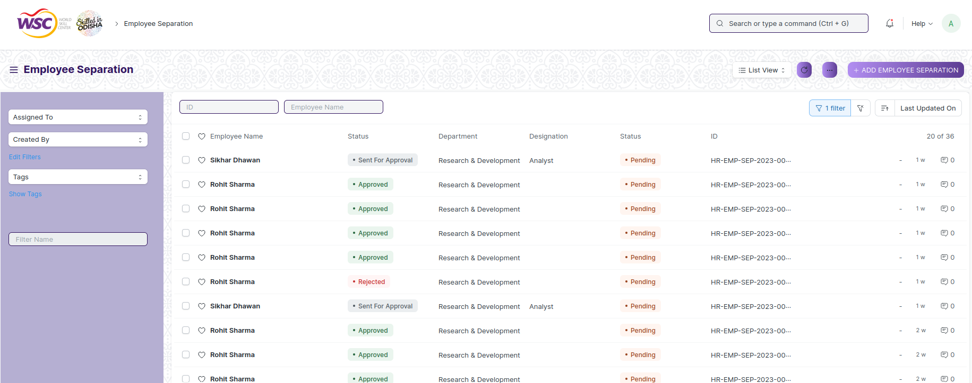

(List View of Employee On-boarding)

**Note :** If an Employee On-boarding Template isn't created, you can directly fill the on-boarding information in the Employee On-boarding screen itself.

**Note :** After submitting the document , a workflow begins. After submission , it will be forwarded to the Director Admin. Once the director admin approves tasks will be assigned to the users.

Email will be sent to the respective authority in each workflow state.

**Process After Submission**

**Action of Director Admin**

If logged in user is the Director Admin and the document state is Pending Approval from Director Admin , then an action button will be visible in the right corner of the document. Click on Action button , select Approve or Reject to end the process .

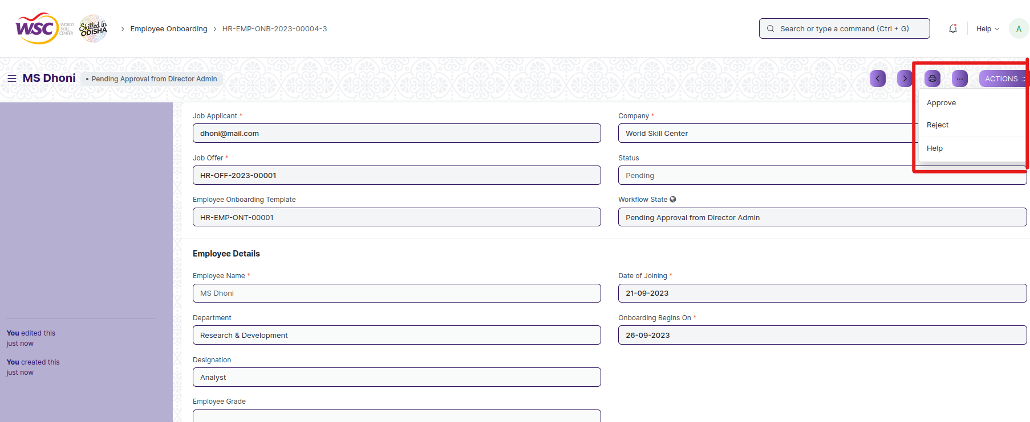

(Action button for Director Admin)

**Note :** Once the document is finally get approved by Director Admin , the final email will be sent to the HR Admin.

On submission of the Employee On-boarding, a Project will be created. Within the Project, Tasks will also be created for each Activity. If you have set the date and duration against activities, tasks will be created with appropriate Start and End Date excluding holidays.

You can view the created Projects and Tasks through View > Project/ Tasks.

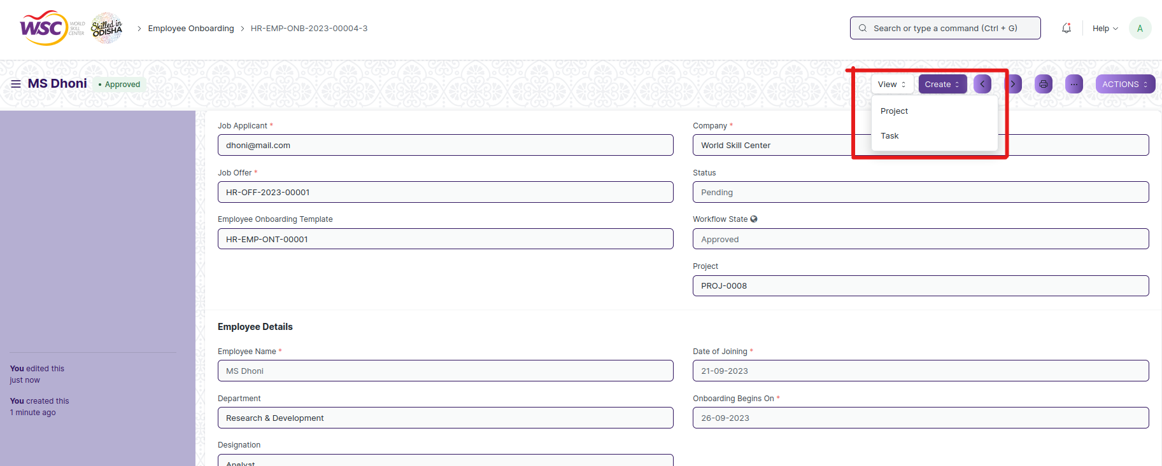

(Options to view Project and Task)

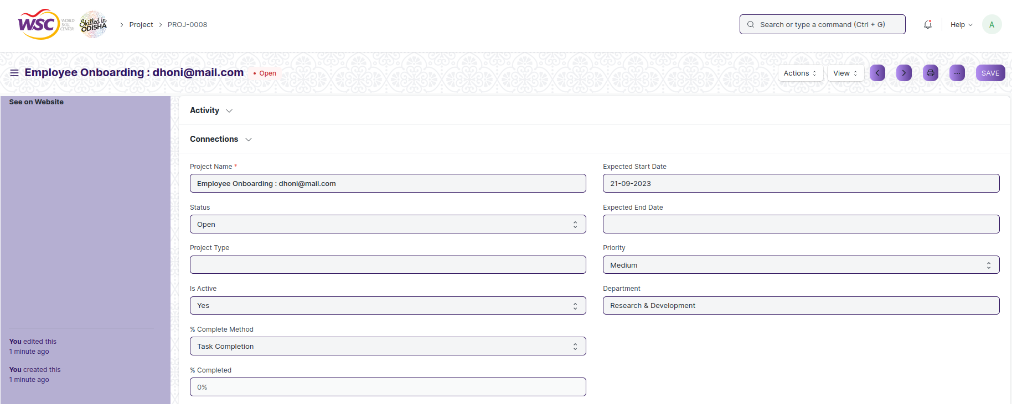

(View of Project)

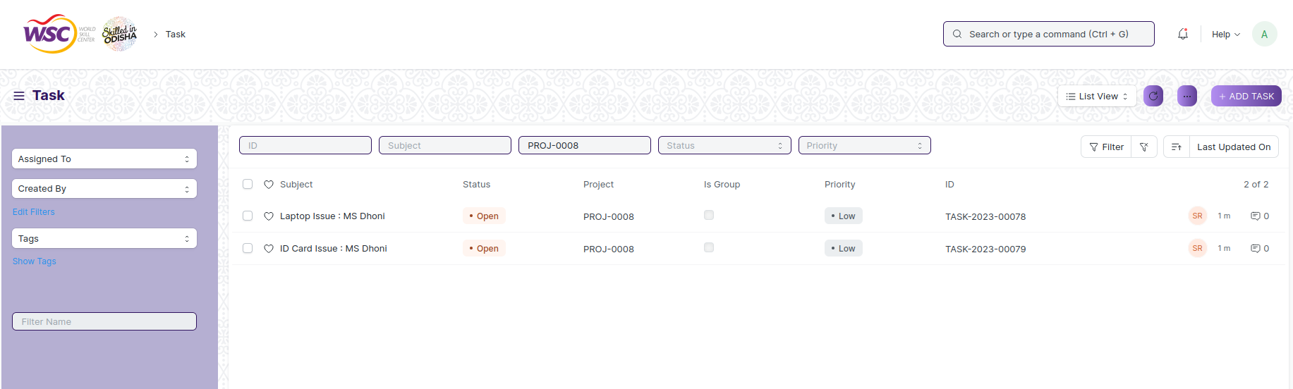

(List view of tasks that comes under the project)

**Note :** You can set the Task order and Task Dependency in the Employee On-boarding Template. Once the previous dependent task is not completed , the the user will not be able to complete the next task.

**Note :**The 'Status' of the Employee On-boarding will change to Completed once all the associated Activities are complete.

**View On-boarding**

As it is an submittable screen, follow the procedure to view a submitable document as mentioned above.

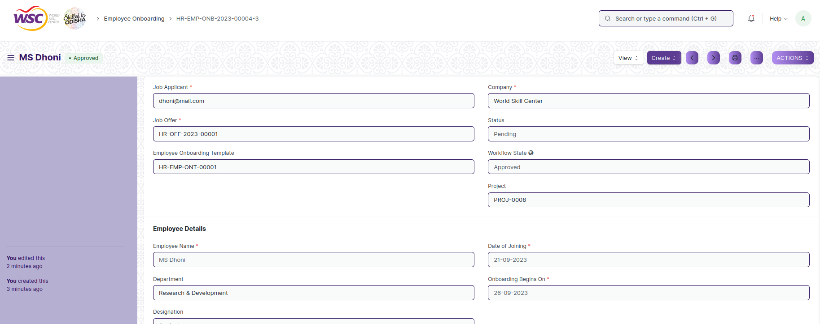

(View of a submitted Employee On-boarding)

**Cancel Employee On-boarding**

As it is a submittable screen, follow the general procedure to Cancel a submittable document as mentioned above.

On cancellation of the document , the document status will be updated to Pending .

All the tasks that has created for the Employee On-boarding will be deleted.

**Delete On-boarding**

If the document is not submitted , it is in draft state , you can delete the document by following the procedure to delete a save document.

If the document is submitted, follow the procedure to delete the submittable document.

**Amend On-boarding**

As it is a submittable screen , follow the general procedure to Amend the document.

**Edit Employee On-boarding**

If the document is in draft state , the document can be editable.

Once the document is submitted , it cannot be edited.

**Print Employee On-boarding**

Follow the general procedure to print a saved document.

**View Employee On-boarding in different format**

follow the general procedure to view a saved document in different format.

## Employee Resignation

The "Employee Resignation screen " screen typically designed to apply for resignation for employee.

The screen is accessible to Employee , HR Admin,HR Manager /Cs officer ,Director,HR Assistant.

To access the Employee Resignation screen ,go to :

***Home>HRMS(Base)>Employee Lifecycle>Employee Resignation***

Screen Type : Submit

**Prerequisites**

Before creating an Employee Resignation , it is advisable you create the following documents:

* Employee

**Adding a new Employee Resignation**

As it is a submittable screen follow the general procedure to create a submittable document.

* Go to: Employee Resignation, Click on Add New.
* Enter the details in the form.
* Save and Submit.

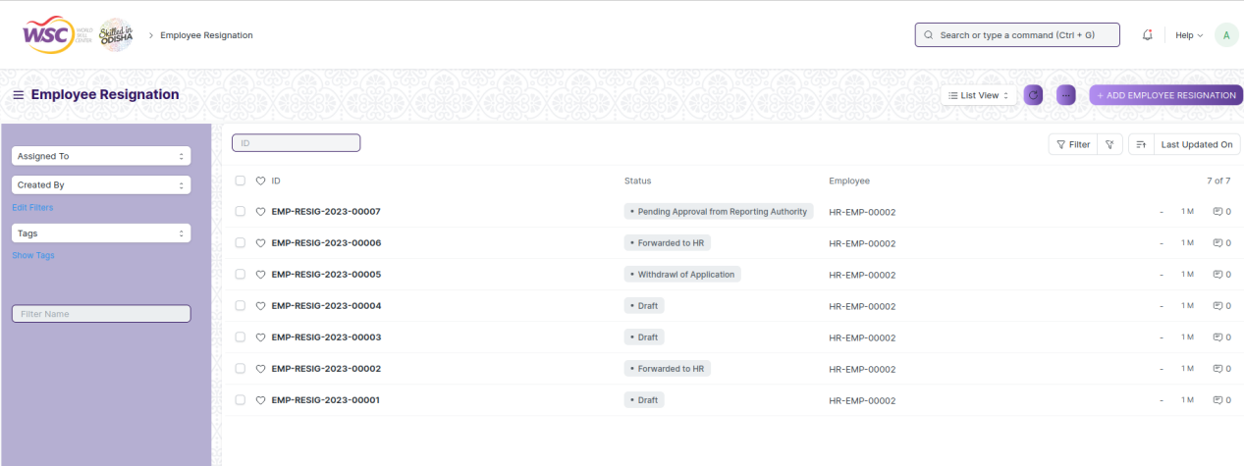

(List View of Employee Resignation)

**Note :** After submitting the document , a workflow begins. First it will be forwarded to the HR Admin, if HR Admin approves , it will be forwarded to the Reporting Authority of the employee. Once the reporting authority approves , it will be forwarded to the department head of the employee . Finally after the approval of the department head, it will be forwarded to the Director Admin for final Approval.

Email will be sent to the respective authority in each workflow state.

**Process After Submission**

**Action of HR Admin**

If the logged in user is HR Admin and the document status is Forwarded to HR , then an action button will be visible in the right corner of the document. Click on Action button, select Send for Approval or withdrawl to approve or withdraw the document.

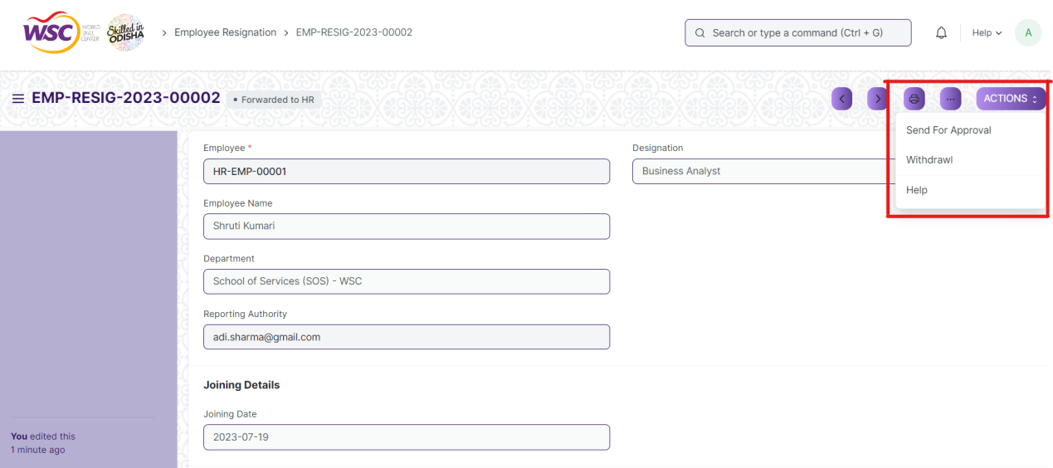

(Action button for HR Admin)

**Action of Reporting Authority**

If logged in user is the reporting authority of the employee and the document state is Pending Approval from Reporting Authority, then an action button will be visible in the right corner of the document. Click on Action button , select Send for Approval to forward the document to the department head.

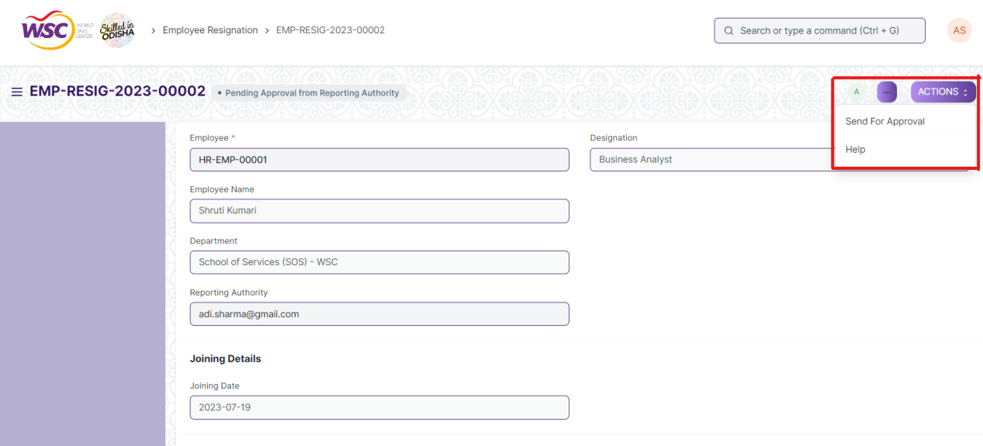

(Action button for Reporting Authority)

**Action of Department Head**

If logged in user is the Department head of the employee and the document state is Pending Approval from Department Head, then an action button will be visible in the right corner of the document. Click on Action button , select Send for Approval or Reject to forward the document to the Director Admin or Reject the document.

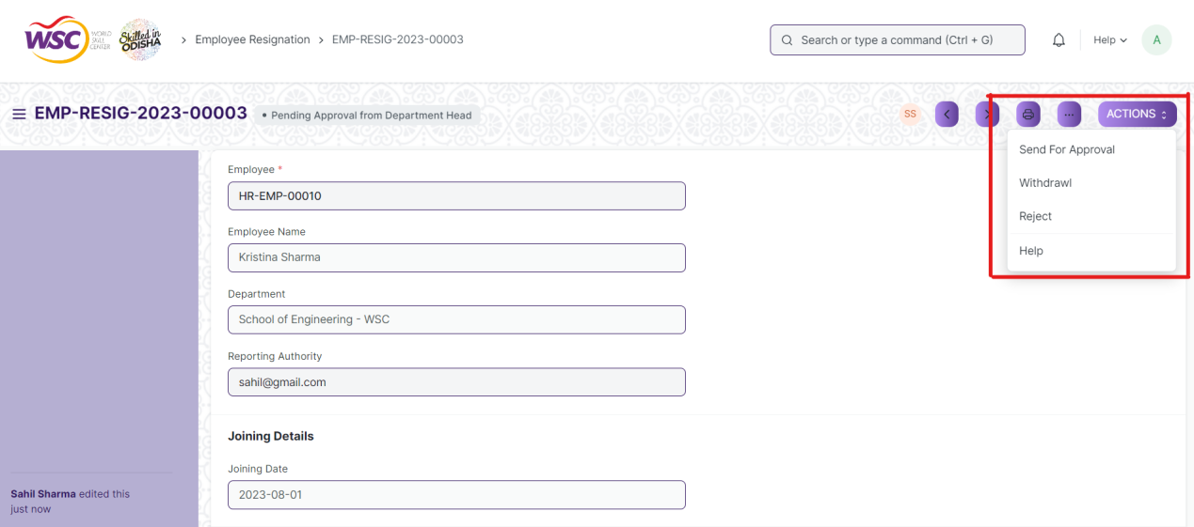

(Action button for Department Head)

**Action of Director Admin**

If logged in user is the Director Admin and the document state is Pending Approval from Director Admin , then an action button will be visible in the right corner of the document. Click on Action button , select Approve or Reject to end the process .

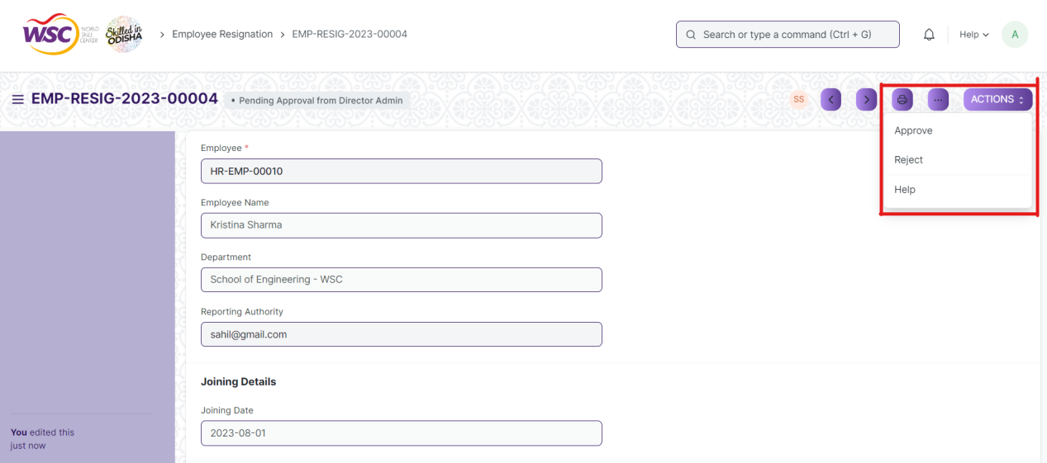

(Action button for Director Admin)

**Note :** Once the document is finally get approved by Director Admin , the employee will not be able to withdraw anymore.

**View Resignation**

As it is an submittable screen, follow the procedure to view a submittable document as mentioned above.

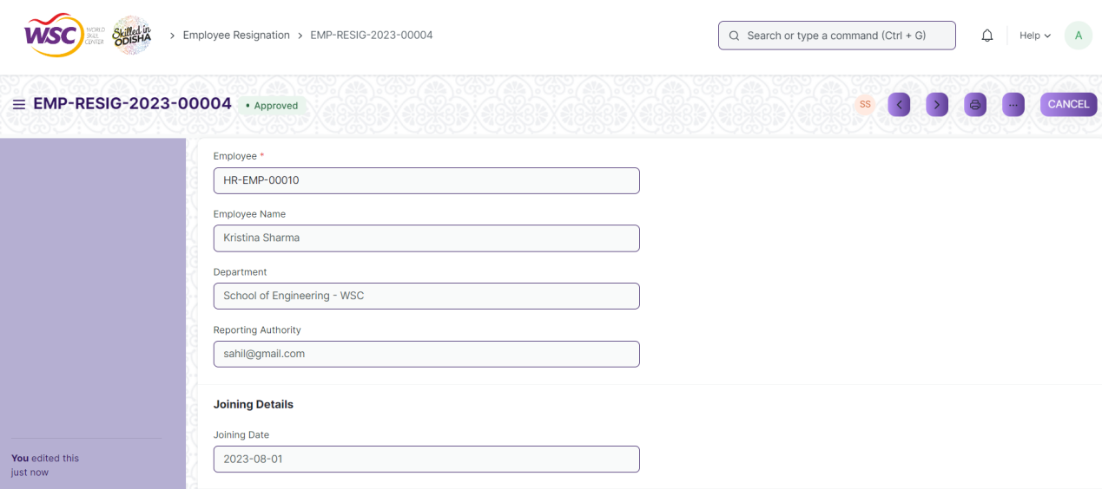

(View of a submitted Employee Resignation)

**Cancel Employee Resignation**

As it is a submittable screen, follow the general procedure to Cancel a submittable document as mentioned above.

**Delete Resignation**

If the document is not submitted , it is in draft state , you can delete the document by following the procedure to delete a save document.

If the document is submitted, follow the procedure to delete the submittable document.

**Amend Employee Resignation**

As it is a submittable screen , follow the general procedure to Amend the document.

**Edit Employee Resignation**

If the document is in draft state , the document can be editable.

Once the document is submitted , it cannot be edited.

**Print Employee Resignation**

Follow the general procedure to print a saved document.

**View Employee Resignation in different format**

follow the general procedure to view a saved document in different format.

## Employee Separation Template

The Employee Separation Template is a blueprint which contains a predefined list of Activities for Employee Separation. An Employee Separation Template can be created for a particular Department, Designation and Employee Grade.

The screen is accessible to employees , HR Admin,HR Manager /Cs officer ,Director,HR Assistant.

To access the Employee Separation Template Master screen ,go to :

***Home>HRMS(Base)>Masters>Employee Separation Template***

Screen Type : Save

**Adding a new Employee Separation Template**

As it is a save screen, follow the general procedure to create a save document as mentioned above .

* Go to Employee Separation Template, click on Add New.
* Enter the Department, Designation and Employee Grade (optional).
* Mention the Activities for separation. For each Activity, you can also mention the User or Role, or one of it, to whom this Activity will be assigned.
* You can also schedule the Separation Activities by specifying the Begin On (Days) i.e. when the activity has to start and the Duration (Days) for the same.
* You can set the task order , and dependent tasks in the template.
* Click on save .



(Activity table in Employee Separation Template)

After creating an Employee separation template , the record will be visible in the List view of the screen.

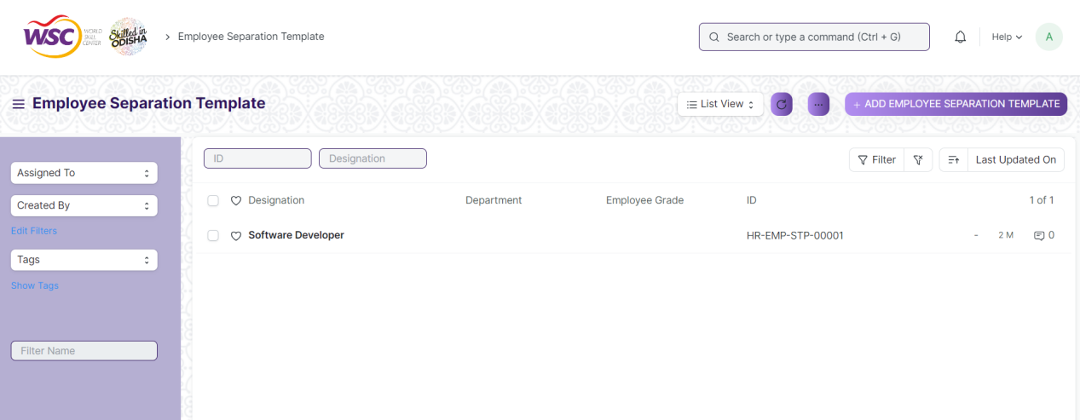

(List View of Employee Separation Template)

**Note :** Employee Separation Template can be linked with Employee Separation

**View Employee Separation Template**

As it is a save screen, follow the general procedure to view a save document as mentioned above .

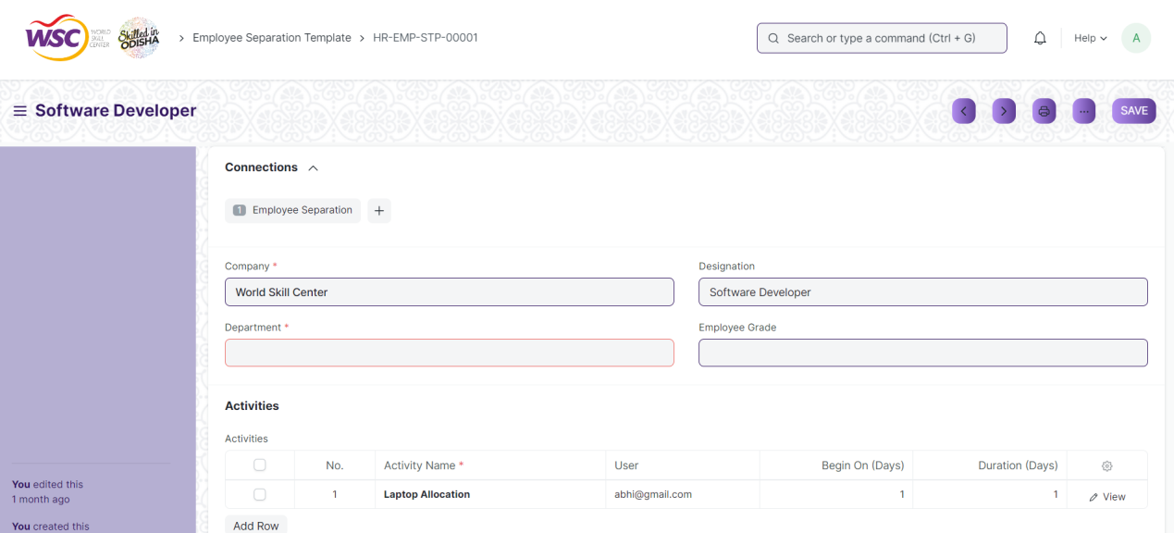

(View of a saved Employee Separation Template.)

**Delete Employee Separation Template**

As it a Save screen , follow the general procedure to delete a save document .

If an Employee Separation template is linked with Employee Separation, you cannot delete directly that template. You have to unlink the Separation template first , then you can delete it.

**Edit Employee Separation Template**

Follow the steps to view a saved employee separation template.

Edit the field that you want to change.

Click on Save.

**Print Employee Separation Template**

As it is a Save screen , follow the general procedure to print a saved document.

**View Employee Separation Template in different format**

As it is a Save screen , follow the general procedure to view a saved document in different format.

## Employee Separation

Employee Separation is a situation when the service agreement of an Employee with his/her organization comes to an end and the Employee leaves the organization.

Employee Separation is created for an Employee who has resigned or terminated from the organization.

The screen is accessible to Employee , HR Admin,HR Manager /Cs officer ,Director,HR Assistant.

To access the Employee Separation screen ,go to :

***Home>HRMS(Base)>Employee Lifecycle>Employee Separation***

Screen Type : Submit

**Prerequisites**

Before creating an Employee separation , it is advisable you create the following documents:

* Employee
* Department
* Designation
* Employee Grade

**Adding a new Employee Separation**

As it is a submittable screen follow the general procedure to create a submittable document.

* Go to: Employee Separation ,click on Add New.
* Select the Employee. Once the Employee is selected, the corresponding Employee information such as Department, Designation and Employee Grade will automatically get fetched.
* Select the Employee Separation Template. Based on the template selected, information such as Department, Designation and Employee grade will be automatically fetched (if already mentioned in the Separation Template).
* Enter the Resignation Letter Date.
* Additionally, you can also enter the Exit Interview Summary.
* Save and Submit.



(List View of Employee Separation)

**Note :** After submitting the document , a workflow begins. First it will be forwarded to the Reporting authority of the person , if reporting authority approves , it will be forwarded to the Department Head of the employee. Finally after the approval of the department head, it will be forwarded to the Director Admin for final Approval.

Email will be sent to the respective authority in each workflow state.

**Process After Submission**

**Action of Reporting Authority**

If logged in user is the reporting authority of the employee and the document state is Pending Approval from Reporting Authority, then an action button will be visible in the right corner of the document. Click on Action button , select Approve forward the document to the department head.

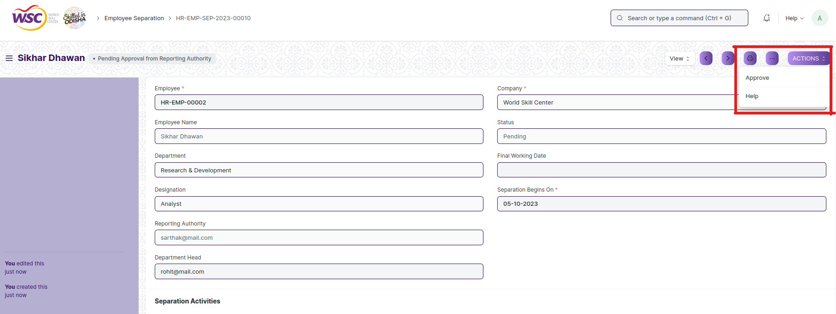

(Action button for Reporting Authority)

**Action of Department Head**

If logged in user is the Department head of the employee and the document state is Pending Approval from Department Head, then an action button will be visible in the right corner of the document. Click on Action button , select Approve to forward the document to the Director Admin or Reject the document.

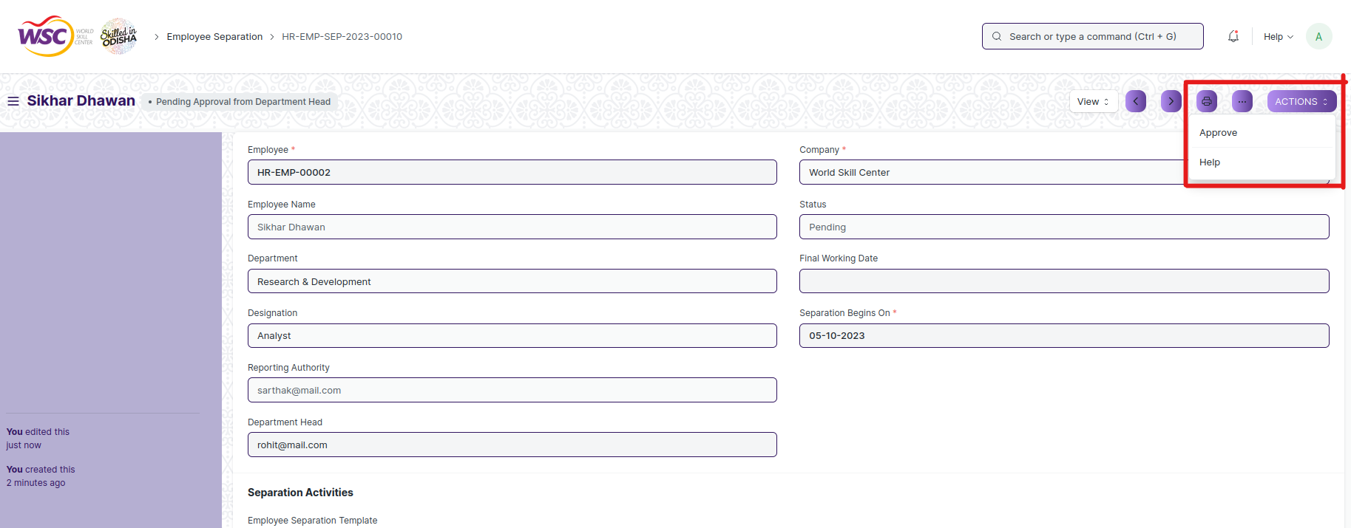

(Action button for Department Head)

**Action of Director Admin**

If logged in user is the Director Admin and the document state is Pending Approval from Director Admin , then an action button will be visible in the right corner of the document. Click on Action button , select Approve or Reject to end the process .

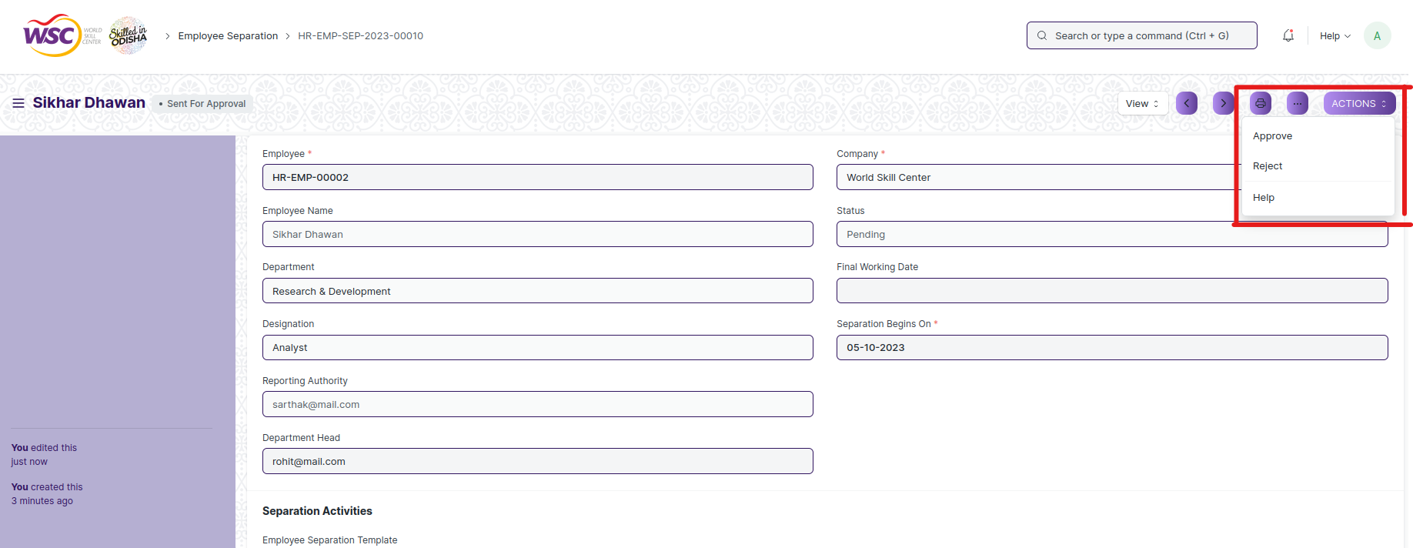

(Action button for Director Admin)

**Note :** Once the document is finally get approved by Director Admin , the final email will be sent to the HR Admin.

On submission of the Employee Separation, a Project will be created. Within the Project, Tasks will also be created for each Activity. If you have set the date and duration against activities, tasks will be created with appropriate Start and End Date excluding holidays.

You can view the created Projects and Tasks through View > Project/ Tasks.

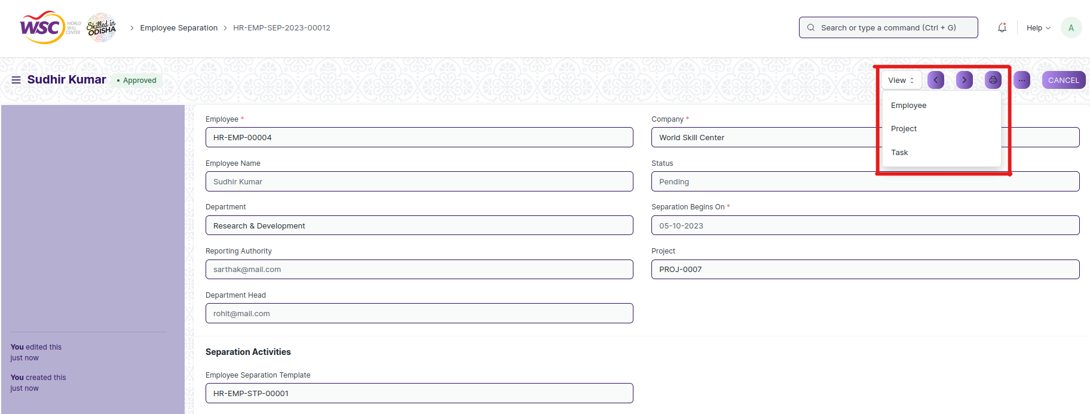

(Options in the view button after approval)

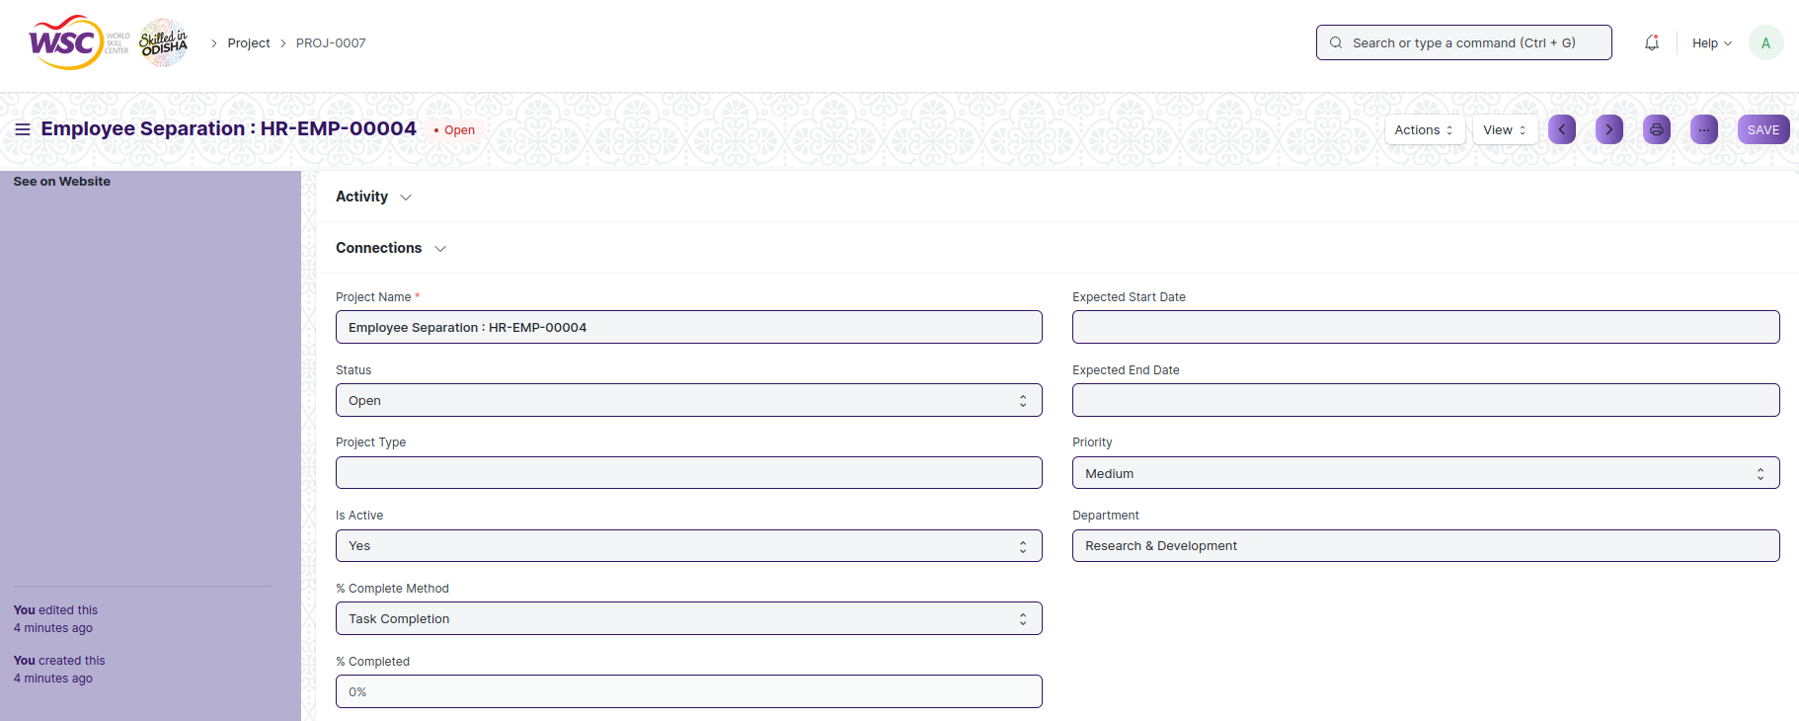

(View of Project )

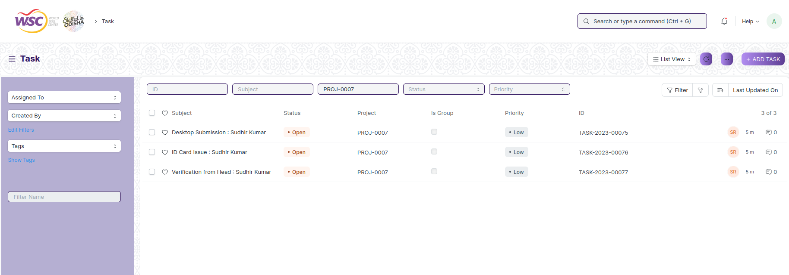

(List view of tasks that comes under the project)

**Note :** You can set the Task order and Task Dependency in the Employee Separation Template. Once the previous dependent task is not completed , the the user will not be able to complete the next task.

**View Separation**

As it is an submittable screen, follow the procedure to view a submittable document as mentioned above.

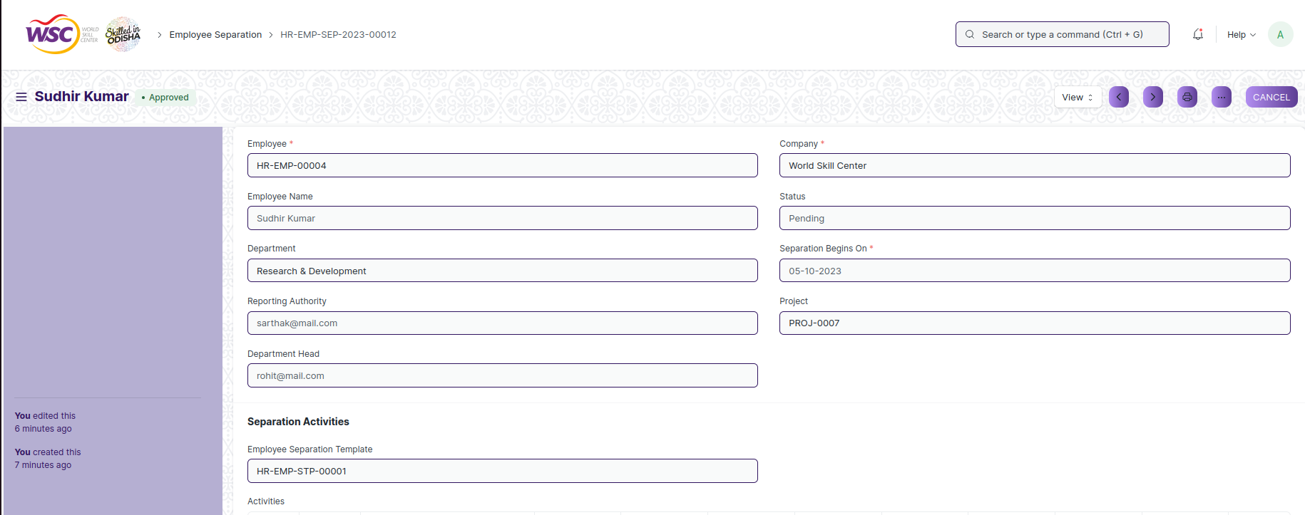

(View of a submitted Employee Separation )

**Cancel Employee Separation**

As it is a submittable screen, follow the general procedure to Cancel a submittable document as mentioned above.

On cancellation of the document , the document status will be updated to Pending .

All the tasks that has created for the Employee separation will be deleted.

**Delete Separation**

If the document is not submitted , it is in draft state , you can delete the document by following the procedure to delete a save document.

If the document is submitted, follow the procedure to delete the submittable document.

**Amend Employee Separation**

As it is a submittable screen , follow the general procedure to Amend the document.

**Edit Employee Separation**

If the document is in draft state , the document can be editable.

Once the document is submitted , it cannot be edited.

**Print Employee Separation**

Follow the general procedure to print a saved document.

**View Employee Separation in different format**

follow the general procedure to view a saved document in different format.

## Employee Suggestion

An employee suggestion screen is a form that allows employees to submit their ideas or suggestions for improving policies, processes, or any other aspect of the organization. The purpose of the form is to provide a structured and organized way for employees to contribute their suggestions and for the organization to review, evaluate, and potentially implement those suggestions.

The screen is accessible to Employee , HR Admin,HR Manager /Cs officer ,Director,HR Assistant,Suggestion Committee member.

To access the Employee Suggestion screen ,go to :

***Home>HRMS(Base)>Employee Lifecycle>Employee Suggestion***

Screen Type : Submit

**Prerequisites**

Before creating an Employee suggestion , it is advisable you create the following documents:

* Employee
* Department

**Adding a new Employee Suggestion**

As it is a submittable screen follow the general procedure to create a submittable document.

* Go to: Employee Resignation ,click on Add New.
* Enter the details in the form.
* Save and Submit.

After submit , the record will be visible in the list view of the screen.

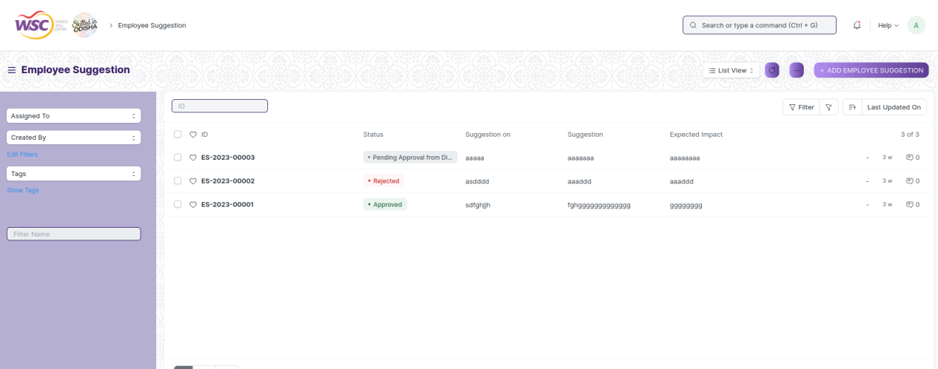

(List view of Employee Suggestion)

**Note :** After submitting the document , a workflow begins. First it will be forwarded to the HR Admin if HR Admin approves , it will be forwarded to the Suggestion Committee . Finally after the approval of the Suggestion Committee, it will be forwarded to the Director Admin for final Approval.

Email will be sent to the respective authority in each workflow state.

**Process After Submission**

**Action of HR Admin**

If logged in user is the HR Admin and the document state is Pending Approval from HR , then an action button will be visible in the right corner of the document. Click on Action button , select Approve to forward the document to the Suggestion Committee and Reject to reject the document.

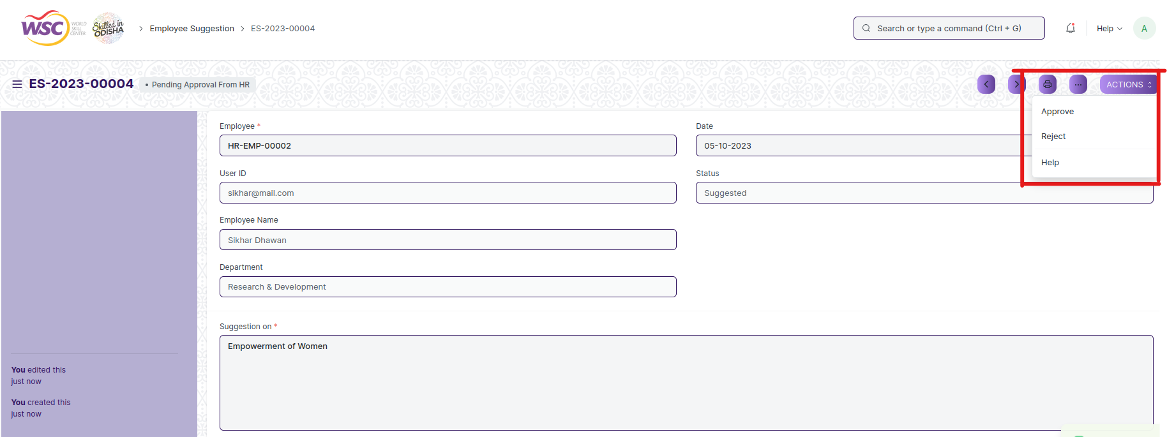

(Action button for HR Admin)

**Action of Suggestion Committee**

If logged in user is the Suggestion Committee Member and the document state is Pending Approval from Committee, then an action button will be visible in the right corner of the document. Click on Action button , select Approve to forward the document to the Director Admin or Reject the document.

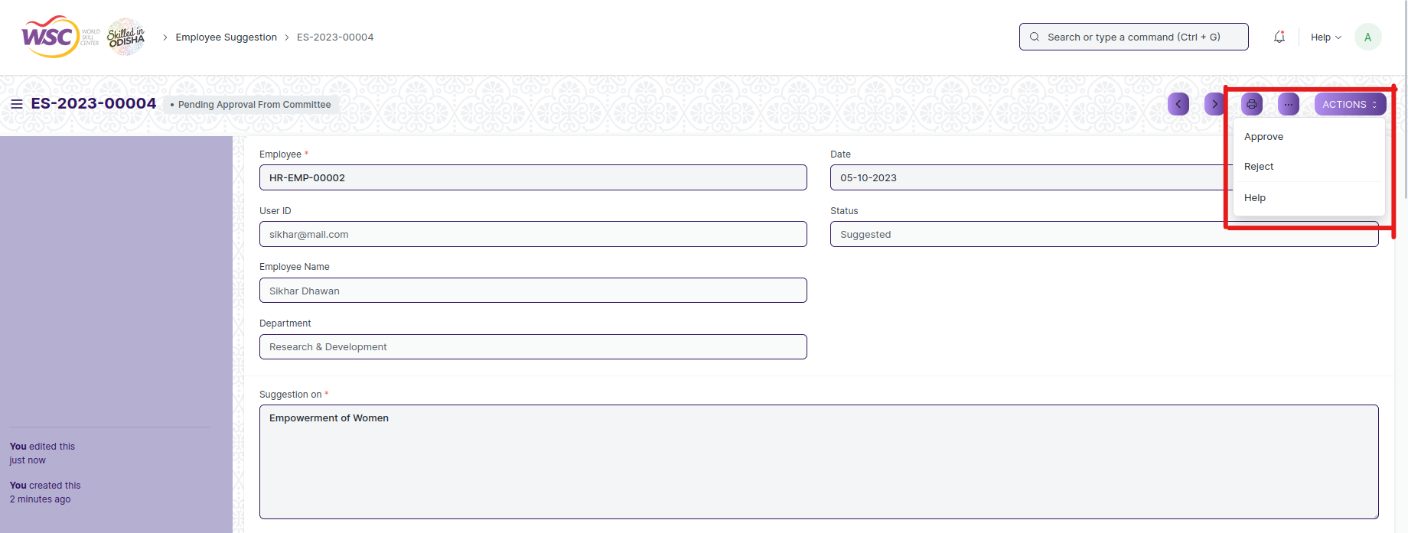

(Action button for Suggestion Committee)

**Note :** Suggestion committee can be able to comment on the suggestion in the comment section.

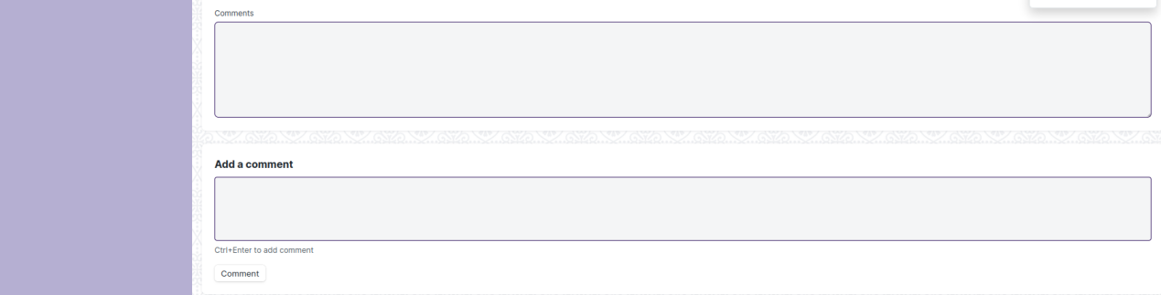

(Comment Section in the Employee Suggestion Screen)

**Action of Director Admin**

If logged in user is the Director Admin and the document state is Pending Approval from Director Admin , then an action button will be visible in the right corner of the document. Click on Action button , select Approve or Reject to end the process .

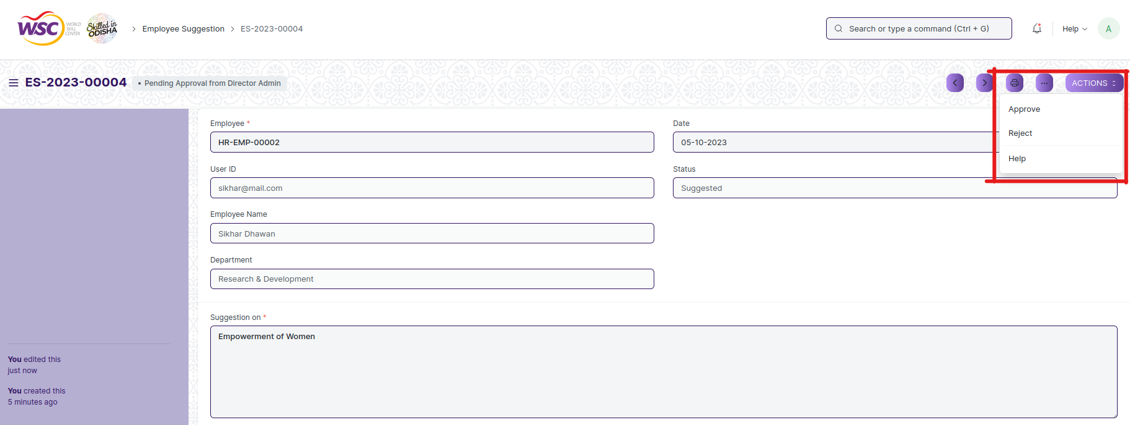

(Action button for Director Admin)

**Note :** Once the document is finally get approved by Director Admin , the final email will be sent to the HR Admin and the Employee.

**View Separation**

As it is an submittable screen, follow the procedure to view a submittable document as mentioned above.

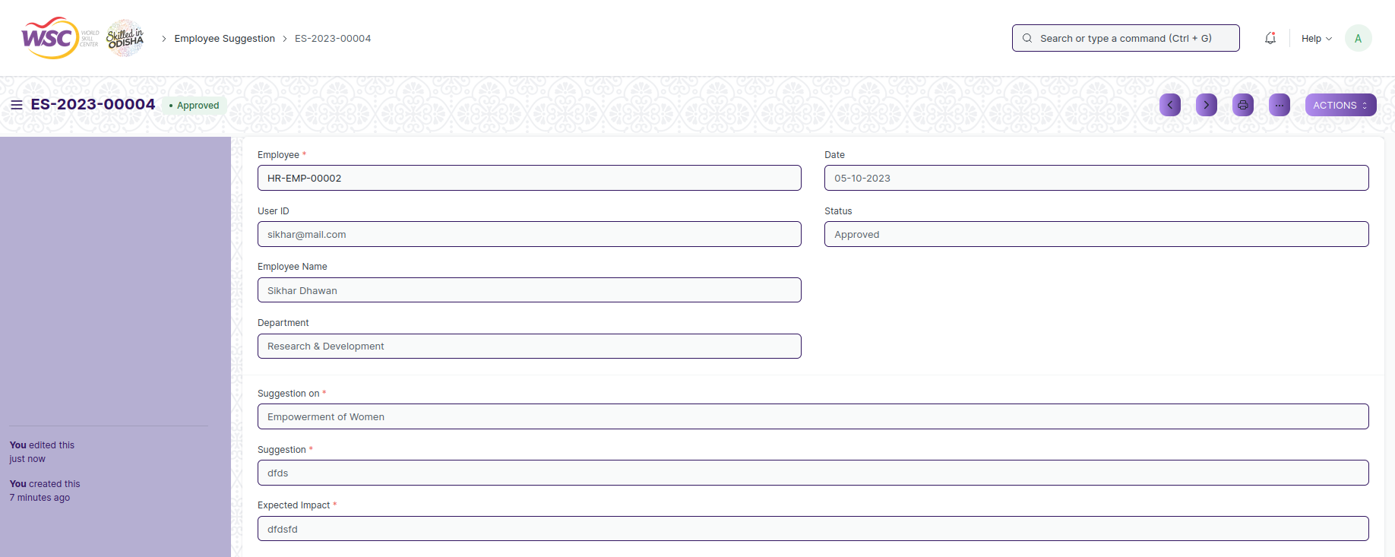

(View of a submitted Employee Suggestion.)

**Cancel Employee Suggestion**

As it is a submittable screen, follow the general procedure to Cancel a submittable document as mentioned above.

**Delete Employee Suggestion**

If the document is not submitted , it is in draft state , you can delete the document by following the procedure to delete a save document.

If the document is submitted, follow the procedure to delete the submittable document.

**Amend Employee Suggestion**

As it is a submittable screen , follow the general procedure to Amend the document.

**Edit Employee Suggestion**

If the document is in draft state , the document can be editable.

Once the document is submitted , it cannot be edited.

**Print Employee Suggestion**

Follow the general procedure to print a saved document.

**View Employee Suggestion in different format**

follow the general procedure to view a saved document in different format.

## Employee Re-engagement

The employee re-engagement screen is a form that an employee uses to request the renewal of their employment contract with the organization. This form is typically submitted to the HR department or relevant authority within the organization responsible for contract management.

The screen is accessible to Employee , HR Admin,HR Manager /Cs officer ,Director,HR Assistant.

To access the Employee Re-engagement screen ,go to :

***Home>HRMS(Base)>Employee Lifecycle>Employee Re-engagement***

Screen Type : Submit

**Prerequisites**

Before creating an Employee suggestion , it is advisable you create the following documents:

* Employee
* Department

**Adding a new Employee Re-engagement**

As it is a submittable screen follow the general procedure to create a submittable document.

* Go to: Employee Re-engagement ,click on Add New.
* Enter the details.
* Save and Submit.

After creation of document it will show in the list view of the screen.

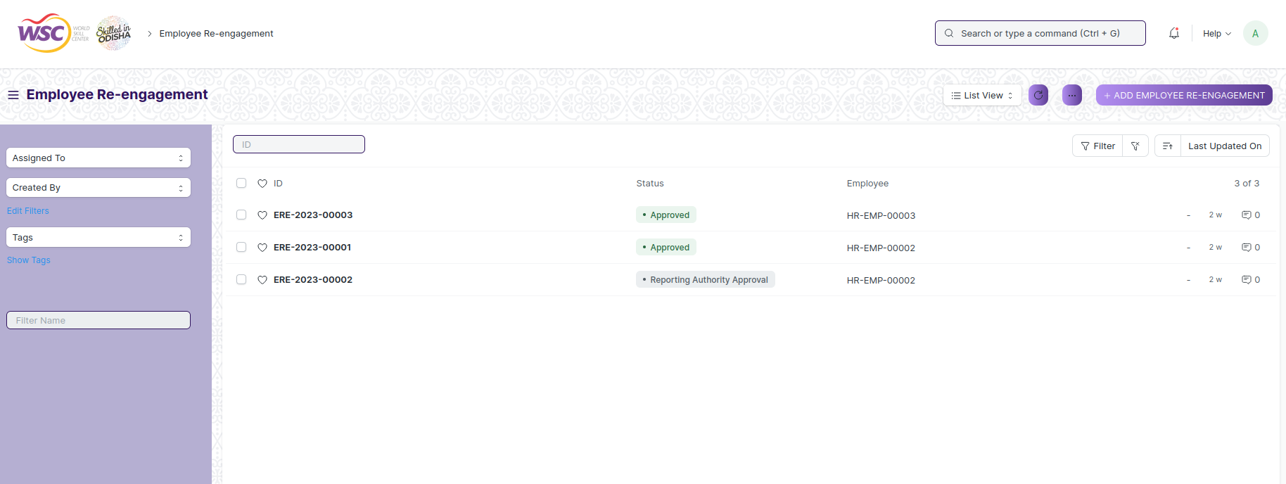

(List view of Employee Re-engagement)

**Note :** After submitting the document , a workflow begins. First it will be forwarded to the HR Admin if HR Admin approves , it will be forwarded to the Reporting Authority of the employee .After approval from the reporting authority it will be forwarded to the Department Head. Finally after the approval of the Department Head, it will be forwarded to the Director Admin for final Approval.

Email will be sent to the respective authority in each workflow state.

**Process After Submission**

**Action of HR Admin**

If logged in user is the HR Admin and the document state is Submit , then an action button will be visible in the right corner of the document. Click on Action button , select Approve to forward the document to the reporting authority of the employee and Reject to reject the document.

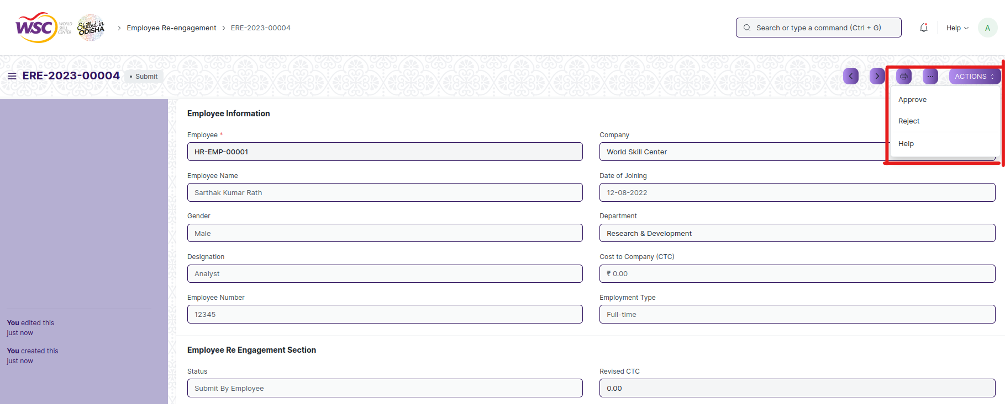

(Action button for HR Admin)

**Action of Reporting Authority**

If logged in user is the reporting authority of the employee and the document state is Reporting Authority Approval, then an action button will be visible in the right corner of the document. Click on Action button , select Approve forward the document to the department head and Reject to reject the document.

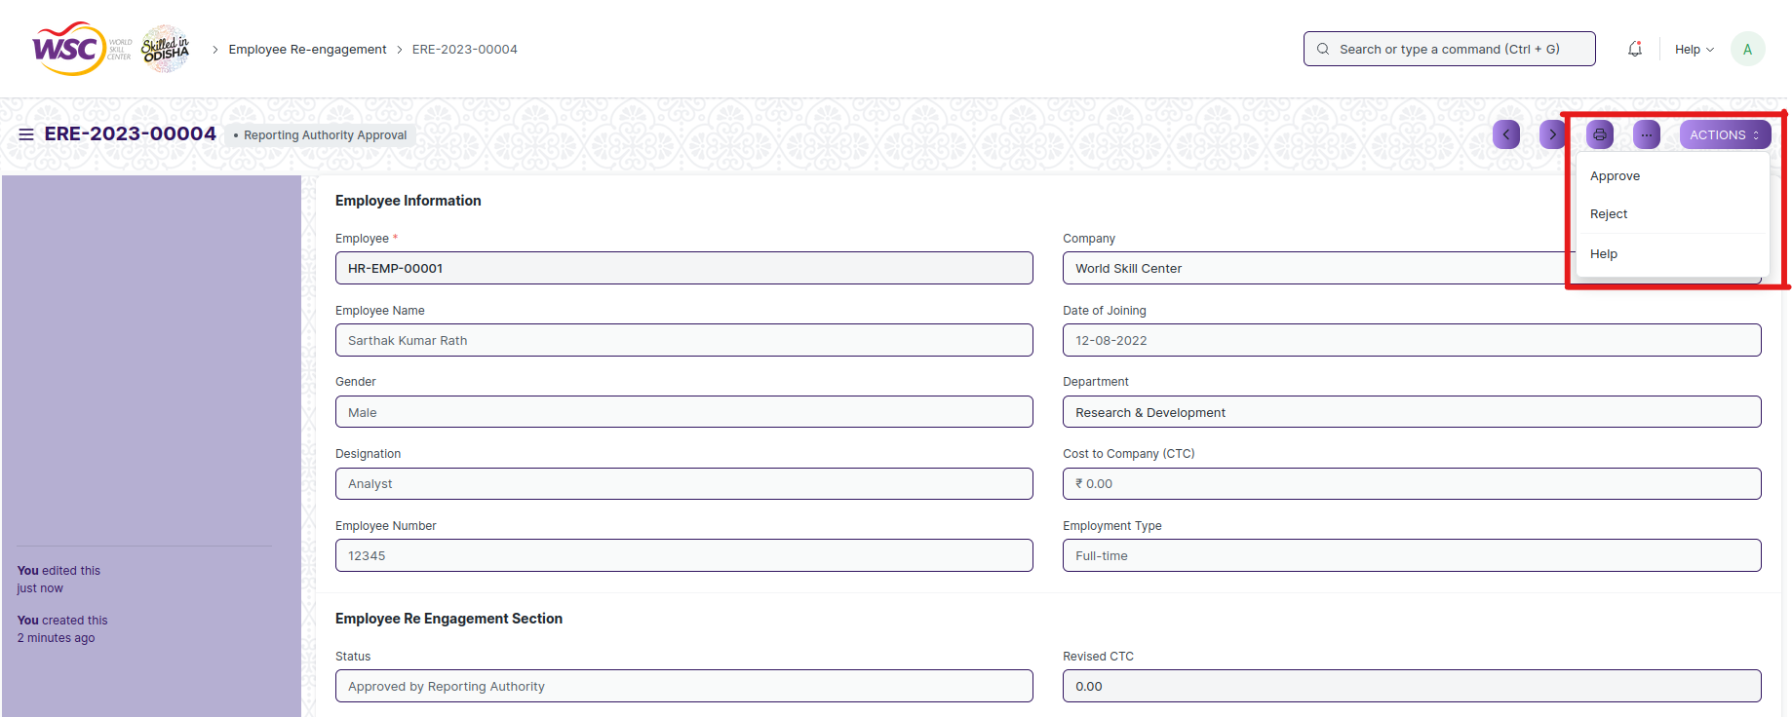

(Action button for Reporting Authority)

**Note :** Reporting authority can be able to add the the revised ctc , New Contract Start Date and New Contract End Date.

**Action of Department Head**

If logged in user is the Department head of the employee and the document state is Department Head Approval , then an action button will be visible in the right corner of the document. Click on Action button , select Approve to forward the document to the Director Admin or Reject the document.

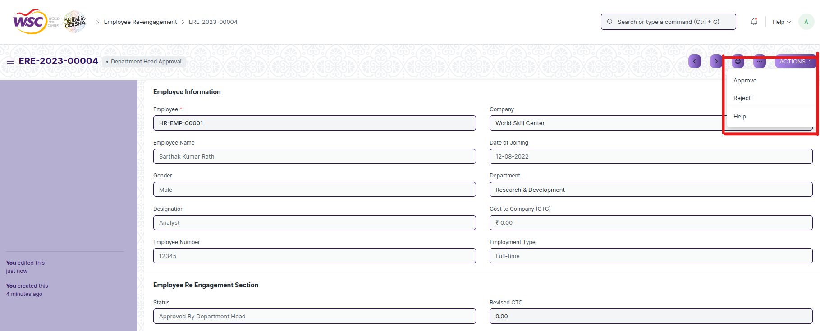

(Action button for Department Head)

**Action of Director Admin**

If logged in user is the Director Admin and the document state is Director Admin Approval , then an action button will be visible in the right corner of the document. Click on Action button , select Approve or Reject to end the process .

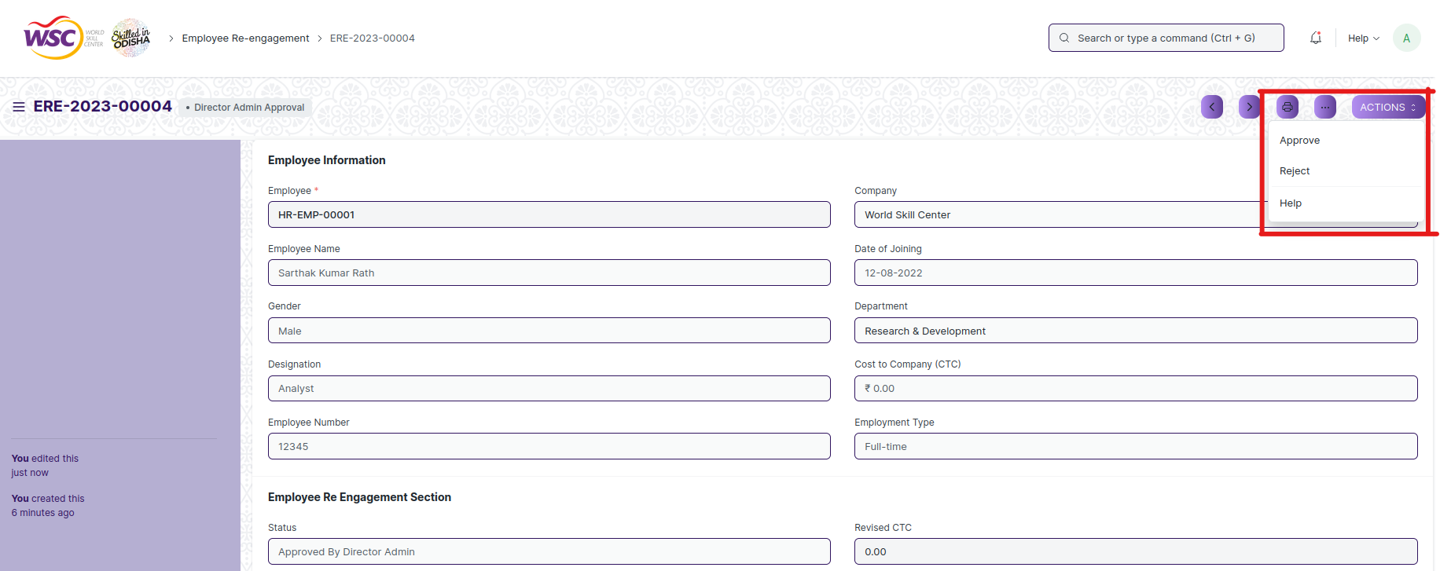

(Action button for Director Admin)

**Note :** Director Admin also can be able to add the the revised ctc , New Contract Start Date and New Contract End Date.

**Note :** Once the document is finally get approved by Director Admin , the final email will be sent to the HR Admin.

**View Employee Re-engagement**

As it is an submittable screen, follow the procedure to view a submitable document as mentioned above.

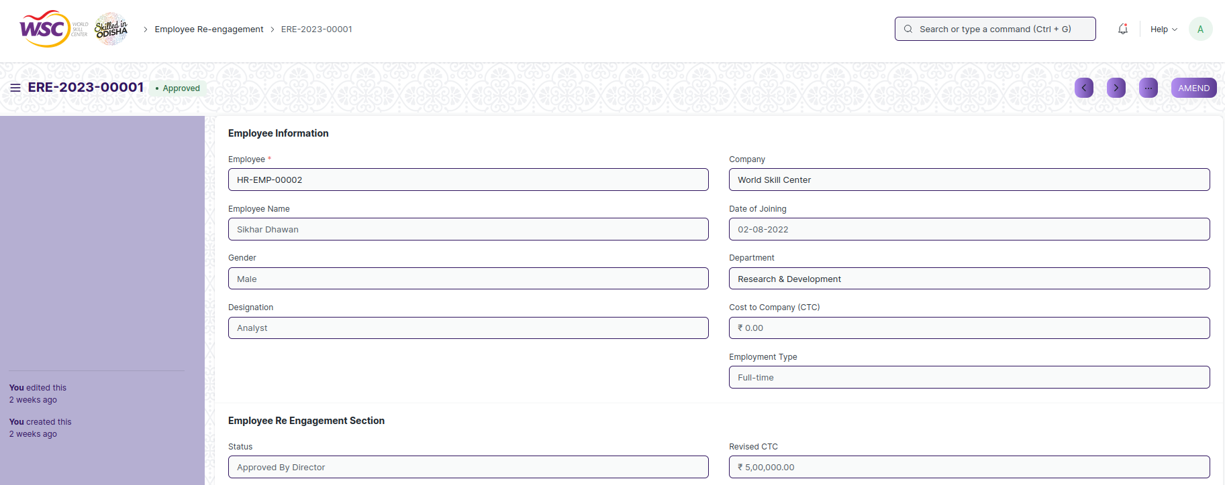

(View of a submitted Employee Re-engagement.)

**Cancel Employee Re-engagement**

As it is a submittable screen, follow the general procedure to Cancel a submittable document as mentioned above.

**Delete Employee Re-engagement**

If the document is not submitted , it is in draft state , you can delete the document by following the procedure to delete a save document.

If the document is submitted, follow the procedure to delete the submittable document.

**Amend Employee Re-engagement**

As it is a submittable screen , follow the general procedure to Amend the document.

**Edit Employee Re-engagement**

If the document is in draft state , the document can be editable.

Once the document is submitted , it cannot be edited.

**Print Employee Re-engagement**

Follow the general procedure to print a saved document.

**View Employee Re-engagement in different format**

follow the general procedure to view a saved document in different format.

## Employee Grievance Cell

The employee grievance cell it the screen , where you can manage the Members of Grievance Cell.

The screen is accessible to Employee , HR Admin,HR Manager /Cs officer ,Director,HR Assistant,Grievance Cell Members.

To access the Employee Grievance Cell screen ,go to :

***Home>HRMS(Base)>Employee Lifecycle>Employee Grievance Cell***

Screen Type : Save

**Prerequisites**

Before creating an Employee suggestion , it is advisable you create the following documents:

* Employee

**Adding a new Employee Grievance Cell**

As it is a save screen type follow the general procedure to create a save document.

* Go to: Employee Grievance Cell ,click on add New.
* Add the Grievance cell members in the table.
* Save .

**Note :** The users present in the grievance cell member should have role Grievance Cell Member .

After creation of document it will show in the list view of the screen.

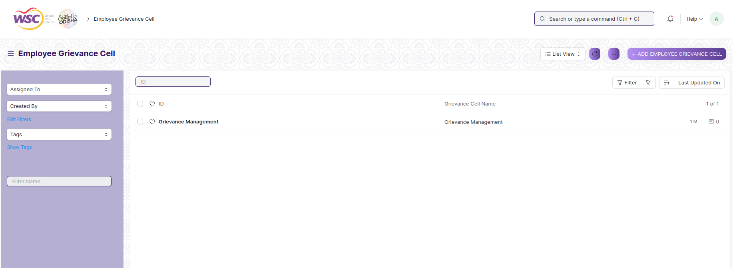

(List view of Employee grievance cell)

**View Employee Grievance Cell**

As it is an save screen, follow the procedure to view a save document as mentioned above.

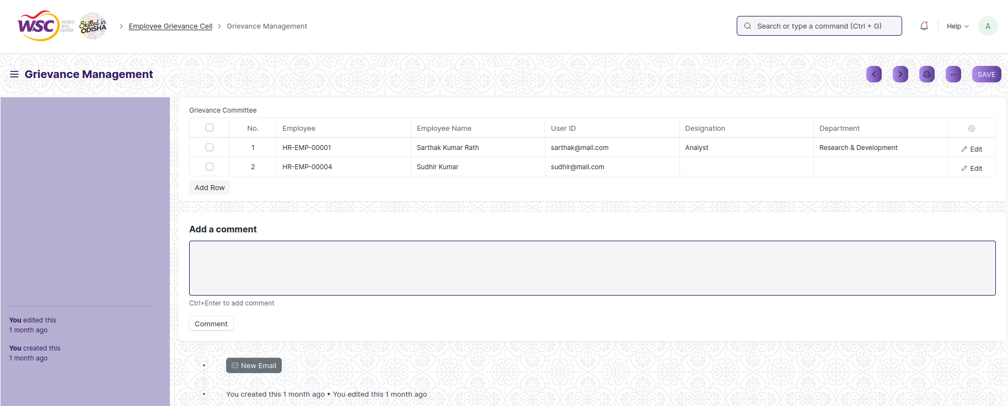

(View of a saved Employee Grievance Cell.)

**Edit Employee Grievance Cell**

As it is a save screen type, follow the general procedure to edit a save document.

**Print Employee Grievance Cell**

Follow the general procedure to print a saved document.

**View Employee Grievance Cell in different format**

follow the general procedure to view a saved document in different format.

## Employee Grievance

The employee grievance screen is used to manage and address employee grievances within an organization. It serves as a platform for employees to raise their concerns, complaints, or issues they may have regarding their work environment, colleagues, supervisors, policies, or any other relevant matter.

The screen is accessible to Employee , HR Admin,HR Manager /Cs officer ,Director,HR Assistant,Grievance Cell Member.

To access the Employee Grievance screen ,go to :

***Home>HRMS(Base)>Employee Lifecycle>Employee Grievance***

Screen Type : Submit

**Prerequisites**

Before creating an Employee suggestion , it is advisable you create the following documents:

* Employee
* Employee Grievance Cell
* Grievance Type

**Adding a new Employee Grievance**

As it is a submittable screen follow the general procedure to create a submittable document.

* Go to: Employee Grievance , click on Add New.
* Enter the Grievance Details.
* Select the Grievance Type.
* Select the Grievance Against .
* Based on the Grievance Against, Grievance Against party will be fetched.
* Select the Grievance cell.
* Save and Submit.

After creation of document it will show in the list view of the screen.



(List view of Employee Grievance)

**Note :** After submitting the document , a workflow begins. First it will be forwarded to the HR Admin if HR Admin approves , it will be forwarded to the Grievance Committee .The final approval will be done by the grievance committee.

Email will be sent to the respective authority in each workflow state.

**Process After Submission**

**Action of HR Admin**

If logged in user is the HR Admin and the document state is Forwarded to HR , then an action button will be visible in the right corner of the document. Click on Action button , select Forward to Grievance Cell to forward the document to the Grievance Committee and Reject to reject the document.

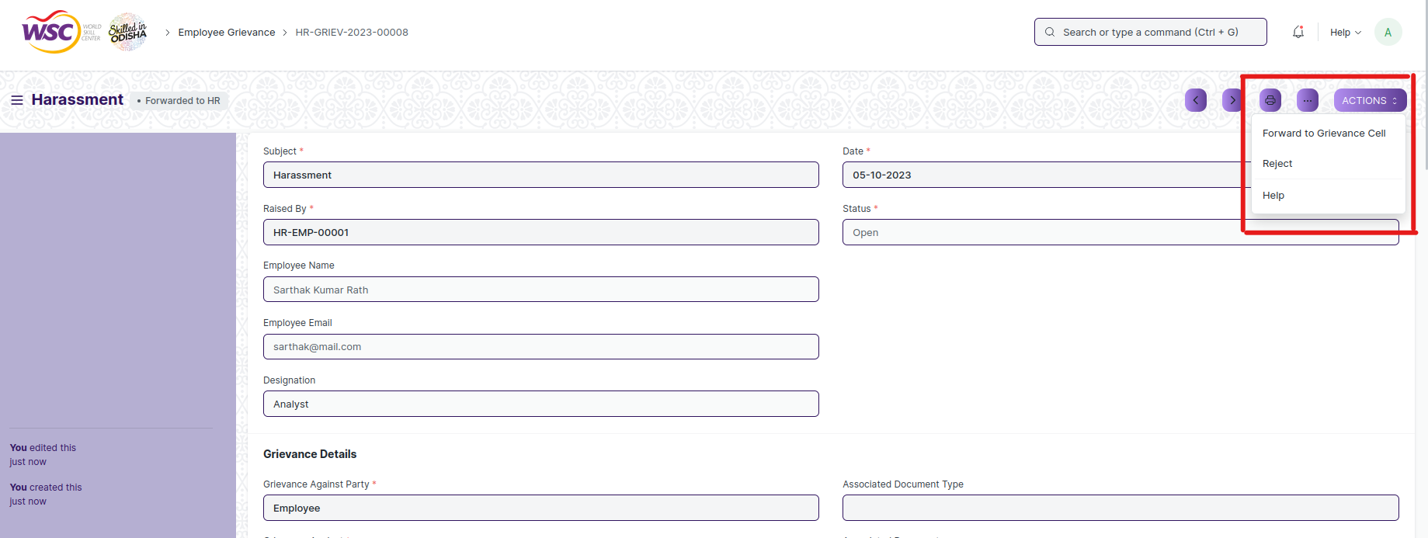

(Action button for HR Admin)

**Action of Grievance Committee**

If logged in user is the Grievance Cell Member of the employee and the document state is Forwarded to Grievance Cell , then an action button will be visible in the right corner of the document. Click on Action button , select Resolve or Reject End the process.

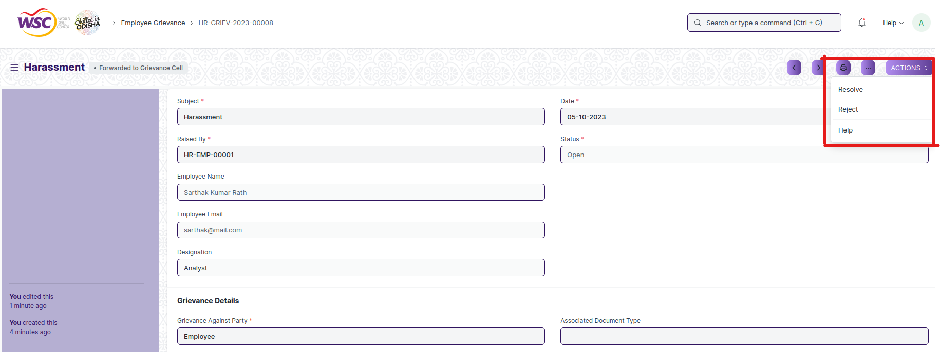

(Action button for Grievance Committee Members)

**Note :** The Grievance Cell Member can be able to add the resolution details in the form.

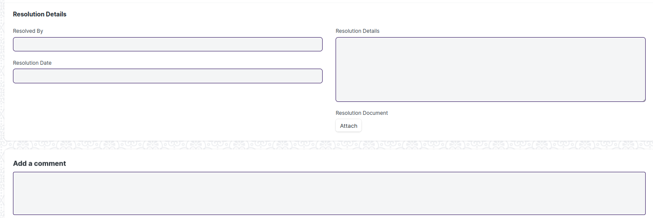

(Resolution Details section in the screen)

**View Employee Grievance**

As it is an submittable screen, follow the procedure to view a submittable document as mentioned above.

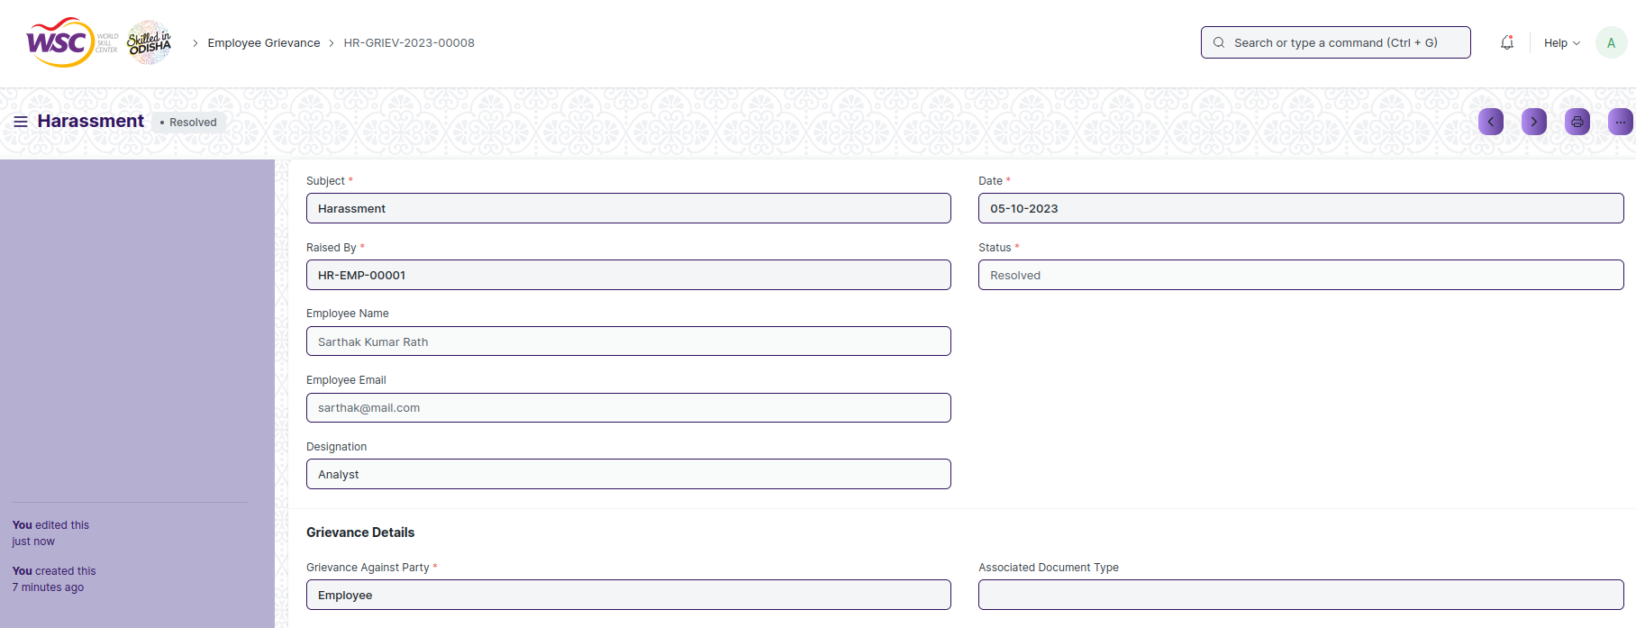

(View of a submitted Employee Grievance.)

**Cancel Employee Grievance**

As it is a submittable screen, follow the general procedure to Cancel a submittable document as mentioned above.

**Delete Employee Grievance**

If the document is not submitted , it is in draft state , you can delete the document by following the procedure to delete a save document.

If the document is submitted, follow the procedure to delete the submittable document.

**Amend Employee Grievance**

As it is a submittable screen , follow the general procedure to Amend the document.

**Edit Employee Grievance**

If the document is in draft state , the document can be editable.

Once the document is submitted , it cannot be edited.

**Print Employee Grievance**

Follow the general procedure to print a saved document.

**View Employee Grievance in different format**

follow the general procedure to view a saved document in different format.

## Employee Transfer

Employee Transfer is a form of internal mobility, in which the Employee is shifted from one job to another usually at a different location, department, or unit.

The screen is accessible to Employee , HR Admin,HR Manager /Cs officer ,Director,HR Assistant.

To access the Employee Grievance screen ,go to :

***Home>HRMS(Base)>Employee Lifecycle>Employee Transfer***

Screen Type : Submit

**Prerequisites**

Before creating an Employee Transfer , it is advisable you create the following documents:

* Employee
* Department

**Adding a new Employee Transfer**

As it is a save screen type follow the general procedure to create a save document.

* Go to Employee Transfer , click on Add New.
* Select the Employee.
* Select the Transfer Date.
* Select the New Company in case the Employee is transferred to a different company (optional).
* In the Employee Transfer Details table, select the Property and set the Current and New value.
* Additionally, 'Create New Employee' checkbox can be checked to create a new Employee ID for the transferred Employee.

After creation of document it will show in the list view of the screen.

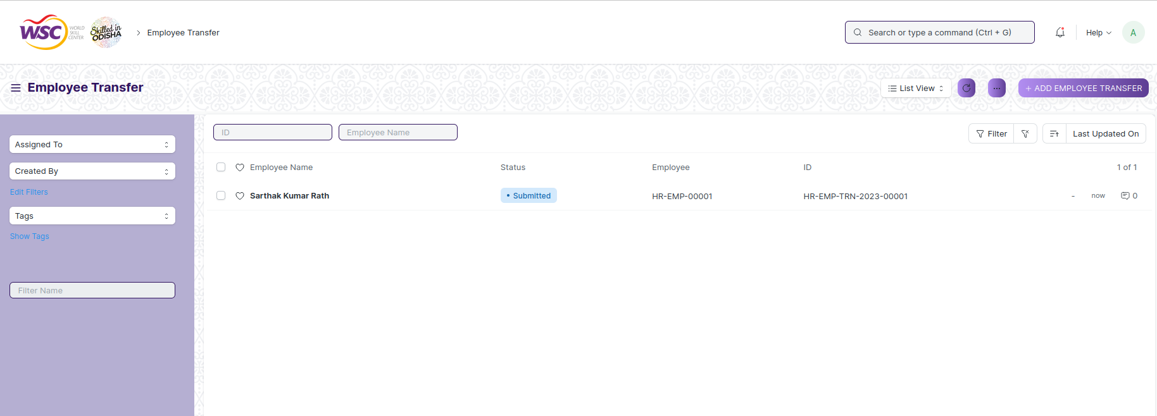

(List view of Employee transfer)

**Note:** If Create New Employee ID is checked, a new Employee will be created with property changes in Transfer Details table and old Employee will be marked as relieved. Leave allocations for the new Employee has to be manually created from Leave Period.

**Note:** Transfer document can be submitted on or after Transfer Date. Once submitted all the changes added to Transfer Details table will applied to Employee.

**View Employee Transfer**

As it is an submittable screen, follow the procedure to view a submittable document as mentioned above.

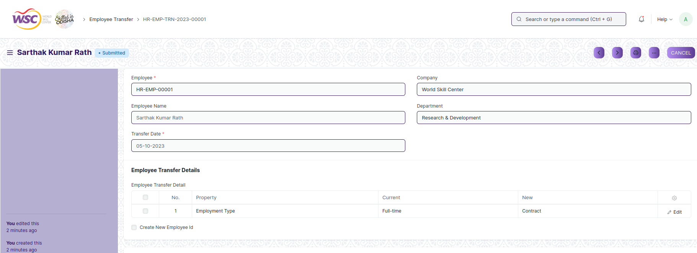

(View of a submitted Employee Transfer.)

**Cancel Employee Transfer**

As it is a submittable screen, follow the general procedure to Cancel a submittable document as mentioned above.

**Delete Employee Transfer**

If the document is not submitted , it is in draft state , you can delete the document by following the procedure to delete a save document.

If the document is submitted, follow the procedure to delete the submittable document.

**Amend Employee Transfer**

As it is a submittable screen , follow the general procedure to Amend the document.

**Edit Employee Transfer**

If the document is in draft state , the document can be editable.

Once the document is submitted , it cannot be edited.

**Print Employee Transfer**

Follow the general procedure to print a saved document.

**View Employee Transfer in different format**

follow the general procedure to view a saved document in different format.

## Suggestion Committee

The Suggestion Committee screen , where you can manage the Members of Suggestion Committee.

The screen is accessible to HR Admin,HR Manager /Cs officer ,Director,Suggestion Committee Members.

To access the Suggestion Committee screen ,go to :

***Home>HRMS(Base)>Employee Lifecycle>Suggestion Committee***

Screen Type : Save

**Prerequisites**

Before creating an Employee suggestion , it is advisable you create the following documents:

* Employee

**Adding a new Suggestion Committee**

As it is a save screen type follow the general procedure to create a save document.

* Go to: Suggestion Committee screen ,click on add New.
* Add the Suggestion Committee members in the table.
* Save .

**Note :** The users present in the grievance cell member should have role Suggestion Committee Member .

After creation of document it will show in the list view of the screen.

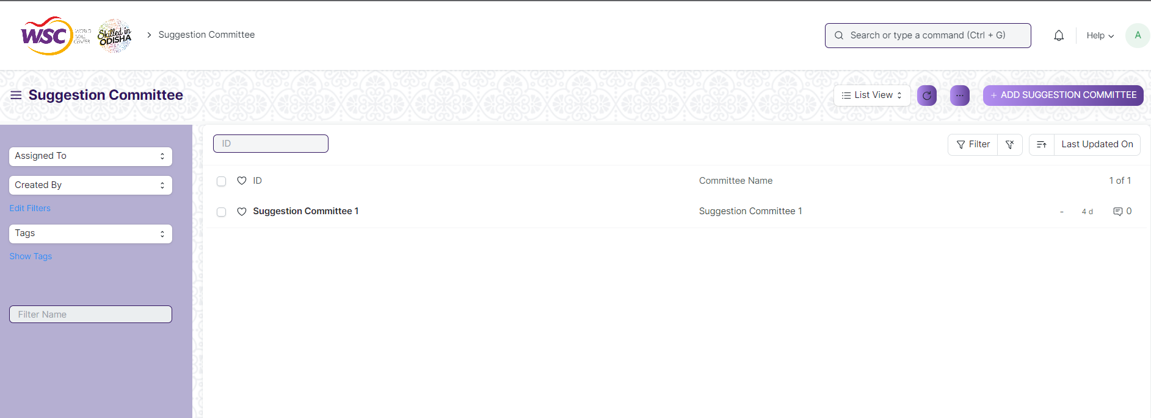

(List view of Suggestion Committee)

**View Suggestion Committee**

As it is an save screen, follow the procedure to view a save document as mentioned above.

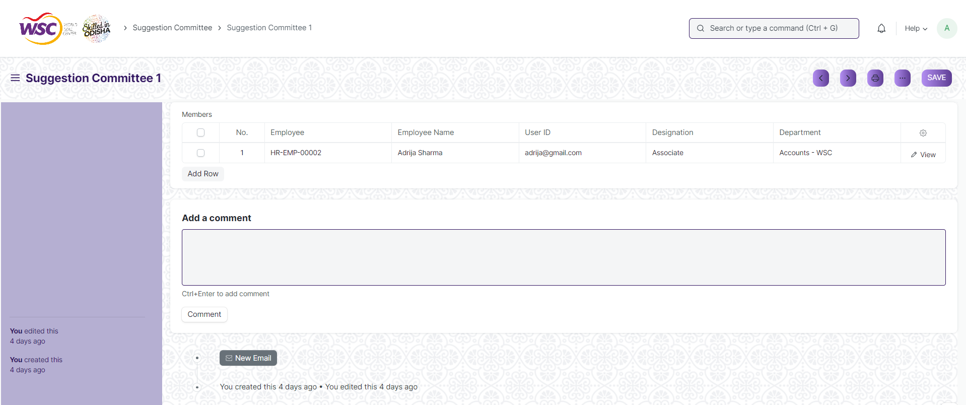

(View of a saved Suggestion Committee.)

**Edit Suggestion Committee**

As it is a save screen type, follow the general procedure to edit a save document.

**Print Suggestion Committee**

Follow the general procedure to print a saved document.

**View Suggestion Committee in different format**

follow the general procedure to view a saved document in different format.

# Leave Management

## 6.1 Leave Type

Leave Type refers to the types of leaves allocated to an Employee which they can use while making Leave Applications.

You can create any number of Leave Types based on your company’s requirements.

The screen is accessible to Employee , HR Admin,HR Manager /Cs officer ,Director,HR Assistant.

To access the Leave Type Master screen ,go to :

***Home>HRMS(Base)>Leave Management>Leave Type***

Screen Type : Save

**Prerequisites :**

Before creating an Leave Type , it is advisable you create the following documents:

* Employment Type

**Adding a new Leave Type**

As it is a save screen, follow the general procedure to create a save document as mentioned above .

* Go to Leave Type list, click on Add New.
* Enter Leave Type Name.
* Enter Max Leaves Allowed, Applicable After (Working Days), Maximum Continuous Days Applicable (optional).
* Save.

**Below is a detailed explanation of all the fields and check boxes in Leave Type.**

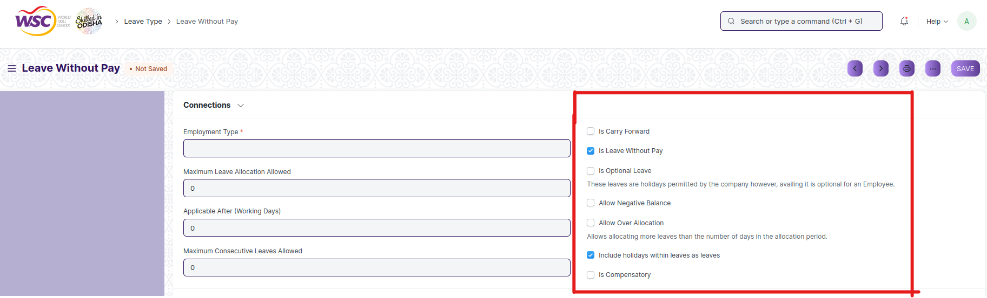

(Check boxes present in the Leave Type screen)

**Max Leaves Allowed:** This field allows you to set the maximum number of the annual allocation of this Leave Type while creating the Leave Policy.

**Applicable After (Working Days):** Enter the minimum number of working days here. Only the employees who have worked for this number of days or more will be allowed to apply for this particular leave type. Any other leaves (such as Casual Leave, Sick Leave.etc.) availed by the Employees after their joining date will also be considered while calculating working days of the Employee.

**Maximum Continuous Days Applicable:** It refers to the maximum number of days this particular Leave Type can be availed at a stretch. If an employee exceeds the maximum number of days, their extended leave will be considered as ‘Leave Without Pay'.

**Is Carry Forward:** If checked, the balance leaves of this Leave Type will be carried forward to the next allocation period.

**Is Leave Without Pay:** This ensures that the Leave Type will be treated as leaves without pay and salary will get deducted for this Leave Type.

**Is Optional:** Optional Leaves are holidays that Employees can choose to avail from a list of holidays published by the company. The Holiday List for Optional Leaves can have any number of holidays, but you can restrict the number of such leaves by setting the Max Days Leave Allowed field.

**Allow Negative Balance:** If checked, the system will always allow to apply and approve Leave Applications for the Leave Type, even if there is no leave balance.

**Allow Over Allocation:** If checked, the system will allow allocating more leaves than the number of days in the allocation period.

**Include holidays within leaves as leaves:** Check this option if you wish to count holidays within leaves as a ‘leave’. For example, if an Employee has applied for leave on Friday and Monday, and Saturday and Sunday are weekly offs, if the 'Include holidays within leaves as leaves' checkbox for the Leave Type is checked, the system will consider Saturday as Sunday as leaves too. Such holidays will be deducted from the total number of leaves.

**Is Compensatory:** Compensatory leaves are leaves granted for working overtime or on holidays, normally compensated as an encashable leave. You can check this option to mark the Leave Type as compensatory. An Employee can request for compensatory leaves using Compensatory Leave Request.

**Is Partially Paid Leaves:** This checkbox ensures that Leave Type will be treated as partially paid and some part of daily earnings will be paid through salary slip. If this checkbox is enabled then a field "Fraction of Daily Salary Per Leave" appears where you can define the fraction of daily salary paid on the partial leave day.

**Note:** The Leave Type can be either Leave Without pay or Partially Paid.

**Leave Encashment :** It is possible that Employees can receive cash from their Employer for unused leaves granted to them in a Leave Period. Not all Leave Types need to be encashable, so, you should set "Allow Encashment" for only those Leave Types which are encashable.

**Note:** Leave encashment is allowed only in the last month of the Leave Period.

**Leave Encashment and Earned Leave Section in the form :**

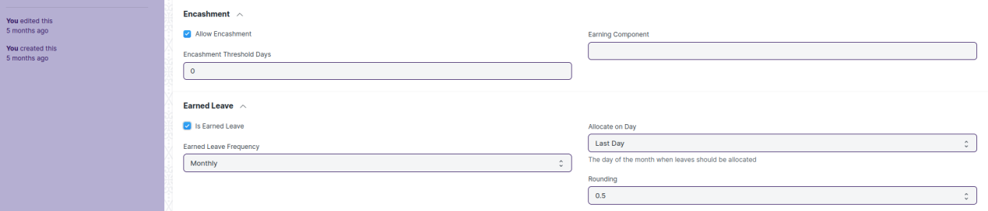

(Leave Encashment and Earned Leave section in the screen)

**Encashment Threshold Days:** This field indicates the number of leave days the Employees won't be able to encash. Above the mentioned days, the Employee is eligible to encash leaves.

For example, if there are 10 leaves of a particular Leave Type which is encashable, and the Employee has 8 leaves left. If Encashment Threshold Days = 5, the Employee is given encashment of only 8 - 5 = 3 leaves.

**Earning Component:** This field allows you to specify the Salary Component that will be encashed to Employees as a part of their Salary in the Salary Slip.

**Earned Leave :** Earned Leaves are leaves earned by an Employee after working with the company for a certain amount of time. Checking "Is Earned Leave" will allot leaves pro-rata basis by automatically updating Leave Allocation for leaves of this type at intervals set by 'Earned Leave Frequency'.

For example, an Employee is allotted 24 Privilege Leaves in a year, wherein the Privilege Leave is set as Earned Leave with Monthly allotment. In this case, the Employee will earn 2 (24 leaves/12 months) Privilege Leaves at the end of every month. The leave allotment process (background job) will only allot leaves considering the max leaves for the leave type and will round to 'Rounding' for fractions.

After creating an Leave Type , the record will be visible in the List view of the screen.

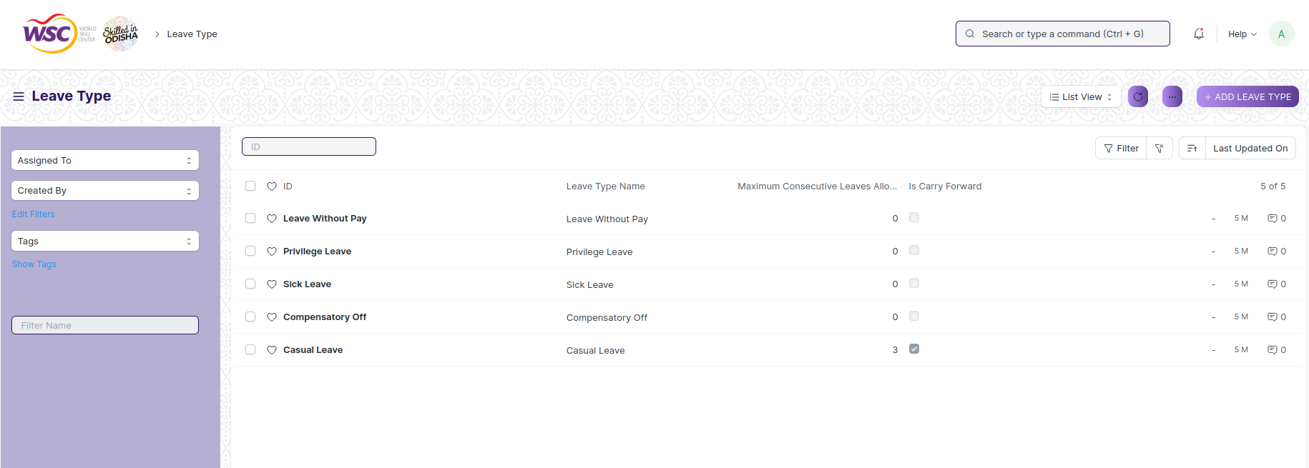

(List view of Leave Type)

**View Leave Type**

As it is a save screen, follow the general procedure to view a save document as mentioned above .

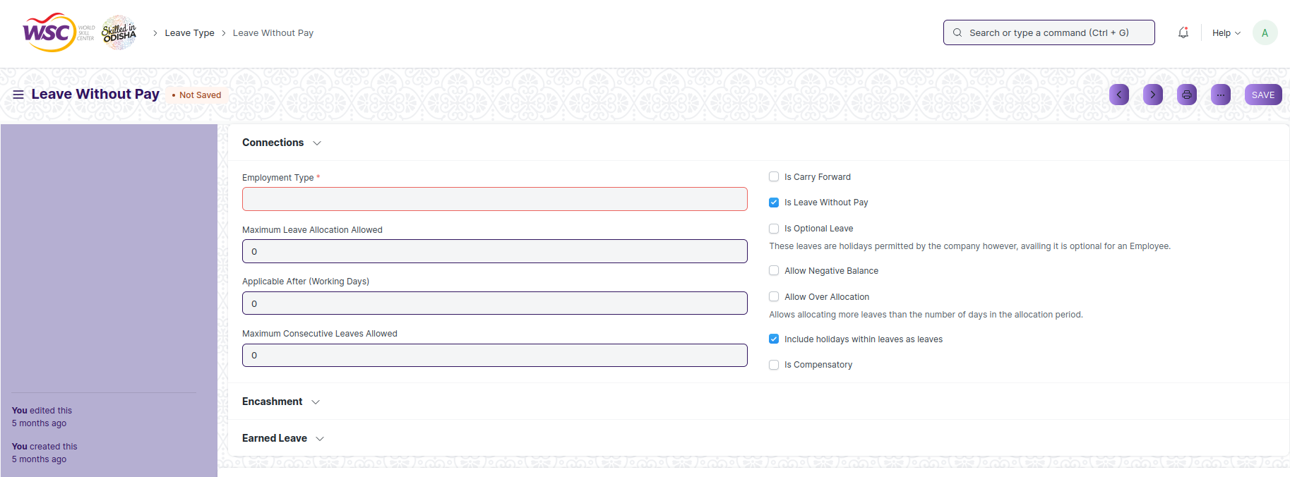

(View of a saved Leave Type)

**Delete Leave Type**

As it a Save screen , follow the general procedure to delete a save document .

**Edit Leave Type**

Follow the steps to view a saved Leave Type type.

Edit the field that you want to change.

Click on Save.

**Print Leave Type Type**

As it is a Save screen , follow the general procedure to print a saved document.

**View Leave Type in different format**

As it is a Save screen , follow the general procedure to view a saved document in different format.

## 6.2 Leave Policy

This screen allows you to create and manage multiple Leave Policies and allocate leaves to Employees as defined by the policy.

The screen is accessible to Employee , HR Admin,HR Manager /Cs officer ,Director,HR Assistant.

To access the Leave Policy Master screen ,go to :

***Home>HRMS(Base)>Leave Management>Leave Policy***

Screen Type : Submit

**Adding a new Leave Type**

As it is a Submittable screen, follow the general procedure to create a submittable document as mentioned above .

* Go to Leave Policy list, click on New.
* Select the Leave Type and enter its Annual Allocation.
* Save and Submit.

After creating an Leave policy , the record will be visible in the List view of the screen.

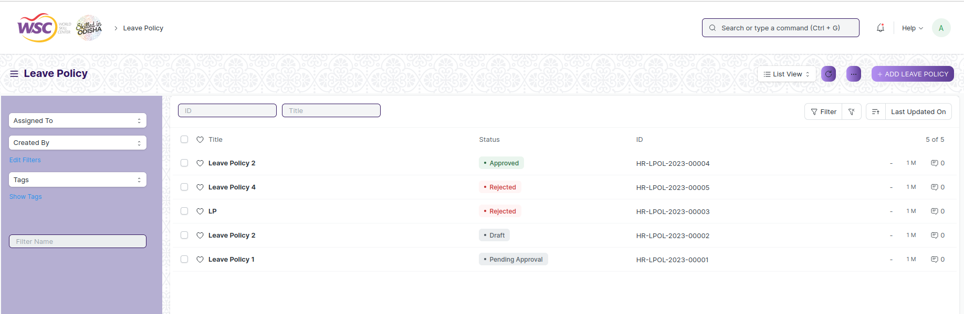

(List View of Leave Policy)

**View Leave Policy**

As it is a save screen, follow the general procedure to view a save document as mentioned above .



(View of a saved Leave Policy)

**Note :** After submitting the leave policy , a workflow begins. HR Admin will submit the form and it will be forwarded to the Director Admin. Once the director admin approves the process terminates.

Email will be sent to the respective authority in each workflow state.

**Process After Submission**

**Action of Director Admin**

If logged in user is the Director Admin and the document state is Pending Approval , then an action button will be visible in the right corner of the document. Click on Action button , select Approve or Reject to end the process .

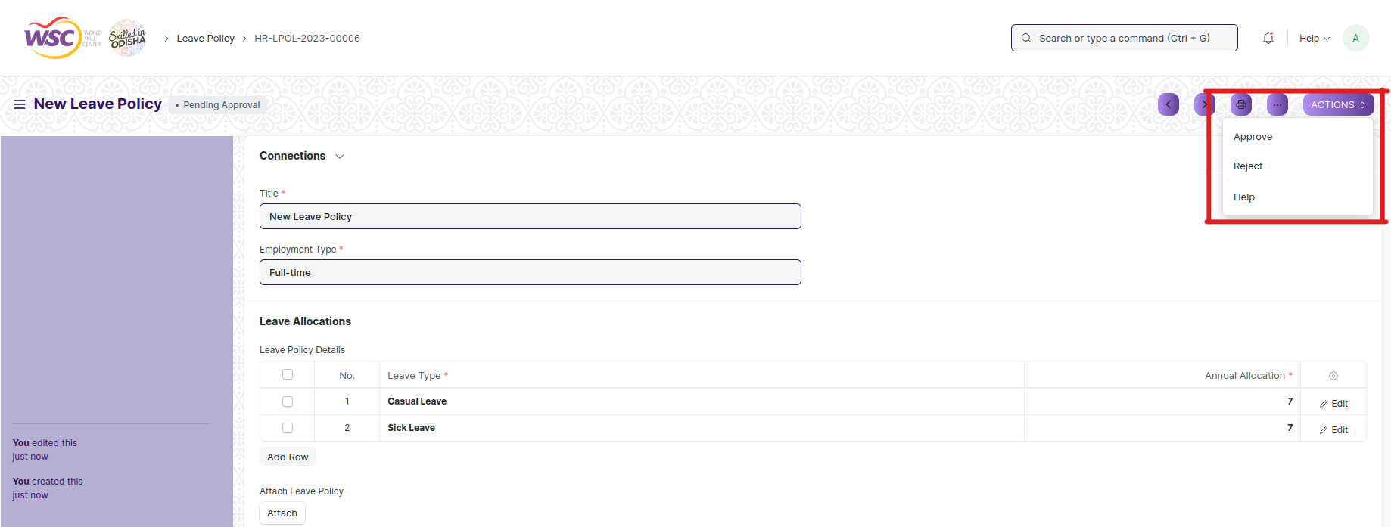

(Action button for Director)

**Note :** Once the document is finally get approved by Director Admin , the final email will be sent to the HR Admin.

**Cancel Leave Policy**

As it is a submittable screen, follow the general procedure to Cancel a submittable document as mentioned above.

**Delete Leave Policy**

If the document is not submitted , it is in draft state , you can delete the document by following the procedure to delete a save document.

If the document is submitted, follow the procedure to delete the submittable document.

**Amend Leave Policy**

As it is a submittable screen , follow the general procedure to Amend the document.

**Edit leave Policy**

If the document is in draft state , the document can be editable.

Once the document is submitted , it cannot be edited.

**Print Leave Policy**

Follow the general procedure to print a saved document.

**View leave Policy in different format**

follow the general procedure to view a saved document in different format.

## 6.3 Leave Period

A Leave Period is used to create duration of time for which leaves are allocated.

Most companies manage leaves based on a Leave Period, corresponding to a calendar year or the fiscal year.

The screen is accessible to Employee , HR Admin,HR Manager /Cs officer ,Director,HR Assistant.

To access the Leave Policy Master screen ,go to :

***Home>HRMS(Base)>Leave Management>Leave Period***

Screen Type : Submit

**Prerequisites :**

Before creating an Leave Period , it is advisable you create the following documents:

* Company
* Holiday List

**Adding a new Leave Period**

As it is a Save screen type , follow the general procedure to create a save document as mentioned above .

* Go to Leave Period list, click on New.
* Enter the From Date and To Date of the Leave Period.
* Select the Company name for which the Leave Period is applicable.
* Save.

**Note :** The Leave Period also allows you to select a Holiday List for Optional Leaves (optional) which will be considered for allocating Optional Leaves for the period.

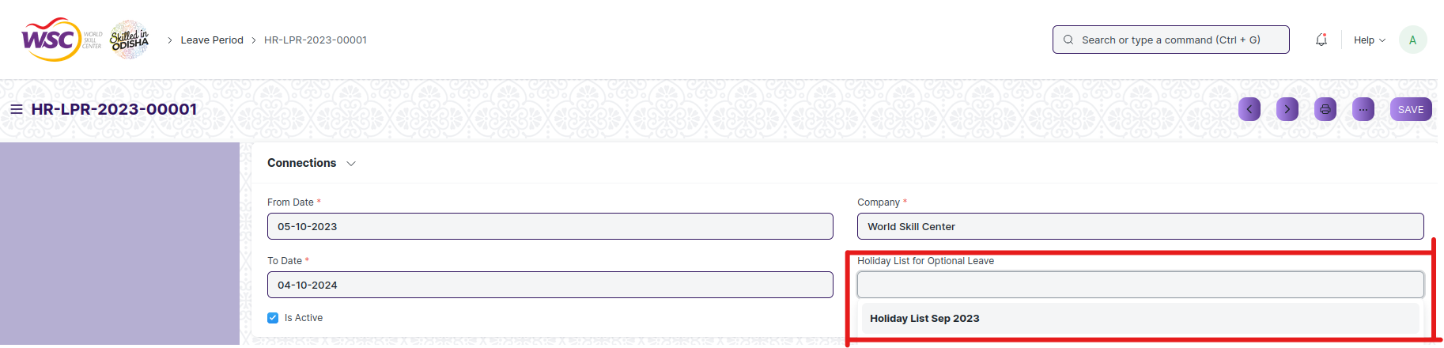

(View of Holiday list for optional Leaves )

**Note:** The 'Holiday List for Optional Leaves' is not the same as the usual 'Holiday List'. This list will contain a list of optional holidays only. 'Holiday List for Optional Leaves' can be created from the Holiday List document. You can create two Holiday Lists for a Leave Period; one containing the usual set of holidays and the other for optional holidays.

After creating an Leave period , the record will be visible in the List view of the screen.

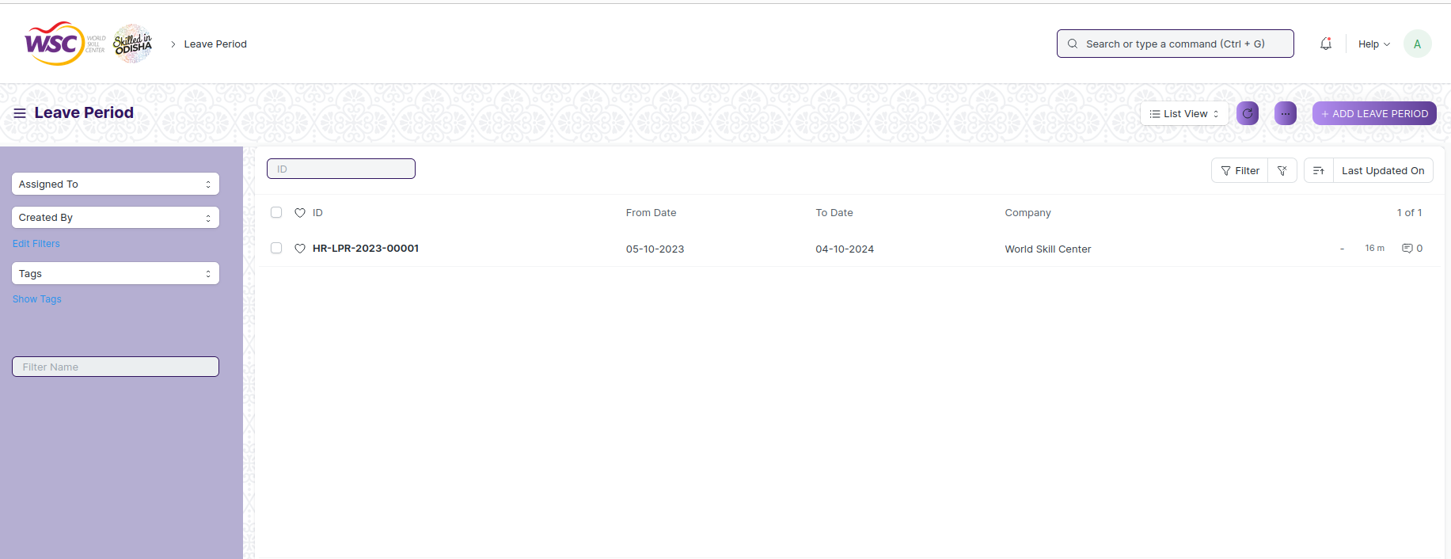

(List View of Leave Period)

**View Leave Period**

As it is a save screen, follow the general procedure to view a save document as mentioned above .

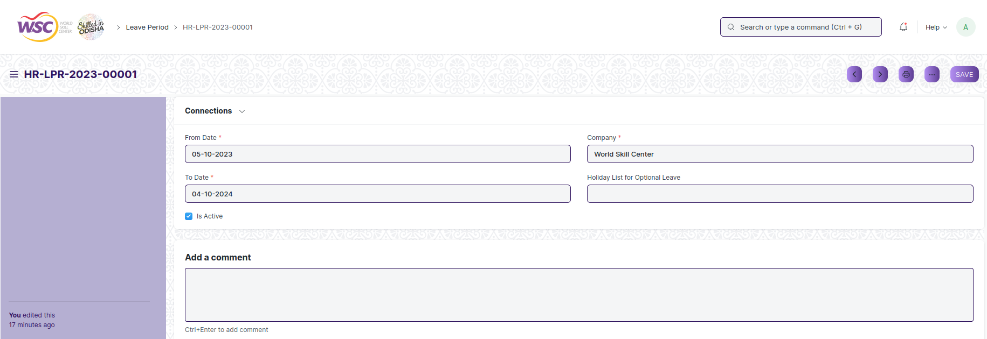

(View of a saved Leave Period)

**Delete Leave Period**

As it a Save screen , follow the general procedure to delete a save document .

**Edit Leave Period**

Follow the steps to view a saved Leave Period document.

Edit the field that you want to change.

Click on Save.

**Print Leave Period**

As it is a Save screen , follow the general procedure to print a saved document.

**View Leave Period in different format**

As it is a Save screen , follow the general procedure to view a saved document in different format.

## 6.4 Leave Policy Assignment

Leave Policy Assignment is used to assign leaves to employees based on created policies.

The screen is accessible to HR Admin,HR Manager /Cs officer ,Director,HR Assistant.

To access the Leave Policy Assignment screen ,go to :

***Home>HRMS(Base)>Leave Management>Leave Policy Assignment***

Screen Type : Submit

**Prerequisites :**

Before creating an Leave Policy Assignment , it is advisable you create the following documents:

* Leave Policy
* Leave Period

**Adding a new Leave Policy Assignment**

As it is a Submittable screen, follow the general procedure to create a submittable document as mentioned above .

* Go to Leave Policy Assignment, click on New.
* Select Employee and Leave Policy.
* Select Assignment based on the following as needed:
* If "Assignment based on" is set to Leave Period, you need to select the applicable Leave Period. The Effective From and Effective To dates will be set automatically based on the Leave Period selected.
* If "Assignment based on" is set to Joining Date, the Effective From date will be set to the employee's Date of Joining.
* If "Assignment based on" is left blank, then you will have to set the Effective From and Effective To date manually.
* Save and Submit.

After creating an Leave policy Assignment , the record will be visible in the List view of the screen.

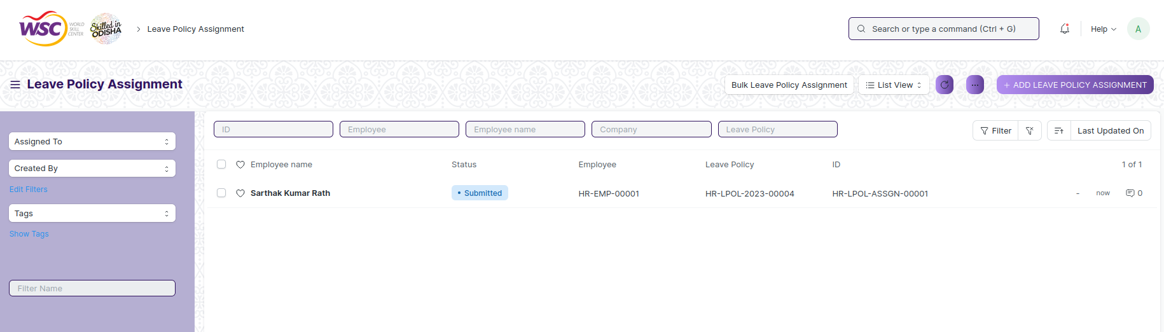

(List view of Leave Policy Assignment)

On submission, Leave Allocation documents would be created automatically based on the Leave Policy as shown below.

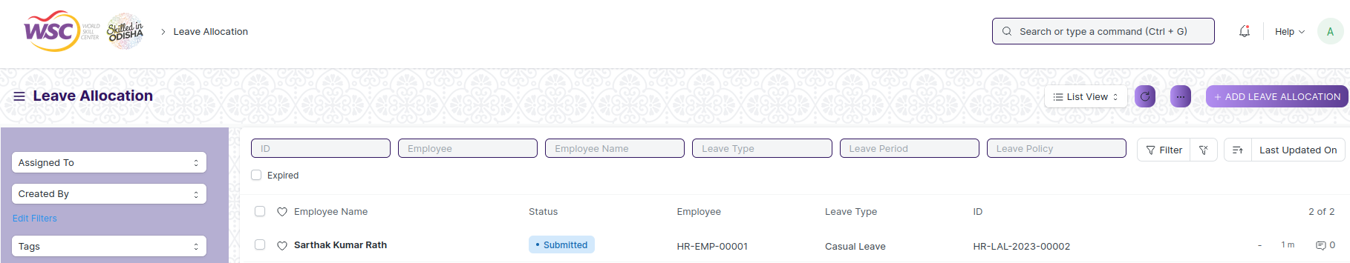

(View of Record Creation in Leave Allocation after creation of Leave Policy Assignment)

**Some more features in the Leave Policy Assignment are given below :**

**Bulk Leave Policy Assignment**

System also allows creating multiple Leave Policy Assignment for multiple employees.

* Go to Leave Policy Assignment list, click on Bulk Leave Policy Assignment.

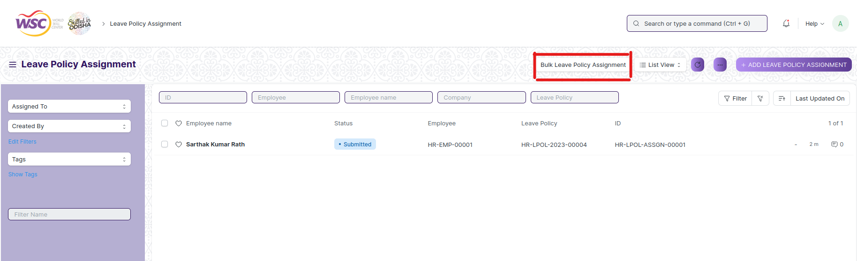

* Dialog Will appear, Select Employee. You can filter Employee based on Company and Department or You can also use standard filters by clicking Add Filters.

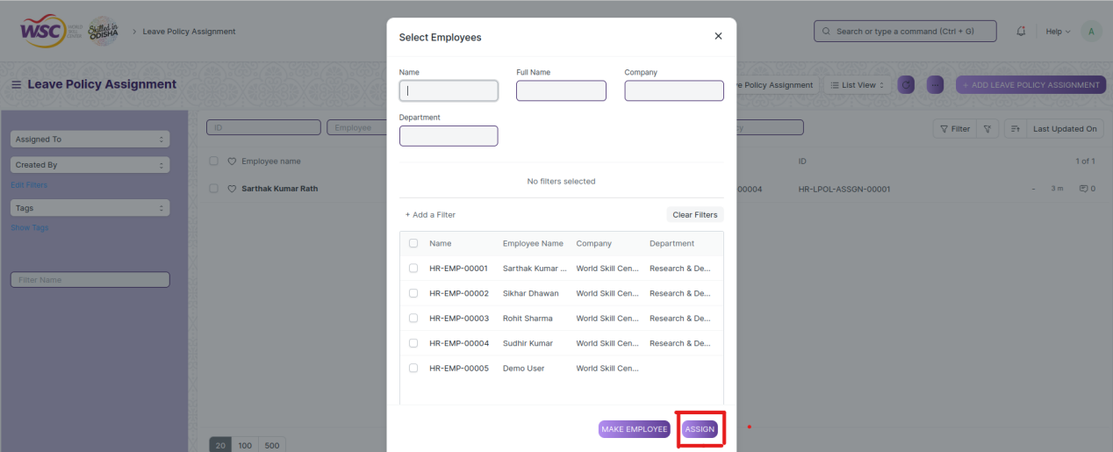

(View of Dialog box on clicking Bulk Assignment button )

* Select Leave Policy and Effective From and Effective To dates.
* Click on Assign.

**View Leave Policy Assignment**

As it is a save screen, follow the general procedure to view a save document as mentioned above .

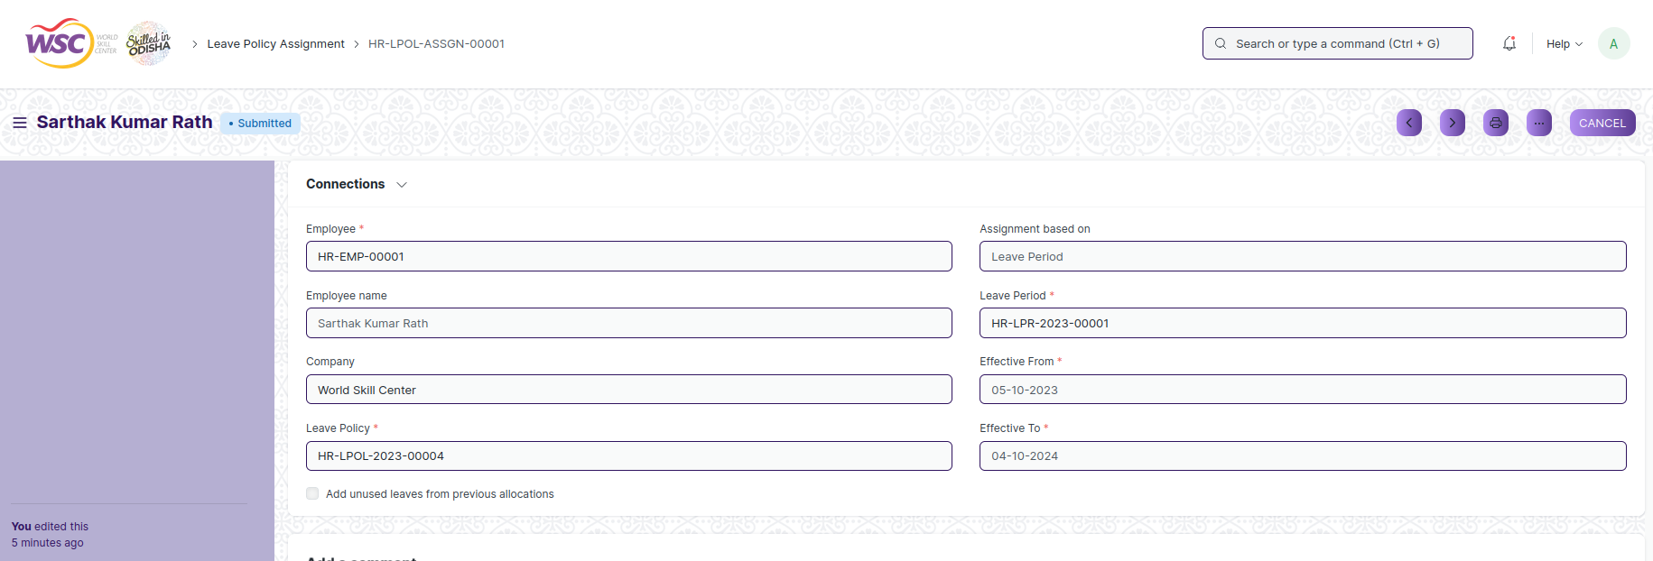

(View of a saved Leave Policy Assignment)

**Cancel Leave Policy Assignment**

As it is a submittable screen, follow the general procedure to Cancel a submittable document as mentioned above.

**Delete Leave Policy Assignment**

If the document is not submitted , it is in draft state , you can delete the document by following the procedure to delete a save document.

If the document is submitted, follow the procedure to delete the submittable document.

**Amend Leave Policy Assignment**

As it is a submittable screen , follow the general procedure to Amend the document.

**Edit leave Policy Assignment**

If the document is in draft state , the document can be editable.

Once the document is submitted , it cannot be edited.

**Print Leave Policy Assignment**

Follow the general procedure to print a saved document.

**View leave Policy Assignment in different format**

follow the general procedure to view a saved document in different format.

## 6.5 Leave Allocation

Leave Allocation screen enables you to allocate a specific number of leaves of a particular type to an Employee.

The screen is accessible to Employee,HR Admin,HR Manager /Cs officer ,Director,HR Assistant.

To access the Leave Allocation screen ,go to :

***Home>HRMS(Base)>Leave Management>Leave Allocation***

Screen Type : Submit

**Prerequisites :**

Before creating an Leave Allocation , it is advisable you create the following documents:

* Leave Policy
* Leave Period
* Leave Type
* Employee

**Adding a new Leave Allocation**

As it is a Submittable screen, follow the general procedure to create a submittable document as mentioned above .

* Go to Leave Allocation list, click on New.
* Select the Employee, Leave Type, From Date and To Date.
* Enter the number of New Leaves Allocated for that particular Leave Type.
* Save and Submit.

After creating an Leave policy Assignment , the record will be visible in the List view of the screen.

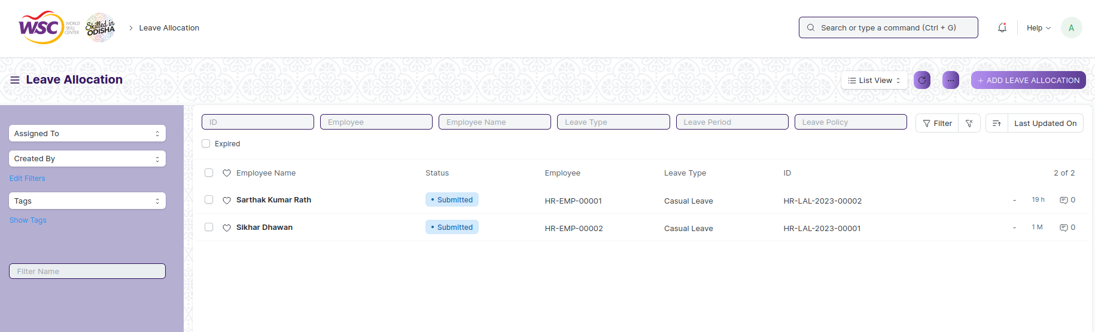

(List View of Leave Allocation)

**Note:** Enable the 'Add unused leaves from previous allocations' option in case you want to carry forward unused leaves from the previous allocation period for this particular Leave Type.

**Note :** You can allocate leaves based on Employee Grade, Department or Designation.

**View Leave Allocation**

As it is a submittable screen, follow the general procedure to view a submitted document as mentioned above .

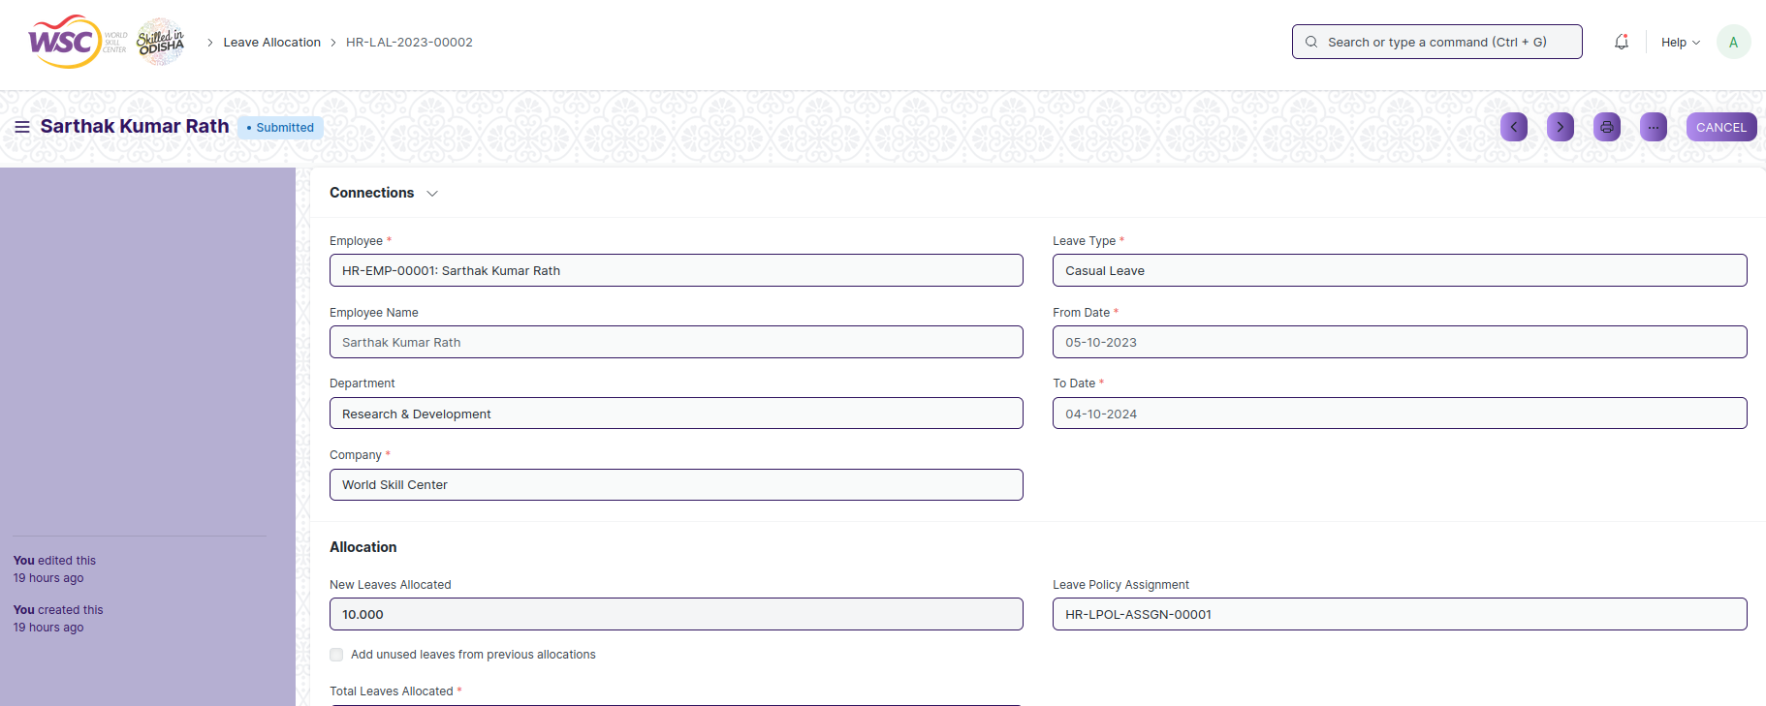

(View of a submitted Leave Allocation)

**Cancel Leave Allocation**

As it is a submittable screen, follow the general procedure to Cancel a submittable document as mentioned above.

**Delete Leave Allocation**

If the document is not submitted , it is in draft state , you can delete the document by following the procedure to delete a save document.

If the document is submitted, follow the procedure to delete the submittable document.

**Amend Leave Allocation**

As it is a submittable screen , follow the general procedure to Amend the document.

**Edit Leave Allocation**

If the document is in draft state , the document can be editable.

Once the document is submitted , it cannot be edited.

**Print Leave Allocation**

Follow the general procedure to print a saved document.

**View Leave Allocation**

follow the general procedure to view a saved document in different format.

## 6.6 Leave Blocklist

This screen helps you to create a list of dates in a year, on which employees cannot apply for leave.

The Screen is accessible to HR Admin,HR Manager /Cs officer ,Director,HR Assistant.

To access the Leave Blocklist screen ,go to :

***Home>HRMS(Base)>Leave Management>Leave Blocklist***

Screen Type : Save

**Prerequisites :**

Before creating an Leave Blocklist , it is advisable you create the following documents:

* Company
* Department
* Leave period
* Holiday List

**Adding a new Leave Blocklist**

As it is a save screen, follow the general procedure to create a save document as mentioned above .

* Go to Leave Block list, and click on New.
* Enter Leave Block List Name.
* Enter Block Date and Reason in the 'Leave Block List Dates' table.
* Enter Users to approve Leave Applications for Blocked Days in the 'Leave BLock List Allowed' table.
* Save.

Our System allows you to define a list of Leave Approvers who can approve Leave Applications on blocked days, in case of urgency. You can also define whether the list will be applied to the entire company or on any specific departments.

In the screen Enter Users to approve Leave Applications for Blocked Days in the 'Leave BLock List Allowed' table.

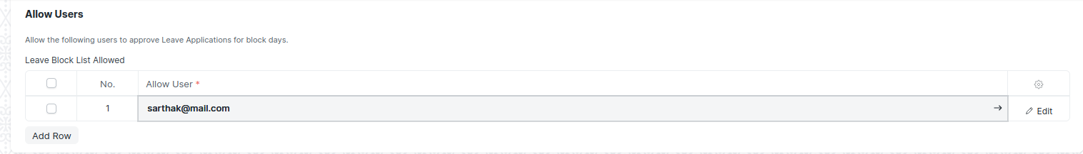

(Allow user section )

After creating an Leave Block list , the record will be visible in the List view of the screen.

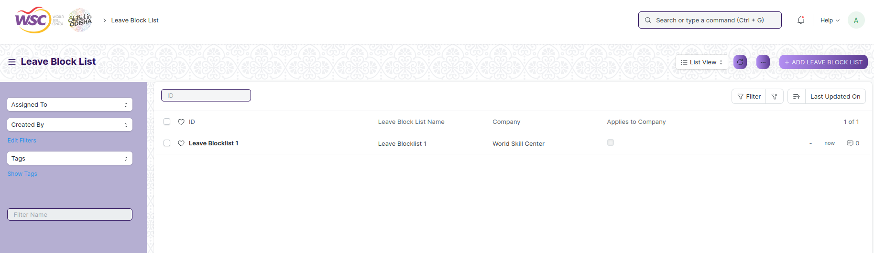

(List View Leave blocklist)

**Note:** Enable the 'Applies to Company' option if you want the Leave Block List to be applicable for the entire Company. If not checked, the list will have to be added to each Department where it has to be applied.

**View Leave Blocklist**

As it is a save screen, follow the general procedure to view a save document as mentioned above .

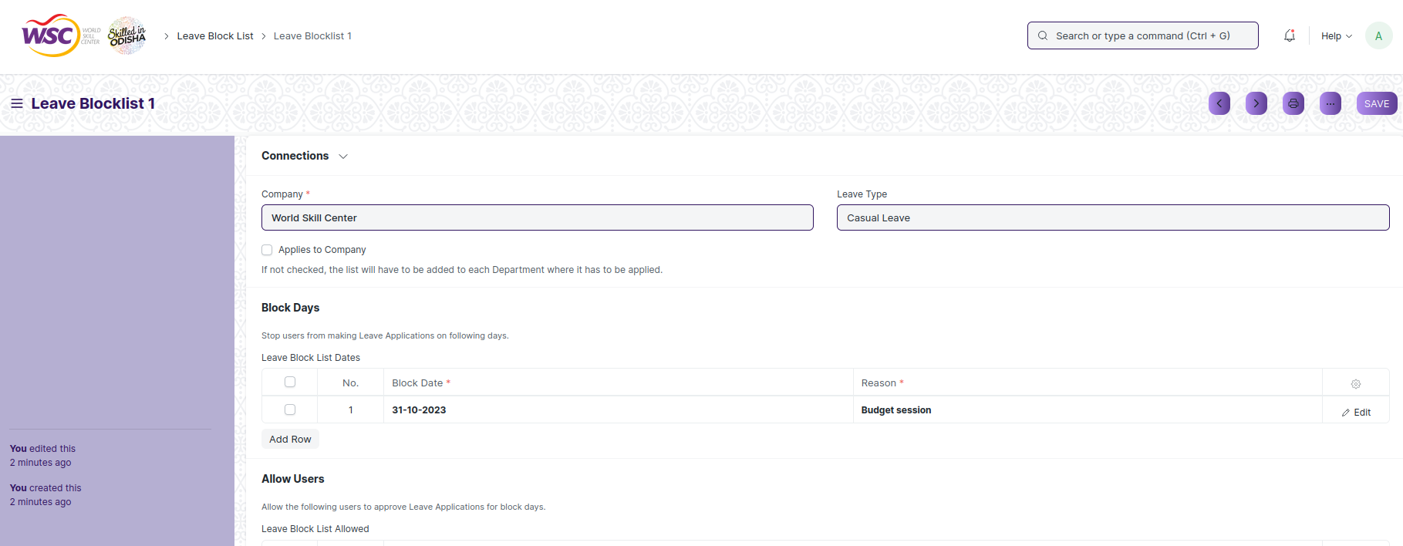

(View of a saved Leave Blocklist.)

**Delete Leave Blocklist**

As it a Save screen , follow the general procedure to delete a save document .

**Edit Leave Blocklist**

Follow the steps to view a saved Leave Blocklist.

Edit the field that you want to change.

Click on Save.

**Print Leave Blocklist**

As it is a Save screen , follow the general procedure to print a saved document.

**View Leave Blocklist in different format**

As it is a Save screen , follow the general procedure to view a saved document in different format.

## 6.7 Leave Application

Leave Application screen helps an Employee to apply for Leaves for a particular time period.

Our system allows your employees to apply for leaves via Leave Applications and get them approved by the Leave Approvers.

The screen is accessible to Employee,HR Admin,HR Manager /Cs officer ,Director,HR Assistant.

To access the Leave Application screen ,go to :

***Home>HRMS(Base)>Leave Management>Leave Application***

Screen Type : Submit

**Prerequisites :**

Before creating an Leave Application , it is advisable you create the following documents:

* Leave Policy
* Leave Period
* Leave Type
* Employee
* Department
* Holiday List
* Leave Allocation

**Adding a new Leave Application**

As it is a Submittable screen, follow the general procedure to create a submittable document as mentioned above .

* Go to Leave Application list, click on New.
* In the screen , when you select employee , A table of Allocated Leaves will be shown. Based on the Leaves taken, the available leaves are displayed for each Leave Type.

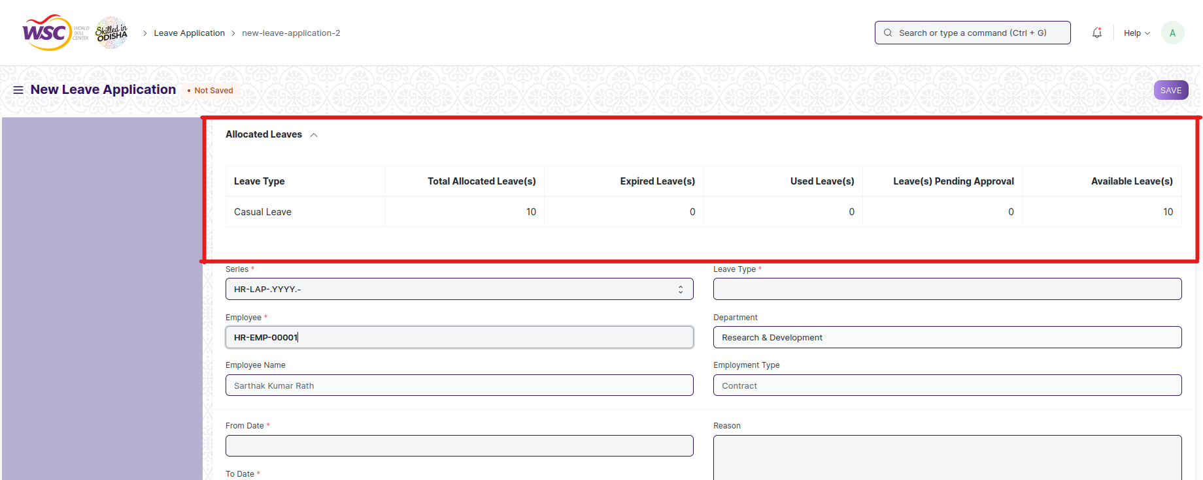

(View of Leave Allocated to the selected Employee)

* Select the Employee Name and Leave Type.
* Set the Leave duration using From Date and To Date. Based on the dates selected, the 'Total Leave Days' and the 'Leave Balance Before Application' fields will be displayed.
* If the Leave applied is for a half-day, select the 'Half Day' checkbox.
* Enter the Reason for Leave.
* Select Leave Approver.
* Select the Posting Date of the Leave Application.
* Check the 'Follow via Email' checkbox to send notification of the Leave Application to the Leave Approver.
* You can also link the Salary Slip of the Employee in the Leave Application for the record.
* Click on Save.Once the Employee saves the Leave Application, the status of the Leave Application changes to 'Open', and an email is sent to the Reporting Authority of the Employee and the Leave Approver for approval.

After creating an Leave Application , the record will be visible in the List view of the screen.

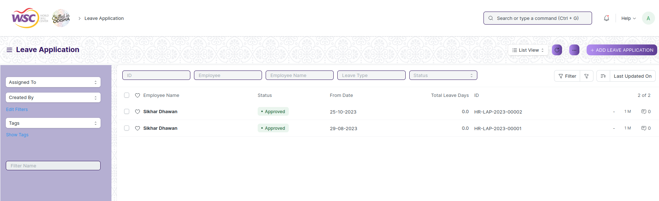

(List view of Leave Application)

**Note:** After creation of leave application the document will be forwarded first to the Reporting authority of the employee. If the reporting authority approves , it will be forwarded to the Leave Approver of the employee.

**Note :** Once the Leave Approver receives the email, they can Approve, Reject, or Cancel the Leave Application. Once this is done, the Leave Approver can submit the Leave Application. On submission, the status of the document changes accordingly, and an email is sent to the Employee notifying them the same.

**View Leave**

As it is a submittable screen, follow the general procedure to view a submitted document as mentioned above .

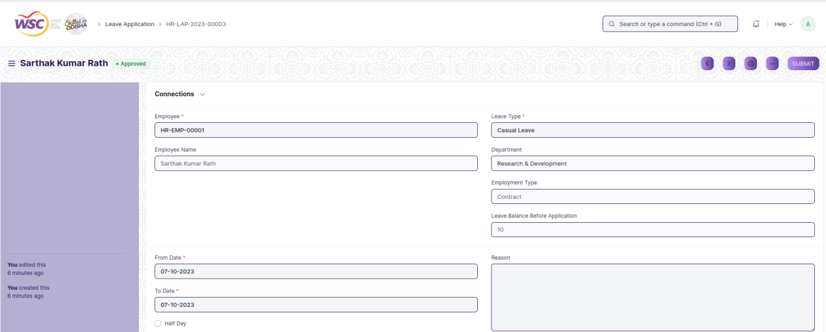

(View of a submitted Leave Application)

**Cancel Leave Application**

As it is a submittable screen, follow the general procedure to Cancel a submittable document as mentioned above.

**Delete Leave Application**

If the document is not submitted , it is in draft state , you can delete the document by following the procedure to delete a save document.

If the document is submitted, follow the procedure to delete the submittable document.

**Amend Leave Application**

As it is a submittable screen , follow the general procedure to Amend the document.

**Edit Leave Application**

If the document is in draft state , the document can be editable.

Once the document is submitted , it cannot be edited.

**Print Leave Application**

Follow the general procedure to print a saved document.

**View Leave Application**

follow the general procedure to view a saved document in different format.

## 6.8 Compensatory Leave Request

Compensatory Leave Request screen helps employee to apply for leave as compensation for working overtime or on holidays.

It is necessary that the dates mentioned in the Compensatory Leave Request should be in default Holiday List and also that the Employee should have their attendance marked Present.

The screen is accessible to Employee,HR Admin,HR Manager /Cs officer ,Director,HR Assistant.

To access the Compensatory Leave Request screen ,go to :

***Home>HRMS(Base)>Leave Management>Compensatory Leave Request***

Screen Type : Submit

**Note:** Only Leave Types which are marked as 'Is Compensatory' can be selected in the Compensatory Leave Request.

**Prerequisites :**

Before creating an Compensatory Leave Request , it is advisable you create the following documents:

* Leave Policy
* Leave Period
* Leave Type
* Employee
* Holiday List
* Leave Allocation
* Attendance

**Adding a new Compensatory Leave Request**

As it is a Submittable screen, follow the general procedure to create a submittable document as mentioned above .

* Go to Compensatory Leave Request list, click on New.
* Select the Employee ID. Once selected, The Employee Name and Department will get automatically fetched.
* Select Leave Type.
* Select Work From Date and Work End Date. This is the date of the day(s) the Employee has worked on, during a Holiday.
* Enter the Reason.
* Save and Submit.

**Note:** On submitting the Compensatory Leave Request, the system updates the Leave Allocation record for the Compensatory leave type, allowing the Employee to apply for leaves of this type later on depending upon the number of leaves left.

**View Compensatory Leave Request**

As it is a submittable screen, follow the general procedure to view a submitted document as mentioned above .

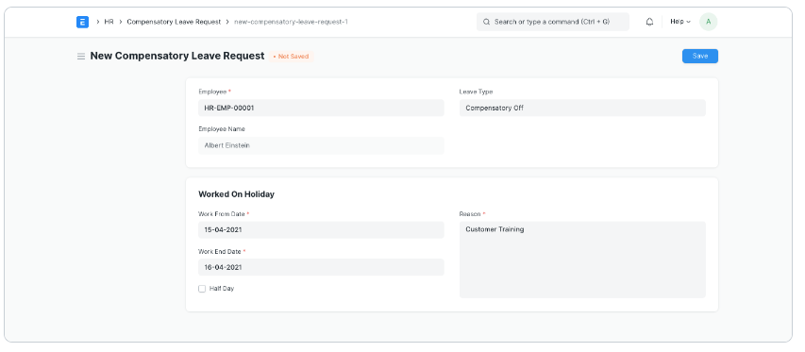

(View of a submitted Compensatory Leave Request.)

**Cancel Compensatory Leave Request**

As it is a submittable screen, follow the general procedure to Cancel a submittable document as mentioned above.

**Delete Compensatory Leave Request**

If the document is not submitted , it is in draft state , you can delete the document by following the procedure to delete a save document.

If the document is submitted, follow the procedure to delete the submittable document.

**Amend Compensatory Leave Request**

As it is a submittable screen , follow the general procedure to Amend the document.

**Edit Compensatory Leave Request**

If the document is in draft state , the document can be editable.

Once the document is submitted , it cannot be edited.

**Print Compensatory Leave Request**

Follow the general procedure to print a saved document.

**View Compensatory Leave Request in different format.**

follow the general procedure to view a saved document in different format.

# Shift Management

## Shift Type

The “Shift Type” document allows you to define the different types of Shifts in your Organization and set up auto attendance for the shift.

 Auto attendance marks attendance based on [Employee Checkin](https://docs.erpnext.com/docs/v14/user/manual/en/human-resources/employee_checkin) records for employees assigned to a shift.

The feature is accessible to HR Admin,HR Manager /Cs officer ,Director,HR Assistant.

To access the Shift Type screen ,go to :

***Home>HRMS>Shift Management>Shift Type***

Screen Type : Save

**Adding a new Appointment Letter**

* Login to the system.
* Go the HRMS workspace.
* Go to Shift Type.
* Enter the Start Time,End Time and Holiday List.
* Check the Auto Attendance checkbox if required and fill the required data.
* Click on “Save”.

**Note:**In addition to defining the different shifts in your organization, the Shift Type document also has settings for auto attendance. **Auto attendance** marks the attendance for the employees assigned to this shift based on records in the **'Employee Checkin'** Document. Auto Attendance for all shift type records is attempted to be marked every hour. You can also trigger the auto attendance manually for a single shift type by pressing the **'Mark Attendance'** button in the shift type document.

**Auto Attendance Settings**

**You can use the following settings to configure the Auto Attendance as per your requirements:**

* **Determine Check-in and Check-out**: This setting determines how your check-in logs should be interpreted by the auto attendance system.

1. Alternating entries as IN and OUT during the same shift: The first entry is taken as IN followed by the next entry as OUT and the following entry as IN and so on. Employee Check-in may not always have an IN/OUT log type. Not all biometric devices return Log Type for every log. For such scenarios you can use this option.
2. Strictly based on Log Type in Employee Checkin: The check-in is determined as IN or OUT strictly based on the 'Log Type' in the Employee Checkin record. This should be used when the logs that are being recorded in Frappe HR have the exact log type.

* **Working Hours Calculation Based On**: Working hours can be calculated either by including the breaks in between the shift or by excluding the breaks. This can be configured using the following options:

1. First Check-in and Last Check-out:Use this option when you want to include breaks or all out/in entries in your working hours.Selecting this option calculates the working hours by considering the first IN and last OUT Employee Checkin during the shift. The time difference between the two is considered as the actual working hours.
2. Every Valid Check-in and Check-out:Selecting this option excludes the time during which the Employee is checked out.i.e. Only the time during which the employee is checked in is calculated as working hours.

* **Begin check-in before shift start time (in minutes):** Often employees would check-in a few minutes before the shift start time. To consider these check-ins as part of the shift during the calculation of working hours and marking attendance, you can set up this value accordingly.
* **Allow check-out after shift end time (in minutes):** Often employees would check-out after the shift end time. To consider these check-outs as part of the shift during the calculation of attendance, you can set up this value accordingly.
* **Mark Auto Attendance on Holidays:** If enabled, auto attendance will be marked on holidays if Employee Checkins exist on that date. By default, auto attendance is skipped on holidays.
* **Working Hours Threshold for Half Day:** If the actual number of working hours is less than the given value in this field then the employee attendance is marked as 'Half Day'. If you never want to mark Half Day based on working hours, you should set this value to zero.
* **Working Hours Threshold for Absent:** If the actual number of working hours is less than the given value in this field then the employee attendance is marked as 'Absent'. If you never want to mark Absent based on working hours, you should set this value to zero.
* **Process Attendance After:** The date from which 'Auto Attendance' should start marking attendance. You should set it to a date after which you have Employee Checkin records for this shift.
* **Last Sync of Checkin:** This is the timestamp up to which Employee Checkin records have been synced. This field has to be updated by the script/person(in case of manual entry) making the Employee Checkin Records. If your logs are automatically pushed to Frappe HR using the sync tool, this timestamp will automatically be updated for you. You should set this to a date and time up to which the Employee Checkin has been synced.

After creating Shift Type , the record will be visible in the List view of the screen.

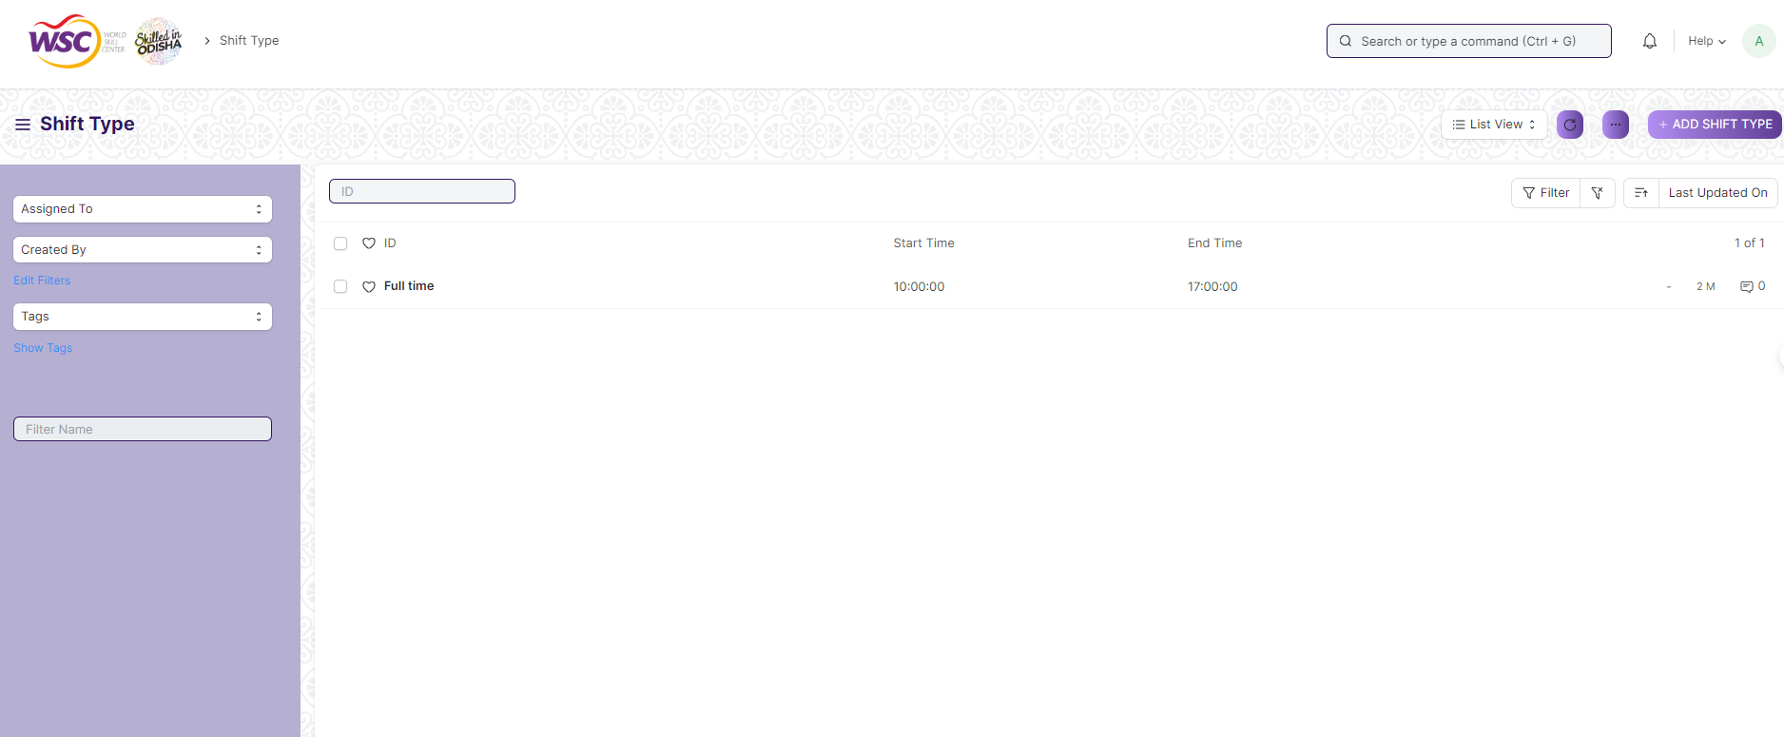

**View Shift Type**

As it is a save screen, follow the general procedure to view a save document as mentioned above .

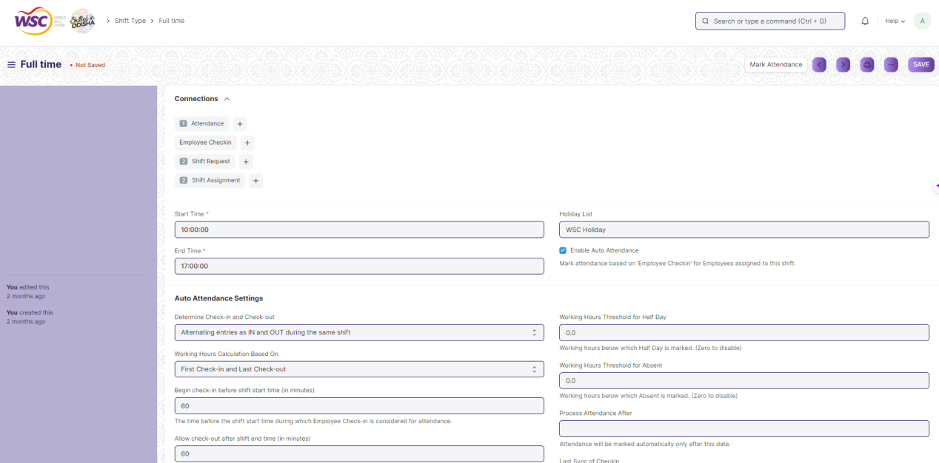

View of a saved Shift Type .

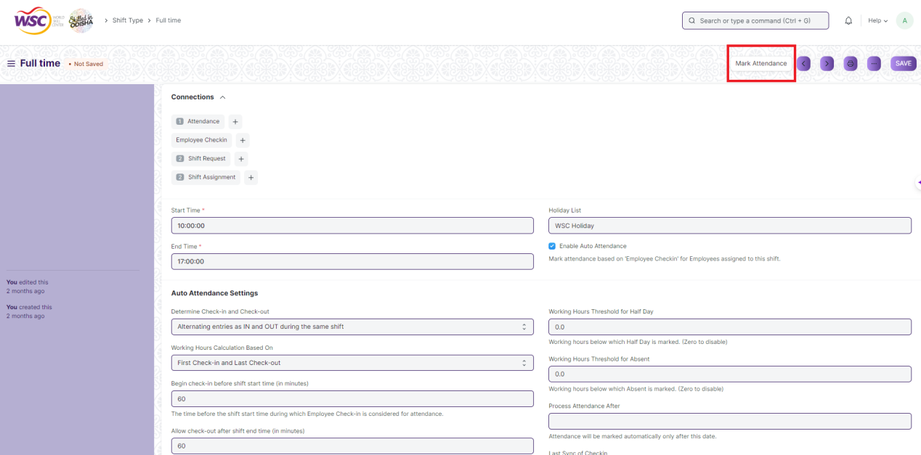

**Note:** Usercan also trigger the auto attendance manually for a single shift type by pressing the **'Mark Attendance'** button in the shift type document.

**Delete Shift Type**

As it a Save screen , follow the general procedure to delete a save document . If the Shift Type is linked or assigned to an employee you need to first unlink and then delete the shift type record.

**Edit Shift Type**

Follow the steps to view a saved Shift Type

Edit the field that you want to change.

Click on Save.

**Print Shift Type**

As it is a Save screen , follow the general procedure to print a saved document.

**View Shift Type in different format**

As it is a Save screen , follow the general procedure to view a saved document in different format.

## Shift Assignment

The “Shift Assignment” is created to assign a particular shift type to an employee for a specific period.

The feature is accessible to Employee , HR Admin,HR Manager /Cs officer ,Director,HR Assistant.

To access the Shift Assignment screen ,go to :

***Home>HRMS>Shift Management>Shift Assignment***

Screen Type : Submit

**Prerequisites**

Before creating Shift Assignment , it is advisable you create the following documents:

* Employee
* Shift Type

**Adding a new Shift Assignment**

* Login to the system.
* Go the HRMS workspace.
* Go to Shift Assignment.
* Enter the Employee,Shift Type,Start date and End Date.
* Click on “Save”.
* Click on “Submit”

After creating Shift Assignment , the record will be visible in the List view of the screen.

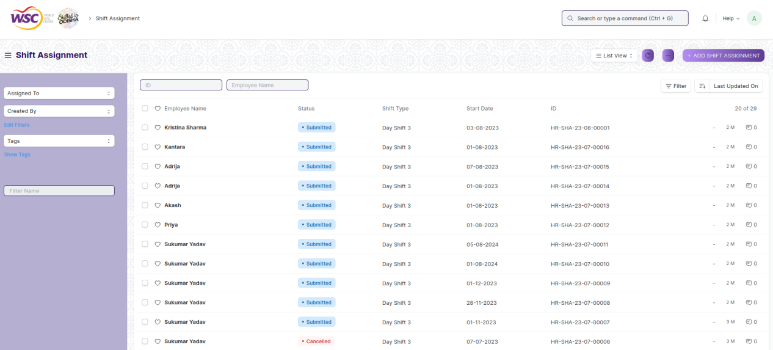

**View Shift Assignment**

As it is an submittable screen, follow the procedure to view a submittable document as mentioned above.

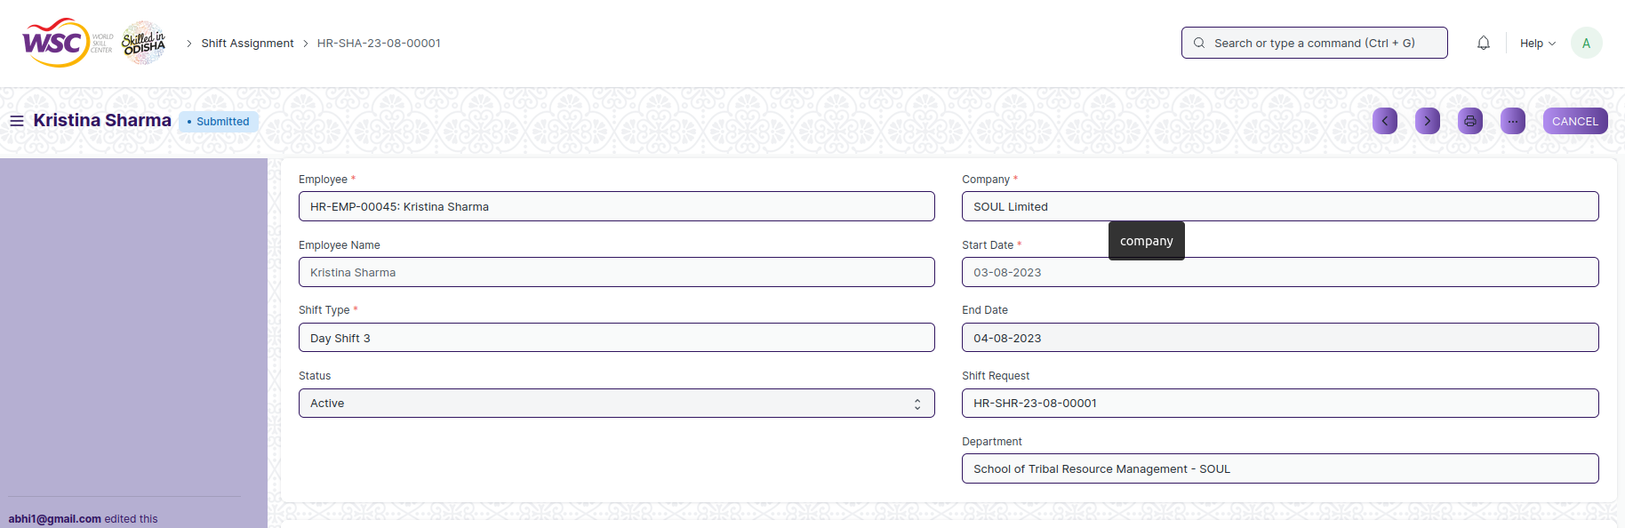

View of a submitted Shift Assignment

**Cancel Shift Assignment**

As it is a submittable screen, follow the general procedure to Cancel a submittable document as mentioned above.

**Delete Shift Assignment**

If the document is submitted, follow the procedure to delete the submittable document.

**Amend Shift Assignment**

As it is a submittable screen , follow the general procedure to Amend the document.

**Edit Shift Assignment**

Once the document is submitted , it cannot be edited.

**Print Shift Assignment**

Follow the general procedure to print a submitted document.

**View Shift Assignment in different format**

Follow the general procedure to view a submitted document in different format.

## Shift Request

The “Shift Request” is used by an employee to request for a particular Shift Type.

The feature is accessible to Employee , HR Admin,HR Manager /Cs officer ,Director,HR Assistant.

To access the Shift Request screen ,go to :

***Home>HRMS>Shift Management>Shift Request***

Screen Type : Submit

**Prerequisites**

Before creating Shift Request , it is advisable you create the following documents:

* Employee
* Shift Type
* Shift Assignment

**Adding a new Shift Request**

* Login to the system.
* Go the HRMS workspace.
* Go to Shift Request.
* Enter the Employee,Shift Type,Start Date and End Date.
* Click on “Save”.

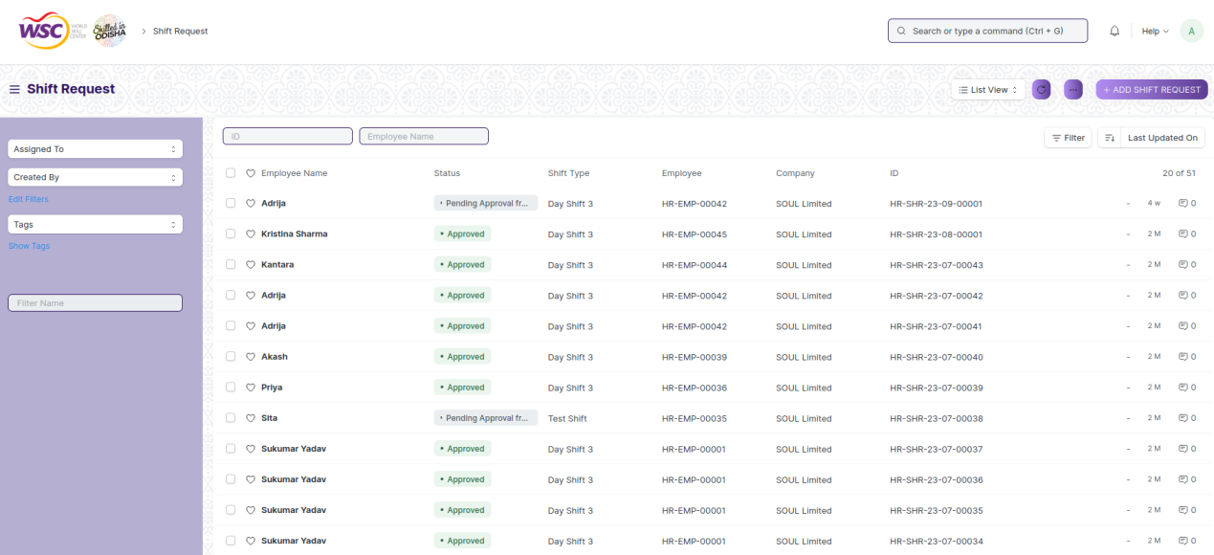

**Note :** After saving the document , a workflow begins. The “**Shift Request**” is initiated by the employee and then it will be forwarded to the respective reporting authority and then to the Approving Authority.

**Process After Saving**

**Action of Reporting Authority**

If logged in user is the reporting authority of the employee, then an action button will be visible in the right corner of the document.

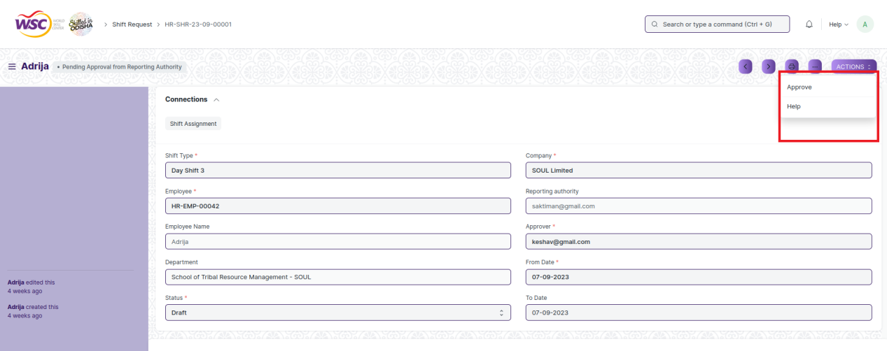

**Action of Shift Approving Authority**

If the logged in user is HR Admin and the document status is “Sent for Approval” , then an action button will be visible in the right corner of the document. Click on Action button, select Approve or Reject.

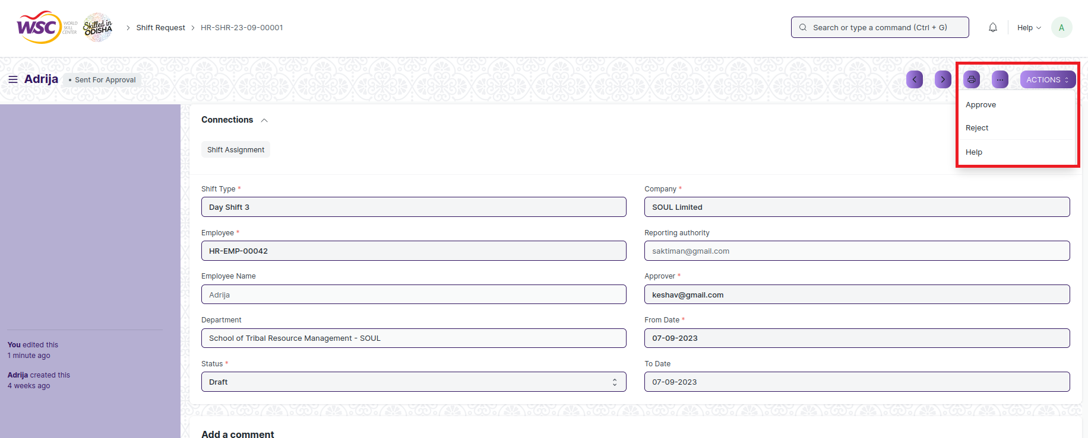

After clicking on “**Approve**” , the respective Shift Assignment will be created for that Employee.

Email will also be sent to the Employee and HR Admin.

**View Shift Request**

As it is an submittable screen, follow the procedure to view a submittable document as mentioned above.

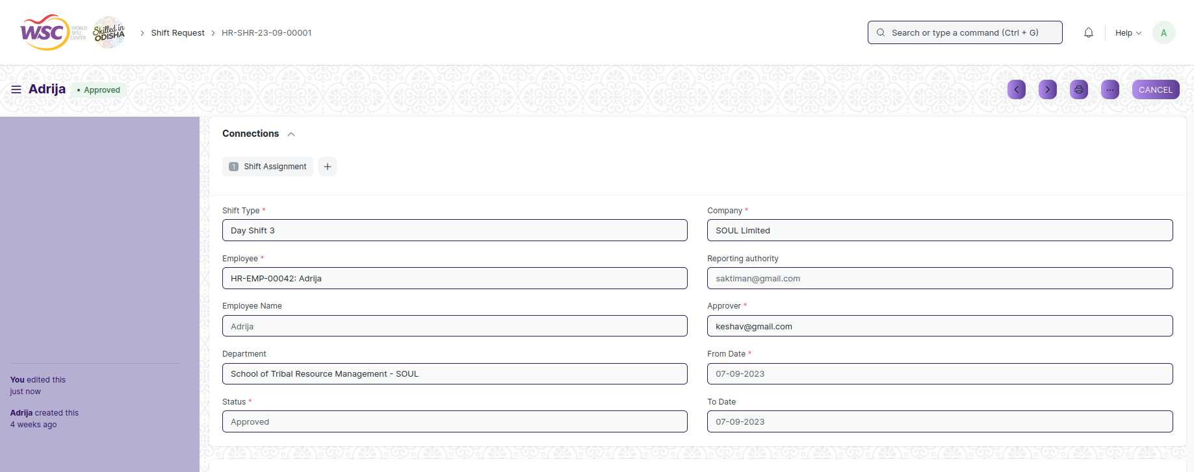

View of a submitted Shift Request.

**Cancel Shift Request**

As it is a submittable screen, follow the general procedure to Cancel a submittable document as mentioned above.

**Delete Shift Request**

If the document is not submitted , it is in Pending state , you can delete the document by following the procedure to delete a save document.

If the document is submitted, follow the procedure to delete the submittable document.

**Amend Shift Request**

As it is a submittable screen , follow the general procedure to Amend the document.

**Edit Shift Request**

If the document is in Pending state , the document can be editable.

Once the document is submitted , it cannot be edited.

**Print Shift Request**

Follow the general procedure to print a submitted document.

**View Shift Request in different format**

Follow the general procedure to view a submitted document in different format.

# Attendance

## Employee Attendance Tool

The “Employee Attendance Tool” allows you to mark attendance of multiple employees for a particular date.

This tool allows you to add attendance records for multiple employees based on their Department and Branch for a given day quickly.

The feature is accessible to HR Admin,HR Manager /Cs officer ,Director,HR Assistant.

To access the Employee Attendance Tool ,go to :

***Home>HRMS>Attendance>Employee Attendance Tool***

**Screen Type :** NA

**Prerequisites**

Before creating an Employee Attendance Tool, it is advisable you create the following documents:

* Company
* Department
* Designation
* Employee

**Adding a new Employee Attendance Tool**

* Login to the system.
* Go the HRMS workspace.
* Go to the “Employee Attendance Tool”.
* Enter the Date,Department,Designation.
* Mark the Attendance by clicking any one of the option “Mark Present/Mark Work From Home/Mark Half Day/Mark Absent”.

**Note:**

1. After Clicking on **“Mark Present/Mark Work From Home/Mark Half Day/Mark Absent”,**therecord for the attendance is marked in **“Attendance”**form**.**

**View Employee Attendance Tool**

View of Employee Attendance Tool.

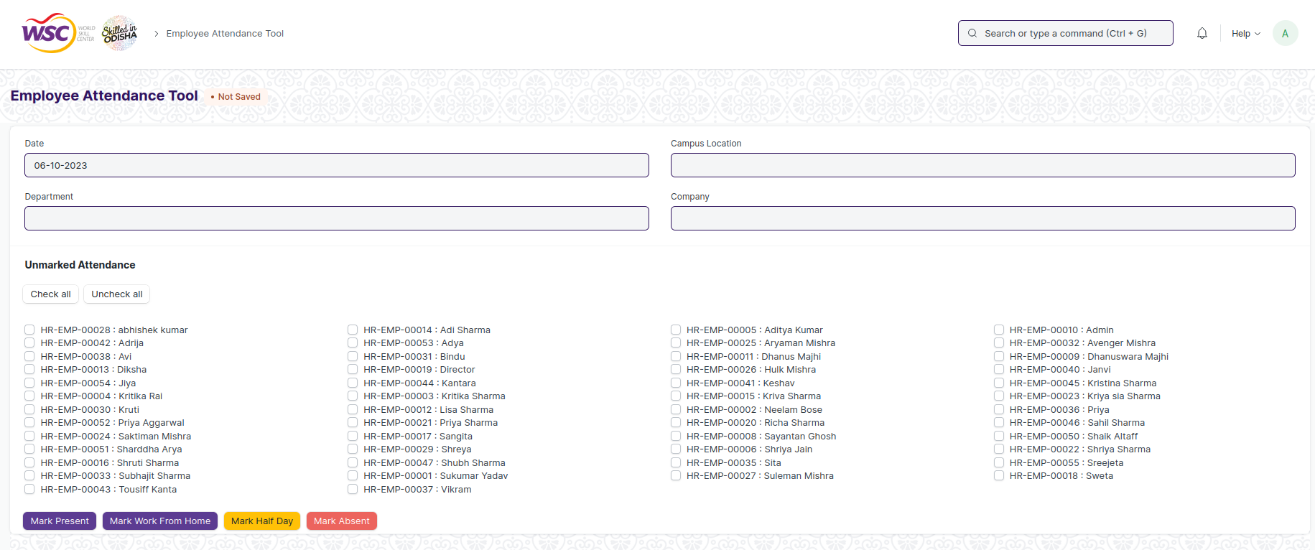

**Delete Employee Attendance Tool**

This is a tool so the user cannot delete the records from Tool but can delete the record from the transactional screen is linked to Employee Attendance Tool i.e Attendance.

**Edit Employee Attendance Tool**

User cannot edit record in Tool.

**Print Employee Attendance Tool**

User cannot Print the Employee Attendance Tool record

**View Employee Attendance Tool Type in different format**

User cannot view a tool in different format.

## Attendance

The “Attendance” is a record stating whether an Employee has been present on a particular day or not.

The feature is accessible to HR Admin,HR Manager /Cs officer ,Director,HR Assistant.

To access the Attendance screen ,go to :

***Home>HRMS>Attendance>Attendance***

Screen Type : Submit

**Prerequisites**

Before creating Attendance , it is advisable you create the following documents:

* Employee
* Shift Type

**Adding a new Attendance**

* Login to the system.
* Go the HRMS workspace.
* Go to Attendance.
* Enter the Employee,Attendance Date,Status,Company and so on.
* Click on “Save”.
* Click on “Submit”

After creating Attendance , the record will be visible in the List view of the screen.

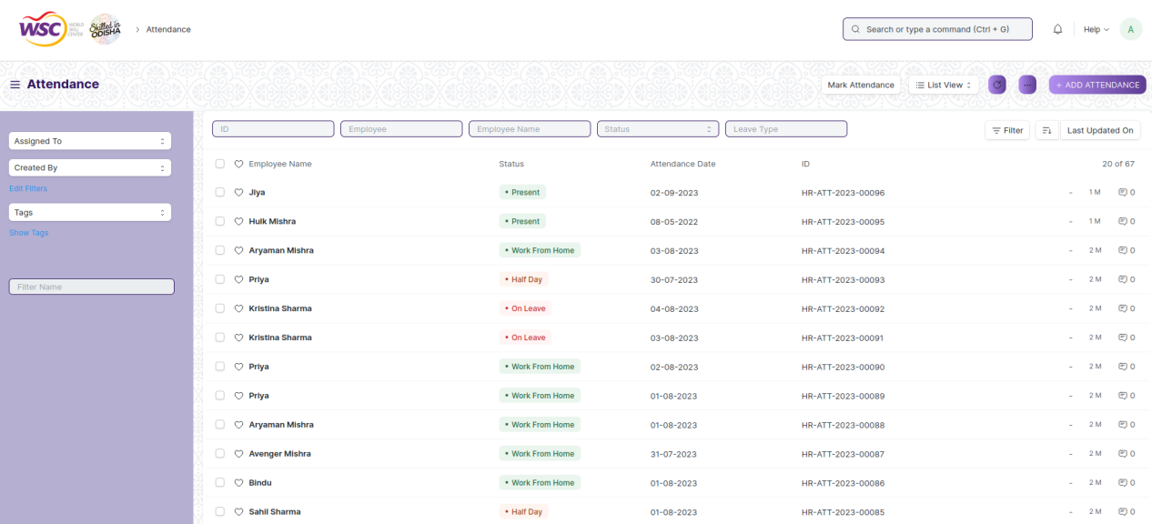

**View Attendance**

As it is a submittable screen, follow the procedure to view a submittable document as mentioned above.

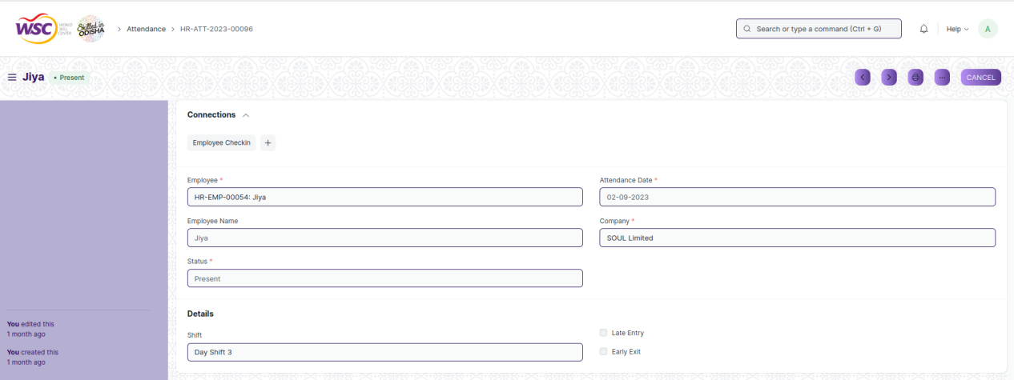

View of a submitted Attendance.

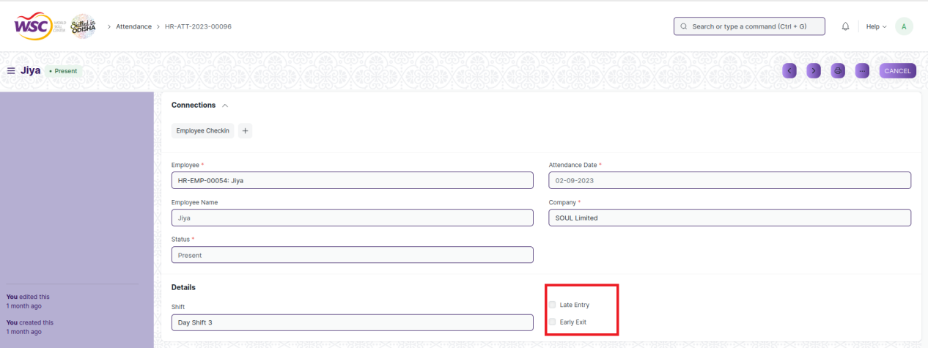

**Note:**

1. User can also mark the Late Entry and Early Exit for an employee.

**Cancel Attendance**

As it is a submittable screen, follow the general procedure to Cancel a submittable document as mentioned above.

**Delete Attendance**

If the document is submitted, follow the procedure to delete the submittable document.

**Amend Attendance**

As it is a submittable screen , follow the general procedure to Amend the document.

**Edit Attendance**

Once the document is submitted , it cannot be edited.

**Print Attendance**

Follow the general procedure to print a submitted document.

**View Attendance in different format**

Follow the general procedure to view a submitted document in different format.

## Attendance Request

Using the “Attendance Request”, employees can submit their attendance request for the days when their attendance wasn't marked due to various reasons such as on-site duty or work from home.Attendance Request can also be used for Attendance Regularization to overwrite existing attendance records.

The feature is accessible to Employee , HR Admin,HR Manager /Cs officer ,Director,HR Assistant.

To access the Attendance Request screen ,go to :

***Home>HRMS>Attendance>Attendance Request***

Screen Type : Submit

**Prerequisites**

Before creating Attendance Request , it is advisable you create the following documents:

* Employee
* Shift Type

**Adding a new Attendance Request**

* Login to the system.
* Go the HRMS workspace.
* Go to Attendance Request.
* Enter the Employee,Company,From Date,To Date and Reason.
* Click on “Save”.

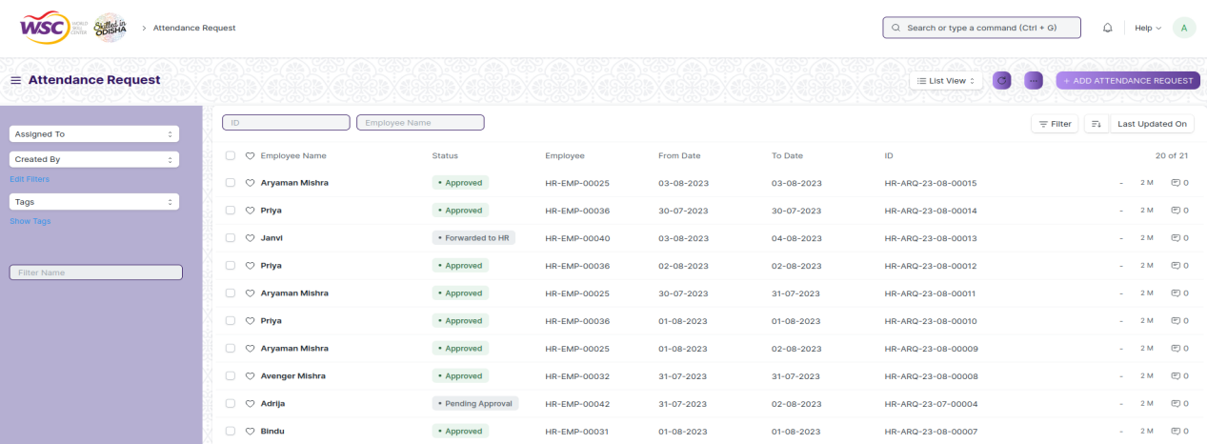

**Note :** After saving the document , a workflow begins. The “**Attendance Request**” is initiated by the employee and then it will be forwarded to the HR Admin and then to the Reporting Authority for the Approval.Once the “Attendance Request”is submitted by the Employee mail will be sent to the HR Admin.

**Process After Saving**

**Action of HR Admin**

If logged in user is the HR Admin and the status of the form is “Forwarded to HR”, then an action button will be visible in the right corner of the document.

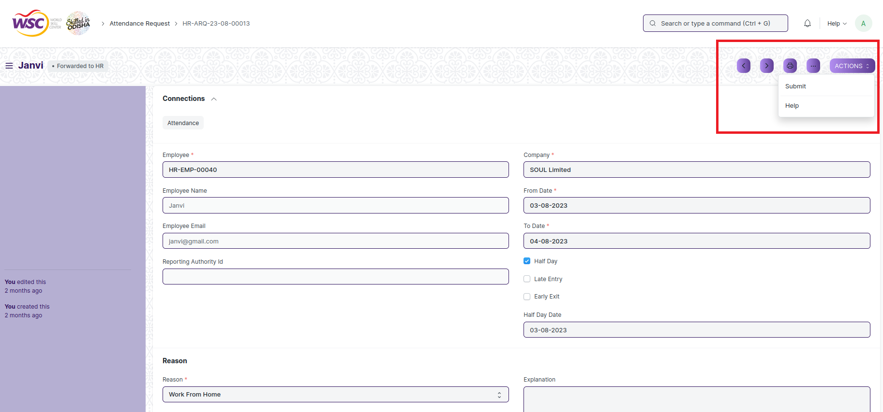

After Clicking on “**Submit**”,the mail will be sent to the Reporting Authority of the Employee and mail will also be sent to the Reporting Authority.

**Action of Reporting Authority**

If the logged in user is Reporting Authority and the document status is “Pending Approval” , then an action button will be visible in the right corner of the document. Click on Action button, select Approve or Reject.

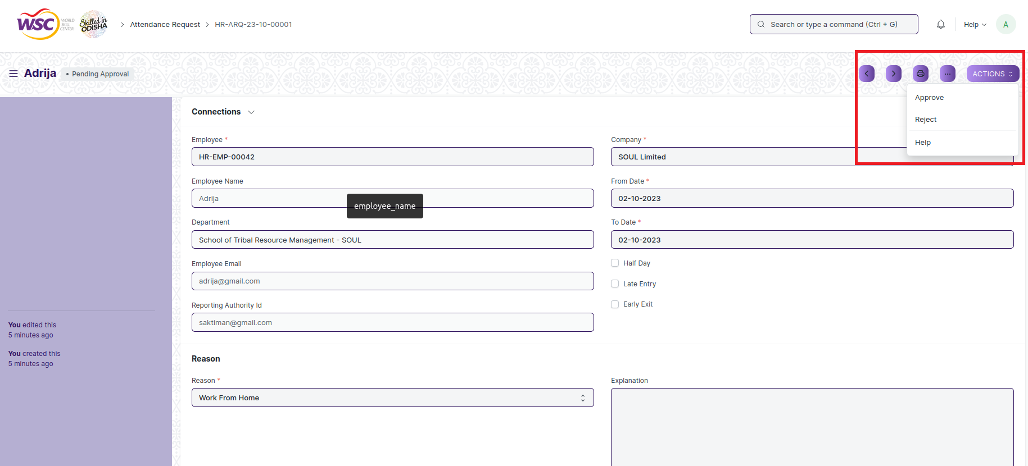

After clicking on “**Approve**” , the respective Attendance will be created for that Employee in the “Attendance” form.

Email will also be sent to the Employee and HR Admin.

**View Attendance Request**

As it is an submittable screen, follow the procedure to view a submittable document as mentioned above.

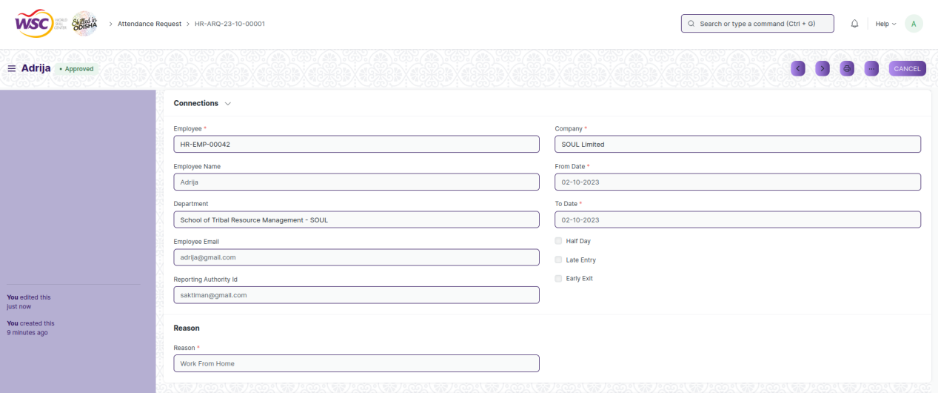

View of a submitted Attendance Request.

**Cancel Attendance Request**

As it is a submittable screen, follow the general procedure to Cancel a submittable document as mentioned above.

**Delete Attendance Request**

If the document is not submitted , it is in Draft , you can delete the document by following the procedure to delete a save document.

If the document is submitted, follow the procedure to delete the submittable document.

**Amend Attendance Request**

As it is a submittable screen , follow the general procedure to Amend the document.

**Edit Attendance Request**

If the document is in Draft state , the document can be editable.

Once the document is submitted , it cannot be edited.

**Print Attendance Request**

Follow the general procedure to print a submitted document.

**View Attendance Request in different format**

Follow the general procedure to view a submitted document in different format.

## Employee Checkin

Employee Checkin is used to keep a log of all the check-ins and check-outs of an employee in the organization. Most organizations use this for attendance, shift management, and working hours calculations.

The feature is accessible to HR Admin,HR Manager /Cs officer ,Director,HR Assistant.

To access the Employee Checkin screen ,go to :

***Home>HRMS>Attendance>Employee Checkin***

Screen Type : Save

**Prerequisites**

Before creating Employee Checkin , it is advisable you create the following documents:

* Employee
* Shift Type
* Shift Assignment

**Adding a new Employee Checkin**

* Login to the system.
* Go the HRMS workspace.
* Go to Employee Checkin.
* Enter the Employee,Log Type
* Click on “Save”.
* If you have set up shifts and shift assignments, the Employee Checkin will set the appropriate shift in which the timestamp falls after saving.
* You can enable Skip Auto Attendance to skip that record while marking attendance.
* You can also capture the location from where the employee has checked in or the Biometric Device ID.

**Note:**

1. If auto attendance is enabled, the attendance record marked for a set of check-ins will be linked to the document later.

After creating Employee Checkin , the record will be visible in the List view of the screen.

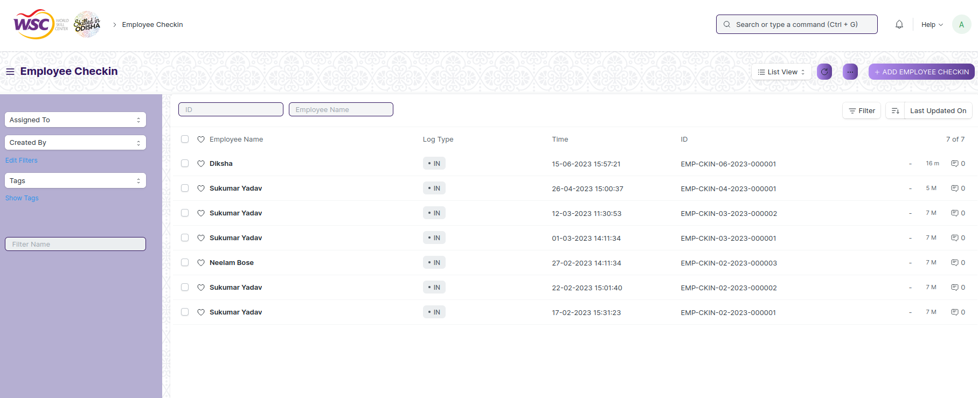

**View Employee Checkin**

As it is a save screen, follow the procedure to view a saved document as mentioned above.

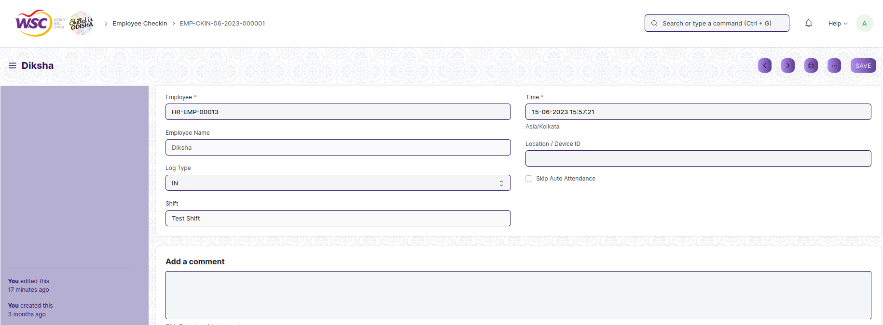

View of a saved Employee Checkin.

**Delete Recruitment Employee Checkin**

As it a Save screen , follow the general procedure to delete a save document .

**Edit Recruitment Employee Checkin**

Follow the steps to view a saved Employee Checkin .

Edit the field that you want to change.

Click on Save.

**View Employee Checkin in different format**

As it is a Save screen , follow the general procedure to view a saved document in different format.

# Appraisal

## KRA

This screen helps you to different types of KRA for appraisal, which will be used in appraisal template.

The screen is accessible to Employee , HR Admin,HR Manager /Cs officer ,Director,HR Assistant.

To access the KRA Master screen ,go to :

***Home>HRMS(Base)>Appraisal System>KRA***

Screen Type : Save

**Adding a new KRA**

As it is a save screen, follow the general procedure to create a save document as mentioned above .

* Go to KRA list, click on Add New.
* KRA Name.
* Save.

After creating an KRA , the record will be visible in the List view of the screen.

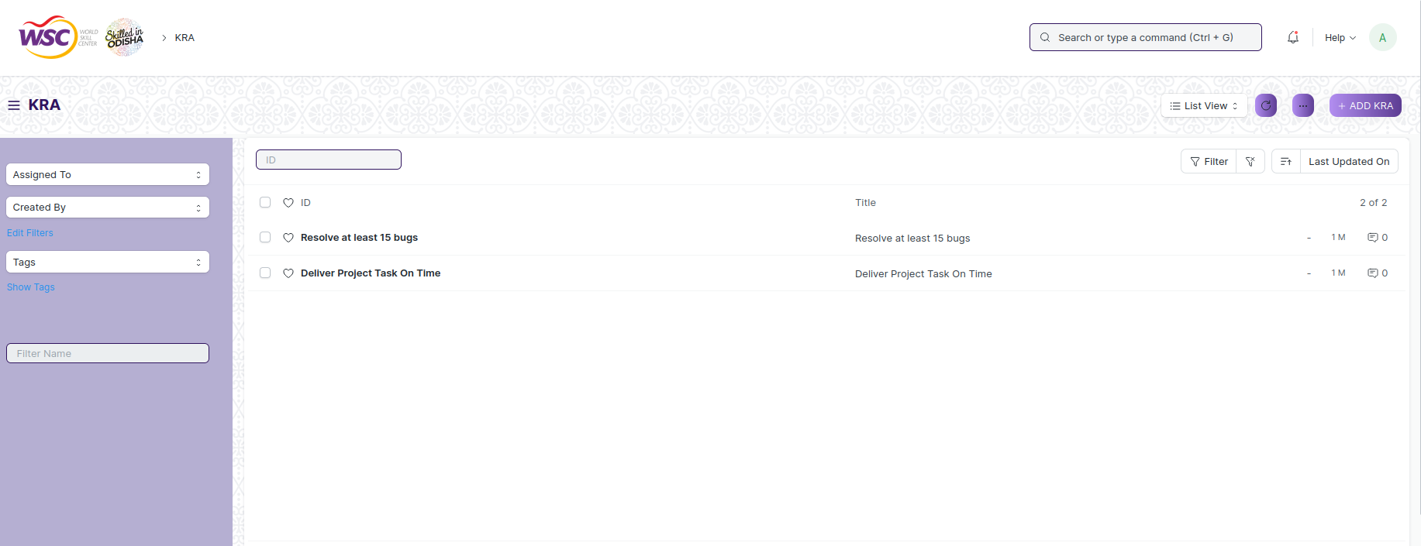

(List view of KRA)

**View KRA**

As it is a save screen, follow the general procedure to view a save document as mentioned above .

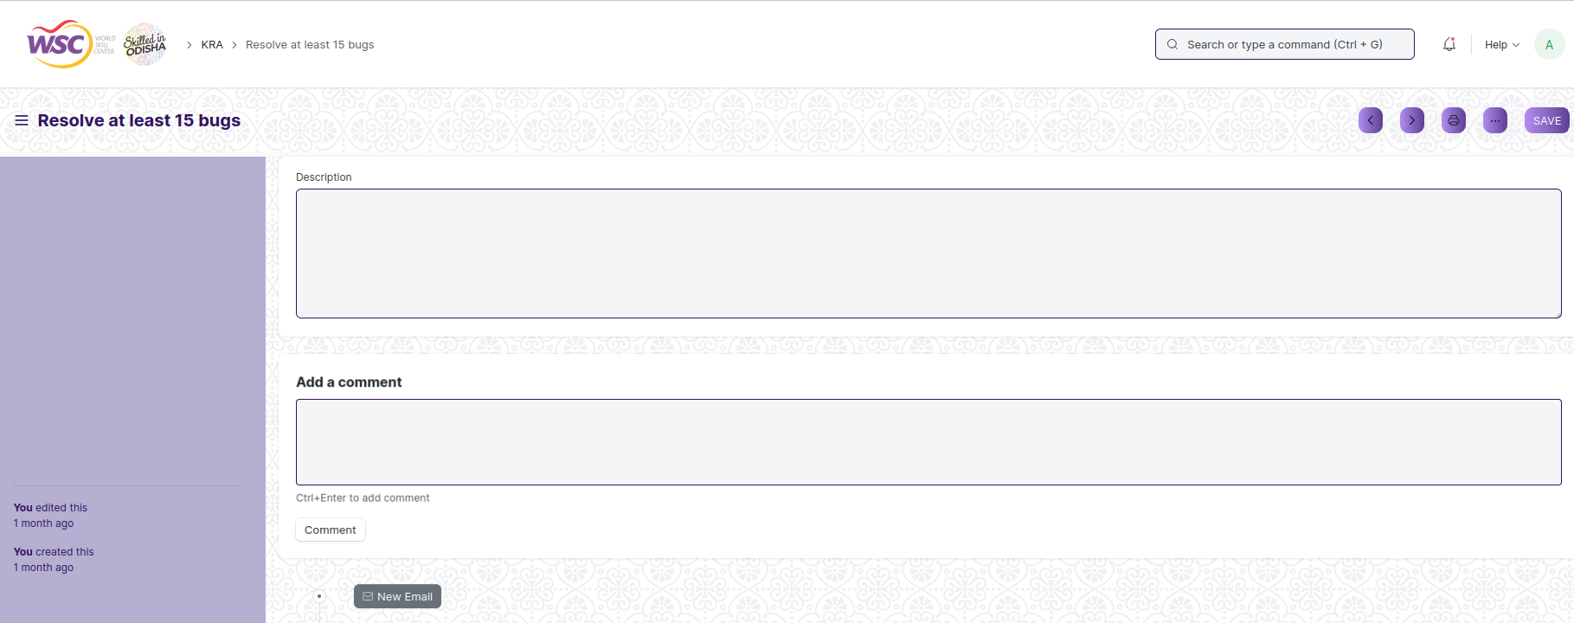

(View of a saved KRA)

**Delete Leave Type**

As it a Save screen , follow the general procedure to delete a save document .

**Edit Leave Type**

Follow the steps to view a saved KRA.

Edit the field that you want to change.

Click on Save.

**Print Leave Type Type**

As it is a Save screen , follow the general procedure to print a saved document.

**View Leave Type in different format**

As it is a Save screen , follow the general procedure to view a saved document in different format.

## Dimensions for Appraisal

This is a master screen which will help to create the dimensions which will be used in self appraisal process.

The screen is accessible to Employee , HR Admin,HR Manager /Cs officer ,Director,HR Assistant.

To access the Dimensions for Appraisal Master screen ,go to :

***Home>HRMS(Base)>Appraisal System>Dimension for Appraisal***

Screen Type : Save

**Adding a new Dimension for Appraisal**

As it is a save screen, follow the general procedure to create a save document as mentioned above .

* Go to Dimension for Appraisal List, click on Add New.
* Enter the Dimension Name.
* Mark Active , if you want to use the dimension in the self appraisal process.
* Save.

After creating an KRA , the record will be visible in the List view of the screen.

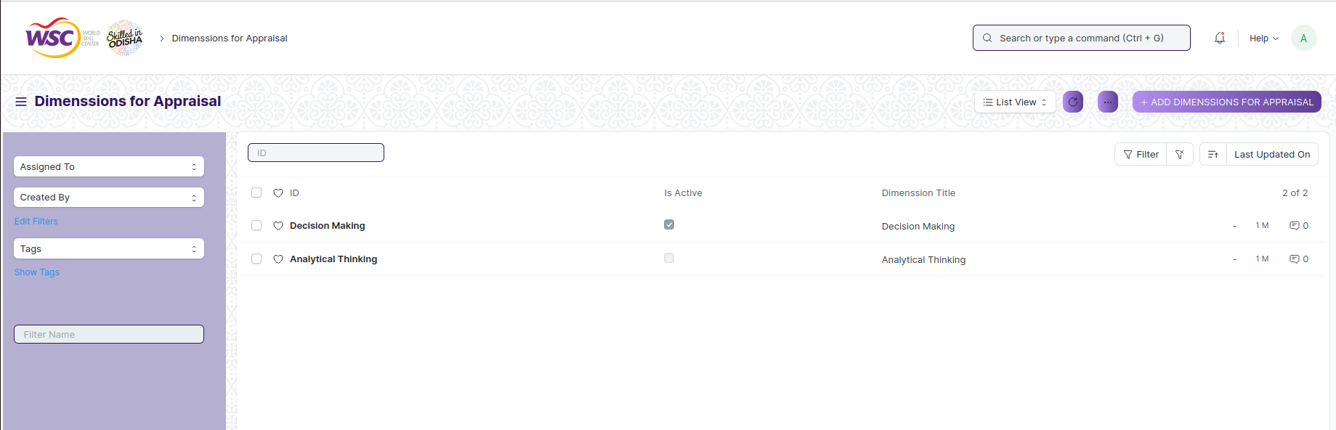

(List view of Dimension for Appraisal)

**View Dimension for Appraisal**

As it is a save screen, follow the general procedure to view a save document as mentioned above .

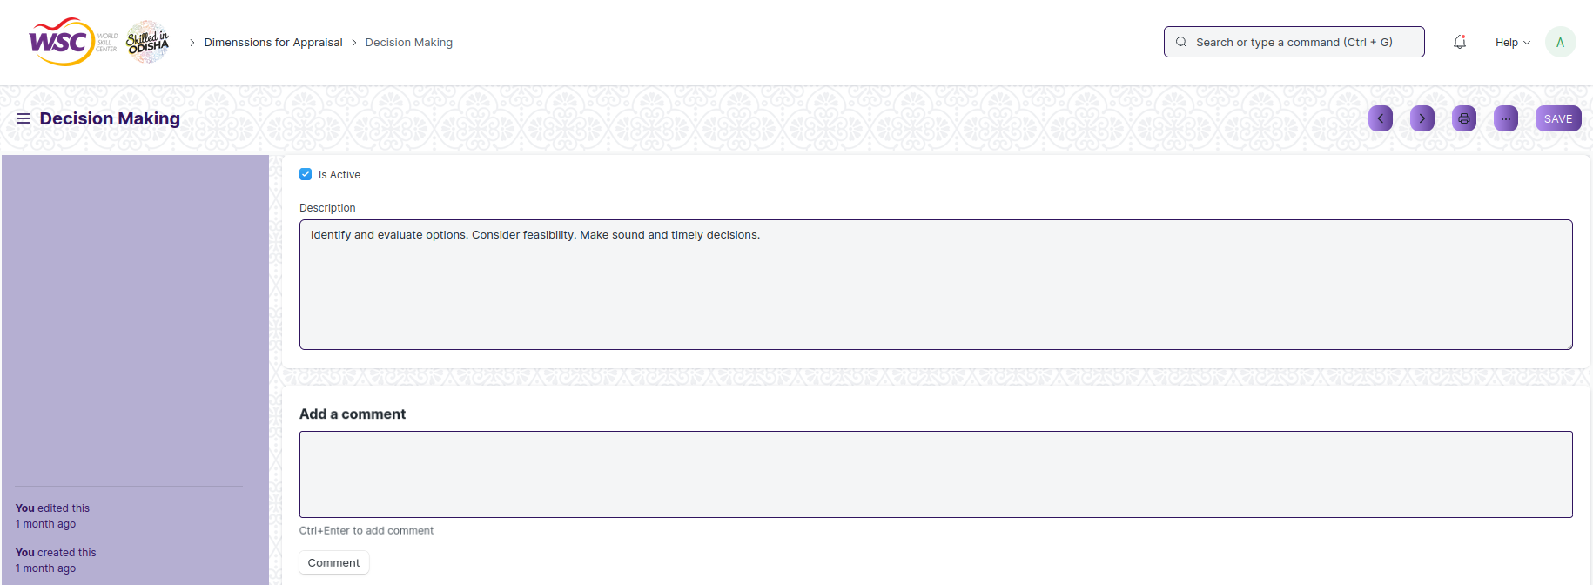

(View of a saved Dimension for Appraisal)

**Delete Dimension for Appraisal**

As it a Save screen , follow the general procedure to delete a save document .

**Edit Dimension for Appraisal**

Follow the steps to view a saved Dimension for Appraisal.

Edit the field that you want to change.

Click on Save.

**Print Dimension for Appraisal**

As it is a Save screen , follow the general procedure to print a saved document.

**View Dimension for Appraisal**

As it is a Save screen , follow the general procedure to view a saved document in different format.

## Employee Appraisal Evaluation Template

In this screen You can define the KRAs based on which employees would be rated in the Appraisal Template.

The screen is accessible to Employee , HR Admin,HR Manager /Cs officer ,Director,HR Assistant.

To access the Employee Appraisal Evaluation Template screen ,go to :

***Home>HRMS(Base)>Appraisal System>Employee Appraisal Evaluation Template***

Screen Type : Save

**Prerequisites :**

Before creating an Appraisal Template , it is advisable you create the following documents:

* KRA

**Adding a new Appraisal Template**

As it is a save screen, follow the general procedure to create a save document as mentioned above .

* Go to Employee Appraisal Evaluation Template List, click on Add New.
* Enter the Template Name.
* Enter the description.
* Enter the KRAs , due date , category in the Key work goal table.
* Click on save.

After creating an Appraisal Template , the record will be visible in the List view of the screen.

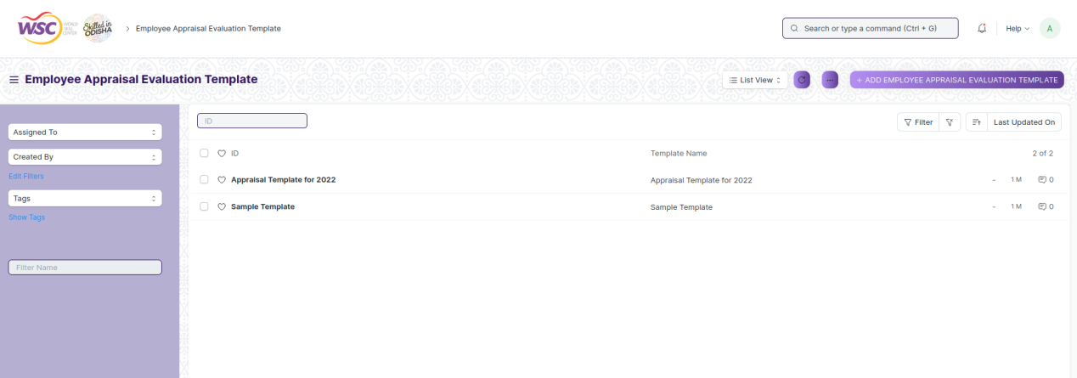

(List view of Employee Appraisal Evaluation Template)

**View Appraisal Template**

As it is a save screen, follow the general procedure to view a save document as mentioned above .

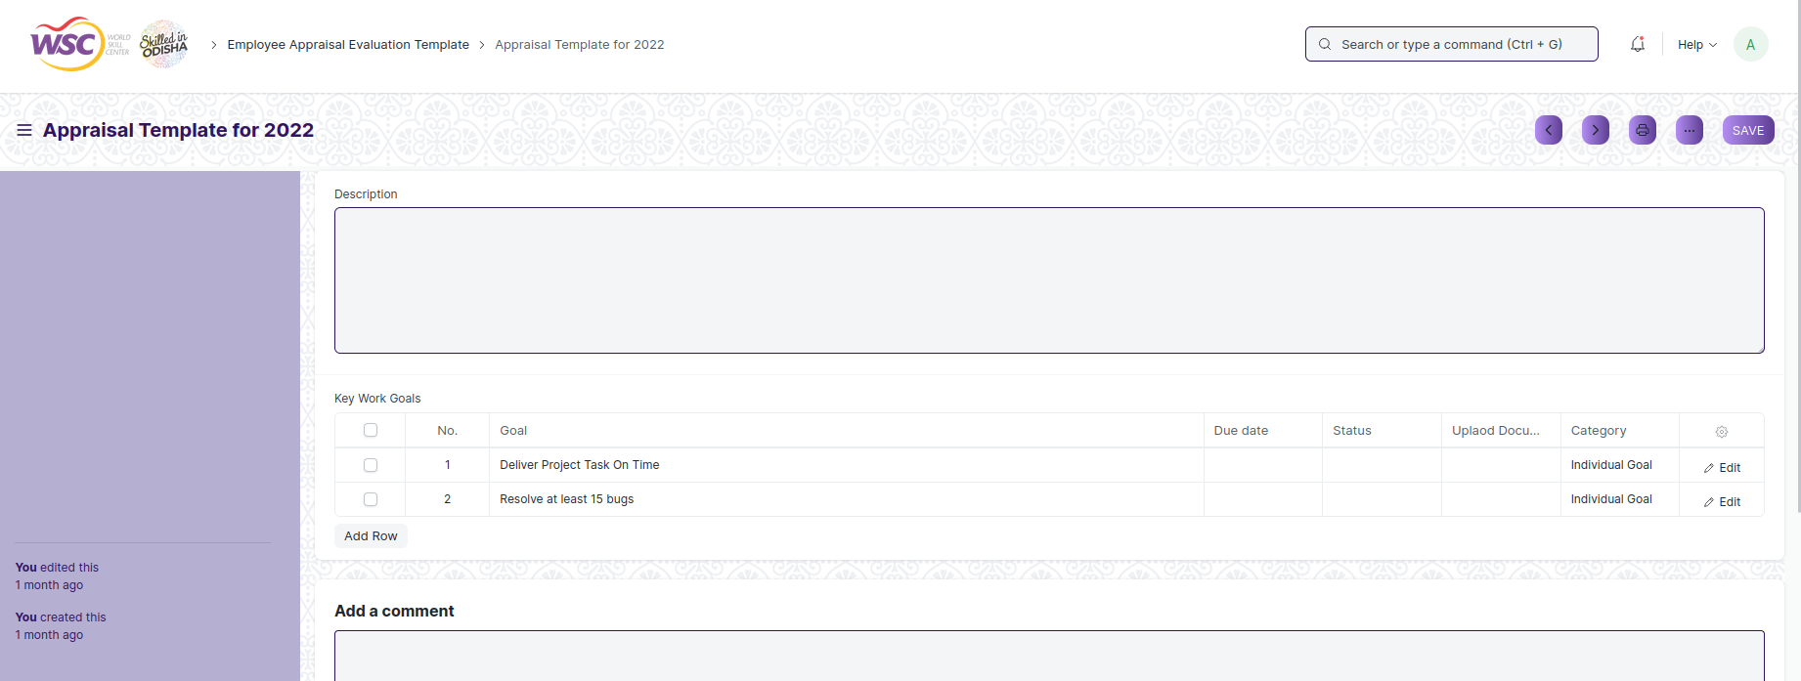

(View of a saved Appraisal Template)

**Delete Appraisal Template**

As it a Save screen , follow the general procedure to delete a save document .

**Edit Appraisal Template**

Follow the steps to view a saved Appraisal Template.

Edit the field that you want to change.

Click on Save.

**Print Appraisal Template**

As it is a Save screen , follow the general procedure to print a saved document.

**View Appraisal Template**

As it is a Save screen , follow the general procedure to view a saved document in different format.

## Employee Appraisal Cycle

This is a master screen which will help to create the appraisal cycle , which will be used in the employee appraisal.

The screen is accessible to employee , HR Admin,HR Manager /Cs officer ,Director,HR Assistant.

To access the Employee Appraisal cycle screen ,go to :

***Home>HRMS(Base)>Appraisal System>Employee Appraisal Cycle***

Screen Type : Save

**Prerequisites :**

Before creating an Appraisal Template , it is advisable you create the following documents:

* Appraisal Template

**Adding a new Appraisal Cycle**

As it is a save screen, follow the general procedure to create a save document as mentioned above .

* Go to Employee Appraisal Cycle List, click on Add New.
* Enter the Appraisal cycle name.
* Enter the Appraisal Year , from date, to date.
* Select the appraisal template.
* Select the appraisal round ( 1 or 2 )
* Enter the date to notify employee after.
* Save.

**Note :** Select appraisal round as 1 if it is 1st round of appraisal, select 2 if the 2nd round to the appraisal which includes self appraisal process.

**Note :** Notify Employee After field is used to trigger email to employees after that date.

After creating an Appraisal Cycle , the record will be visible in the List view of the screen.

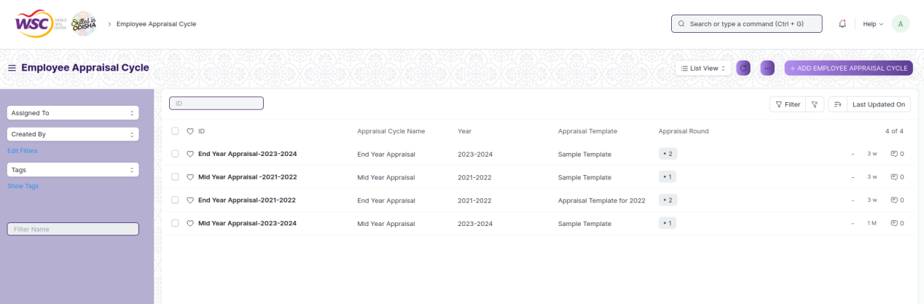

(List view of Appraisal Cycle)

**View Appraisal cycle**

As it is a save screen, follow the general procedure to view a save document as mentioned above .

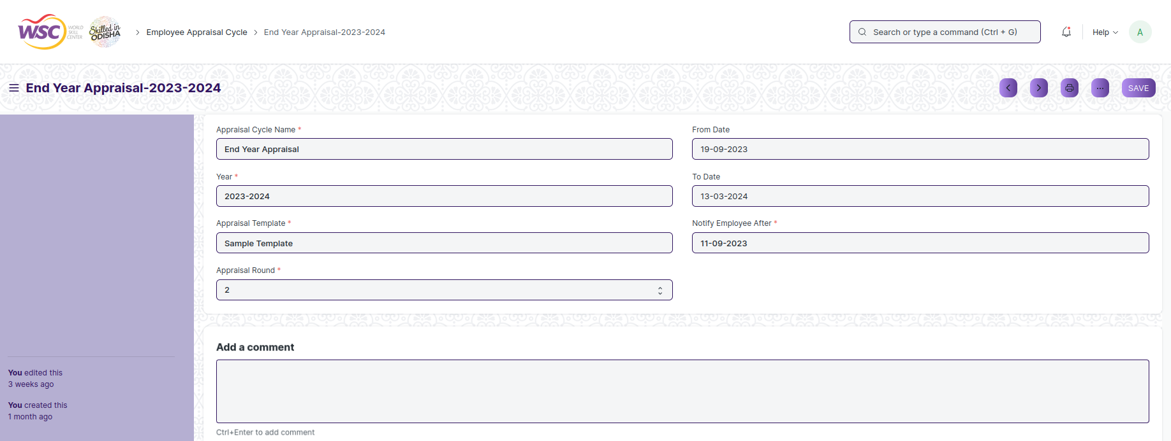

(View of a saved Appraisal Cycle)

**Delete Appraisal Cycle**

As it a Save screen , follow the general procedure to delete a save document .

**Edit Appraisal Cycle**

Follow the steps to view a saved Appraisal Cycle.

Edit the field that you want to change.

Click on Save.

**Print Appraisal Cycle**

As it is a Save screen , follow the general procedure to print a saved document.

**View Appraisal Cycle**

As it is a Save screen , follow the general procedure to view a saved document in different format.

## Employee Appraisal Portal

This screen is used for the appraisal process.In this screen the employee will be apply for the appraisal.

The screen is accessible to Employee , HR Admin,HR Manager /Cs officer ,Director,HR Assistant.

To access the Employee Appraisal Portal screen ,go to :

***Home>HRMS(Base)>Appraisal System>Employee Appraisal Portal***

Screen Type : Submit

**Prerequisites**

Before creating an Employee Resignation , it is advisable you create the following documents:

* Employee
* Employee Appraisal Evaluation Template
* Appraisal Cycle

**Adding a new Employee Appraisal**

As it is a submittable screen follow the general procedure to create a submittable document.

* Go to: Employee Appraisal Portal, Click on Add New.
* Select employee, appraisal cycle.
* Appraisal Template will be automatically fetched.
* Fill the details in the Key work goals table.
* Save and Submit.

**Note :** If it is the final appraisal round (I.e. 2nd round of appraisal) then the self appraisal process I.e. competency rating field ( for self appraisal ) will show in the screen.

After submitting the appraisal will be show in the list view of the screen.

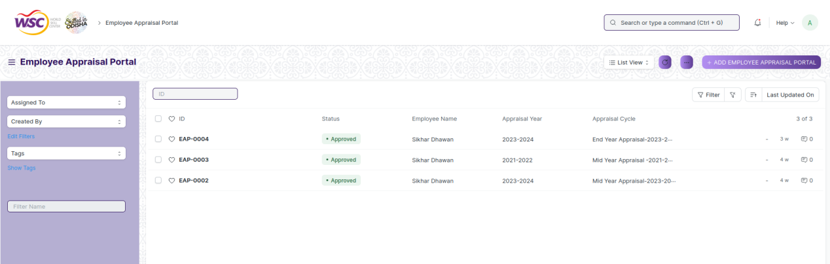

(List View of Employee Appraisal)

**Note :** After submitting the document , a workflow begins. First it will be forwarded to the Reporting Authority of the employee. Once the reporting authority approves , it will be forwarded to the department head of the employee . Finally after the approval of the department head, it will be forwarded to the Director Admin for final Approval.

Email will be sent to the respective authority in each workflow state.The final email will be sent to the HR Admin , after the completion of workflow.

**Process After Submission**

**Action of Reporting Authority**

If logged in user is the reporting authority of the employee and the document state is Pending Approval from Reporting Authority, then an action button will be visible in the right corner of the document. Click on Action button , select Approve to forward the document to the department head and Reject to reject the document.

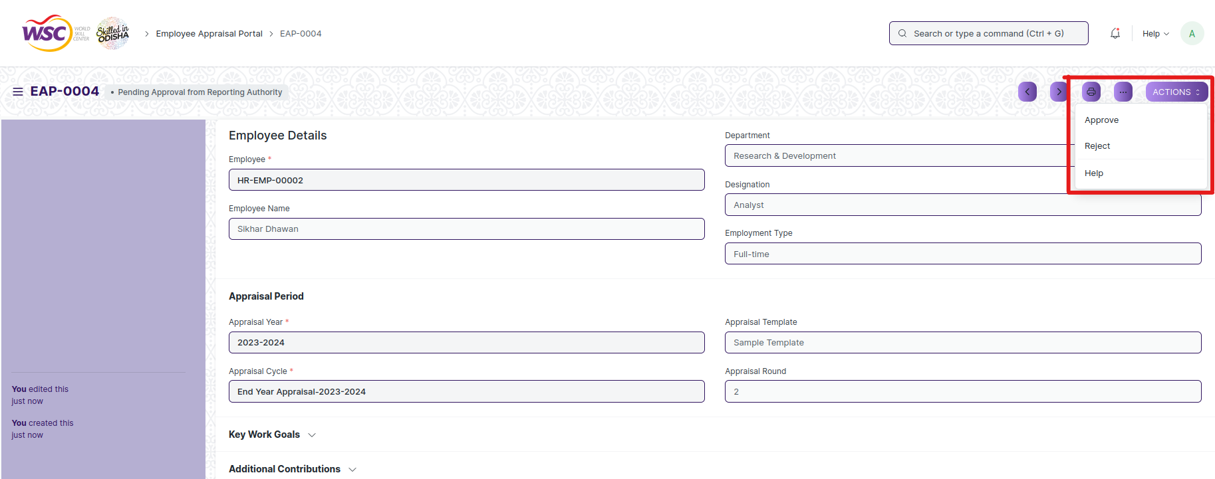

(Action button for Reporting Authority)

**Note :** The reporting authority will be able to add the comments in the Key work goal table. Also can be able to add the Final Grade and overall grade in the screen.

**Action of Department Head**

If logged in user is the Department head of the employee and the document state is Pending Approval from Department Head, then an action button will be visible in the right corner of the document. Click on Action button , select Approve to forward the document to the Director Admin or Reject the document.

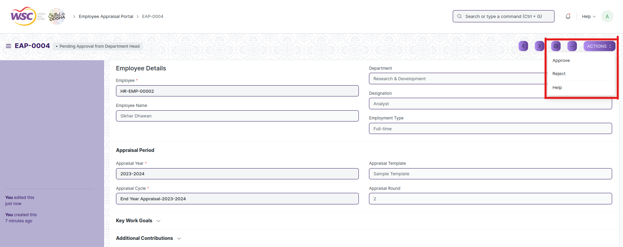

(Action button for Department Head)

**Action of Director Admin**

If logged in user is the Director Admin and the document state is Pending Approval from Director Admin , then an action button will be visible in the right corner of the document. Click on Action button , select Approve or Reject to end the process .

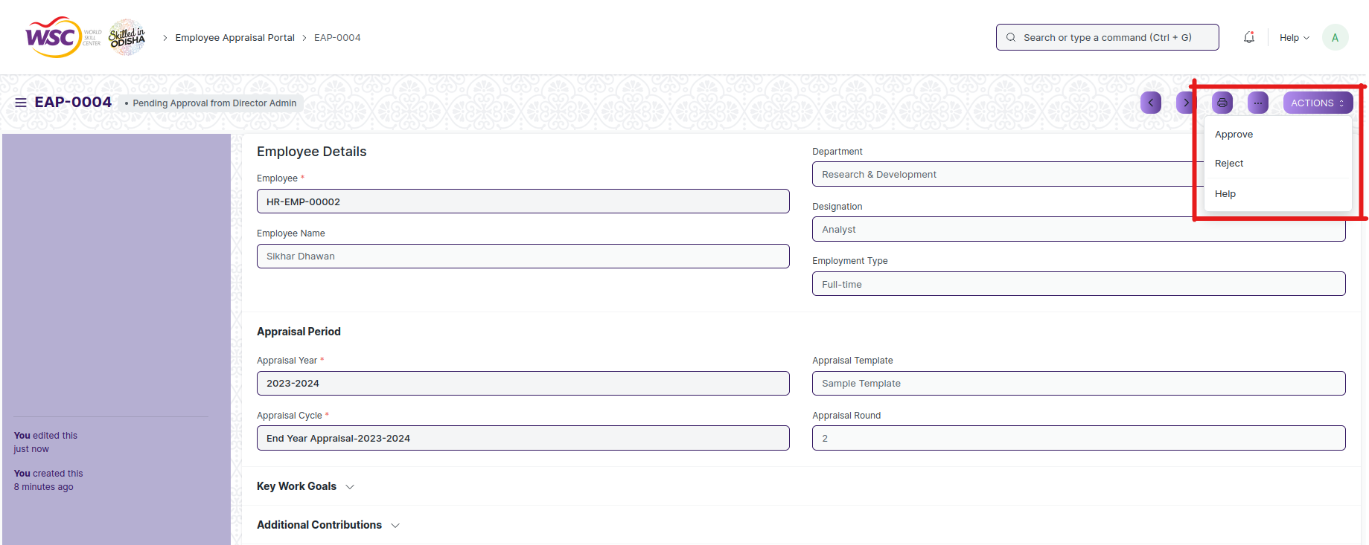

(Action button for Director Admin)

**Note :** Once the document is finally get approved by Director Admin , the final email will be sent to the HR admin.

**View Employee Appraisal**

As it is an submittable screen, follow the procedure to view a submittable document as mentioned above.

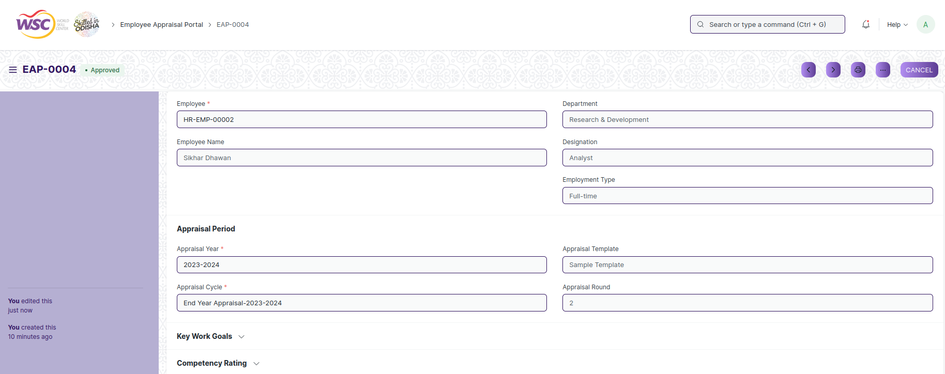

(View of a submitted Employee Appraisal)

**Cancel Employee Appraisal**

As it is a submittable screen, follow the general procedure to Cancel a submittable document as mentioned above.

**Delete Employee Appraisal**

If the document is not submitted , it is in draft state , you can delete the document by following the procedure to delete a save document.

If the document is submitted, follow the procedure to delete the submittable document.

**Amend Employee Appraisal**

As it is a submittable screen , follow the general procedure to Amend the document.

**Edit Employee Appraisal**

If the document is in draft state , the document can be editable.

Once the document is submitted , it cannot be edited.

**Print Employee Appraisal**

Follow the general procedure to print a saved document.

**View Employee Appraisal in different format**

follow the general procedure to view a saved document in different format.

# Settings

## HR Setting

HR Settings allows global settings for HR-related documents.

The screen is accessible to HR Admin,HR Manager /Cs officer ,Director,HR Assistant.

To access the HR Settings ,go to :

***Home>HRMS(Base)>Settings>HR Settings***

Screen Type : Save

There are various settings available in the HR Settings.

**Employee Settings**

**Retirement Age:**

* You can enter the retirement age (in years) for your employees.

**Employee Records to be created by**

The naming for employee documents is based on the value selected in this field.

* **Naming Series:** The employee documents created will be named using the naming series selected in the 'Series' field.
* **Employee Number:** The Employee Number field becomes visible in selecting this field, and the naming of the employee document happens based on this field.
* **Full Name:** The employee document is named using the full name of the employee.

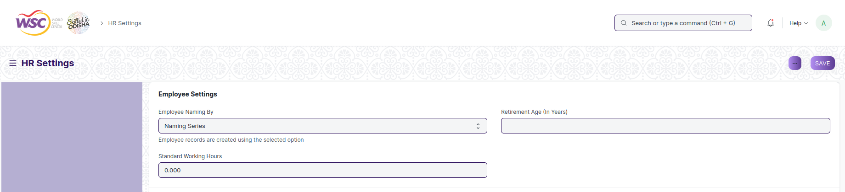

(View of Employee Settings )

**Reminders**

**Birthday Reminders**

* An email is sent to all the employees of the company when an employee has a birthday. To stop this email from being sent you can uncheck this option.

**Anniversary Reminders**

* An email is sent to all the employees of the company when an employee has a anniversary. To stop this email from being sent you can uncheck this option.

**Holiday**

* An email is sent to all the employees of the company when there is an holiday. To stop this email from being sent you can uncheck this option.

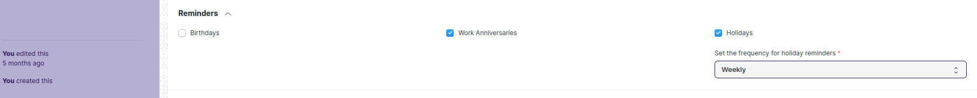

(View of Reminders)

**Leave and Expense Claim Settings**

* In Expense Claim Document the 'Expense Approver' field is set to mandatory on checking this option.
* **Leave Approval Notification Template :** On creating or updating a leave application with a leave approver, an email is sent to this leave approver notifying about the new leave application. The email template used for this purpose can be selected here.
* **Leave Status Notification Template :** On Submission/Cancellation of a leave application, the employee receives an email with the updated status of their leave application. The email template used for this purpose can be selected here.
* **Leave Approver Mandatory In Leave Application :** In Leave Application document the 'Leave Approver' field is set to mandatory on checking this option.
* **Show Leaves Of All Department Members In Calendar :** The approved leaves of all employees in the same department are shown in the calendar view on checking this option.
* **Auto Leave Encashment :** If checked, the system generates a draft Leave Encashment record on the expiry of the leave allocation for all encashable Leave Types.
* **Restrict Backdated Leave Application :** If checked, the system will not allow making a backdated leave application.
* **Automatic Allocate Leaves Based On Leave Policy :** If checked, leaves will be granted to the employees automatically based on the Effective From date as per the present Leave Policy Assignment.



(View of Leave and Expense claim settings)

**Hiring Settings**

* **Check Vacancies On Job Offer Creation :** On the creation of a job offer for a particular position, vacancies present in the staffing plan for that position are checked to warn the user from over hiring for a particular position.
* **Send Interview Feedback Reminder :** Check this option to send notification to the candidate for interview feedback.
* **Send Interview Reminder :** Check this option if you want to send notifications to the candidates for interview reminder.



# Roles and Permissions

## Masters

**Employment Type**

|  |  |  |  |  |  |  |  |  |  |
| --- | --- | --- | --- | --- | --- | --- | --- | --- | --- |
| **ID** | **Role** | **Select** | **Read** | **Write** | **Create** | **Delete** | **Submit** | **Cancel** | **Amend** |
| 1 | HR Admin/Director Admin | Yes | Yes | Yes | Yes | Yes | NA | NA | NA |
| 2 | HR Manager/CS | No | Yes | Yes | Yes | No | NA | NA | NA |
| 3 | HR Assistant | No | Yes | No | No | No | NA | NA | NA |
| 4 | Employee | No | No | No | No | No | NA | NA | NA |

**Campus Location**

|  |  |  |  |  |  |  |  |  |  |
| --- | --- | --- | --- | --- | --- | --- | --- | --- | --- |
| **ID** | **Role** | **Select** | **Read** | **Write** | **Create** | **Delete** | **Submit** | **Cancel** | **Amend** |
| 1 | HR Admin/Director Admin | Yes | Yes | Yes | Yes | Yes | NA | NA | NA |
| 2 | HR Manager/CS | No | Yes | Yes | Yes | No | NA | NA | NA |
| 3 | HR Assistant | No | Yes | No | No | No | NA | NA | NA |
| 4 | Employee | No | Yes | No | No | No | NA | NA | NA |

**Department**

|  |  |  |  |  |  |  |  |  |  |
| --- | --- | --- | --- | --- | --- | --- | --- | --- | --- |
| **ID** | **Role** | **Select** | **Read** | **Write** | **Create** | **Delete** | **Submit** | **Cancel** | **Amend** |
| 1 | HR Admin/Director Admin | Yes | Yes | Yes | Yes | Yes | NA | NA | NA |
| 2 | HR Manager/CS | No | Yes | Yes | Yes | No | NA | NA | NA |
| 3 | HR Assistant | No | Yes | No | No | No | NA | NA | NA |
| 4 | Employee | No | Yes | No | No | No | NA | NA | NA |

**Designation**

|  |  |  |  |  |  |  |  |  |  |
| --- | --- | --- | --- | --- | --- | --- | --- | --- | --- |
| **ID** | **Role** | **Select** | **Read** | **Write** | **Create** | **Delete** | **Submit** | **Cancel** | **Amend** |
| 1 | HR Admin/Director Admin | Yes | Yes | Yes | Yes | Yes | NA | NA | NA |
| 2 | HR Manager/CS | No | Yes | Yes | Yes | No | NA | NA | NA |
| 3 | HR Assistant | No | Yes | No | No | No | NA | NA | NA |
| 4 | Employee | No | Yes | No | No | No | NA | NA | NA |

**Employee Grade**

|  |  |  |  |  |  |  |  |  |  |
| --- | --- | --- | --- | --- | --- | --- | --- | --- | --- |
| **ID** | **Role** | **Select** | **Read** | **Write** | **Create** | **Delete** | **Submit** | **Cancel** | **Amend** |
| 1 | HR Admin/Director Admin | Yes | Yes | Yes | Yes | Yes | NA | NA | NA |
| 2 | HR Manager/CS | No | Yes | Yes | Yes | No | NA | NA | NA |
| 3 | HR Assistant | No | Yes | No | No | No | NA | NA | NA |
| 4 | Employee | No | Yes | No | No | No | NA | NA | NA |

**Employee Group**

|  |  |  |  |  |  |  |  |  |  |
| --- | --- | --- | --- | --- | --- | --- | --- | --- | --- |
| **ID** | **Role** | **Select** | **Read** | **Write** | **Create** | **Delete** | **Submit** | **Cancel** | **Amend** |
| 1 | HR Admin/Director Admin | Yes | Yes | Yes | Yes | Yes | NA | NA | NA |
| 2 | HR Manager/CS | No | Yes | Yes | Yes | No | NA | NA | NA |
| 3 | HR Assistant | No | Yes | No | No | No | NA | NA | NA |
| 4 | Employee | No | Yes | No | No | No | NA | NA | NA |

**Holiday List**

|  |  |  |  |  |  |  |  |  |  |
| --- | --- | --- | --- | --- | --- | --- | --- | --- | --- |
| **ID** | **Role** | **Select** | **Read** | **Write** | **Create** | **Delete** | **Submit** | **Cancel** | **Amend** |
| 1 | HR Admin/Director Admin | Yes | Yes | Yes | Yes | Yes | NA | NA | NA |
| 2 | HR Manager/CS | No | Yes | Yes | Yes | No | NA | NA | NA |
| 3 | HR Assistant | No | Yes | No | No | No | NA | NA | NA |
| 4 | Employee | No | Yes | No | No | No | NA | NA | NA |

## Recruitment

**Recruitment Exam Center**

|  |  |  |  |  |  |  |  |  |  |
| --- | --- | --- | --- | --- | --- | --- | --- | --- | --- |
| **ID** | **Role** | **Select** | **Read** | **Write** | **Create** | **Delete** | **Submit** | **Cancel** | **Amend** |
| 1 | HR Admin/Director Admin | Yes | Yes | Yes | Yes | Yes | NA | NA | NA |
| 2 | HR Manager/CS | No | Yes | Yes | Yes | No | NA | NA | NA |
| 3 | HR Assistant | No | Yes | No | No | No | NA | NA | NA |
| 4 | Employee | No | No | No | No | No | NA | NA | NA |

**Job Requisition**

|  |  |  |  |  |  |  |  |  |  |
| --- | --- | --- | --- | --- | --- | --- | --- | --- | --- |
| **ID** | **Role** | **Select** | **Read** | **Write** | **Create** | **Delete** | **Submit** | **Cancel** | **Amend** |
| 1 | HR Admin/Director Admin | Yes | Yes | Yes | Yes | Yes | Yes | Yes | Yes |
| 2 | HR Manager/CS | No | Yes | Yes | Yes | No | Yes | Yes | No |
| 3 | HR Assistant | No | Yes | Yes | Yes | No | Yes | No | No |
| 4 | Employee | No | Yes | Yes | Yes | No | Yes | No | No |

**Staffing Plan**

|  |  |  |  |  |  |  |  |  |  |
| --- | --- | --- | --- | --- | --- | --- | --- | --- | --- |
| **ID** | **Role** | **Select** | **Read** | **Write** | **Create** | **Delete** | **Submit** | **Cancel** | **Amend** |
| 1 | HR Admin/Director Admin | Yes | Yes | Yes | Yes | Yes | NA | NA | NA |
| 2 | HR Manager/CS | No | Yes | No | Yes | No | NA | NA | NA |
| 3 | HR Assistant | No | Yes | No | No | No | NA | NA | NA |
| 4 | Employee | No | Yes | No | No | No | NA | NA | NA |

**Job Opening**

|  |  |  |  |  |  |  |  |  |  |
| --- | --- | --- | --- | --- | --- | --- | --- | --- | --- |
| **ID** | **Role** | **Select** | **Read** | **Write** | **Create** | **Delete** | **Submit** | **Cancel** | **Amend** |
| 1 | HR Admin/Director Admin | Yes | Yes | Yes | Yes | Yes | NA | NA | NA |
| 2 | HR Manager/CS | No | Yes | Yes | Yes | No | NA | NA | NA |
| 3 | HR Assistant | No | Yes | No | No | No | NA | NA | NA |
| 4 | Employee | No | Yes | No | No | No | NA | NA | NA |

**Job Applicant**

|  |  |  |  |  |  |  |  |  |  |
| --- | --- | --- | --- | --- | --- | --- | --- | --- | --- |
| **ID** | **Role** | **Select** | **Read** | **Write** | **Create** | **Delete** | **Submit** | **Cancel** | **Amend** |
| 1 | HR Admin/Director Admin | Yes | Yes | Yes | Yes | Yes | NA | NA | NA |
| 2 | HR Manager | No | Yes | Yes | Yes | No | NA | NA | NA |
| 3 | HR Assistant | No | Yes | Yes | Yes | No | NA | NA | NA |
| 4 | Employee | No | Yes | Yes | Yes | No | NA | NA | NA |

**Recruitment Exam Declaration**

|  |  |  |  |  |  |  |  |  |  |
| --- | --- | --- | --- | --- | --- | --- | --- | --- | --- |
| **ID** | **Role** | **Select** | **Read** | **Write** | **Create** | **Delete** | **Submit** | **Cancel** | **Amend** |
| 1 | HR Admin/Director Admin | Yes | Yes | Yes | Yes | Yes | NA | NA | NA |
| 2 | HR Manager/CS | No | Yes | Yes | Yes | No | NA | NA | NA |
| 3 | HR Assistant | No | Yes | No | No | No | NA | NA | NA |
| 4 | Employee | No | Yes | No | No | No | NA | NA | NA |

**Recruitment Admit Card Generation Tool**

|  |  |  |  |  |  |  |  |  |  |
| --- | --- | --- | --- | --- | --- | --- | --- | --- | --- |
| **ID** | **Role** | **Select** | **Read** | **Write** | **Create** | **Delete** | **Submit** | **Cancel** | **Amend** |
| 1 | HR Admin/Director Admin | Yes | Yes | Yes | Yes | Yes | NA | NA | NA |
| 2 | HR Manager/CS | No | Yes | Yes | Yes | No | NA | NA | NA |
| 3 | HR Assistant | No | Yes | No | No | No | NA | NA | NA |
| 4 | Employee | No | Yes | No | No | No | NA | NA | NA |

**Recruitment Admit Card Generation**

|  |  |  |  |  |  |  |  |  |  |
| --- | --- | --- | --- | --- | --- | --- | --- | --- | --- |
| **ID** | **Role** | **Select** | **Read** | **Write** | **Create** | **Delete** | **Submit** | **Cancel** | **Amend** |
| 1 | HR Admin/Director Admin | Yes | Yes | Yes | Yes | Yes | NA | NA | NA |
| 2 | HR Manager/CS | No | Yes | Yes | Yes | No | NA | NA | NA |
| 3 | HR Assistant | No | Yes | No | No | No | NA | NA | NA |
| 4 | Employee | No | Yes | No | No | No | NA | NA | NA |

**Recruitment Exam Result Declaration Tool**

|  |  |  |  |  |  |  |  |  |  |
| --- | --- | --- | --- | --- | --- | --- | --- | --- | --- |
| **ID** | **Role** | **Select** | **Read** | **Write** | **Create** | **Delete** | **Submit** | **Cancel** | **Amend** |
| 1 | HR Admin/Director Admin | Yes | Yes | Yes | Yes | Yes | NA | NA | NA |
| 2 | HR Manager/CS | No | Yes | Yes | Yes | No | NA | NA | NA |
| 3 | HR Assistant | No | Yes | No | No | No | NA | NA | NA |
| 4 | Employee | No | Yes | No | No | No | NA | NA | NA |

**Recruitment Exam Result Declaration**

|  |  |  |  |  |  |  |  |  |  |
| --- | --- | --- | --- | --- | --- | --- | --- | --- | --- |
| **ID** | **Role** | **Select** | **Read** | **Write** | **Create** | **Delete** | **Submit** | **Cancel** | **Amend** |
| 1 | HR Admin/Director Admin | Yes | Yes | Yes | Yes | Yes | NA | NA | NA |
| 2 | HR Manager/CS | No | Yes | Yes | Yes | No | NA | NA | NA |
| 3 | HR Assistant | No | Yes | No | No | No | NA | NA | NA |
| 4 | Employee | No | Yes | No | No | No | NA | NA | NA |

**Job Offer**

|  |  |  |  |  |  |  |  |  |  |
| --- | --- | --- | --- | --- | --- | --- | --- | --- | --- |
| **ID** | **Role** | **Select** | **Read** | **Write** | **Create** | **Delete** | **Submit** | **Cancel** | **Amend** |
| 1 | HR Admin/Director Admin | Yes | Yes | Yes | Yes | Yes | Yes | Yes | Yes |
| 2 | HR Manager/CS | No | Yes | Yes | Yes | Yes | Yes | Yes | Yes |
| 3 | HR Assistant | No | Yes | No | No | No | No | No | No |
| 4 | Employee | No | Yes | No | No | No | No | No | No |

**Appointment Letter Template**

|  |  |  |  |  |  |  |  |  |  |
| --- | --- | --- | --- | --- | --- | --- | --- | --- | --- |
| **ID** | **Role** | **Select** | **Read** | **Write** | **Create** | **Delete** | **Submit** | **Cancel** | **Amend** |
| 1 | HR Admin/Director Admin | Yes | Yes | Yes | Yes | Yes | NA | NA | NA |
| 2 | HR Manager | No | Yes | Yes | Yes | Yes | NA | NA | NA |
| 3 | HR Assistant | No | Yes | No | No | No | NA | NA | NA |
| 4 | Employee | No | Yes | No | No | No | NA | NA | NA |

**Appointment Letter**

|  |  |  |  |  |  |  |  |  |  |
| --- | --- | --- | --- | --- | --- | --- | --- | --- | --- |
| **ID** | **Role** | **Select** | **Read** | **Write** | **Create** | **Delete** | **Submit** | **Cancel** | **Amend** |
| 1 | HR Admin/Director Admin | Yes | Yes | Yes | Yes | Yes | NA | NA | NA |
| 2 | HR Manager | No | Yes | Yes | Yes | Yes | NA | NA | NA |
| 3 | HR Assistant | No | Yes | No | No | No | NA | NA | NA |
| 4 | Employee | No | No | No | No | No | NA | NA | NA |

## Employee Life Cycle

**Employee**

|  |  |  |  |  |  |  |  |  |  |
| --- | --- | --- | --- | --- | --- | --- | --- | --- | --- |
| **ID** | **Role** | **Select** | **Read** | **Write** | **Create** | **Delete** | **Submit** | **Cancel** | **Amend** |
| 1 | HR Admin/Director Admin | Yes | Yes | Yes | Yes | Yes | NA | NA | NA |
| 2 | HR Manager/CS | Yes | Yes | Yes | Yes | No | NA | NA | NA |
| 3 | HR Assistant | No | Yes | No | No | No | NA | NA | NA |
| 4 | Employee | No | Yes | No | No | No | NA | NA | NA |

**Employee Profile Updation**

|  |  |  |  |  |  |  |  |  |  |
| --- | --- | --- | --- | --- | --- | --- | --- | --- | --- |
| **ID** | **Role** | **Select** | **Read** | **Write** | **Create** | **Delete** | **Submit** | **Cancel** | **Amend** |
| 1 | HR Admin/Director Admin | Yes | Yes | Yes | Yes | Yes | Yes | Yes | Yes |
| 2 | HR Manager/CS | No | Yes | Yes | Yes | Yes | Yes | Yes | No |
| 3 | HR Assistant | No | Yes | No | Yes | No | Yes | No | No |
| 4 | Employee | Yes | Yes | Yes | Yes | No | Yes | No | No |

**Employee On-boarding Template**

|  |  |  |  |  |  |  |  |  |  |
| --- | --- | --- | --- | --- | --- | --- | --- | --- | --- |
| **ID** | **Role** | **Select** | **Read** | **Write** | **Create** | **Delete** | **Submit** | **Cancel** | **Amend** |
| 1 | HR Admin/Director Admin | Yes | Yes | Yes | Yes | Yes | NA | NA | NA |
| 2 | HR Manager/CS | Yes | Yes | Yes | Yes | Yes | NA | NA | NA |
| 3 | HR Assistant | No | Yes | No | No | No | NA | NA | NA |
| 4 | Employee | No | No | No | No | No | NA | NA | NA |

**Employee On-boarding**

|  |  |  |  |  |  |  |  |  |  |
| --- | --- | --- | --- | --- | --- | --- | --- | --- | --- |
| **ID** | **Role** | **Select** | **Read** | **Write** | **Create** | **Delete** | **Submit** | **Cancel** | **Amend** |
| 1 | HR Admin/Director Admin | Yes | Yes | Yes | Yes | Yes | Yes | Yes | Yes |
| 2 | HR Manager/CS | Yes | Yes | Yes | Yes | Yes | Yes | Yes | No |
| 3 | HR Assistant | No | Yes | Yes | Yes | No | Yes | No | No |
| 4 | Employee | No | Yes | Yes | No | No | No | No | No |

**Employee Resignation**

|  |  |  |  |  |  |  |  |  |  |
| --- | --- | --- | --- | --- | --- | --- | --- | --- | --- |
| **ID** | **Role** | **Select** | **Read** | **Write** | **Create** | **Delete** | **Submit** | **Cancel** | **Amend** |
| 1 | HR Admin/Director Admin | Yes | Yes | Yes | Yes | Yes | Yes | Yes | Yes |
| 2 | HR Manager/CS | No | Yes | Yes | Yes | No | Yes | Yes | No |
| 3 | HR Assistant | No | Yes | No | No | No | No | No | No |
| 4 | Employee | No | Yes | Yes | No | No | No | No | No |

**Employee Separation Template**

|  |  |  |  |  |  |  |  |  |  |
| --- | --- | --- | --- | --- | --- | --- | --- | --- | --- |
| **ID** | **Role** | **Select** | **Read** | **Write** | **Create** | **Delete** | **Submit** | **Cancel** | **Amend** |
| 1 | HR Admin/Director Admin | Yes | Yes | Yes | Yes | Yes | NA | NA | NA |
| 2 | HR Manager/CS | Yes | Yes | Yes | Yes | No | NA | NA | NA |
| 3 | HR Assistant | No | Yes | No | No | No | NA | NA | NA |
| 4 | Employee | No | No | No | No | No | NA | NA | NA |

**Employee Separation**

|  |  |  |  |  |  |  |  |  |  |
| --- | --- | --- | --- | --- | --- | --- | --- | --- | --- |
| **ID** | **Role** | **Select** | **Read** | **Write** | **Create** | **Delete** | **Submit** | **Cancel** | **Amend** |
| 1 | HR Admin/Director Admin | Yes | Yes | Yes | Yes | Yes | Yes | Yes | Yes |
| 2 | HR Manager/CS | No | Yes | Yes | Yes | No | Yes | Yes | No |
| 3 | HR Assistant | No | Yes | No | No | No | No | No | No |
| 4 | Employee | No | Yes | No | No | No | No | No | No |

**Employee Suggestion**

|  |  |  |  |  |  |  |  |  |  |
| --- | --- | --- | --- | --- | --- | --- | --- | --- | --- |
| **ID** | **Role** | **Select** | **Read** | **Write** | **Create** | **Delete** | **Submit** | **Cancel** | **Amend** |
| 1 | HR Admin/Director Admin | Yes | Yes | Yes | Yes | Yes | Yes | Yes | Yes |
| 2 | HR Manager/CS | Yes | Yes | Yes | Yes | Yes | Yes | Yes | No |
| 3 | HR Assistant | No | Yes | Yes | Yes | No | Yes | No | No |
| 4 | Employee | No | Yes | Yes | Yes | No | Yes | No | No |

**Employee Re-engagement**

|  |  |  |  |  |  |  |  |  |  |
| --- | --- | --- | --- | --- | --- | --- | --- | --- | --- |
| **ID** | **Role** | **Select** | **Read** | **Write** | **Create** | **Delete** | **Submit** | **Cancel** | **Amend** |
| 1 | HR Admin/Director Admin | Yes | Yes | Yes | Yes | Yes | Yes | Yes | Yes |
| 2 | HR Manager/CS | No | Yes | Yes | Yes | No | Yes | Yes | No |
| 3 | HR Assistant | No | Yes | Yes | Yes | No | Yes | No | No |
| 4 | Employee | No | Yes | Yes | Yes | No | Yes | No | No |

**Employee Grievance Cell**

|  |  |  |  |  |  |  |  |  |  |
| --- | --- | --- | --- | --- | --- | --- | --- | --- | --- |
| **ID** | **Role** | **Select** | **Read** | **Write** | **Create** | **Delete** | **Submit** | **Cancel** | **Amend** |
| 1 | HR Admin/Director Admin | Yes | Yes | Yes | Yes | Yes | Yes | Yes | Yes |
| 2 | HR Manager/CS | No | Yes | Yes | Yes | No | Yes | Yes | No |
| 3 | HR Assistant | No | Yes | Yes | Yes | No | Yes | No | No |
| 4 | Employee | Yes | No | No | No | No | No | No | No |

**Employee Grievance**

|  |  |  |  |  |  |  |  |  |  |
| --- | --- | --- | --- | --- | --- | --- | --- | --- | --- |
| **ID** | **Role** | **Select** | **Read** | **Write** | **Create** | **Delete** | **Submit** | **Cancel** | **Amend** |
| 1 | HR Admin/Director Admin | Yes | Yes | Yes | Yes | Yes | Yes | Yes | Yes |
| 2 | HR Manager/CS | No | Yes | Yes | Yes | No | Yes | Yes | No |
| 3 | HR Assistant | No | Yes | Yes | Yes | No | Yes | No | No |
| 4 | Employee | No | Yes | Yes | Yes | No | Yes | No | No |

**Employee Transfer**

|  |  |  |  |  |  |  |  |  |  |
| --- | --- | --- | --- | --- | --- | --- | --- | --- | --- |
| **ID** | **Role** | **Select** | **Read** | **Write** | **Create** | **Delete** | **Submit** | **Cancel** | **Amend** |
| 1 | HR Admin/Director Admin | Yes | Yes | Yes | Yes | Yes | Yes | Yes | Yes |
| 2 | HR Manager/CS | No | Yes | Yes | Yes | No | Yes | Yes | No |
| 3 | HR Assistant | No | Yes | Yes | Yes | No | Yes | No | No |
| 4 | Employee | No | Yes | Yes | Yes | No | Yes | No | No |

## Leave Management

**Leave Type**

|  |  |  |  |  |  |  |  |  |  |
| --- | --- | --- | --- | --- | --- | --- | --- | --- | --- |
| **ID** | **Role** | **Select** | **Read** | **Write** | **Create** | **Delete** | **Submit** | **Cancel** | **Amend** |
| 1 | HR Admin/Director Admin | Yes | Yes | Yes | Yes | Yes | NA | NA | NA |
| 2 | HR Manager/CS | No | Yes | Yes | Yes | No | NA | NA | NA |
| 3 | HR Assistant | No | Yes | No | No | No | NA | NA | NA |
| 4 | Employee | No | Yes | No | No | No | NA | NA | NA |

**Leave Policy**

|  |  |  |  |  |  |  |  |  |  |
| --- | --- | --- | --- | --- | --- | --- | --- | --- | --- |
| **ID** | **Role** | **Select** | **Read** | **Write** | **Create** | **Delete** | **Submit** | **Cancel** | **Amend** |
| 1 | HR Admin/Director Admin | Yes | Yes | Yes | Yes | Yes | Yes | Yes | Yes |
| 2 | HR Manager/CS | No | Yes | Yes | Yes | Yes | Yes | Yes | Yes |
| 3 | HR Assistant | No | Yes | No | No | No | No | No | No |
| 4 | Employee | No | Yes | No | No | No | No | No | No |

**Leave Period**

|  |  |  |  |  |  |  |  |  |  |
| --- | --- | --- | --- | --- | --- | --- | --- | --- | --- |
| **ID** | **Role** | **Select** | **Read** | **Write** | **Create** | **Delete** | **Submit** | **Cancel** | **Amend** |
| 1 | HR Admin/Director Admin | Yes | Yes | Yes | Yes | Yes | NA | NA | NA |
| 2 | HR Manager/CS | No | Yes | Yes | Yes | No | NA | NA | NA |
| 3 | HR Assistant | No | Yes | No | No | No | NA | NA | NA |
| 4 | Employee | No | Yes | No | No | No | NA | NA | NA |

**Leave Policy Assignment**

|  |  |  |  |  |  |  |  |  |  |
| --- | --- | --- | --- | --- | --- | --- | --- | --- | --- |
| **ID** | **Role** | **Select** | **Read** | **Write** | **Create** | **Delete** | **Submit** | **Cancel** | **Amend** |
| 1 | HR Admin/Director Admin | Yes | Yes | Yes | Yes | Yes | Yes | Yes | Yes |
| 2 | HR Manager/CS | No | Yes | Yes | Yes | No | Yes | Yes | No |
| 3 | HR Assistant | No | Yes | No | No | No | No | No | No |
| 4 | Employee | No | No | No | No | No | No | No | No |

**Leave Allocation**

|  |  |  |  |  |  |  |  |  |  |
| --- | --- | --- | --- | --- | --- | --- | --- | --- | --- |
| **ID** | **Role** | **Select** | **Read** | **Write** | **Create** | **Delete** | **Submit** | **Cancel** | **Amend** |
| 1 | HR Admin/Director Admin | Yes | Yes | Yes | Yes | Yes | Yes | Yes | Yes |
| 2 | HR Manager | Yes | Yes | Yes | Yes | No | Yes | Yes | No |
| 3 | HR Assistant | Yes | Yes | No | No | No | No | No | No |
| 4 | Employee | No | No | No | No | No | No | No | No |

**Leave Blocklist**

|  |  |  |  |  |  |  |  |  |  |
| --- | --- | --- | --- | --- | --- | --- | --- | --- | --- |
| **ID** | **Role** | **Select** | **Read** | **Write** | **Create** | **Delete** | **Submit** | **Cancel** | **Amend** |
| 1 | HR Admin/Director Admin | Yes | Yes | Yes | Yes | Yes | NA | NA | NA |
| 2 | HR Manager/CS | Yes | Yes | Yes | Yes | No | NA | NA | NA |
| 3 | HR Assistant | Yes | Yes | No | No | No | NA | NA | NA |
| 4 | Employee | No | Yes | No | No | No | NA | NA | NA |

**Leave Application**

|  |  |  |  |  |  |  |  |  |  |
| --- | --- | --- | --- | --- | --- | --- | --- | --- | --- |
| **ID** | **Role** | **Select** | **Read** | **Write** | **Create** | **Delete** | **Submit** | **Cancel** | **Amend** |
| 1 | HR Admin/Director Admin | Yes | Yes | Yes | Yes | Yes | Yes | Yes | Yes |
| 2 | HR Manager | Yes | Yes | Yes | Yes | No | Yes | Yes | No |
| 3 | HR Assistant | Yes | Yes | Yes | Yes | No | No | No | No |
| 4 | Employee | Yes | Yes | Yes | Yes | Yes | Yes | Yes | Yes |

**Compensatory Leave Request**

|  |  |  |  |  |  |  |  |  |  |
| --- | --- | --- | --- | --- | --- | --- | --- | --- | --- |
| **ID** | **Role** | **Select** | **Read** | **Write** | **Create** | **Delete** | **Submit** | **Cancel** | **Amend** |
| 1 | HR Admin/Director Admin | Yes | Yes | Yes | Yes | Yes | Yes | Yes | Yes |
| 2 | HR Manager | No | Yes | Yes | Yes | Yes | Yes | Yes | Yes |
| 3 | HR Assistant | Yes | Yes | No | No | No | No | No | No |
| 4 | Employee | Yes | Yes | Yes | Yes | Yes | No | No | No |

## Shift Management

**Shift Type**

|  |  |  |  |  |  |  |  |  |  |
| --- | --- | --- | --- | --- | --- | --- | --- | --- | --- |
| **ID** | **Role** | **Select** | **Read** | **Write** | **Create** | **Delete** | **Submit** | **Cancel** | **Amend** |
| 1 | HR Admin/Director Admin | Yes | Yes | Yes | Yes | Yes | NA | NA | NA |
| 2 | HR Manager/CS | No | Yes | Yes | Yes | No | NA | NA | NA |
| 3 | HR Assistant | No | Yes | No | No | No | NA | NA | NA |
| 4 | Employee | No | Yes | No | No | No | NA | NA | NA |

**Shift Assignment**

|  |  |  |  |  |  |  |  |  |  |
| --- | --- | --- | --- | --- | --- | --- | --- | --- | --- |
| **ID** | **Role** | **Select** | **Read** | **Write** | **Create** | **Delete** | **Submit** | **Cancel** | **Amend** |
| 1 | HR Admin/Director Admin | Yes | Yes | Yes | Yes | Yes | Yes | Yes | Yes |
| 2 | HR Manager/CS | No | Yes | Yes | Yes | No | Yes | No | No |
| 3 | HR Assistant | No | Yes | No | No | No | No | No | No |
| 4 | Employee | No | Yes | No | No | No | No | No | No |

**Shift Request**

|  |  |  |  |  |  |  |  |  |  |
| --- | --- | --- | --- | --- | --- | --- | --- | --- | --- |
| **ID** | **Role** | **Select** | **Read** | **Write** | **Create** | **Delete** | **Submit** | **Cancel** | **Amend** |
| 1 | HR Admin/Director Admin | Yes | Yes | Yes | Yes | Yes | Yes | Yes | Yes |
| 2 | HR Manager/CS | No | Yes | Yes | Yes | Yes | Yes | Yes | Yes |
| 3 | HR Assistant | No | Yes | Yes | Yes | No | Yes | No | No |
| 4 | Employee | No | Yes | Yes | Yes | No | No | No | No |

## Attendance

**Employee Attendance Tool**

|  |  |  |  |  |  |  |  |  |  |
| --- | --- | --- | --- | --- | --- | --- | --- | --- | --- |
| **ID** | **Role** | **Select** | **Read** | **Write** | **Create** | **Delete** | **Submit** | **Cancel** | **Amend** |
| 1 | HR Admin/Director Admin | Yes | Yes | Yes | Yes | Yes | NA | NA | NA |
| 2 | HR Manager/CS | No | Yes | Yes | Yes | Yes | NA | NA | NA |
| 3 | HR Assistant | No | Yes | Yes | Yes | No | NA | NA | NA |
| 4 | Employee | No | No | No | No | No | NA | NA | NA |

**Attendance**

|  |  |  |  |  |  |  |  |  |  |
| --- | --- | --- | --- | --- | --- | --- | --- | --- | --- |
| **ID** | **Role** | **Select** | **Read** | **Write** | **Create** | **Delete** | **Submit** | **Cancel** | **Amend** |
| 1 | HR Admin/Director Admin | Yes | Yes | Yes | Yes | Yes | Yes | Yes | Yes |
| 2 | HR Manager/CS | No | Yes | Yes | Yes | Yes | Yes | Yes | Yes |
| 3 | HR Assistant | No | Yes | Yes | Yes | No | Yes | No | No |
| 4 | Employee | No | Yes | No | No | No | No | No | No |

**Attendance Request**

|  |  |  |  |  |  |  |  |  |  |
| --- | --- | --- | --- | --- | --- | --- | --- | --- | --- |
| **ID** | **Role** | **Select** | **Read** | **Write** | **Create** | **Delete** | **Submit** | **Cancel** | **Amend** |
| 1 | HR Admin/Director Admin | Yes | Yes | Yes | Yes | Yes | Yes | Yes | Yes |
| 2 | HR Manager/CS | No | Yes | Yes | Yes | Yes | Yes | Yes | Yes |
| 3 | HR Assistant | No | Yes | Yes | Yes | No | Yes | No | No |
| 4 | Employee | No | Yes | Yes | Yes | No | No | No | No |

**Employee Checkin**

|  |  |  |  |  |  |  |  |  |  |
| --- | --- | --- | --- | --- | --- | --- | --- | --- | --- |
| **ID** | **Role** | **Select** | **Read** | **Write** | **Create** | **Delete** | **Submit** | **Cancel** | **Amend** |
| 1 | HR Admin/Director Admin | Yes | Yes | Yes | Yes | Yes | NA | NA | NA |
| 2 | HR Manager/CS | No | Yes | Yes | Yes | Yes | NA | NA | NA |
| 3 | HR Assistant | No | Yes | Yes | Yes | Yes | NA | NA | NA |
| 4 | Employee | Yes | Yes | No | No | No | NA | NA | NA |

## Appraisal

**KRA**

|  |  |  |  |  |  |  |  |  |  |
| --- | --- | --- | --- | --- | --- | --- | --- | --- | --- |
| **ID** | **Role** | **Select** | **Read** | **Write** | **Create** | **Delete** | **Submit** | **Cancel** | **Amend** |
| 1 | HR Admin/Director Admin | Yes | Yes | Yes | Yes | Yes | NA | NA | NA |
| 2 | HR Manager/CS | No | Yes | Yes | Yes | Yes | NA | NA | NA |
| 3 | HR Assistant | No | Yes | Yes | Yes | Yes | NA | NA | NA |
| 4 | Employee | No | Yes | No | No | No | NA | NA | NA |

**Dimensions for Appraisal**

|  |  |  |  |  |  |  |  |  |  |
| --- | --- | --- | --- | --- | --- | --- | --- | --- | --- |
| **ID** | **Role** | **Select** | **Read** | **Write** | **Create** | **Delete** | **Submit** | **Cancel** | **Amend** |
| 1 | HR Admin/Director Admin | Yes | Yes | Yes | Yes | Yes | NA | NA | NA |
| 2 | HR Manager/CS | No | Yes | Yes | Yes | Yes | NA | NA | NA |
| 3 | HR Assistant | No | Yes | Yes | Yes | Yes | NA | NA | NA |
| 4 | Employee | No | Yes | Yes | Yes | Yes | NA | NA | NA |

**Employee Appraisal Evaluation Template**

|  |  |  |  |  |  |  |  |  |  |
| --- | --- | --- | --- | --- | --- | --- | --- | --- | --- |
| **ID** | **Role** | **Select** | **Read** | **Write** | **Create** | **Delete** | **Submit** | **Cancel** | **Amend** |
| 1 | HR Admin/Director Admin | Yes | Yes | Yes | Yes | Yes | NA | NA | NA |
| 2 | HR Manager/CS | No | Yes | Yes | Yes | Yes | NA | NA | NA |
| 3 | HR Assistant | No | Yes | Yes | Yes | Yes | NA | NA | NA |
| 4 | Employee | Yes | Yes | No | No | No | NA | NA | NA |

**Employee Appraisal Cycle**

|  |  |  |  |  |  |  |  |  |  |
| --- | --- | --- | --- | --- | --- | --- | --- | --- | --- |
| **ID** | **Role** | **Select** | **Read** | **Write** | **Create** | **Delete** | **Submit** | **Cancel** | **Amend** |
| 1 | HR Admin/Director Admin | Yes | Yes | Yes | Yes | Yes | NA | NA | NA |
| 2 | HR Manager/CS | No | Yes | Yes | Yes | Yes | NA | NA | NA |
| 3 | HR Assistant | No | Yes | Yes | Yes | Yes | NA | NA | NA |
| 4 | Employee | No | Yes | No | No | No | NA | NA | NA |

**Employee Appraisal Portal**

|  |  |  |  |  |  |  |  |  |  |
| --- | --- | --- | --- | --- | --- | --- | --- | --- | --- |
| **ID** | **Role** | **Select** | **Read** | **Write** | **Create** | **Delete** | **Submit** | **Cancel** | **Amend** |
| 1 | HR Admin/Director Admin | Yes | Yes | Yes | Yes | Yes | Yes | Yes | Yes |
| 2 | HR Manager/CS | No | Yes | Yes | Yes | Yes | No | No | No |
| 3 | HR Assistant | No | Yes | Yes | Yes | Yes | No | No | No |
| 4 | Employee | No | Yes | Yes | Yes | Yes | No | No | No |

## Settings

**HR Settings**

|  |  |  |  |  |  |  |  |  |  |
| --- | --- | --- | --- | --- | --- | --- | --- | --- | --- |
| **ID** | **Role** | **Select** | **Read** | **Write** | **Create** | **Delete** | **Submit** | **Cancel** | **Amend** |
| 1 | HR Admin/Director Admin | Yes | Yes | Yes | Yes | Yes | NA | NA | NA |
| 2 | HR Manager/CS | No | Yes | Yes | Yes | Yes | NA | NA | NA |
| 3 | HR Assistant | No | Yes | Yes | Yes | Yes | NA | NA | NA |
| 4 | Employee | No | Yes | Yes | Yes | Yes | NA | NA | NA |